Cairo University  
Faculty of Computers and Information



**CS251**

**Software Engineering I**

Fizo.com

Software Requirements Specifications

Abdel-Aziz Abdel-Naser Abdel-Aziz

Mohamed Fawzy Abdel-Salam

Mahmoud Osama Abdel-ghaffar

Mohamed maged gamal

Nov 2016

Content

Team 3

Document Purpose and Audience 3

Introduction 4

Software Purpose 4

Software Scope 4

Definitions, acronyms, and abbreviations 4

Requirements 5

Functional Requirements 5

Non Functional Requirements 7

System Models 8

Use Case Model 8

Use Case Tables 9

Ownership Report 15

Policy Regarding Plagiarism: 15

# 

# Team

|  |  |  |  |
| --- | --- | --- | --- |
| **ID** | **Name** | **Email** | **Mobile** |
| 20140168 | Abdel-aziz Abdel-naser Abdel-aziz | [zizo_naser@ymail.com](mailto:zizo_naser@ymail.com) | 01201660476 |
| 20140234 | Mohamed Fawzy Abdel-Salam | [mohamed5283299@gmail.com](mailto:mohamed5283299@gmail.com) | 01287409694 |
| 20140246 | Mahmoud Osama Abdel-ghaffar | mahmoud_beshbeshy1996@hotmail.com | 01113430717 |
| 20140236 | Mohamed maged gamal |  |  |

# Github:

https://github.com/ZizoNaser/SWP

# Document Purpose and Audience

**It is a document define a use case model and requirements elicitation about an educational website “Fizo.com”**

**Audiences:**

* **Professor**
* **TAs**
* **employees from Computek company**

# 

# Introduction

## Software Purpose

Help student to learn with joy using interactive interesting games

## Software Scope

The software is an educational website that focuses on helping the students to learn their subjects in easy way and learn by playing some games it may contains coding or multiple choice or any easy game that students want to play , the website provide tournaments each specific period of time to encourage competitiveness between the students , the website allow the teachers to create new games with new features or remove it , the website is free for all and any student can enroll in any category .

## Definitions, acronyms, and abbreviations

“fizo.com”   
 is the name of the website to develop

# 

# Requirements

## Functional Requirements

* Sign-up

Why: The site should enable the students and the teacher to sign up

Expected input: personal information such as name , age , faculty .

Expected output: confirmation message

Interacts to: students and teachers

Processing: adding a record to the database

* Sign in

Why: The site should enable the user to sign in with an easy way

Expected input: his mail and password and offer an option to save his mail and password

Expected output: access to the site OR denial message

Interacts to: Students and teachers

Processing: searching the database for the given attributes

* Choose category

Why: to display the related games

Expected input: Category name

Expected output: displaying the related games

Interacts to: Students and teachers

Processing: The user chooses the category from a form which return the category name then the system searches the database for the category name then it displays the related games

* rate games

Why: to give a feedback about the game

Expected input: integer from one to five

Expected output: overall rate

Interacts to: Students and teachers

Processing: display panel to the user to rate the game then the system display the average

* Show profile

Why: providing each user a profile with his information and achievements

Expected input: data stored about the user

Expected output: display a profile with his information and achievements

Interacts to: Students and Teachers

Processing: querying the system for data then displays it to the user

* Create tournament

Why: to add a competitive atmosphere

Expected input: number of players, the games and the due date

Expected output: String contains the winner game

Interacts to: teachers

Process: display an announcement on the homepage, accept number of players, keep track of the result list and return a winner name after the due date

* Create game

Why: enable teachers to add new games

Expected input: game specifications

Expected output: game

Interacts to: teachers

Processing: display a drag and drop panel to the user to add objects and enters the action through a form then the system analyzes it to output the game

* Remove game

Why: enable the teacher to remove the unwanted games

Expected input: the game name

Expected output: confirmation message

Interacts to: teachers

Processing: removes the game data from the system

## 

## Non Functional Requirements

|  |  |
| --- | --- |
| **requirement** | **Details** |
| **Availability** | * **The site should be available 24H per day** |
| **Accessibility** | * **The site is mobile friendly and one can access it using any platform** |
| **Interface** | * **The site should provide an easy to use interface** |
| **Response Time** | * **The site should respond in max 3 sec.** |
| **Robustness** | * **The site should be fault tolerant and avoid crash** |
| **Security** | * **Secure the user’s personal information is a major task** |
| **Supportability** | * **User can post complains in a specific section which’d be reviewed and replied** |

# 

# System Models

## Use Case Model

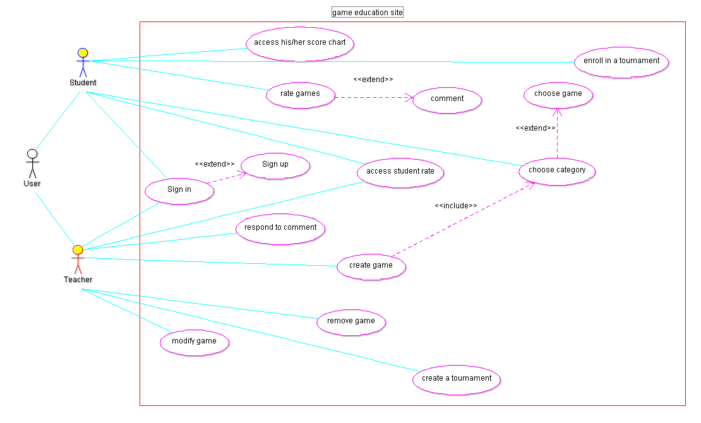

## Use Case Tables

|  |  |  |
| --- | --- | --- |
| Use Case ID: | 001 | |
| Use Case Name: | Student play a game | |
| Actors: | Student | |
| Pre-conditions: | Student with internet connection | |
| Post-conditions: | Student Rate the game | |
| Flow of events: | **User Action** | **Site Action** |
| 1-Student requests the site’s URL |  |
|  | 2- site asks the user to sign in |
| 3- Student types his/her e-mail and password and submit |  |
|  | 4- site validate the user |
|  | 5-site displays the home page |
| 6- Student choose the category |  |
|  |  | 7-site displays the category games |
|  | 8-Student choose the game to play |  |
|  |  | 9- site launches the game |
|  | 10- Student plays the game |  |
|  | 11- Student closes the game |  |
|  |  | 12-site pops the rate panel |
| Exceptions: | **User Action** | **Site Action** |
| @3 -Student forgets the password |  |
| 1- Student chooses “forget password” |  |
|  |  | 2-Site asks the user to enter his e-mail |
|  |  | 3-Site validates the email and send e-mail with link to change the password |
|  | 4- Student access the link |  |
|  |  | 5-Site asks to enter new password |
|  | Resume @3 |  |
|  | @3 Student doesn’t have an account  1- Student choose “sign up” |  |
|  |  | 2-site displays the sign up bage |
|  | 3-Student enters his/her info and fills the required fields |  |
| Includes: | Log in |  |



|  |  |  |
| --- | --- | --- |
| Use Case ID: | 002 | |
| Use Case Name: | Teacher and game creation | |
| Actors: | Teacher | |
| Pre-conditions: | A registered teacher with internet connection | |
| Post-conditions: | Teacher saves the game | |
| Flow of events: | **Teacher Action** | **Site Action** |
| 1-Teacher requests the site URL |  |
|  | 2- site displays the login page |
| 3- Teacher enters the email and password |  |
|  | 4- site validate the user |
|  | 5-site displays the home page |
|  | 6-Teacher chooses the “create a game” |  |
|  |  | 7-site launches the game create game platform |
|  | 8-teacher creates the game |  |
| Exceptions: | **Teacher Action** | **Site Action** |
| @3 Teacher forgets the password  1-Teacher chooses ”forget password” |  |
|  | 2-site asks for the email and sends link to create a new one |
|  | 3-Teacher access the link |  |
|  | 4-Teacher enters the new password |  |
|  | 5-Teacher hits submit |  |
|  | Resume @3 |  |
| Includes: | Log in |  |

|  |  |  |
| --- | --- | --- |
| Use Case ID: | 003 | |
| Use Case Name: | Teacher and game modification | |
| Actors: | Teacher | |
| Pre-conditions: | A registered teacher with internet connection | |
| Post-conditions: | Teacher saves the game | |
| Flow of events: | **Teacher Action** | **Site Action** |
| 1-Teacher requests the site URL |  |
|  | 2- site displays the login page |
| 3- Teacher enters the email and password |  |
|  | 4- site validate the user |
|  | 5-site displays the home page |
|  | 6-Teacher chooses the “modify a game” |  |
|  |  | 7-site launches the game create game platform with the chosen game |
|  | 8-teacher modifies the game |  |
| Exceptions: | **Teacher Action** | **Site Action** |
| @3 Teacher forgets the password  1-Teacher chooses ”forget password” |  |
|  | 2-site asks for the email and sends link to create a new one |
|  | 3-Teacher access the link |  |
|  | 4-Teacher enters the new password |  |
|  | 5-Teacher hits submit |  |
|  | Resume @3 |  |
| Includes: | Log in |  |

|  |  |  |
| --- | --- | --- |
| Use Case ID: | 004 | |
| Use Case Name: | Teacher and game deletion | |
| Actors: | Teacher | |
| Pre-conditions: | A registered teacher with internet connection | |
| Post-conditions: | Site deletes the game | |
| Flow of events: | **Teacher Action** | **Site Action** |
| 1-Teacher requests the site URL |  |
|  | 2- site displays the login page |
| 3- Teacher enters the email and password |  |
|  | 4- site validate the user |
|  | 5-site displays the home page |
|  | 6-Teacher chooses the “delete a game” |  |
|  |  | 7-site asks the teacher to choose the game |
|  | 8-teacher chooses the game |  |
|  |  | 9-Site asks the teacher to confirm |
|  | 9-Teacher confirms |  |
| Exceptions: | **Teacher Action** | **Site Action** |
| @3 Teacher forgets the password  1-Teacher chooses ”forget password” |  |
|  | 2-site asks for the email and sends link to create a new one |
|  | 3-Teacher access the link |  |
|  | 4-Teacher enters the new password |  |
|  | 5-Teacher hits submit |  |
|  | Resume @3 |  |

# Ownership Report

|  |  |
| --- | --- |
| **Item** | **Owners** |
| Functional requirement | *Mohamed Fawzy* |
| non-functional requirement | *Mohamed maged* |
| Use case diagram | Mahmoud osama |
| Use case table | *Abdel-aziz Abdel-naser* |

# Policy Regarding Plagiarism:

1. تشجع الكلية على مناقشة الأفكار و تبادل المعلومات و مناقشات الطلاب حيث يعتبر هذا جوهريا لعملية تعليمية سليمة
2. ساعد زملاءك على قدر ما تستطيع و حل لهم مشاكلهم فى الكود و لكن تبادل الحلول غير مقبول و يعتبر غشا.
3. أى حل يتشابه مع أى حل آخر بدرجة تقطع بأنهما منقولان من نفس المصدر سيعتبر أن صاحبيهما قد قاما بالغش.
4. قد توجد على النت برامج مشابهة لما نكتبه هنا أى نسخ من على النت يعتبر غشا يحاسب عليه صاحبه.
5. إذا لم تكن متأكدا أن فعلا ما يعد غشا فلتسأل المعيد أو أستاذ المادة.
6. فى حالة ثبوت الغش سيأخذ الطالب سالب درجة المسألة ، و فى حالة تكرار الغش سيرسب الطالب فى المقرر.