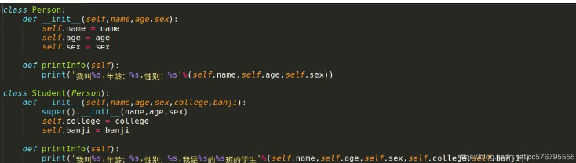

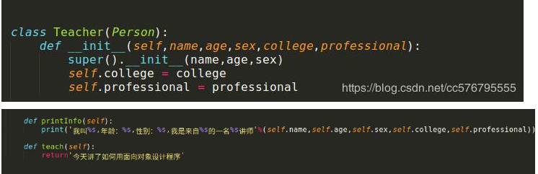

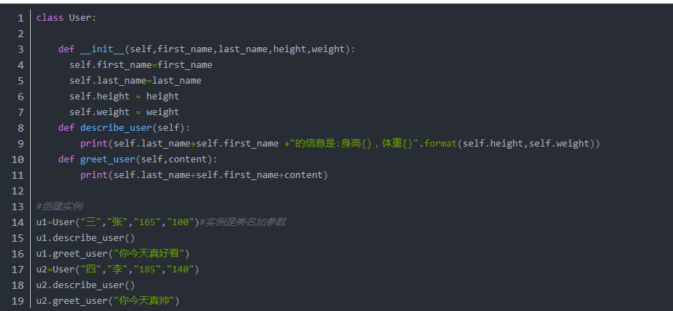

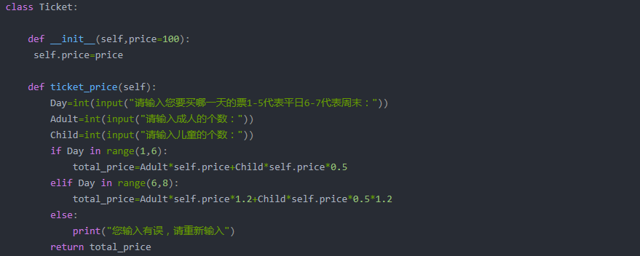

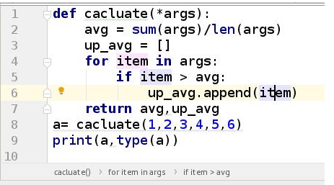

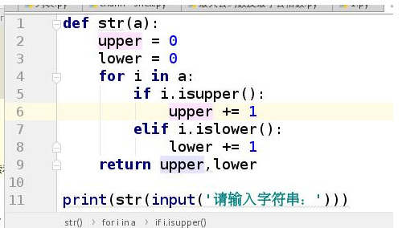

1 l1 = [1,2,3,4,5,6,7]

2 def jishu_list(l,li = []):

3 n = 1

4 for i in l:

5 if n%2 == 1:

6 li.append(i)

7 n += 1

8 return li

9 print(jishu_list(l1))

1 def func(l):

2 # return True if len(l) > 5 else False

3 return len(l) > 5 #比较运算本身返回bool值

4 print(func('546646'))