TECHNICAL ANALYSIS REPORT
Can EM-Driven Vertical Microsaccades
Account for Up/Down Choices?
Multilevel evidence from microsaccade generation, session-level bias, trial-level choice, and MS-by-EM interaction models
Jim and Clay | MT and FST | 12 ms detector | 24 July 2026
Bottom line: EM-related changes in mean vertical MS displacement covary with EM-related changes in fitted behavioral bias across sessions, most convincingly in MT. However, vertical MS does not robustly predict the monkey's individual up/down choice after session and visual-evidence control, and EM does not reliably change that slope. The current data therefore support vertical MS as a session-level correlate or marker, not as a demonstrated mediator of EM's behavioral effect.
Primary trial-level sample: 253 sessions and 77,742 trials containing at least one MS

1. Executive conclusion
The biological question is a mediation question: did EM alter vertical microsaccades, and did those EM-driven MS changes in turn produce the up/down choice bias? Because the choice targets are vertical, MS_y - the signed vertical displacement, positive upward - is the primary oculomotor variable. Three links are needed for a persuasive account.
Claim | Required evidence | Observed evidence | Verdict
A. EM -> MS_y | EM must reproducibly move the vertical-MS distribution. | Group means changed only slightly and in mixed directions; no common vertical shift. | Weak / heterogeneous
B. DeltaMS_y -> DeltaBias | Sessions with upward/downward MS changes should show matching behavioral-bias changes. | Sign concordance: MT 69.2%, FST 65.2%; FDR-significant. Magnitude slope positive only in MT. | Supportive at session level
C. MS_y -> trial choice | Within a session, vertical MS direction should predict the later binary choice. | No adjusted group slope or joint MS effect survived correction; no session fit survived Holm. | Not supported
D. EM x MS_y | If EM changes MS-choice coupling, the interaction should differ from zero. | All vertical and 2-D interactions were nonsignificant after correction. | Not supported
Overall mediation | A formal indirect EM -> MS_y -> choice effect should be estimable and nonzero. | No formal multilevel mediation was fit; the necessary trial-level b-path is not established. | Not established

Important distinction: The absence of an MS_y-by-EM interaction does not by itself rule out mediation; mediation can occur with a common MS_y slope in both conditions. Here, the more consequential result is that the adjusted within-session MS_y-to-choice slope itself is not reliably different from zero.

2. Data and preprocessing

2.1 Behavioral and oculomotor definitions
Choice was the decoded binary response (0/1) for the monkey's two vertical choice targets. The models estimate P(Choice = 1); the sign of a coefficient should be translated to 'up' or 'down' only after confirming the task's response-code mapping. MS_y is signed vertical eye displacement in degrees, with positive values defined as upward.
Microsaccades were detected only during the visual-stimulus interval from event ID 118 to event ID 130, before the instructed choice saccade. The completed population batch used a 12 ms minimum duration, no smoothing, and the merged/unmatched-eye detector. For a trial with multiple MS events, event displacement vectors were averaged within that trial.

2.2 Analysis samples
Monkey-area | Sessions | MS trials | NonStim | Stim
Jim-MT | 56 | 13,346 | 6,601 | 6,745
Jim-FST | 94 | 18,144 | 8,965 | 9,179
Clay-MT | 38 | 16,462 | 8,384 | 8,078
Clay-FST | 65 | 29,790 | 15,211 | 14,579
Total | 253 | 77,742 | 39,161 | 38,581

Source: grouped_ms_choice_summary.csv. The trialwise session analysis attempted 254 sessions; 246 met all per-session fitting criteria. The grouped table contains 253 sessions with usable pooled trial rows.
Trial-level models were conditional on observing at least one MS. This is appropriate for asking whether the direction of an observed MS predicts choice, but it does not estimate behavioral pathways through EM-induced changes in the probability of having an MS.

3. Statistical models
The repository contains complementary models at three levels. They answer different questions and should not be treated as interchangeable.
Model | Unit | Specification | Question
Stim/NonStim MS comparison | Per session | Scalar differences and 2-D first-moment distance; 1,000 label permutations within visual-condition x signed-coherence strata | Does EM change MS production or kinematics in that session?
Paired bias LME | Session-condition | Bias ~ MS_y + condition + (1|SessionKey); interaction sensitivity adds MS_y x condition | Do session means covary after pairing Stim/NonStim conditions?
Centered change | Session | DeltaMS_y and DeltaBias; exact one-sided quadrant-concordance test; positive origin-slope sensitivity | Do EM-induced MS_y and bias changes have matching signs/magnitudes?
Session logistic | Trial within session | Simple, visual-evidence-adjusted vertical, and adjusted X/Y models; Jeffreys-prior binomial fits | Does MS direction predict choice in an individual recording session?
Grouped stratified logistic | Trial pooled within monkey-area | Session-specific Stim/NonStim intercepts plus MS_y x Stim; adjusted model adds signed coherence x visual condition | Is there a common within-session MS_y effect or EM interaction?
Exact pooled logistic | All trial rows in monkey-area | Choice ~ MeanMSY_Z * StimCondition; no SessionID term | Sensitivity to the requested unstratified pooled specification

3.1 Session-level EM effects on MS pattern
For each session, stimulation labels were shuffled 1,000 times within visual-condition and signed-coherence strata. Scalar outcomes were MS rate, probability of any MS, per-trial mean amplitude, peak velocity, and duration. Direction was tested as the Euclidean distance between Stim and NonStim two-dimensional mean displacement vectors. Event properties were summarized within trials before testing so that trials with many events did not count as independent observations.

3.2 Session-mean behavioral-bias models
Bias ~ MS_y + condition + (1|SessionKey)
Bias ~ MS_y * condition + (1|SessionKey)
Only complete Stim/NonStim session pairs with acceptable psychometric fits were used. The common-slope model asks whether mean vertical MS displacement covaries with fitted behavioral bias across the paired conditions. The interaction model asks whether that slope differs under EM. Benjamini-Hochberg FDR correction was applied across the four cue definitions separately within each ROI.

3.3 Centered EM-induced change analysis
DeltaMS_y = MS_y(Stim) - MS_y(NonStim)
DeltaBias = Bias(Stim) - Bias(NonStim)
The primary exact binomial test asks whether DeltaMS_y and DeltaBias have the same sign more often than 50%. A secondary one-sided regression fits DeltaBias = beta * DeltaMS_y through the origin. FDR correction was reported within ROI and across all eight ROI-by-cue tests. The sign test is robust to scale, whereas the origin regression tests whether larger MS changes correspond to proportionally larger bias changes.

3.4 Trial-level logistic models
Simple: Choice ~ MeanMSY_Z * StimCondition
Adjusted: Choice ~ SignedCoherence * VisualCondition + StimCondition + MeanMSY_Z * StimCondition
Vector: Adjusted base + MeanMSX_Z * StimCondition + MeanMSY_Z * StimCondition
MeanMSY_Z and MeanMSX_Z were standardized within recording session; a slope is therefore the change in log odds of Choice = 1 per one within-session SD of trial-average MS displacement. Jeffreys-prior bias reduction was used to avoid infinite estimates in sparse choice-by-cue cells. Session fits required at least 30 usable MS trials, at least 10 in each stimulation condition, variation in MS_y, and both choices within each condition.
For the grouped analysis, trials were pooled into Jim-MT, Jim-FST, Clay-MT, and Clay-FST, but SessionID-by-StimCondition terms supplied session-specific NonStim and Stim intercepts. The primary adjusted group formula was:
Choice ~ SessionID * StimCondition + SignedCoherence * VisualCondition + MeanMSY_Z * StimCondition
The primary MS test was the average of the NonStim and Stim vertical slopes; the primary moderation test was the Stim-minus-NonStim slope difference. Joint tests evaluated any vertical-MS effect and, in the vector model, the combined horizontal/vertical effects. Holm-Bonferroni correction was applied across the four monkey-area groups separately for each model/test family.

3.5 Pooled sensitivity model
Choice ~ MeanMSY_Z * StimCondition
This exact pooled model used the same trial rows and within-session standardization but omitted SessionID. It treats trial rows as independent and can attribute stable session-to-session differences in choice baseline to MS_y. It is retained as a sensitivity analysis; the session-stratified grouped model is the preferred inferential model.

4. Results

4.1 Did EM change vertical MS?
Group | N | NonStim MS_y | Stim MS_y | Mean delta | Negative % N/S | 2-D direction p<.05
Jim-MT | 56 | -0.00561 | -0.00608 | -0.00047 | 71.4% / 76.8% | 20/56
Jim-FST | 94 | -0.00250 | -0.00214 | +0.00036 | 72.3% / 67.0% | 21/94
Clay-MT | 38 | -0.04259 | -0.04072 | +0.00187 | 100.0% / 100.0% | 7/38
Clay-FST | 65 | -0.03705 | -0.04549 | -0.00845 | 95.4% / 93.8% | 7/65

MS_y values are session-condition means in degrees. The last column is the number of individual sessions with an unadjusted p < .05 in the stratified 2-D mean-vector permutation test; it is not a vertical-only test and should not be read as a group-level effect.
The mean Stim-minus-NonStim vertical change was small and did not have a common sign across groups: -0.00047 degrees in Jim-MT, +0.00036 in Jim-FST, +0.00187 in Clay-MT, and -0.00845 in Clay-FST. Clay's MS_y distribution was strongly downward in both conditions, whereas Jim's was much closer to zero. Thus EM did not impose a single population-wide vertical shift. Individual sessions did show 2-D pattern changes, especially in Jim, but a change in the two-dimensional vector need not be a behaviorally aligned change in MS_y.
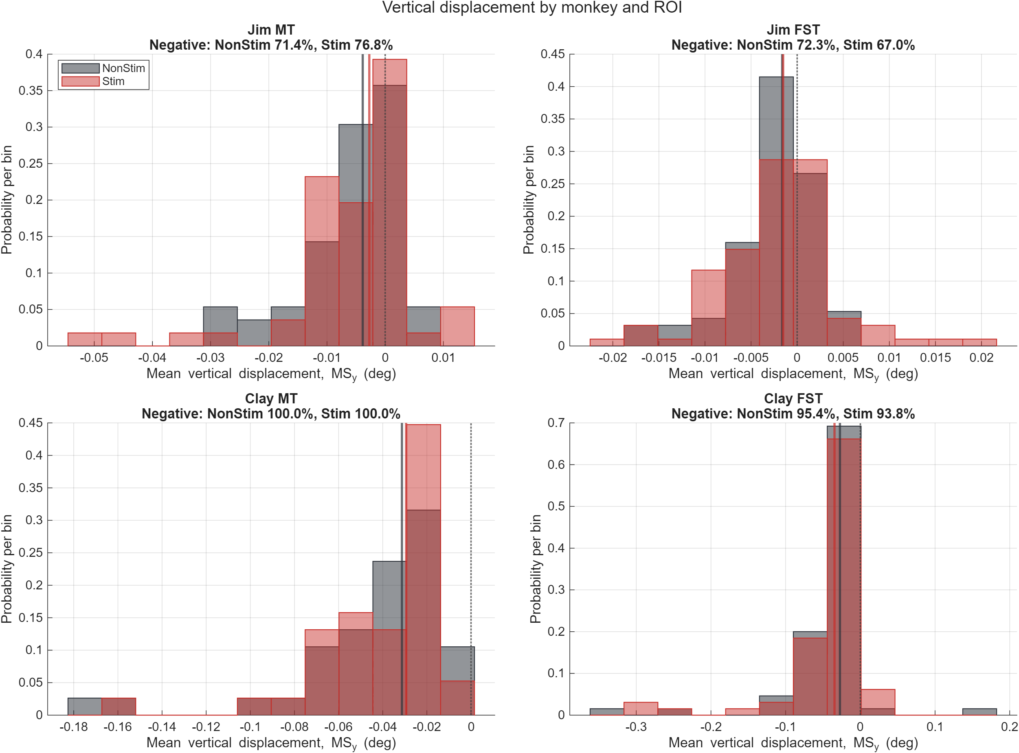
Figure 1. Session-level distributions of mean vertical MS displacement by monkey-area group and EM condition. Solid lines mark condition medians; the dotted line marks zero. The extensive overlap and mixed direction of mean shifts argue against a uniform EM-induced vertical-MS change.

4.2 Do EM-induced MS_y changes track behavioral-bias changes?
ROI | Sessions | Concordant | 95% CI | Quadrant q | Origin slope +/- SE | Slope q
MT | 91 | 63/91 (69.2%) | [0.591, 0.778] | 4.17e-04 | 5.091 +/- 1.791 | 0.006
FST | 159 | 103/158 (65.2%) | [0.575, 0.722] | 3.76e-04 | 0.270 +/- 0.606 | 0.328

For the combined-cue behavioral bias, MT showed matching signs of DeltaMS_y and DeltaBias in 63 of 91 sessions (69.2%, FDR q = 0.00042). The positive through-origin slope was also significant (5.09 +/- 1.79, q = 0.0061), so sessions with larger vertical-MS shifts tended to have larger bias shifts in the same direction.
FST also showed significant sign concordance: 103 of 158 non-axis sessions (65.2%, q = 0.00038). However, its origin slope was small and nonsignificant (0.27 +/- 0.61, q = 0.328). The FST evidence therefore supports directional agreement but not proportional scaling of effect magnitude. Across cue-specific analyses, quadrant concordance remained FDR-significant in all MT and FST cue definitions; origin slopes were significant in all MT definitions and in none of the FST definitions.

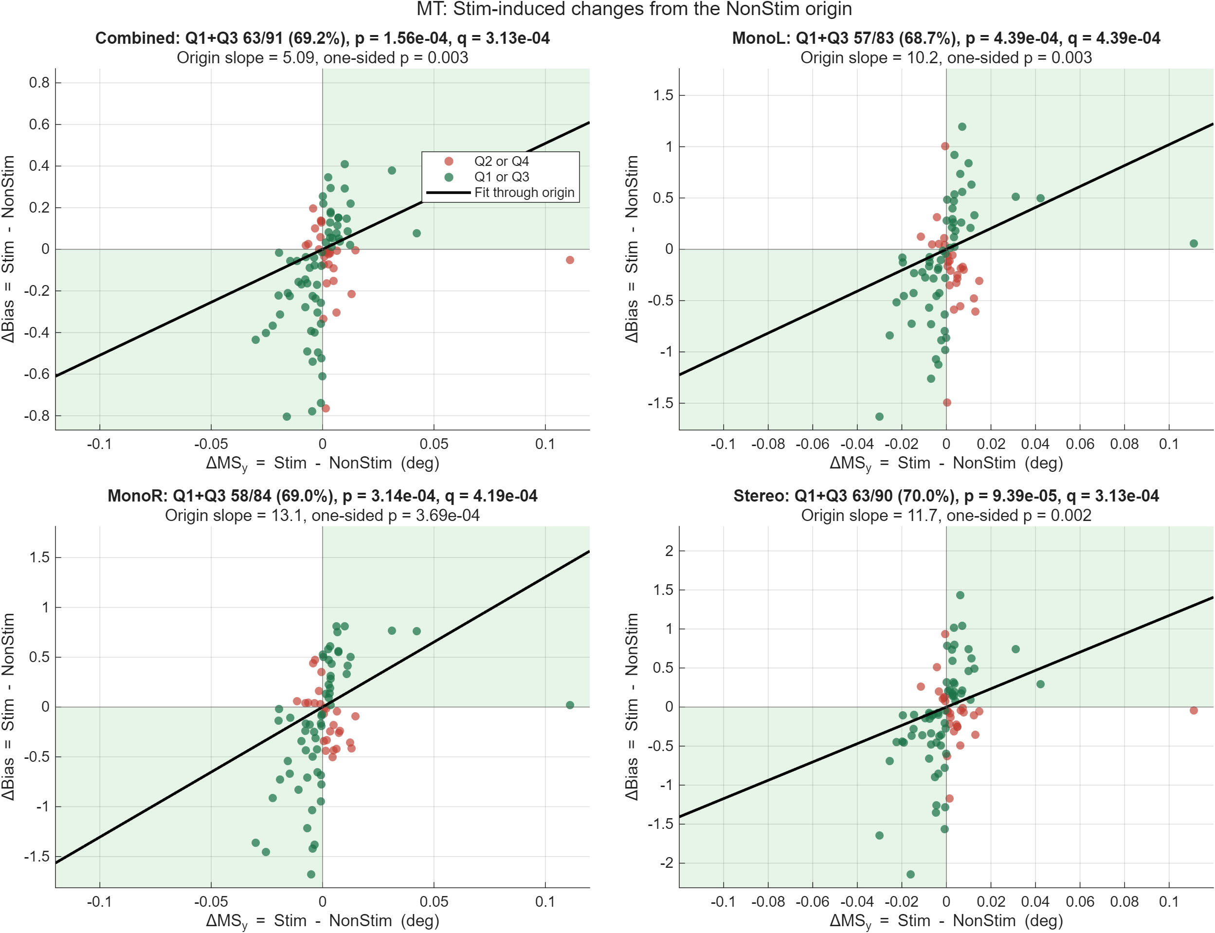
Figure 2. MT session-level EM-induced changes. Green points fall in concordant quadrants, where DeltaMS_y and DeltaBias share a sign. The combined and cue-specific results show both excess sign concordance and positive magnitude scaling.

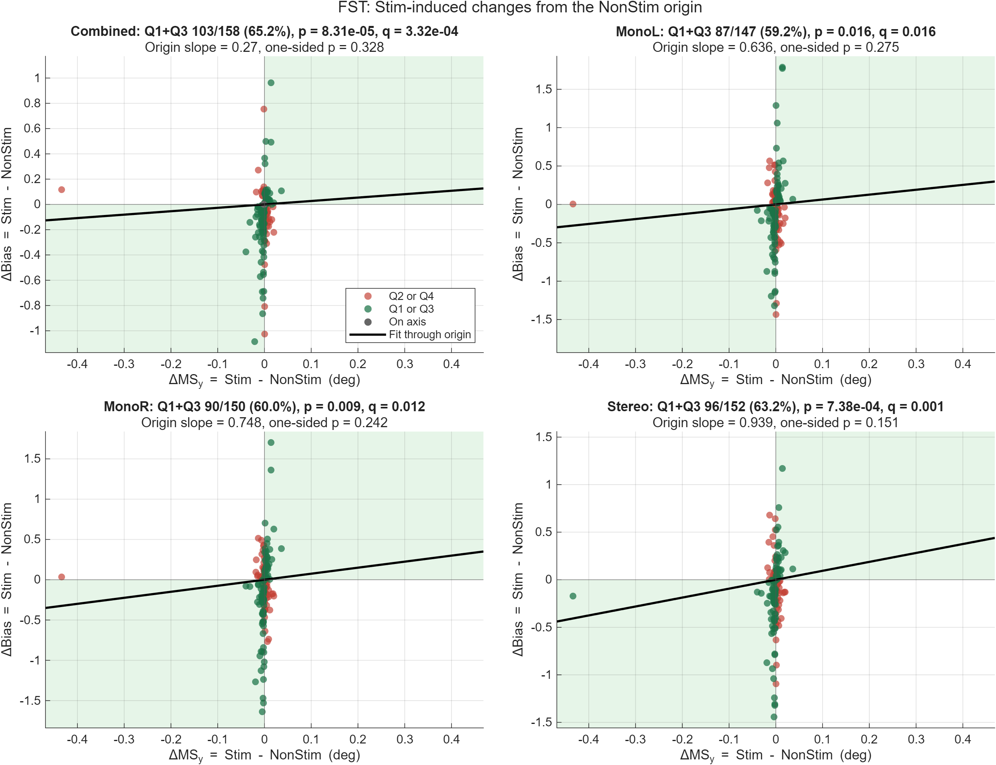
Figure 3. FST session-level EM-induced changes. Sign concordance exceeds 50%, but the fitted through-origin slopes are shallow and nonsignificant, indicating weak correspondence in change magnitude.

4.3 Session-mean mixed models
ROI | Sessions | Common MS_y slope +/- SE | Slope q | MS_y x EM | Interaction q
MT | 91 | 1.354 +/- 0.410 | 0.005 | 0.454 | 0.901
FST | 159 | 0.744 +/- 0.197 | 7.51e-04 | 0.349 | 0.762

The paired session-mean LME gave a positive common MS_y-bias slope for the combined cue in MT (1.354 +/- 0.410, q = 0.0047) and FST (0.744 +/- 0.197, q = 0.00075). The MS_y-by-condition interaction was not significant in either ROI (MT q = 0.901; FST q = 0.762). These results agree with a stable session-level association but do not show that the MS occurring on a particular trial determines the subsequent choice.

4.4 Does vertical MS predict the individual up/down choice?
Group | Adjusted average slope [95% CI] | Avg Holm p | N/S slopes | MS_y x EM [95% CI] | Int Holm p | 2-D int Holm p
Jim-MT | 0.015 [-0.028, 0.058] | 1.000 | 0.037 / -0.006 | -0.043 [-0.128, 0.042] | 0.980 | 1.000
Jim-FST | 0.008 [-0.030, 0.045] | 1.000 | 0.014 / 0.002 | -0.012 [-0.087, 0.062] | 1.000 | 1.000
Clay-MT | 0.028 [-0.010, 0.066] | 0.604 | 0.051 / 0.005 | -0.045 [-0.122, 0.031] | 0.980 | 1.000
Clay-FST | 0.014 [-0.015, 0.043] | 1.000 | 0.020 / 0.008 | -0.011 [-0.068, 0.046] | 1.000 | 1.000

No adjusted average vertical-MS slope was significant after correction (Holm p = 0.604 to 1.000). The largest condition-specific coefficient was Clay-MT in NonStim trials (0.051 log-odds per within-session SD, unadjusted p = 0.078), but its Stim slope was near zero (0.005, p = 0.839), and the interaction was not significant. Effect sizes were small: the adjusted average odds ratios per one-SD MS_y increase were approximately 1.008 to 1.029.
At the individual-session level, 246 fits were complete. Only 11 had an unadjusted adjusted-vertical 'any MS' p < .05 and 8 had an unadjusted vertical interaction p < .05. The 2-D vector model produced 6 raw any-effect and 8 raw interaction findings. None survived Holm-Bonferroni correction across sessions.

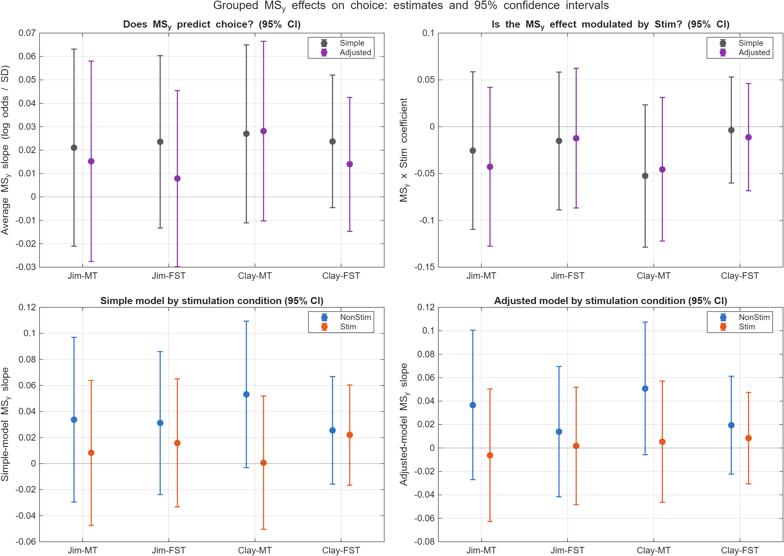
Figure 4. Grouped session-stratified vertical-MS results. The upper-left panel tests whether MS_y predicts choice on average; the upper-right panel tests EM moderation. The lower panels show condition-specific slopes. All adjusted 95% confidence intervals include zero.

4.5 Does EM modulate the MS_y-to-choice relationship?
The preferred adjusted interaction estimates were -0.043 in Jim-MT, -0.012 in Jim-FST, -0.045 in Clay-MT, and -0.011 in Clay-FST. Raw interaction p values ranged from 0.245 to 0.748; Holm-adjusted values ranged from 0.980 to 1.000. The adjusted 2-D X/Y interaction tests had raw p values from 0.454 to 0.813 and Holm p = 1.000 in every group. There is therefore no evidence that EM makes vertical MS more or less predictive of the later choice.

4.6 Pooled-model sensitivity
Group | Average slope | Average Holm p | MS_y x EM | Interaction Holm p | Any MS Holm p
Jim-MT | 0.026 | 0.428 | -0.014 | 1.000 | 0.840
Jim-FST | 0.024 | 0.428 | -0.016 | 1.000 | 0.840
Clay-MT | 0.028 | 0.428 | -0.050 | 0.762 | 0.697
Clay-FST | 0.025 | 0.334 | 0.006 | 1.000 | 0.697

The exact pooled logistic model reached the same qualitative conclusion. Average-slope Holm p values were 0.334 to 0.428; interaction Holm p values were 0.762 to 1.000; and joint any-MS Holm p values were 0.697 to 0.840. Session-stratified and pooled estimates were similar and all corresponding 95% confidence intervals crossed zero.

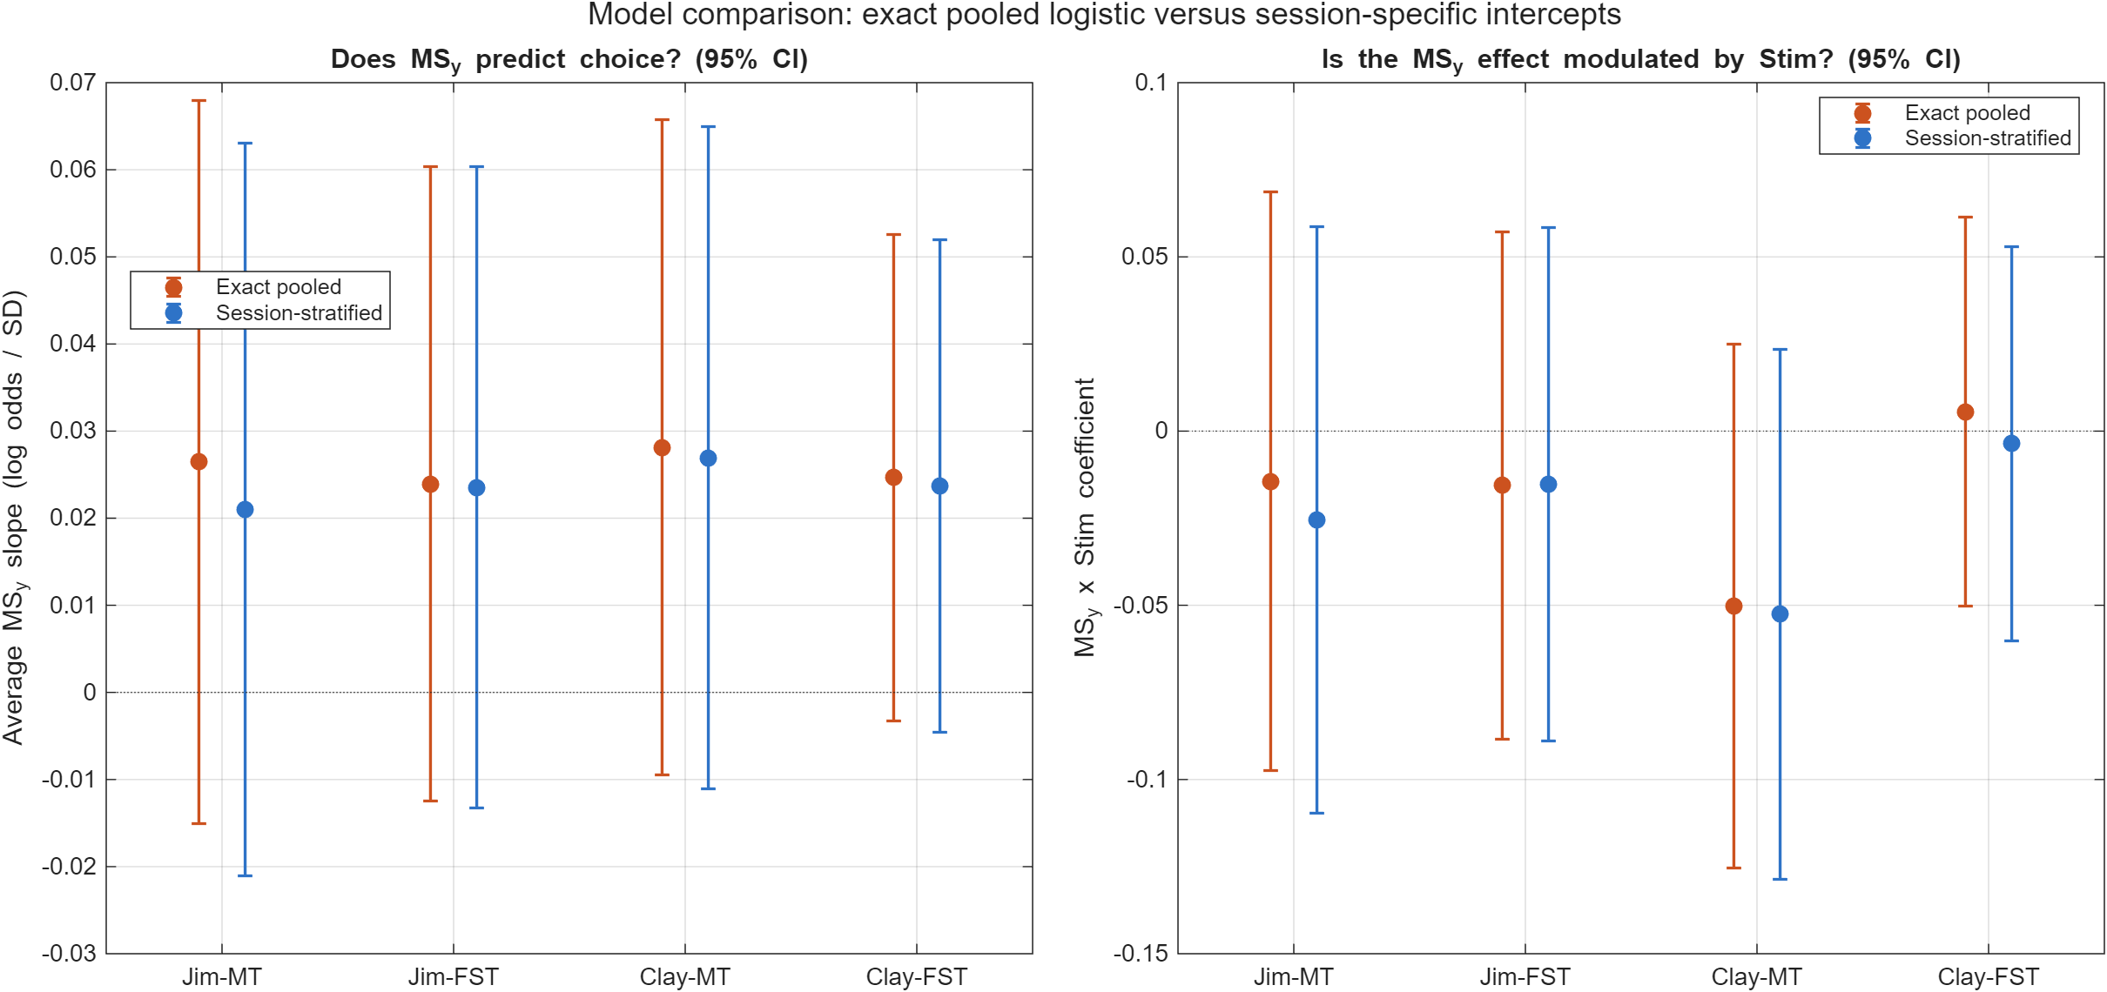
Figure 5. Sensitivity comparison of the unstratified pooled logistic model and the model with session-specific condition intercepts. Neither model supports a reliable average MS_y slope or MS_y-by-EM interaction.

5. Integrated interpretation

5.1 What the positive session-level results mean
The centered analysis is the strongest evidence in favor of an EM-MS-behavior link. In many sessions, an EM-induced upward shift in mean MS_y accompanied an upward shift in fitted choice bias, and a downward shift accompanied a downward bias shift. This relationship was especially coherent in MT, where both sign concordance and change-magnitude scaling were significant.
However, this is an aggregate change-change association. It does not identify which trials produced the behavioral effect, and it cannot distinguish mediation from a shared upstream EM effect. EM could alter a latent oculomotor/decision state that independently changes mean MS_y and psychometric bias. Under that account, MS_y is a useful marker of the state without being the mechanism that generates the choice.

5.2 Why the trial-level null result matters
If vertical MS were a proximal driver of the up/down decision, trials with more upward MS displacement should have a reliably different probability of Choice = 1 than trials with more downward displacement, after accounting for signed motion evidence, visual condition, EM, and recording session. That prediction was not supported. The adjusted slopes were small, their confidence intervals included zero, and the result held across pooled, session-stratified, vector, and per-session models.

5.3 Answer to the central question
Interpretation: The analyses do not demonstrate that EM made vertical-MS changes that account for the monkeys' choices. They demonstrate a reproducible session-level covariation between EM-induced MS_y change and behavioral bias change, especially in MT, but not the within-trial choice-predictive link needed to treat MS_y as a behavioral mediator.
Accordingly, the most defensible language is: 'EM-induced vertical-MS changes track EM-induced behavioral-bias changes across sessions, but vertical MS direction does not robustly predict individual choices and its choice relationship is not detectably modulated by EM. Vertical MS is therefore better interpreted as a correlated readout than as an established causal intermediary.'

6. Limitations and inferential boundaries
Issue | Implication
MS-containing trials only | Direction models exclude trials without an MS. They cannot capture a pathway through EM-induced changes in MS occurrence.
Aggregate bias outcomes | Psychometric bias and session-mean MS_y can covary because of shared session-level factors; this is an ecological association.
No formal indirect effect | The pipeline does not estimate a multilevel natural indirect effect or product-of-coefficients EM -> MS_y -> choice pathway.
Response-code sign | The model predicts Choice = 1. The up/down interpretation of coefficient sign requires confirming the behavioral response coding.
Multiple events per trial | Averaging event vectors is reproducible but may hide timing, order, or opposing MS events within a trial.
Temporal and latent-state confounding | MS precedes the choice saccade, but both MS and choice may reflect the same EM-driven sensory or oculomotor state.
Session dependence | The unstratified pooled model treats trials as independent. The session-stratified model is preferred, but it uses many fixed intercept terms rather than a hierarchical random-effects model.

7. Recommended confirmatory analysis
A confirmatory mediation analysis should preserve the multilevel structure and include every valid trial, not only trials containing an MS. Because MS direction is undefined when no MS occurs, a two-part mediator is preferable.
Component | Model sketch | Purpose
Occurrence model | AnyMS ~ EM + SignedCoherence * VisualCondition + (1 + EM | Session) | Tests whether EM changes the probability that a trial contains an MS.
Direction model | MS_y | AnyMS = 1 ~ EM + SignedCoherence * VisualCondition + (1 + EM | Session) | Tests the EM effect on vertical direction conditional on an MS.
Choice model | Choice ~ EM + AnyMS + MS_y + EM:MS_y + SignedCoherence * VisualCondition + session effects | Estimates the within-trial occurrence and direction pathways.
Indirect effects | Cluster bootstrap or Bayesian posterior over sessions | Quantifies uncertainty in EM -> AnyMS -> choice and EM -> MS_y -> choice pathways.

The confirmatory analysis should predefine the response-code mapping, the MS time window relative to sensory evidence and decision formation, and whether MS_y is summarized by the first event, the last event, a time-weighted mean, or the current within-trial vector average. Session-clustered resampling should be used so trial count does not overstate precision.

8. Reproducibility
The report was generated from the completed 12 ms, no-smoothing population output. Re-running should start from the repository root and use the MATLAB entry points below in order.
Stage | Entrypoint | Primary outputs
Population postprocessing | run_12ms_population_postprocessing.m | MS metric histograms, paired bias LME, centered DeltaMS_y-DeltaBias tests
Per-session choice models | run_12ms_trialwise_ms_choice.m | Trial table, 254 session summaries, coefficients, diagnostic figures
Grouped and pooled models | run_grouped_monkey_roi_ms_choice.m | Four monkey-area fits, probability plots, pooled sensitivity comparison

8.1 Core analysis functions
analyze_microsaccades.m
analyze_ms_behavior_bias.m
analyze_paired_ms_bias_lme.m
analyze_centered_ms_bias_changes.m
analyze_trialwise_ms_choice.m
analyze_grouped_ms_choice.m
analyze_pooled_logistic_ms_choice.m

8.2 Key machine-readable result files
Result | File
EM effects on MS | C:\EM\Microsac\population_merged_12ms_no_smoothing\population_microsaccade_stim_nonstim_tests_complete.csv
Session-condition MS metrics | C:\EM\Microsac\population_merged_12ms_no_smoothing\population_analysis\histograms\population_ms_session_condition_metrics.csv
Paired bias LME | C:\EM\Microsac\population_merged_12ms_no_smoothing\population_analysis\paired_ms_y_bias_lme\paired_ms_y_bias_lme_summary.csv
Centered changes | C:\EM\Microsac\population_merged_12ms_no_smoothing\population_analysis\paired_ms_y_bias_lme\centered_change\centered_delta_ms_y_bias_test_summary.csv
Session choice models | C:\EM\Microsac\population_merged_12ms_no_smoothing\population_analysis\trialwise_ms_choice\trialwise_ms_choice_session_summary.csv
Grouped choice models | C:\EM\Microsac\population_merged_12ms_no_smoothing\population_analysis\grouped_monkey_roi_ms_choice\grouped_ms_choice_summary.csv
Pooled sensitivity | C:\EM\Microsac\population_merged_12ms_no_smoothing\population_analysis\grouped_monkey_roi_ms_choice\pooled_logistic\pooled_logistic_ms_choice_summary.csv

Appendix A. Cue-specific aggregate results
ROI | Cue | N | Concordance | 95% CI | Quadrant q | Origin slope | Slope q
FST | Combined | 159 | 65.2% | [0.575, 0.722] | 3.76e-04 | 0.270 | 0.328
FST | MonoL | 147 | 59.2% | [0.511, 0.668] | 0.016 | 0.636 | 0.315
FST | MonoR | 150 | 60.0% | [0.520, 0.675] | 0.010 | 0.748 | 0.315
FST | Stereo | 152 | 63.2% | [0.553, 0.704] | 9.84e-04 | 0.939 | 0.242
MT | Combined | 91 | 69.2% | [0.591, 0.778] | 4.17e-04 | 5.091 | 0.006
MT | MonoL | 83 | 68.7% | [0.581, 0.776] | 7.02e-04 | 10.206 | 0.006
MT | MonoR | 84 | 69.0% | [0.585, 0.779] | 6.28e-04 | 13.051 | 0.003
MT | Stereo | 90 | 70.0% | [0.599, 0.785] | 3.76e-04 | 11.729 | 0.006

Quadrant q and slope q use Benjamini-Hochberg FDR correction across all eight ROI-by-cue tests.
ROI | Cue | N | Common slope +/- SE | Slope q | Interaction | Interaction q
FST | Combined | 159 | 0.744 +/- 0.197 | 7.51e-04 | 0.349 | 0.762
FST | MonoL | 147 | 0.343 +/- 0.373 | 0.462 | -0.226 | 0.762
FST | MonoR | 150 | 0.269 +/- 0.365 | 0.462 | -0.317 | 0.762
FST | Stereo | 152 | 0.562 +/- 0.300 | 0.125 | -0.415 | 0.762
MT | Combined | 91 | 1.354 +/- 0.410 | 0.005 | 0.454 | 0.901
MT | MonoL | 83 | 1.159 +/- 0.835 | 0.222 | -0.865 | 0.901
MT | MonoR | 84 | 1.322 +/- 0.826 | 0.222 | 0.636 | 0.901
MT | Stereo | 90 | 0.823 +/- 0.869 | 0.344 | -0.218 | 0.901

LME q values are FDR-corrected across the four cue definitions within each ROI and test family.

