ANALYSIS SUMMARY

Does electrical stimulation change the link between microsaccades and choice?
  - Trial-level and pooled monkey-by-area results using the 12 ms detector without smoothing
Prepared from repository analyses and saved outputs | 21 July 2026
BOTTOM LINE Across 77,742 trials containing at least one microsaccade, electrical stimulation did not measurably alter how trial-mean MS displacement predicted binary choice. No pooled monkey-by-area interaction, per-session interaction, or two-dimensional X/Y interaction survived multiplicity correction.

Analysis in brief
Data. The pipeline screened 254 recording sessions. A total of 253 sessions contributed 77,742 usable MS-containing trials to the pooled analysis (39,161 NonStim; 38,581 Stim); 246 sessions supported complete standalone fits. Seven had too few trials for a session fit and one had no usable MS trial.
MS measure. Events were detected during the visual-stimulus interval (EID 118 to 130) with a 12 ms minimum duration, no extra smoothing, and the merged/unmatched-eye event rule. For each trial with at least one event, event displacement vectors were averaged; vertical displacement (MS_y) was standardized within session.
Outcome and primary test. The outcome was the saved binary response (Choice = 1 versus 0). The MS_y x StimCondition coefficient directly tests whether stimulation changes the MS-choice slope, while motion evidence, visual condition, and session-specific stimulation terms absorb major behavioral structure.
Choice ~ SessionID * StimCondition + SignedCoherence * VisualCondition + MS_y * StimCondition
Robustness. We compared simple and stimulus-adjusted vertical models, fit a joint horizontal/vertical sensitivity model, repeated tests session by session with Holm correction, and checked the earlier paired session-mean bias analysis. Logistic fits used Jeffreys-prior bias reduction to limit separation from sparse choice cells.

Pooled monkey-by-area results
The pooled models are the clearest population-level answer: they use all usable trials while preserving within-session MS scaling and separate NonStim/Stim baselines for each recording.
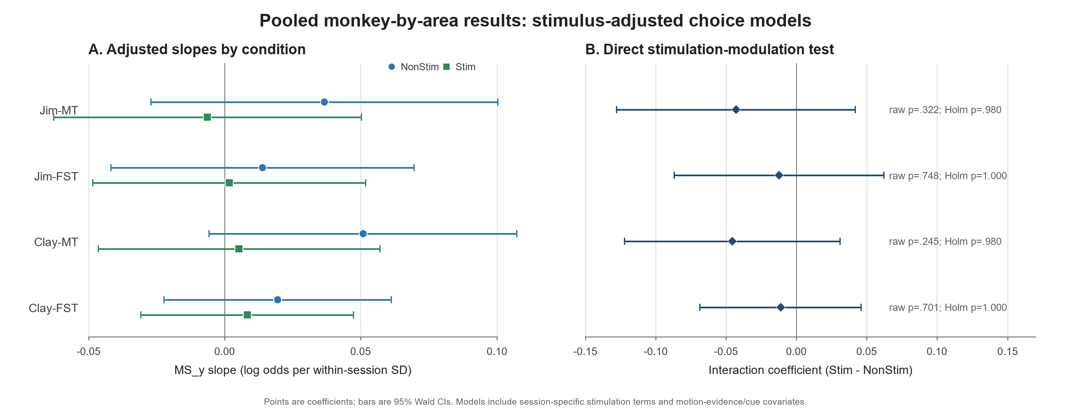
Figure 1. Condition-specific adjusted MS_y slopes and their difference (Stim - NonStim). Coefficients are log-odds changes in Choice = 1 per one within-session SD of vertical MS displacement; bars are 95% Wald confidence intervals.
Table 1. Adjusted vertical MS x stimulation tests
Group | Sessions / trials | Interaction (95% CI) | Raw p | Holm p
Jim-MT | 56 / 13,346 | -0.043 (-0.128, +0.042) | .322 | .980
Jim-FST | 94 / 18,144 | -0.012 (-0.087, +0.062) | .748 | 1.000
Clay-MT | 38 / 16,462 | -0.045 (-0.122, +0.031) | .245 | .980
Clay-FST | 65 / 29,790 | -0.011 (-0.068, +0.046) | .701 | 1.000
Note: Interaction = Stim slope - NonStim slope. Holm correction was applied across the four monkey-area groups within the adjusted vertical interaction family.
Result. All four point estimates were mildly negative, describing weaker MS_y slopes during stimulation, but every confidence interval included zero. Raw interaction p values ranged from .245 to .748 and Holm p values from .980 to 1.000. The joint X/Y interaction was also null in every group (raw p = .454 to .813; Holm p = 1.000).

Session-level checks and interpretation
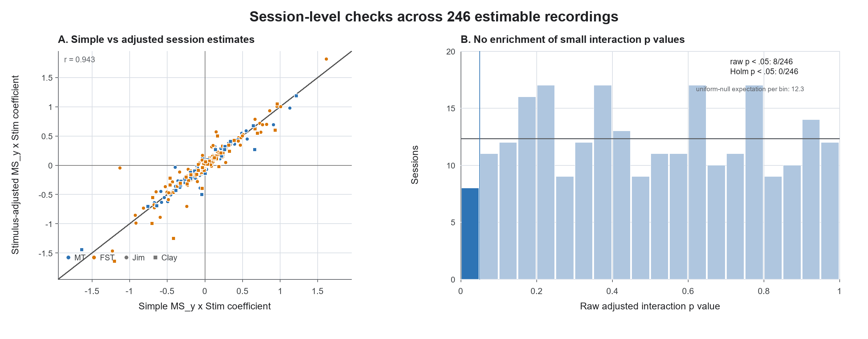
Figure 2. Each point is an estimable recording session. The simple and stimulus-adjusted interaction coefficients were strongly aligned (r = 0.943). The right panel uses .05-wide p-value bins; the horizontal line is the expected count per bin under a uniform null distribution.
Independent session fits. Before correction, 10 of 246 simple vertical interactions and 8 of 246 stimulus-adjusted vertical interactions had p < .05; 8 of 246 vector interactions had raw p < .05. None survived Holm correction in any interaction family. The adjusted p-value histogram showed no excess of small values (8 observed below .05 versus 12.3 expected under a uniform null).
Converging session-mean analysis. The earlier paired mixed-effects models tested Bias ~ MS_y * condition + (1 | SessionKey) across MT/FST and four cue definitions. No MS_y x condition interaction was supported after FDR correction (q = .762 to .901), consistent with the trial-level result. Main MS-bias or condition effects in that analysis do not establish modulation of the slope.

Interpretation
Inference. These analyses do not support the claim that electrical stimulation changes the coupling between MS displacement and choice. Across the four pooled confidence intervals, the most extreme bounds were -0.128 and +0.062 log odds per SD (interaction odds ratios about 0.88 to 1.06).
Scope. The result is conditional on trials that contained at least one MS and uses the trial-mean displacement over the full visual interval. It does not test whether stimulation changes MS occurrence, nor whether fine-grained MS timing predicts choice. A pre-specified hierarchical model of MS presence and timing would be the most informative follow-up if those mechanisms are of interest.
Analysis sources: README.md; analyze_microsaccades.m; analyze_trialwise_ms_choice.m; analyze_grouped_ms_choice.m; analyze_paired_ms_bias_lme.m; and saved session/group summary CSV files under C:\EM\Microsac\population_merged_12ms_no_smoothing\population_analysis.

