Auto Aim

1. Attach AutoAimController.cs to a new gameobject , set values and layers
2. 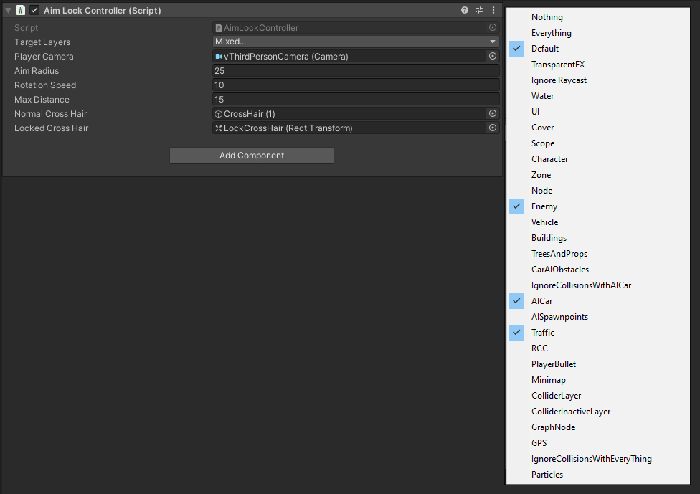Drag _Features/AutoAim/LockCrossHair.prefab to robot canvas
3. Duplicate the prefab and disable 1 of them
4. 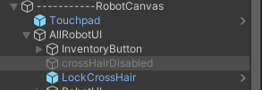Given reference of disabled cross hair to normal cross hair, and enabled one to locked cross hair
5. For given scripts replace the raycast code with this line:

Ray ray = AimLockController.instance.GetRayFromPlayerCamera();

1. 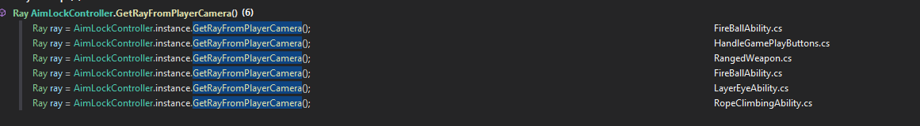Disable cross hair of flying ui as this will be the cross hair for both normal and fly mode
2. Implement AimLockable interface in following scripts