Learning diary of Zlata Shabalina:

Chapter 1.
From chapter 1 I have learned how to download and install Unity Hub, created a new empty 3D project and learned where are the tools for work located. In the first chapter there was no open exercises.

Chapter 2.
I created my first 3D object, learned move, rotate and scale tools in the Unity as well as using keyboard, then created a new scene with the floor and 4 walls, I also applied materials on my game objects. In this chapter I had 1 open exercise where I uploaded the screenshot of my built maze. Here it is. This is a green maze created from simple game objects.

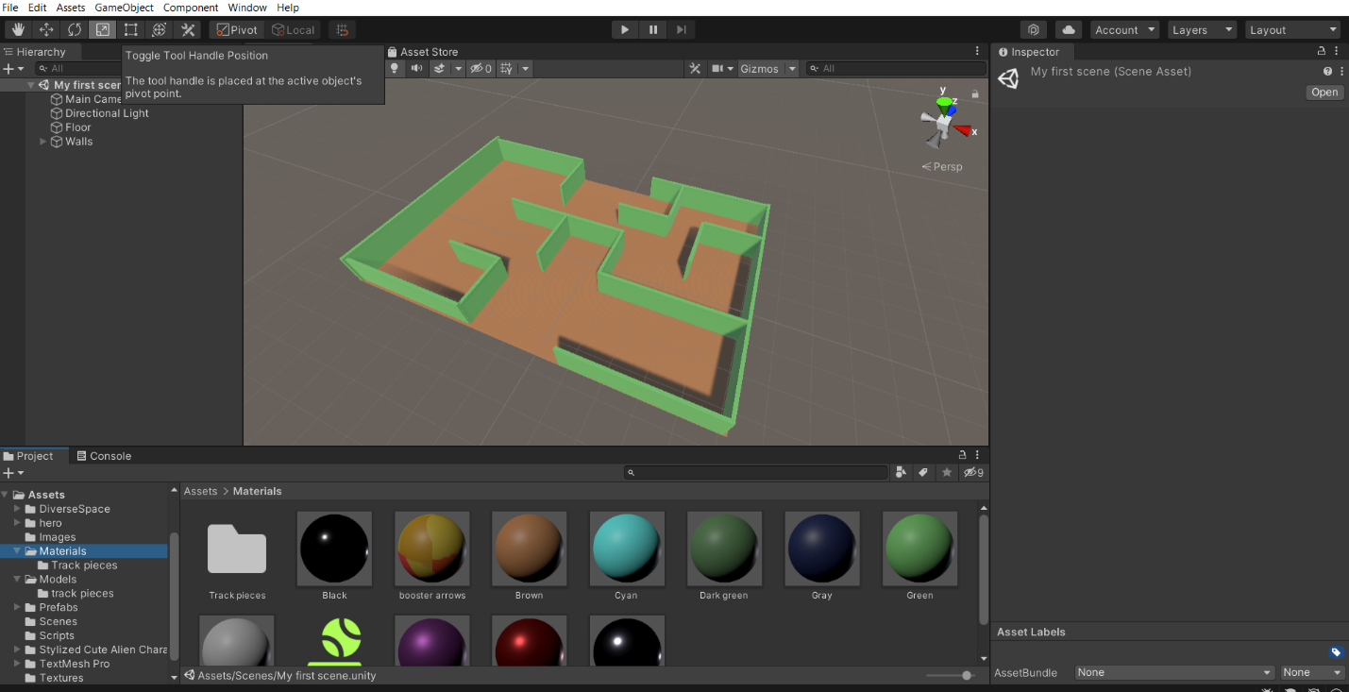

Chapter 3.
In chapter 3 I have learned about the physical characteristics and components of 3D objects such as Rigidbody, different types of Colliders etc, about grouping the objects (parent and child objects) and its advantages. In this chapter I had 1 open exercise and here is the screenshot of it. The ball falls on an inclined plane and while rolling knocks down dominoes on its way.

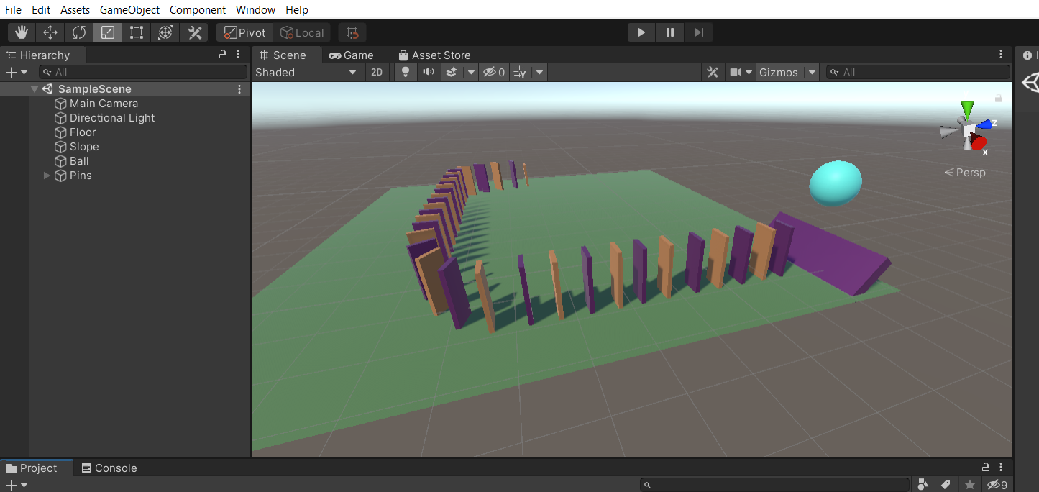

Chapter 4.
In chapter 4 I used my programming skills while coding the scripts for game. The language I used in scripts was C#. I have learned the basics of C# such as variable types, if-else statements, functions and expressions. In this chapter there was no open exercises.

Chapter 5.
In this chapter I started creating my racing game from the very beginning, including writing scripts for my spaceship (make it moving and fly) and for camera (to go right behind my spaceship). Several times I had mistakes in code of the script, but got rid of them successfully. In chapter 5 there was 1 open exercise where I needed to practice my programming skills, edited Player Controls script. I have added 4 additional actions for the spaceship. If the player presses the T key on the keyboard, the spacecraft gains a height of 2 meters. If the player presses the G key on the keyboard, then the spaceship descends 2 meters down. If the player presses the F key on the keyboard, then the spacecraft turns 90 degrees to the left, if the H key, then 90 degrees to the right. I uploaded the edited script with comments to the portal.

Chapter 6.
The final chapter was the most difficult for me, I had lots of appearing mistakes while programming, the game did not work correctly and I spent almost 1 month trying to solve those problems. Recently I finally solved everything and today I successfully finished my game and this game development course. I have created the menu before starting the game, this menu has logo and two buttons (start and exit) as an images. My game has 3 laps and 8 checkpoints. When the spacecraft passes the checkpoint, its red light changes to green. I have more detailed information about my scene in the portal with all the needed screenshots. Here are some of them. 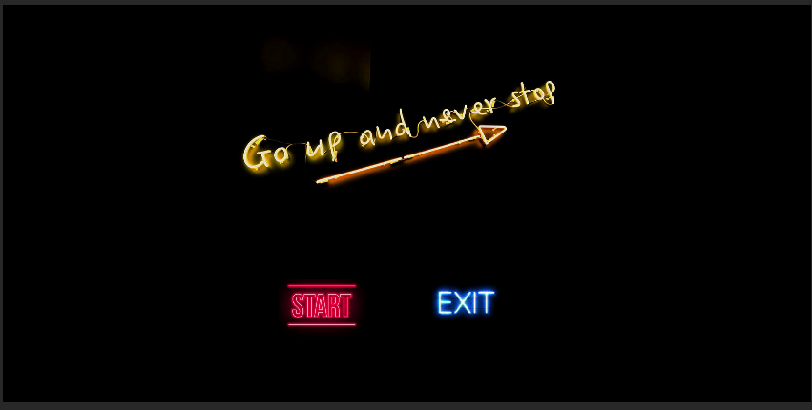
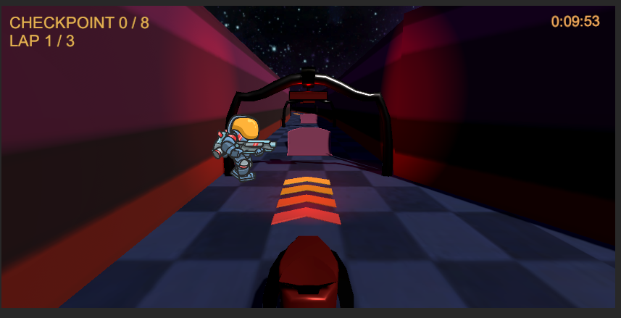
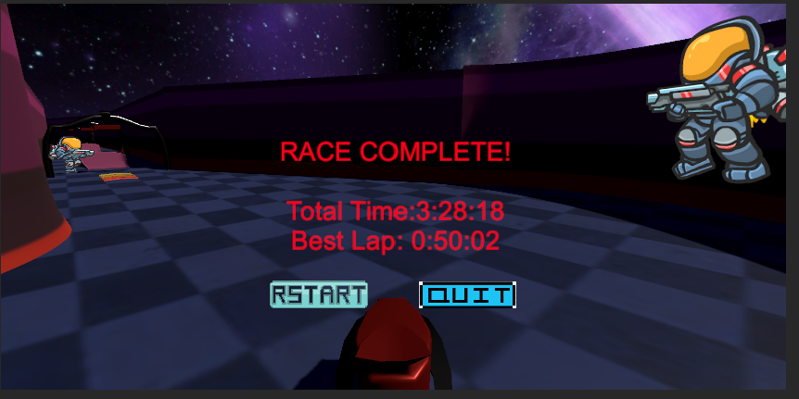
Thank you for this course! I found it really useful and enjoyed it.

