Lab 4 - Introduction to Modeling and Verification of Digital Systems

ZLATEVSKI Andrej - REVERTER Jordi
Group 11

April 2026

NOTE: Assignment “Equipping the testbenches that enable simultaneous visualization of the simulation results before and after synthesis with a specific property” is missing in this report due to lack of time.

1. Preparation of the behavioural description
In the VHDL description of the robot, the design is clearly divided into three main processes: the next-state logic, the state register, and the output logic (which has 3 processes, one per output). Each of them has a different role in the finite state machine and therefore they are synthesized into different kinds of blocks (memory or combinational).
The first process, which computes nextstate, is a combinational block. It only depends on the current state and the input signals (state, findfood, closetofood, lostfood, scantimeup, success, athome, aboverestth, abovesearchth) and it does not store any information by itself. For this reason, its sensitivity list must include all of these signals, because any change in any of them can immediately affect the computed next state. During synthesis, this process will be mapped into combinational logic made of multiplexers and basic logic gates such as AND, OR, NOT, NAND or NOR gates. The case statement over state is typically implemented as a multiplexer controlled by the state variable, while the conditions inside each branch become boolean logic. This process respects the combinational form because every possible condition assigns a value to nextstate, so there is no incomplete assignment that could infer latches.
The second process is the state register process, and this is a memorizing (sequential) block. It is sensitive only to reset and clk, because it describes how the state is stored over time and updated on clock edges or reset events. The use of clk'event and clk='1' together with an asynchronous reset means that this process will be synthesized into edge-triggered D flip-flops with an asynchronous reset input. In hardware terms, the current state signal is stored in flip-flops (after synthesis because of state encoding), and nextstate is connected to the input of those flip-flops.
The third part of the design corresponds to the output logic processes (rest, food, and search). These are also combinational processes because their outputs depend only on the current state and some input signals (because we are talking about a Mealy machine), without any memory element being inferred. Each process has a sensitivity list that includes all signals read inside it: for example, rest depends on state, success, and athome, while food depends on state, closetofood, abovesearchth, and lostfood, and search depends on state and aboverestth. Since all output signals are assigned in every condition (with explicit else branches), the synthesis tool will not infer latches. Instead, each of these processes will be implemented using combinational logic such as AND-OR structures or multiplexers, depending on the final technology mapping. Note that despite the presence of 3 processes, they will be all inside of 1 combinational block. The other combinational block concerns the transition function.
The described processes respect the desired form, and it depends on the type of automaton we are using. In this case, a Mealy machine is used, suggesting an approach requiring:
- Memorizing states. It is an automaton, without it the machine would be stateless, therefore flip-flops are needed (which we already use in the second process)
- Outputs depending on the current state and inputs. In our implementation, the output signals depend clearly on the abovementioned requirements, as described by the sensitivity lists.
- Determining the next state. In order to save one state, we need to decide which state to go to (again, otherwise the machine would be stateless).
It is worth noting as well that every boolean equation can be modeled using NOR and NAND gates as seen in lecture 1, therefore the only restriction during the choice of hardware/gates will be in the second process where a memory block is present, i.e flip-flops are necessary. In the other ones, NOR and NAND can be used.
Finally, no modifications are required because the processes already ensure complete signal assignment and correct separation between combinational and sequential behavior.

2. Synthesis results
First, for the classical binary encoding, the number of flipflops is 4 (DFC1 c35_CORELIB 4 x) and it matches the expected number because the nine states of the FSM require a minimum of 4 flip-flops, since ⌈log⁡2(9)⌉ = 4. Each state is assigned a unique 4-bit code, for example from 0000 for idle up to 1000 for deposit, following the order defined in the type States. This encoding is compact and uses the minimum number of memory elements, which is exactly what is expected from binary encoding. However, the drawback is that the combinational logic becomes relatively complex (4 boolean equations at most for 1 output bit), because the next-state function must decode these 4-bit values and generate the correct transitions. As a result, the total area is 3931 um2. The frequency is 503.2 MHz and is limited because the critical path is longer as a result of having a bigger amount of boolean equations. Since the clock frequency is determined by the inverse of the critical path delay, f=1/T_{critical}, this longer path leads to a lower maximum frequency. For example, from transition 8 (movetohome) to 9 (deposit), 4 bits are changing in the memory block, slowing even more the IP block because of the multiple store and fetching operations done.
For Gray encoding, the number of flip-flops remains the same, that is 4, since it is still a binary encoding. The difference lies in how the states are assigned: consecutive or frequently connected states are given codes that differ by only one bit. This reduces the number of memory operations (store and fetch) and can slightly simplify some transitions. However, in this particular FSM, which is not purely sequential but contains many branches, the benefit is limited. The combinational logic remains quite complex, similar to the classical binary case, and therefore the total area and frequency are also very similar, being 4313 um2 and 478.5 MHz respectively.
In contrast, the number of flipflops in one-hot encoding is 9 (DFC1 c35_CORELIB 8 x , DFP1 c35_CORELIB 1 x) matches the expected number because the one-hot encoding assigns one flip-flop per state, resulting in nine flip-flops. Each state is represented by a vector where only one bit is equal to 1. This clearly increases the number of memory elements, which is expected. However, the combinational logic becomes much simpler, since there is no need to decode the state: each flip-flop directly represents a state. Transitions are implemented using simple AND/OR logic between state bits and input conditions. As a consequence, although the memory area is larger, the combinational area is significantly reduced. The total area is 4623 um2, which is slightly higher than binary encoding. The main advantage is in performance: the critical path is much shorter because the logic depth is reduced. Therefore, the maximum frequency is higher, 806.4 MHz, which again matches the theoretical expectation.
In conclusion, the comparative results are consistent with what is expected from theory. Binary encoding minimizes the number of flip-flops but leads to more complex combinational logic and lower speed. Gray encoding does not bring significant improvements in this case because the FSM is not sequential in nature. One-hot encoding increases the number of flip-flops but simplifies the logic and improves the maximum operating frequency, making the trade-off advantageous in this case.
Briefing Table
 | Binary | Gray | One-Hot
Number flip flops | 4 | 4 | 9
Area (um2) | 3931 | 4313 | 4623
Frequency (MHz) | 503.2 | 478.5 | 806.4

3 & 4. Simulation and verification of temporal properties
The main testbenches were test 1 and 6 because they are the ones involved in the evaluation of the three assertions, as seen in the previous labs. Before dealing with PSL assertions, we did a simulation of these testbenches, comparing the results in the chronogram displayed by the 2 systems (the first one before synthesis, and the second one post synthesis). Every test was satisfactory. The code of the testbenches is located in the annex.
Simulation results with the presence of PSL assertions will be displayed later in the report. Before continuing, we used a different ordering from the conventional one seen previously, to optimize the amount of memory operations. Below is the order we aimed for. The goal is to detect which states have the most outgoing/ingoing transitions, and place them in the middle, as they are most likely connected to the outer up and down states. Using this strategy, 3 bits can be changed in a single transition (from deposit to resting) and on average, 1 bit is changed going from one transition to another. In this type of situation, we need to decide in which states the robot is likely to transition around, thus applying the correct ordering.

Binary encoding
Encodings for States values
value States[3-0]
============================
idle 0000
resting -001
randomwalk -010
homing -011
movetofood -100
scanarena -101
grabfood -110
movetohome -111
deposit 1000


Gray encoding
Encodings for States values
value States[3-0]
============================
idle 0000
resting 0001
randomwalk 0011
homing 0010
movetofood 0110
scanarena 0111
grabfood 0101
movetohome 0100
deposit 1100

One-hot encoding
Encodings for States values
value States[8-0]
============================
idle --------1
resting -------1-
randomwalk ------1--
homing -----1---
movetofood ----1----
scanarena ---1-----
grabfood --1------
movetohome -1-------
deposit 1--------


Temporal assertions
We now present the new temporal assertions, based on the encoding that is used during the synthesis. We encountered Q=>OPEN for some D flip-flops, suggesting that Q-bar is used for some output bits from the flip-flops. They were identified, and knowing the fact that these bits represent the opposite of what it should be, we adapted the temporal assertions correctly. The logic of the assertions is the same from the previous lab. The output bits that are linked with Q-bar are the following:
- In binary encoding: state_3 == nx536.
- In one-hot encoding: state_7 == nx768 and state_6 == nx773.
- No bits linked with Q-bar in gray encoding.
Binary
-- PSL property p1 is always(search = '1' -> ((nx536 /= '1' and state_2 /= '1' and state_1 /= '1' and state_0 /= '0') until (findfood = '1')));
-- PSL property p2 is always((nx536 = '1' and state_2 = '1' and state_1 = '1' and state_0 = '0') -> ((nx536 = '0' and state_2 = '0' and state_1 = '0' and state_0 = '0') before (rest = '1')));
-- PSL property p3 is always({(nx536 = '1' and state_2 = '0' and state_1 = '1' and state_0 = '0') ; (abovesearchth = '0' and findfood = '0')[*]; (abovesearchth = '0' and findfood = '1'); (abovesearchth = '0' and lostfood = '0')[*]; (abovesearchth = '0' and lostfood = '1'); (abovesearchth = '0' and findfood = '0' and scantimeup = '0')[*]; (abovesearchth = '0' and findfood = '0' and scantimeup = '1')} |-> next!((nx536 = '1' and state_2 = '0' and state_1 = '1' and state_0 = '0')));


Gray
-- PSL property p1 is always(search = '1' -> ((state_3 /= '0' and state_2 /= '1' and state_1 /= '0' and state_0 /= '1') until (findfood = '1')));
-- PSL property p2 is always((state_3 = '0' and state_2 = '1' and state_1 = '0' and state_0 = '1') -> ((state_3 = '1' and state_2 = '1' and state_1 = '0' and state_0 = '0') before (rest = '1')));
-- PSL property p3 is always({(state_3 = '0' and state_2 = '0' and state_1 = '1' and state_0 = '1') ; (abovesearchth = '0' and findfood = '0')[*]; (abovesearchth = '0' and findfood = '1'); (abovesearchth = '0' and lostfood = '0')[*]; (abovesearchth = '0' and lostfood = '1'); (abovesearchth = '0' and findfood = '0' and scantimeup = '0')[*]; (abovesearchth = '0' and findfood = '0' and scantimeup = '1')} |-> next!((state_3 = '0' and state_2 = '0' and state_1 = '1' and state_0 = '1')));

One-hot
-- PSL property p1 is always(search = '1' -> ((state_8 /= '0' and nx768 /= '1' and nx773 /= '0' and state_5 /= '0' and state_4 /= '0' and state_3 /= '0' and state_2 /= '0' and state_1 /= '0' and state_0 /= '0') until (findfood = '1')));

-- PSL property p2 is always((state_8 = '0' and nx768 = '1' and nx773 = '0' and state_5 = '0' and state_4 = '0' and state_3 = '0' and state_2 = '0' and state_1 = '0' and state_0 = '0') -> ((state_8 = '1' and nx768 = '1' and nx773 = '1' and state_5 = '0' and state_4 = '0' and state_3 = '0' and state_2 = '0' and state_1 = '0' and state_0 = '0') before (rest = '1')));

-- PSL property p3 is always({(state_8 = '0' and nx768 = '1' and nx773 = '1' and state_5 = '0' and state_4 = '0' and state_3 = '0' and state_2 = '1' and state_1 = '0' and state_0 = '0') ; (abovesearchth = '0' and findfood = '0')[*]; (abovesearchth = '0' and findfood = '1'); (abovesearchth = '0' and lostfood = '0')[*]; (abovesearchth = '0' and lostfood = '1'); (abovesearchth = '0' and findfood = '0' and scantimeup = '0')[*]; (abovesearchth = '0' and findfood = '0' and scantimeup = '1')} |-> next!((state_8 = '0' and nx768 = '1' and nx773 = '1' and state_5 = '0' and state_4 = '0' and state_3 = '0' and state_2 = '1' and state_1 = '0' and state_0 = '0')));


Simulation results using PSL assertions
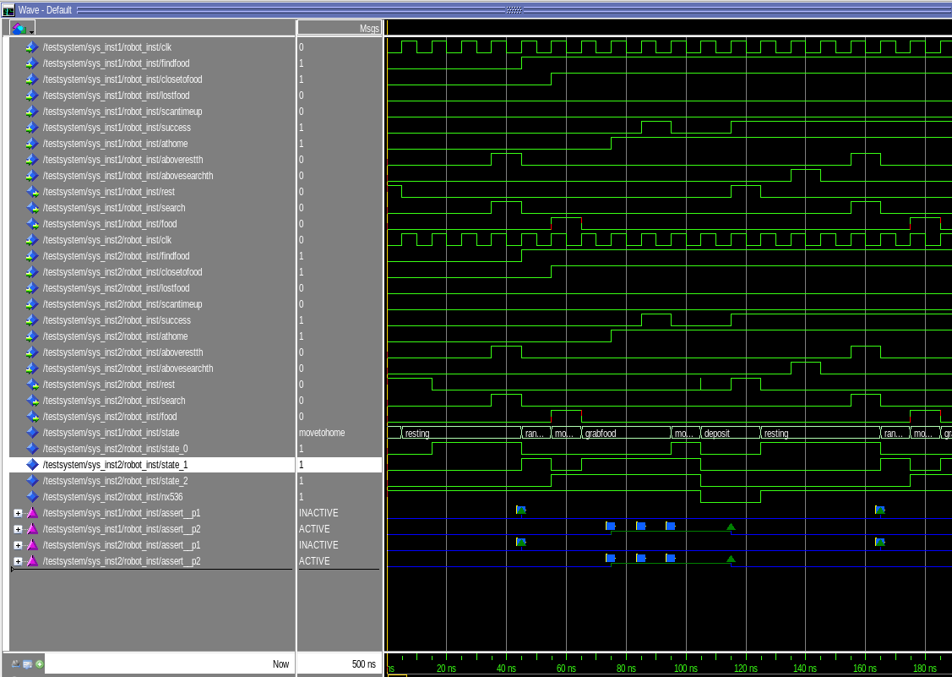
In the following images we can see the simulation trace of test 1 with the different encodings: binary, gray and one-hot. One thing to take into account in the binary encoding is that the flip flop for state3 is open, so we take the nx536 which is the negation of this state bit. Also, in one-hot encoding, states 6 and 7 are open and we have to take the negation of those which are nx773 and nx768 respectively. Comparing the binary encoding with the non synthesized code we see that every state matches his encoding. For example, state grabfood is state3 = 0 and state2 = 1 and state1 = 1 and state0 = 0, and we know state3 is the same as nx536 but negated, so in the image we see that state grabfood matches to nx536 = 1 and state2 = 1 and state1 = 1 and state0 = 0, so the results are immediately satisfactory. In addition, no change has been made in the code. The same happens with the other encodings, the results are immediately satisfactory since the states match their encodings.
Simulation of testbench 1, using binary encoding in the controller post synthesis
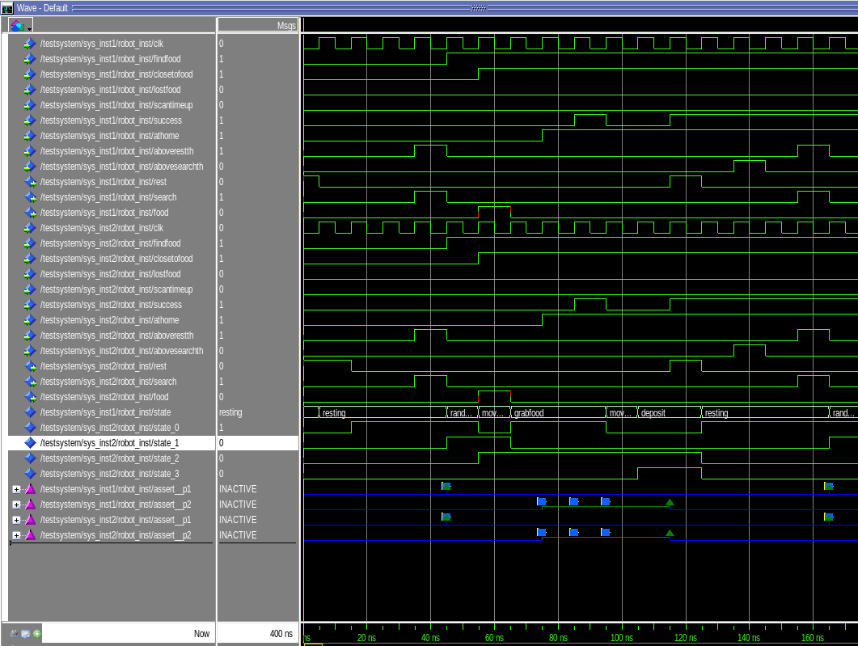
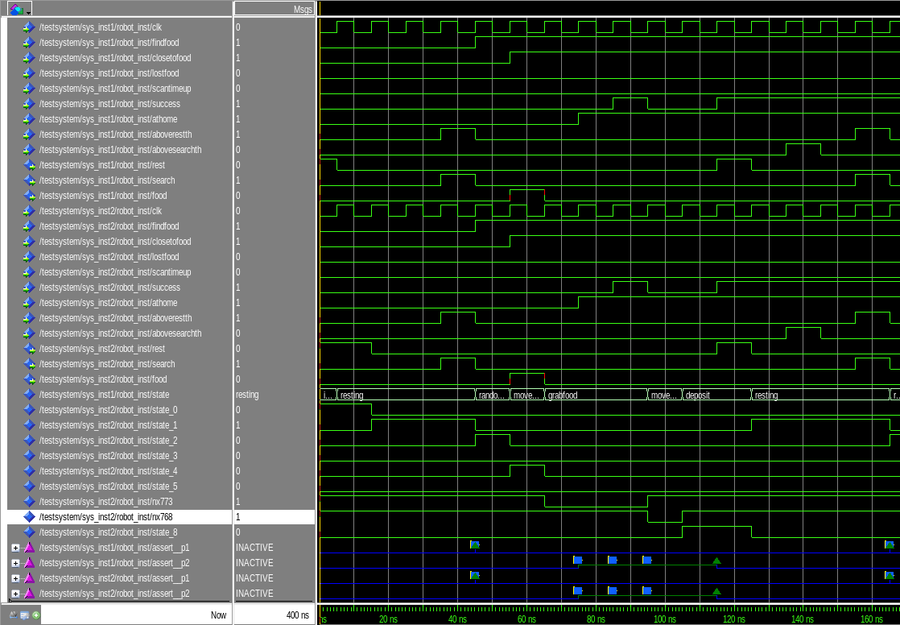
Simulation of testbench 1, using gray encoding in the controller post synthesis
Simulation of testbench 1, using one-hot encoding in the controller post synthesis
Idem for the situation concerning the 6th testbench, in the following images we can see the simulation trace of test 6 with the different encodings: binary, gray and one-hot. One thing to take into account in the binary encoding is that the flip flop for state3 is open, so we take the nx536 which is the negation of this state bit. Also, in one-hot encoding, states 6 and 7 are open and we have to take the negation of those which are nx773 and nx768 respectively. Comparing the binary encoding with the non synthesized code we see that every state matches his encoding. For example, state randomwalk is state3 = 0 and state2 = 0 and state1 = 1 and state0 = 0, and we know state3 is the same as nx536 but negated, so in the image we see that state randomwalk matches to nx536 = 1 and state2 = 0 and state1 = 1 and state0 = 0, so the results are immediately satisfactory. In addition, no change has been made in the code. The same happens with the other encodings, the results are immediately satisfactory since the states match their encodings.
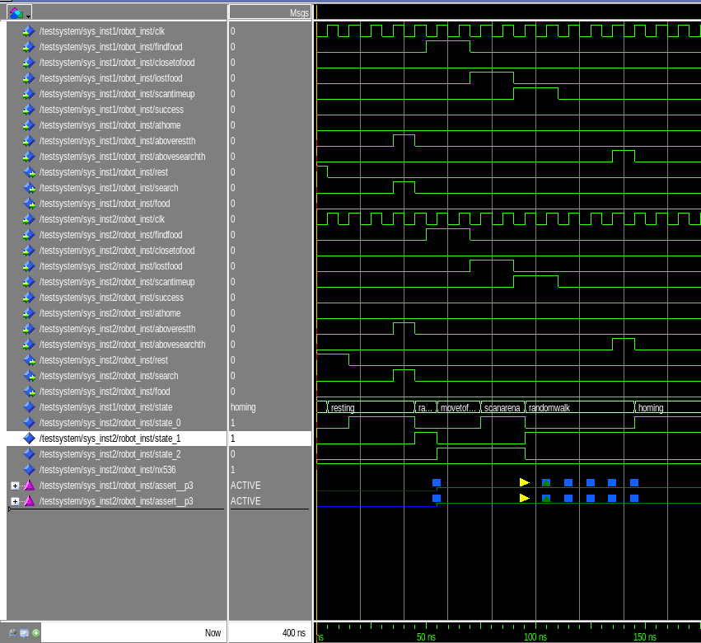
Simulation of testbench 6, using binary encoding in the controller post synthesis
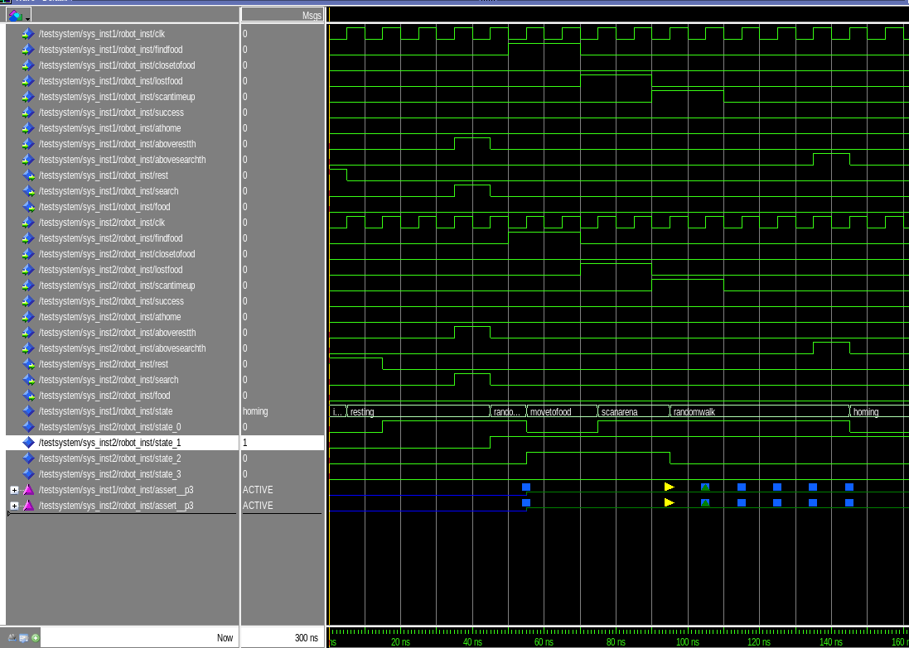
Simulation of testbench 6, using gray encoding in the controller post synthesis

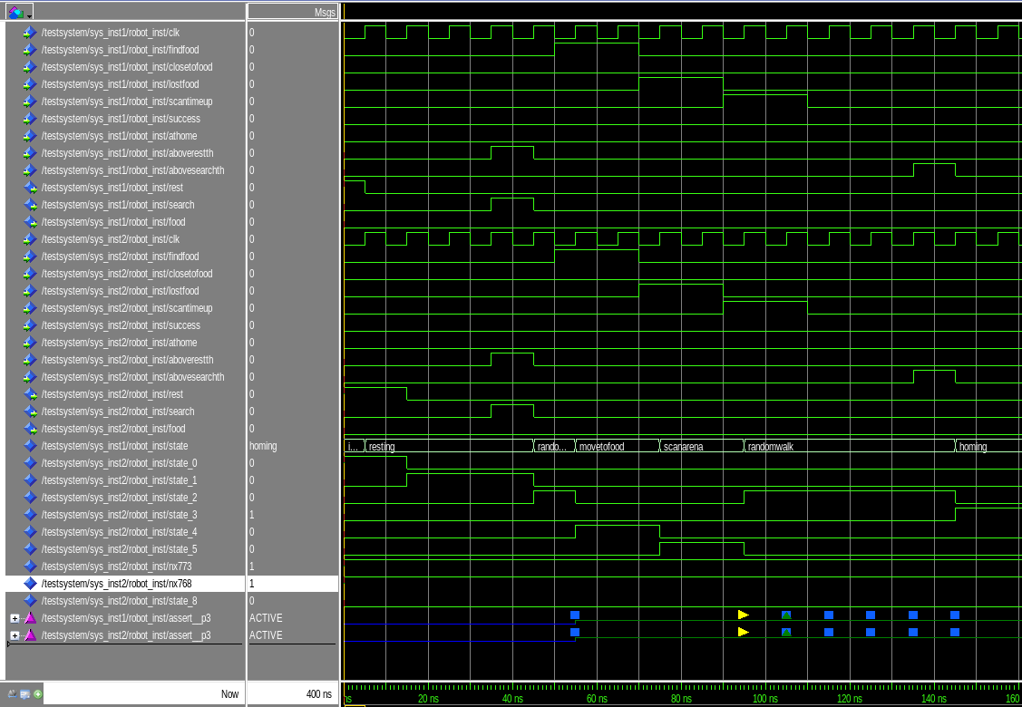Simulation of testbench 6, using gray one-hot in the controller post synthesis

5. Annex

5.1. FSM controller code

library IEEE;
use IEEE.std_logic_1164.all;
use IEEE.numeric_std.all;

entity Robot is
port(reset, clk,
findfood, -- location of the food has been identified
closetofood, -- moving towards the food
lostfood, -- location of the food has been lost
scantimeup, -- scan time has expired
success, -- the food has been grabbed, or deposited
athome, -- control is given to exit the arena
aboverestth, abovesearchth : in std_logic;
rest, search, food : out std_logic);
end Robot;

architecture intf of Robot is
type States is (idle, resting, randomwalk, homing, movetofood, scanarena, grabfood, movetohome, deposit);
signal state, nextstate: States;

-- PSL default clock is (clk'event and clk = '1');

-- PSL property p1 is always(search = '1' -> (state /= grabfood until! (findfood = '1')));

-- PSL property p2 is always(state = grabfood -> (state = deposit before! (rest = '1')));

-- PSL property p3 is always({ state=randomwalk; {abovesearchth='0' and findfood='0'}[*]; {abovesearchth='0' and findfood='1'}; {abovesearchth='0' and lostfood='0'}[*]; {abovesearchth='0' and lostfood='1'}; {abovesearchth='0' and findfood='0' and scantimeup='0'}[*]; {abovesearchth='0' and findfood='0' and scantimeup='1'}}|-> next! state=randomwalk);

-- PSL assert p1;
-- PSL assert p2;
-- PSL assert p3;

begin
-- next state
process(state, findfood, closetofood, lostfood, scantimeup, success, athome, aboverestth, abovesearchth)
begin
case state is
when idle => nextstate <= resting;
when resting =>
if aboverestth = '1' then nextstate <= randomwalk;
else nextstate <= resting;
end if;
when randomwalk =>
if (abovesearchth = '1') then nextstate <= homing;
elsif (findfood = '1') then nextstate <= movetofood;
else nextstate <= randomwalk;
end if;
when movetofood =>
if (abovesearchth = '1') then nextstate <= homing;
elsif (closetofood = '1') then nextstate <= grabfood;
elsif (lostfood = '1') then nextstate <= scanarena;
else nextstate <= movetofood;
end if;
when scanarena =>
if (abovesearchth = '1') then nextstate <= homing;
elsif (findfood = '1') then nextstate <= movetofood;
elsif (scantimeup = '1') then nextstate <= randomwalk;
else nextstate <= scanarena;
end if;
when homing =>
if athome = '1' then nextstate <= resting;
else nextstate <= homing;
end if;
when grabfood =>
if success = '1' then nextstate <= movetohome;
else nextstate <= grabfood;
end if;
when movetohome =>
if athome = '1' then nextstate <= deposit;
else nextstate <= movetohome;
end if;
when deposit =>
if success = '1' then nextstate <= resting;
else nextstate <= deposit;
end if;
end case;
end process;

-- updating of the state register:
process(reset, clk)
begin
-- asynchronous reset (active high):
if (reset = '1') then state <= idle;
-- otherwise, on clock rising edges:
elsif (clk'event and clk='1') then
state <= nextstate;
end if;
end process;

-- output function for rest
process(state, success, athome)
begin
if (state=idle) then rest <= '1';
elsif (state=homing) and (athome='1') then rest <= '1';
elsif (state=deposit) and (success='1') then rest <= '1';
else rest <= '0';
end if;
end process;

-- output function for food
process(state, closetofood, abovesearchth, lostfood)
begin
if (state=movetofood) and (abovesearchth='0') and (lostfood = '0') and (closetofood='1') then food <= '1';
else food <= '0';
end if;
end process;

-- output function for search
process(state, aboverestth)
begin
if (state=resting) and (aboverestth='1') then search <= '1';
else search <= '0';
end if;
end process;
end intf;



5.2. Testbench code
library IEEE;
use IEEE.std_logic_1164.all;
use IEEE.numeric_std.all;

entity testSystem is
end testSystem;

architecture test1 of testSystem is
-- System component
component System1 port(reset, clk, findfood, closetofood, lostfood, scantimeup,
success, athome: in std_logic;
food: out std_logic);
end component;

component System2 port(reset, clk, findfood, closetofood, lostfood, scantimeup,
success, athome: in std_logic;
food: out std_logic);
end component;

signal athome, findfood, lostfood, closetofood, success, scantimeup, clk, reset, food: std_logic := '0';
begin
-- system instqntiation
sys_inst1: System1 port map(reset, clk, findfood, closetofood, lostfood, scantimeup, success, athome, food);

sys_inst2: System2 port map(reset, clk, findfood, closetofood, lostfood, scantimeup, success, athome, food);
reset <= '1', '0' after 5 ns;
clk <= not clk after 5 ns;
-- this is a simulation example where we want to check the appearance of 1 from food. then we go back to the resting point.
findfood <= '1' after 45 ns;
closetofood <= '1' after 55 ns;
--lostfood <=
--scantimeup <=
success <= '1' after 85 ns, '0' after 95 ns, '1' after 115 ns;
athome <= '1' after 75 ns;
end test1;

architecture test2 of testSystem is
-- System component
component System port(reset, clk, findfood, closetofood, lostfood, scantimeup,
success, athome: in std_logic;
food: out std_logic);
end component;

signal athome, findfood, lostfood, closetofood, success, scantimeup, clk, reset, food: std_logic := '0';
begin
-- system instqntiation
sys_inst: System port map(reset, clk, findfood, closetofood, lostfood, scantimeup, success, athome, food);
reset <= '1', '0' after 5 ns;
clk <= not clk after 5 ns;
-- this is a simulation example where we want to check the appearance of 1 from food. then we go back to the resting point.
athome <= '1' after 135 ns;
end test2;

architecture test3 of testSystem is
-- System component
component System port(reset, clk, findfood, closetofood, lostfood, scantimeup,
success, athome: in std_logic;
food: out std_logic);
end component;

signal athome, findfood, lostfood, closetofood, success, scantimeup, clk, reset, food: std_logic := '0';
begin
-- system instqntiation
sys_inst: System port map(reset, clk, findfood, closetofood, lostfood, scantimeup, success, athome, food);
reset <= '1', '0' after 5 ns;
clk <= not clk after 5 ns;
-- this is a simulation example where we want to check the transition between scanarena and homing due to the activation of the abovesearchth threshold
findfood <= '1' after 45 ns, '0' after 55 ns;
lostfood <= '1' after 55 ns;
end test3;

architecture test4 of testSystem is
-- System component
component System port(reset, clk, findfood, closetofood, lostfood, scantimeup,
success, athome: in std_logic;
food: out std_logic);
end component;

signal athome, findfood, lostfood, closetofood, success, scantimeup, clk, reset, food: std_logic := '0';
begin
-- system instqntiation
sys_inst: System port map(reset, clk, findfood, closetofood, lostfood, scantimeup, success, athome, food);
reset <= '1', '0' after 5 ns;
clk <= not clk after 5 ns;
-- this is a simulation example where we want to check the transition between movetofood and homing due to the activation of the abovesearchth threshold and returning to resting when athome = 1.
findfood <= '1' after 45 ns;
athome <= '1' after 135 ns;
end test4;

architecture test5 of testSystem is
-- System component
component System port(reset, clk, findfood, closetofood, lostfood, scantimeup,
success, athome: in std_logic;
food: out std_logic);
end component;

signal athome, findfood, lostfood, closetofood, success, scantimeup, clk, reset, food: std_logic := '0';
begin
-- system instqntiation
sys_inst: System port map(reset, clk, findfood, closetofood, lostfood, scantimeup, success, athome, food);
reset <= '1', '0' after 5 ns;
clk <= not clk after 5 ns;
-- this is a simulation example where we want to check the transition between scanarena and movetofood in the case that the robot has find the food after losing it in a previous time.
findfood <= '1' after 45 ns, '0' after 55 ns, '1' after 65 ns;
lostfood <= '1' after 55 ns, '0' after 65 ns;
end test5;

architecture test6 of testSystem is
-- System component
component System1 port(reset, clk, findfood, closetofood, lostfood, scantimeup,
success, athome: in std_logic;
food: out std_logic);
end component;

component System2 port(reset, clk, findfood, closetofood, lostfood, scantimeup,
success, athome: in std_logic;
food: out std_logic);
end component;

signal athome, findfood, lostfood, closetofood, success, scantimeup, clk, reset, food: std_logic := '0';
begin
-- system instqntiation
sys_inst1: System1 port map(reset, clk, findfood, closetofood, lostfood, scantimeup, success, athome, food);
sys_inst2: System2 port map(reset, clk, findfood, closetofood, lostfood, scantimeup, success, athome, food);
reset <= '1', '0' after 5 ns;
clk <= not clk after 5 ns;
-- this is a simulation example where we want to check the transition scanarena to randomwalk state when the signal scantimeup is set to 1.
findfood <= '1' after 50 ns, '0' after 70 ns;
lostfood <= '1' after 70 ns, '0' after 90 ns;
scantimeup <= '1' after 90 ns, '0' after 110 ns;
end test6;

--test1
library LIB_ROBOT_SYNTH;
library LIB_ROBOT_BENCH;

configuration config_binary1 of LIB_ROBOT_BENCH.testSystem is
for test1
for sys_inst1:System1 use configuration LIB_ROBOT_SYNTH.sys_config;
end for;
for sys_inst2:System2 use configuration LIB_ROBOT_SYNTH.sys_config_binary;
end for;
end for;
end config_binary1;

library LIB_ROBOT_SYNTH;
library LIB_ROBOT_BENCH;

configuration config_gray1 of LIB_ROBOT_BENCH.testSystem is
for test1
for sys_inst1:System1 use configuration LIB_ROBOT_SYNTH.sys_config;
end for;
for sys_inst2:System2 use configuration LIB_ROBOT_SYNTH.sys_config_gray;
end for;
end for;
end config_gray1;

library LIB_ROBOT_SYNTH;
library LIB_ROBOT_BENCH;

configuration config_onehot1 of LIB_ROBOT_BENCH.testSystem is
for test1
for sys_inst1:System1 use configuration LIB_ROBOT_SYNTH.sys_config;
end for;
for sys_inst2:System2 use configuration LIB_ROBOT_SYNTH.sys_config_onehot;
end for;
end for;
end config_onehot1;

--test6
library LIB_ROBOT_SYNTH;
library LIB_ROBOT_BENCH;

configuration config_binary6 of LIB_ROBOT_BENCH.testSystem is
for test6
for sys_inst1:System1 use configuration LIB_ROBOT_SYNTH.sys_config;
end for;
for sys_inst2:System2 use configuration LIB_ROBOT_SYNTH.sys_config_binary;
end for;
end for;
end config_binary6;

library LIB_ROBOT_SYNTH;
library LIB_ROBOT_BENCH;

configuration config_gray6 of LIB_ROBOT_BENCH.testSystem is
for test6
for sys_inst1:System1 use configuration LIB_ROBOT_SYNTH.sys_config;
end for;
for sys_inst2:System2 use configuration LIB_ROBOT_SYNTH.sys_config_gray;
end for;
end for;
end config_gray6;

library LIB_ROBOT_SYNTH;
library LIB_ROBOT_BENCH;

configuration config_onehot6 of LIB_ROBOT_BENCH.testSystem is
for test6
for sys_inst1:System1 use configuration LIB_ROBOT_SYNTH.sys_config;
end for;
for sys_inst2:System2 use configuration LIB_ROBOT_SYNTH.sys_config_onehot;
end for;
end for;
end config_onehot6;


