ASSAM DOWNTOWN UNIVERSITY
Department of Computer Science & Engineering
PROJECT SYNOPSIS
on
Web-Based Inventory Management System
Submitted in partial fulfilment of the requirements for the Final Year Project

Submitted by:  Sajidul Ahmed  Roll No: ADTU/1/2024-28/BCSS/116  Programme: B.Tech CSE(SUNSTONE)  Semester: 4 Sem | Under the guidance of:  Ravi Sir  [Designation]  Department of CSE  Assam downtown University
July 2026

1. Title of the Project
Web-Based Inventory Management System
A real-time, role-based inventory tracking and procurement platform built to help small and medium businesses manage stock, suppliers, and sales through a single web dashboard.

2. Statement of the Problem

2.1 Description of the Problem
Most small and medium-sized businesses still rely on manual methods — paper registers or scattered spreadsheets — to track stock levels, purchases, and sales. This approach creates several recurring issues: stock levels are discovered too late (after items have already run out), there is no single source of truth for what is in the warehouse, reconciling physical stock against records is time-consuming and error-prone, and generating a sales or inventory report can take hours of manual compilation.
These inefficiencies directly translate to lost sales (stock-outs), tied-up capital (overstocking), and poor decision-making, since business owners lack real-time visibility into their supply chain. As operations scale to multiple warehouses or product lines, the manual approach breaks down almost entirely.
The proposed Web-Based Inventory Management System addresses this gap by digitising the entire stock lifecycle — from product cataloguing and supplier procurement to stock movement, automated alerts, and reporting — in a single, role-based web application accessible from any device.

3. Objective and Scope of the Project

3.1 Objectives
- Develop a web-based system for tracking product stock levels, procurement, and sales in real time.
- Automate low-stock alerts, purchase order generation, and inventory reconciliation.
- Provide a barcode/QR-based workflow for fast, error-free stock entry and lookup.
- Generate detailed, exportable inventory and sales reports to support data-driven decisions.
- Enforce role-based access so Admins, Staff, and Auditors see only what is relevant to their role.

3.2 Scope (Version 1)
The first version of the system will cover:
- Product catalog management with categories, SKUs, and live stock levels.
- Stock-in and stock-out transaction recording, including barcode/QR scanning for fast entry.
- Automated low-stock alerts and reorder notifications.
- Supplier records and purchase order history.
- Role-based dashboards for Admin, Staff, and Auditor.
- Inventory and sales reports, exportable as PDF/Excel.
Features such as multi-warehouse support, demand forecasting, expiry tracking, and payment-gateway integration are deliberately kept out of the version-1 scope to fit the project timeline, and are detailed under Section 6 (Future Work).

4. Methodology
The system will be developed using the Waterfall-Agile hybrid model — requirements and design are finalised up front (as this synopsis captures), followed by iterative, sprint-style development of individual modules (authentication, product management, transactions, alerts, reporting), each tested as it is completed.

4.1 System Architecture
The application follows a layered 3-tier architecture, separating presentation, application logic, and data storage, as shown in Fig. 1.
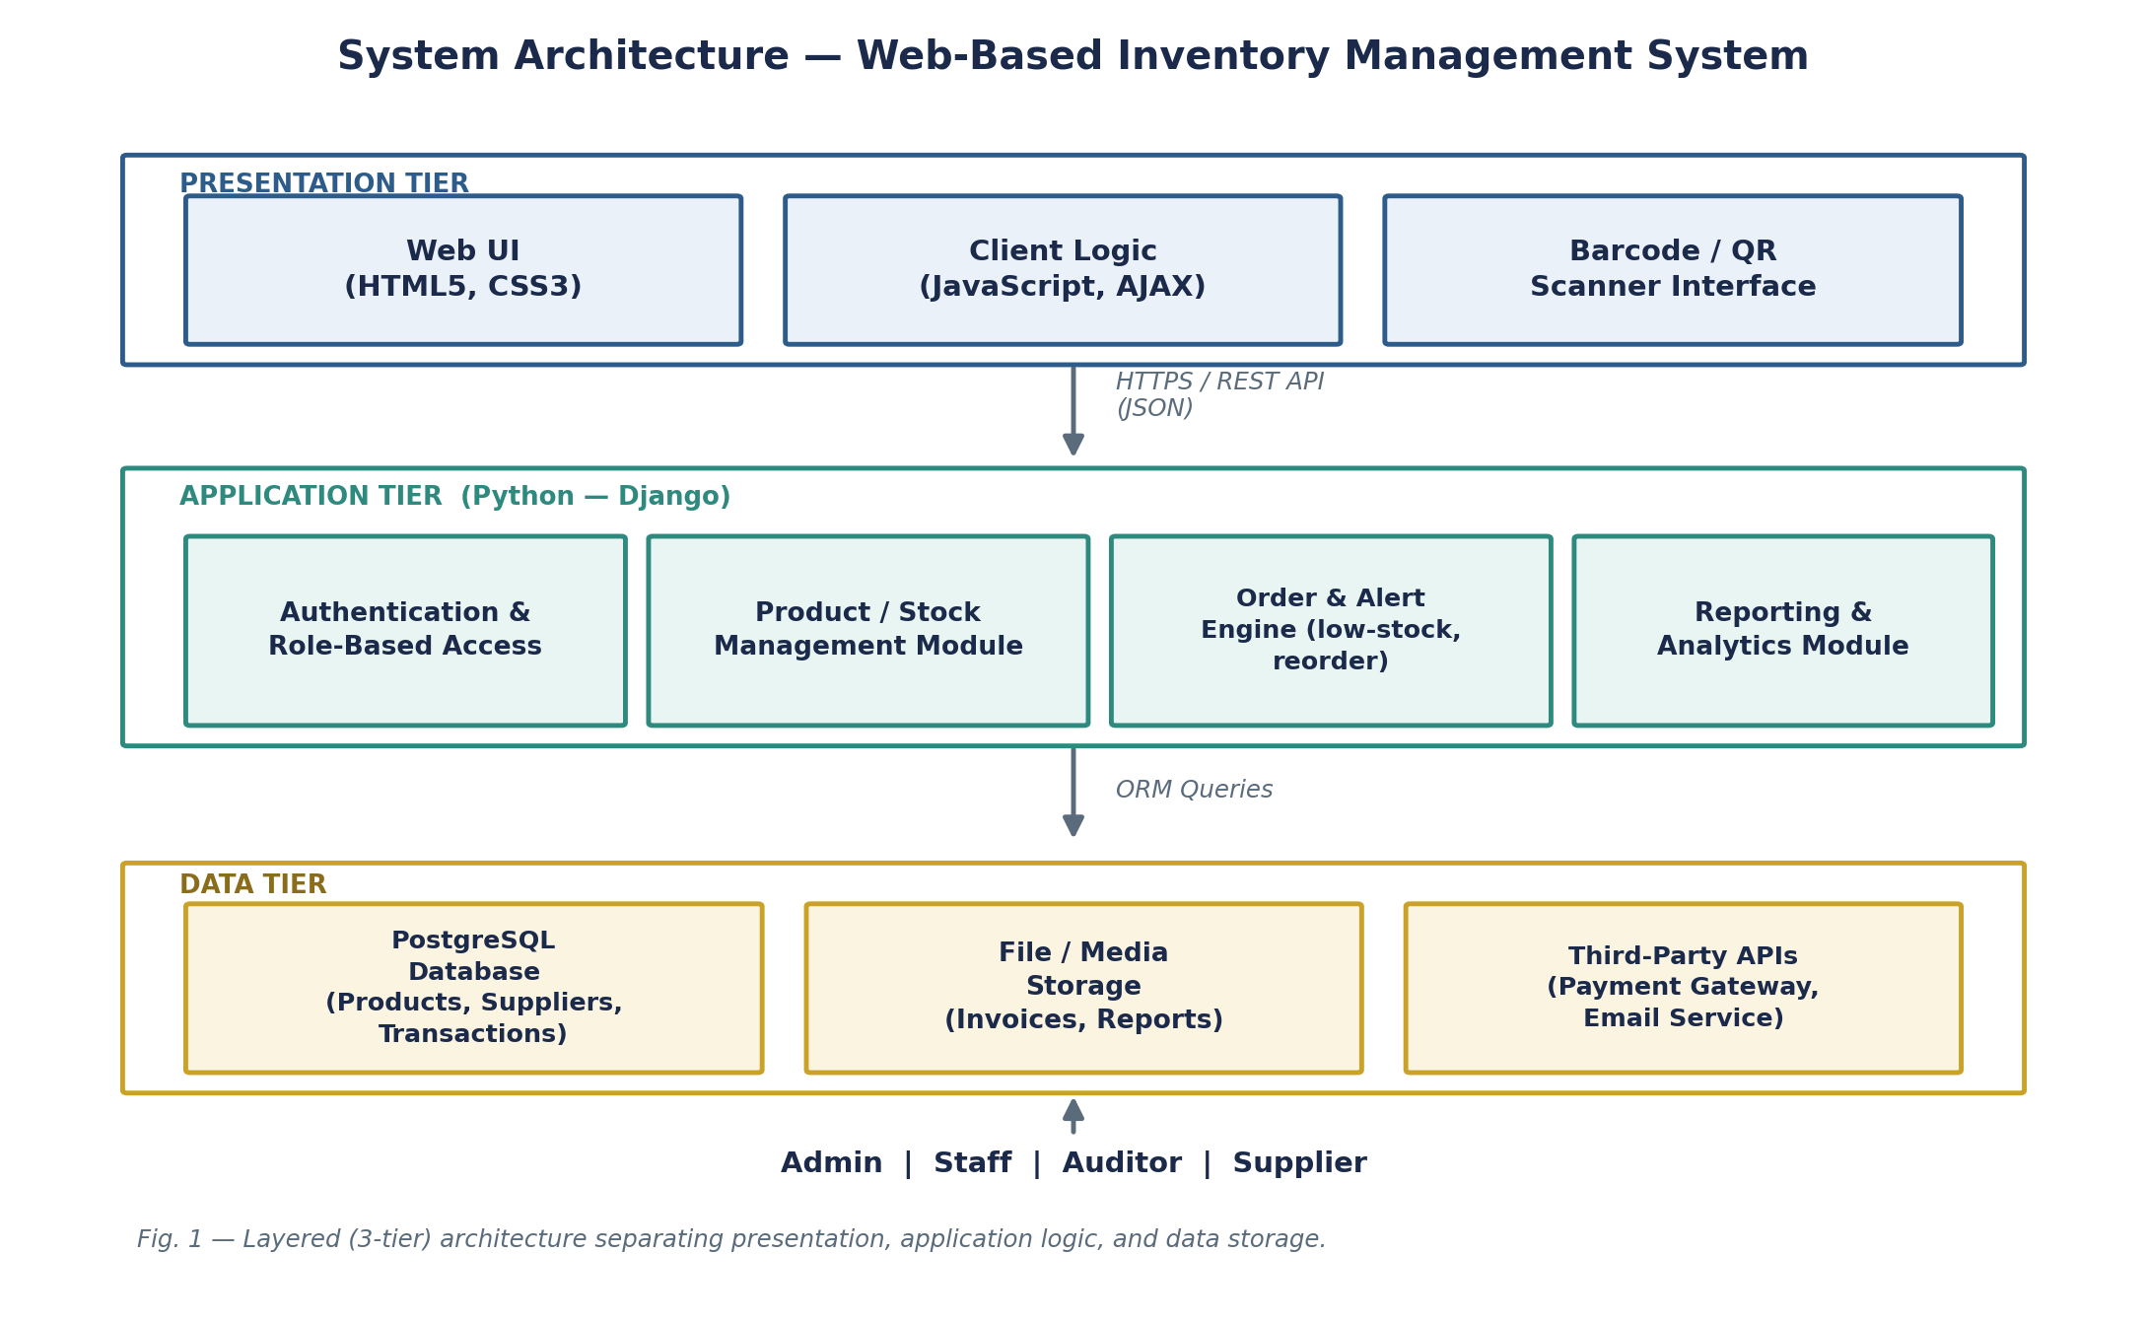
Fig. 1 — Layered (3-tier) architecture of the proposed system.

4.2 Use Case Diagram
The diagram below (Fig. 2) illustrates the key actors — Admin, Staff, Supplier, and Auditor — and the primary use cases each interacts with.
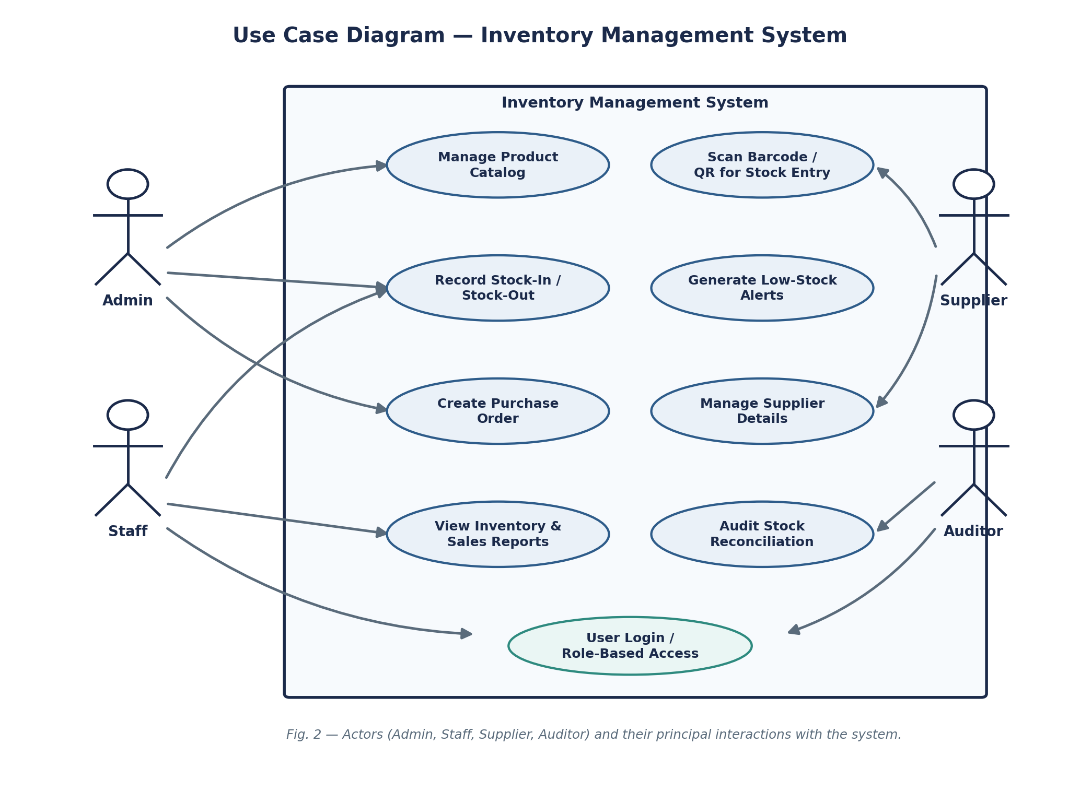
Fig. 2 — Use case diagram showing actor interactions with the system.

4.3 Data Flow
Fig. 3 shows the Level-1 Data Flow Diagram (DFD), tracing how product, transaction, and supplier data move between processes and stores.
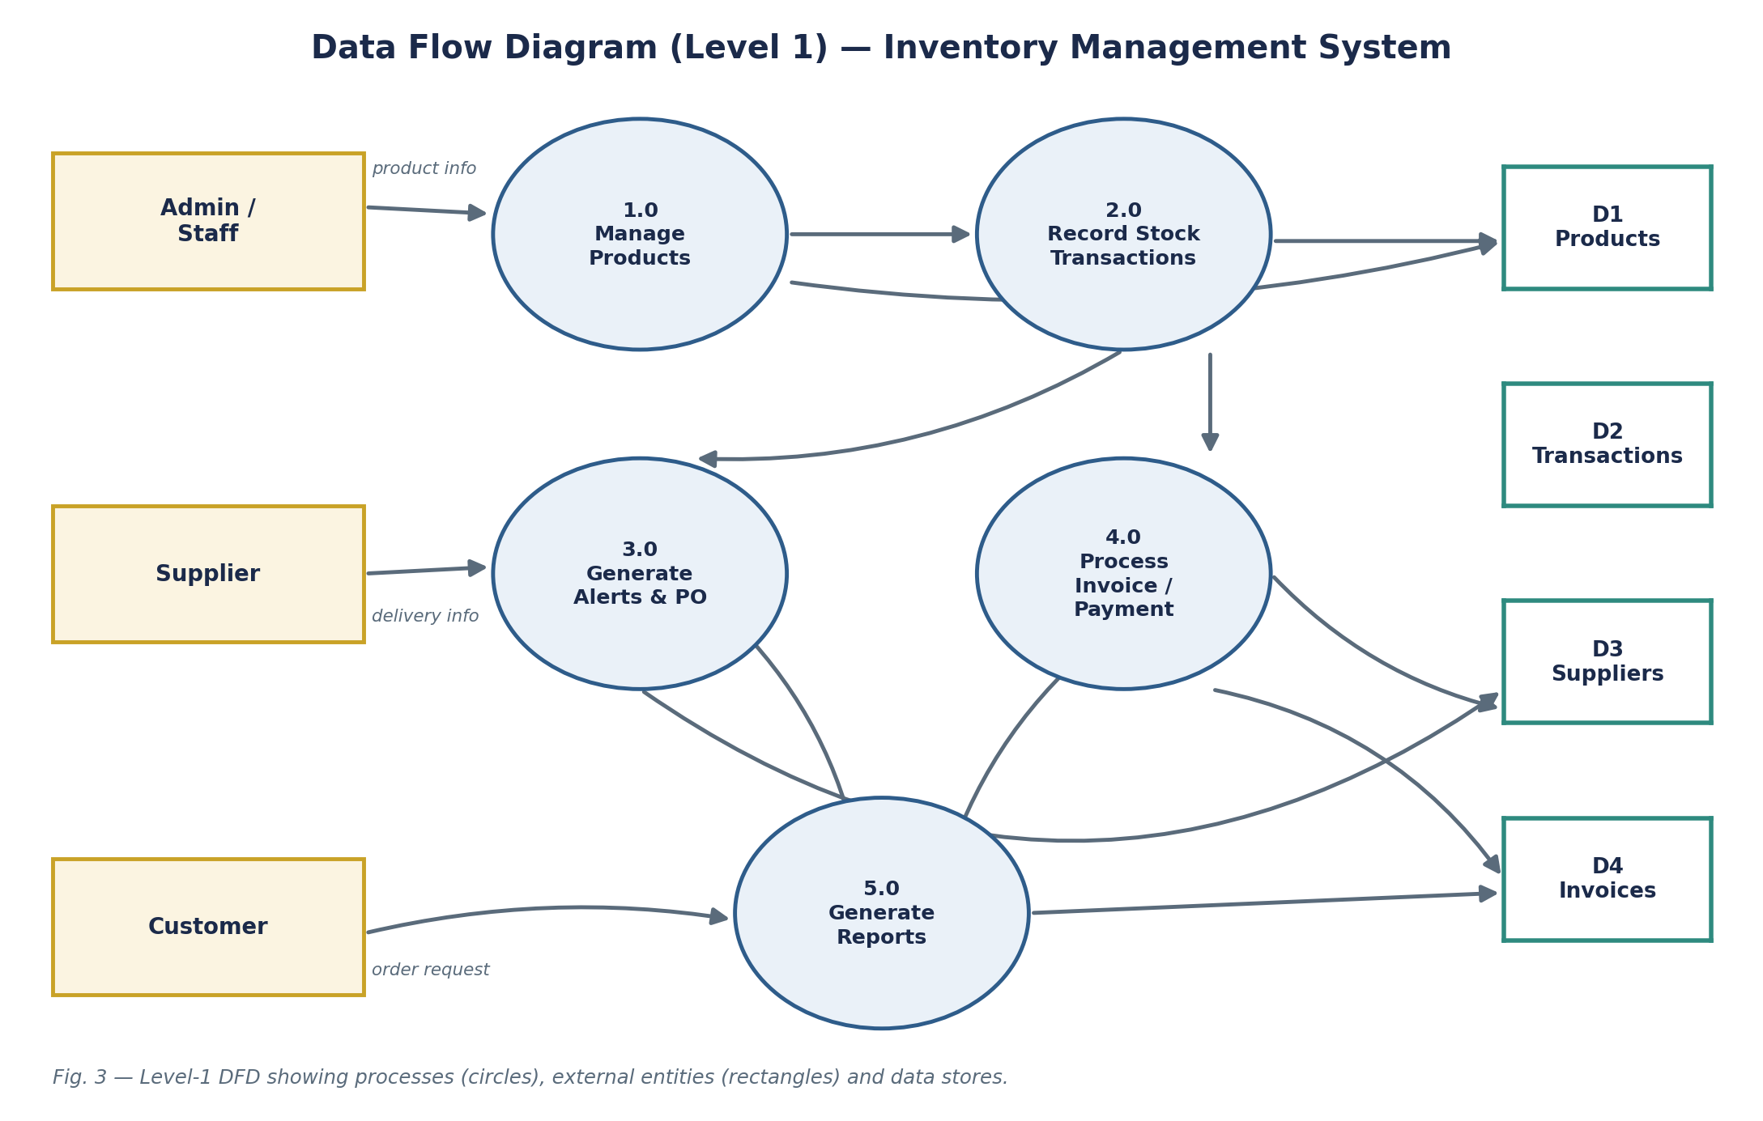
Fig. 3 — Level-1 Data Flow Diagram of the system.

4.4 Development Approach
- Requirement gathering & synopsis preparation.
- Database schema design (ER modelling) in PostgreSQL.
- Backend module development using Django (models, views, REST endpoints, authentication).
- Frontend development using HTML5, CSS3, and JavaScript, consuming the backend APIs via AJAX/fetch.
- Integration of a barcode/QR scanning library for stock entry and lookup.
- Testing (unit + integration) and iterative bug fixing.
- Final documentation and presentation.

5. Hardware and Software Requirements

5.1 Software Requirements
- Frontend: HTML5, CSS3, JavaScript (with Chart.js for dashboard visualisations).
- Backend Framework: Python — Django (chosen for its built-in admin panel, ORM, and authentication system, which suit the project's timeline).
- Database: PostgreSQL (relational schema for products, suppliers, transactions, and stock logs).
- Barcode/QR: JavaScript-based scanning library (e.g., QuaggaJS / html5-qrcode) integrated into the stock-entry form.
- Version Control: Git and GitHub.
- IDE/Editor: Visual Studio Code.
- Testing: Django's built-in test framework / Postman for API testing.

5.2 Hardware Requirements
- A standard development machine (minimum 8 GB RAM, dual-core processor).
- A webcam-enabled device or handheld barcode/QR scanner for testing the scanning module.
- Internet connectivity for development, testing, and (if deployed) hosting.

6. Future Work
The following features, though part of the broader vision for the system, are deferred beyond version 1 to keep the current project timeline realistic:
- Multi-Warehouse Support — tracking inventory across multiple physical locations.
- Expiry Tracking — monitoring perishable goods with expiry-date alerts.
- Demand Forecasting — predicting future stock needs from historical sales trends.
- Batch & Serial Number Tracking — tracing individual units through the supply chain.
- Payment Gateway Integration — accepting supplier payments via Stripe.
- Automated Customer Invoice Generation & Email Delivery.
- Payment Status Tracking — outstanding, paid, and overdue payments from the dashboard.
- Mobile app companion and deeper integration-readiness with POS/accounting software.

7. Project Schedule
Given the 4-week timeline for this phase of the project, development has been broken down into overlapping stages to make the best use of the available time, as shown in the Gantt chart below (Fig. 4).
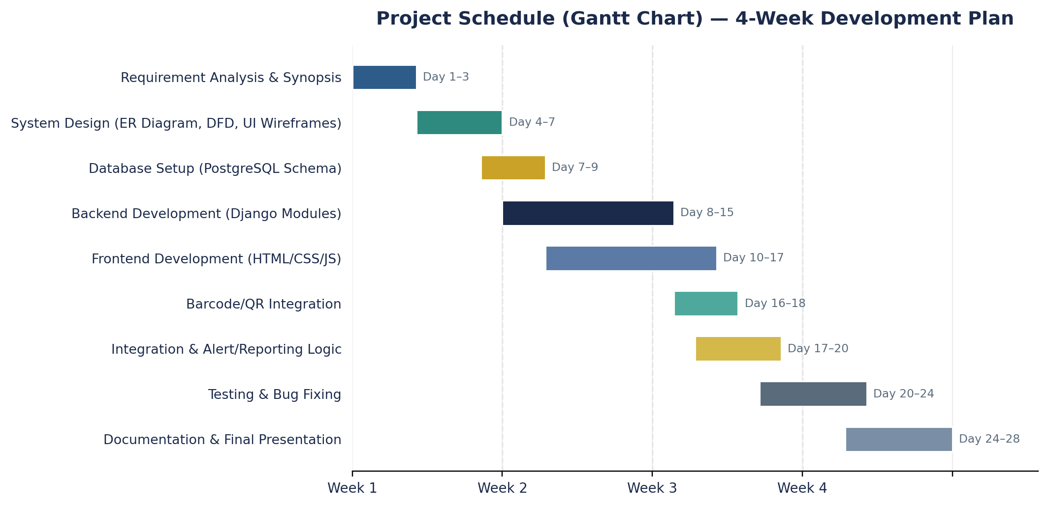
Fig. 4 — Gantt chart showing the 4-week development schedule.

8. Conclusion
The proposed Web-Based Inventory Management System brings together real-time stock tracking, barcode-based data entry, automated alerts, and role-based access into a single cohesive platform — replacing error-prone manual processes with a reliable, auditable digital workflow. By scoping version 1 tightly around the features that deliver the most immediate value (cataloguing, transactions, alerts, reporting) and clearly documenting future enhancements, the project is positioned to be both achievable within the given timeline and extensible well beyond it.

9. References
[1] Md. R. Tanaman, J. L. A. Baylosis, B. J. A. Abiles, M. L. P. Catungal, and P. C. Encarnacion, "Web-based Inventory Management System," International Journal of Science and Advanced Information Technology, vol. 12, no. 5, pp. 44–48, Sep.–Oct. 2023.
[2] "Web-based systems for inventory control in organizations: A Systematic Review," in Proc. IEEE Conf., 2022.
[3] "Research and Design of the Intelligent Inventory Management System Based on RFID," in Proc. IEEE Conf., 2014.
[4] J. Ladani, M. Sanodiya, S. Thakur, T. Kadoo, and K. Pandey, "Web Based Inventory and Warehouse Management System," in Proc. 6th Int. Conf. on Communication and Electronics Systems (ICCES), Springer, 2021, pp. 846–852.
[5] "Inventory Management System for Education Institutions," in Proc. IEEE Conf., 2023.
[6] "Inventory management for retail companies: A literature review and current trends," in Proc. IEEE Conf., 2020.
[7] "Towards inventory control excellence: An innovative approach based on a web-based platform," PMC, National Center for Biotechnology Information, 2024.
[8] Django Software Foundation, "Django Documentation," [Online]. Available: https://docs.djangoproject.com/
[9] PostgreSQL Global Development Group, "PostgreSQL Documentation," [Online]. Available: https://www.postgresql.org/docs/
[10] MDN Web Docs, "HTML, CSS, and JavaScript References," Mozilla, [Online]. Available: https://developer.mozilla.org/

Appendix: Anticipated Viva-Voce Questions

Q1. Why should the department approve this project?
Manual inventory tracking remains a widespread, real-world problem for small and medium businesses, making this a practical, verifiable project with a clear end-user. It combines core web-development skills (frontend, backend, database design) with a well-defined feature set — barcode scanning, automated alerts, role-based access, and reporting — that is neither trivially simple nor unrealistically large for the given timeframe. The modular architecture also allows the scope to be adjusted mid-way without derailing the whole project, and the roadmap of future features (forecasting, multi-warehouse support, payments) demonstrates that the design has been thought through beyond just the immediate deliverable.

Q2. What are the strengths and limitations of the proposed work?
Strengths: real-time stock visibility, automated low-stock alerts that reduce human oversight, faster data entry via barcode/QR scanning, and role-based access that keeps sensitive operations restricted to authorised users. Limitations: version 1 is scoped to a single warehouse (no multi-location support yet), depends on stable internet connectivity for real-time updates, and does not yet include demand forecasting or payment processing — both flagged for future iterations.

Q3. What is the positive impact of this project on academics/industry?
Academically, the project demonstrates end-to-end application of full-stack web development, database design, and system-analysis techniques (DFDs, use case modelling) within a single, cohesive build — reinforcing classroom concepts through a hands-on deliverable. From an industry perspective, small businesses that currently rely on manual or spreadsheet-based tracking stand to gain measurable time savings, fewer stock-outs, and better-informed purchasing decisions if such a system were adopted, illustrating how a modestly scoped academic project can map directly onto a genuine operational need.

