PROJECT SYNOPSIS

Smart Inventory Management System with Barcode-Based Stock Tracking
A Web-Based Platform forInventory management

By

Sajidul Ahmed
Roll No. / Registration No.: ADTU/1/2024-28/BCSS/116 Semester: 4th

Under the Guidance of

Ravi Sir

B.Tech CSE (Sunstone)

Assam downtown University
July, 2026

Statement of the Problem

Inventory management is one of the most important aspects of any business. Many small and medium-sized businesses still maintain inventory records manually using notebooks or spreadsheets. This approach is time-consuming, error-prone, and inefficient. Manual inventory tracking often results in stock shortages, excess inventory, inaccurate stock records, delayed purchase decisions, and financial losses.

Businesses also face difficulties in tracking product movement, monitoring supplier information, generating reports, and identifying low-stock items. Existing manual systems lack automation and real-time monitoring, making inventory management challenging.

To overcome these issues, a web-based Inventory Management System is proposed. The system will automate inventory operations, maintain accurate stock records, generate reports, and provide barcode-based product identification for faster inventory handling.

Objective and Scope of the Project
The primary objective of this project is to develop a secure, user-friendly, web-based Inventory Management System that simplifies inventory operations.
The objectives are:
- Develop a centralized inventory management system.
- Maintain accurate product records.
- Track stock-in and stock-out transactions.
- Automate low-stock notifications.
- Generate inventory and sales reports.
- Provide barcode/QR code-based product scanning.
- Improve inventory accuracy.
- Reduce manual workload.
- Enhance business decision-making using reports.
The proposed system is intended for small and medium-sized businesses.
- The system provides:
- User Authentication
- Product Management
- Category Management
- Supplier Management
- Inventory Tracking
- Barcode Scanning
- Stock Alerts
- Report Generation
- Dashboard Analytics
- The project does not include:
- Accounting Module
- GST Management
- Multi-company Management
- AI-based Demand Forecasting
- Mobile Application
- These features can be implemented in future versions.

Methodology
The project will follow the Software Development Life Cycle (SDLC).
Phase 1 – Requirement Analysis
- Study inventory problems
- Identify user requirements
- Analyze existing systems
↓
Phase 2 – System Design
- Database Design
- UI Design
- Architecture Design
↓
Phase 3 – Development
Frontend
- HTML
- CSS
- JavaScript
Backend
- Python Django
Database
- MySQL
↓
Phase 4 – Testing
- Unit Testing
- Integration Testing
- User Acceptance Testing
↓
Phase 5 – Deployment
- Final Implementation
- Documentation
- User Demonstration

Hardware and Software Requirements

Software

Operating System

Windows 10/11

Frontend

HTML5

CSS3

JavaScript

Backend

Python

Django Framework

Database

MySQL

IDE

Visual Studio Code

Browser

Google Chrome

Version Control

Git

Hardware
• Intel Core i3 Processor or above
• 4 GB RAM
• 100 GB Hard Disk
• Barcode Scanner (Optional)
• Internet Connection

Future Work

The proposed system can be further enhanced by integrating advanced technologies such as:

Multi-Warehouse Inventory Management

AI-Based Demand Forecasting

Mobile Application

Cloud Deployment

Payment Gateway Integration

Email Invoice Generation

QR Code Printing

Accounting Software Integration

Real-Time Analytics Dashboard

IoT-Based Smart Inventory Monitoring

Project Schedule
T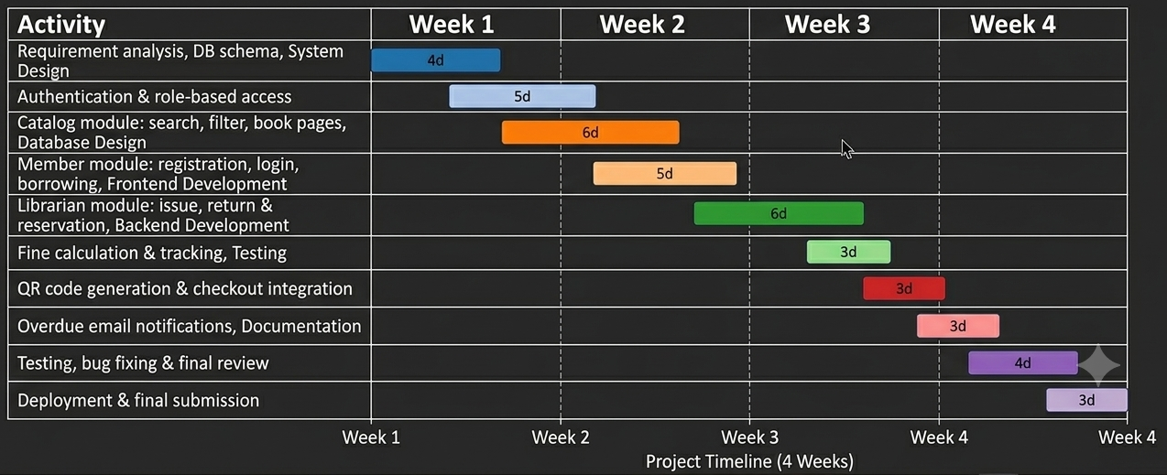he project is planned for completion within 4 weeks (28 days), broken down into the following tasks:

Conclusion
Fig. 3 — Gantt Chart of the 4-Week Project Schedule

The proposed Smart Inventory Management System aims to improve inventory handling through automation, accuracy, and real-time monitoring. The system reduces manual effort, minimizes inventory errors, and enables businesses to make informed decisions using analytical reports.
By incorporating barcode-based stock tracking, secure user authentication, and comprehensive reporting, the proposed solution offers an efficient and scalable inventory management platform suitable for small and medium-sized businesses.

References
- • Django Software Foundation, Django Documentation. https://docs.djangoproject.com/
- • Oracle Corporation, MySQL Documentation. https://dev.mysql.com/doc/
- • Mozilla Developer Network (MDN), HTML, CSS & JavaScript Documentation. https://developer.mozilla.org/
- • Ian Sommerville, Software Engineering, 10th Edition, Pearson Education.
- • Roger S. Pressman, Software Engineering: A Practitioner's Approach, McGraw-Hill.
- • Martin Fowler, Patterns of Enterprise Application Architecture, Addison-Wesley.
- • BarcodeFAQ, Barcode Technology Guide. https://www.barcodefaq.com/

