人工智能 上机实验报告
学号： 1908090117 姓名： 李泉志 所在系： 信息学院 班级： 惠测191班
实验名称： 知识表示方法及应用 实验日期 2021年11月7日
实验指导教师 李 辉 实验机房 D2-602
------------------------------------------------------------------------------------------------------

- 实验目的：
（1）在掌握状态空间搜索策略的基础上，理解知识表示的方法。
（2）能够应用知识表示方法，解决实际问题。
2. 实验内容及要求：
M-C问题描述
有n个牧师和n个野人准备渡河，但只有一条能容纳c个人的小船，为了防止野人侵犯牧师，要求无论在何处，牧师的人数不得少于野人的人数(除非牧师人数为0)，且假定野人与牧师都会划船，试设计一个算法，确定他们能否渡过河去，若能，则给出小船来回次数最少的最佳方案。
3．算法设计（编程思路或流程图或关键源代码）
令s = {x1, x2, x3}
使用A*算法，使用估价函数f(s) =x1+x2-2*x3
控制台版本：
// mc-console.cpp
#include <iostream>
#include <queue>
#include <algorithm>
#include <tuple>
#include <map>

struct state {

int x1, x2, x3;

bool operator == (const state& rhs) const {
return x1 == rhs.x1 && x2 == rhs.x2 && x3 == rhs.x3;
}

bool operator < (const state& rhs) const {
if (x1 == rhs.x1) {
if (x2 == rhs.x2) {
return x3 < rhs.x3;
}
return x2 < rhs.x2;
}
return x1 < rhs.x1;
}

};

std::ostream &operator << (std::ostream& out, const state& rhs) {
out << "(" << rhs.x1 << ", " << rhs.x2 << ", " << rhs.x3 << ")";
return out;
}

int f(const state& key) {
return key.x1 + key.x2 - (key.x3 << 1);
}

struct CompareByF {
bool operator () (const state& lhs, const state& rhs) {
return f(lhs) < f(rhs);
}
};

std::vector<state> solve(int n, int c) {
const state end = {0, 0, 0};
const state border = {-1, -1, -1};
const state start = state{n, n, 1};
std::priority_queue<state, std::vector<state>, CompareByF> q;
std::map<state, state> pre;
q.push(start);
pre[start] = border;
auto contains = [=](const state& s) {
return (s.x1 >= s.x2 || s.x1 == 0) && (s.x1 >= 0 && s.x2 >= 0);
};
auto opposite = [=](const state& s) {
return state{n - s.x1, n - s.x2, s.x3 ^ 1};
};
auto calc_process = [&]() {
std::vector<state> result;
state now = {0, 0, 0};
state border = {-1, -1, -1};
for (; !(now == border); now = pre[now]) {
result.push_back(now);
}
std::reverse(result.begin(), result.end());
return result;
};
for (; !q.empty(); ) {
state now = q.top();
q.pop();
if (now == end) {
return calc_process();
}
for (int j = 0; j <= c; ++ j) {
for (int i = j; i + j <= c; ++ i) {
if (i + j == 0) {
continue;
}
int t = now.x3 ? -1 : 1;
state tmp = {now.x1 + t * i, now.x2 + t * j, now.x3 ^ 1};
state opt = opposite(tmp);
if (contains(tmp) && contains(opt) && !pre.count(tmp)) {
q.emplace(tmp);
pre[tmp] = now;
}
}
}
}
return {};
}

template <typename T>
void log(T x) {
std::cout << x << '\n';
}

int main() {
int n, k;
log("Please input the n and c.");
std::cin >> n >> k;
auto p = solve(n, k);
if (p.size() == 0) {
log("No solution!");
return 0;
}
log("Total " + std::to_string(p.size() - 1) + " step.");
for (int i = 0; i < (int)p.size(); ++ i) {
std::cout << p[i];
if (i != p.size() - 1) {
std::cout << "->";
}
}
return 0;
}
图形化界面版本：
# CMakeLists.txt
cmake_minimum_required(VERSION 3.5)

project(Experiment2 LANGUAGES CXX)

set(CMAKE_INCLUDE_CURRENT_DIR ON)

set(CMAKE_AUTOUIC ON)
set(CMAKE_AUTOMOC ON)
set(CMAKE_AUTORCC ON)

set(CMAKE_CXX_STANDARD 11)
set(CMAKE_CXX_STANDARD_REQUIRED ON)

# QtCreator supports the following variables for Android, which are identical to qmake Android variables.
# Check http://doc.qt.io/qt-5/deployment-android.html for more information.
# They need to be set before the find_package(Qt5 ...) call.

#if(ANDROID)
# set(ANDROID_PACKAGE_SOURCE_DIR "${CMAKE_CURRENT_SOURCE_DIR}/android")
# if (ANDROID_ABI STREQUAL "armeabi-v7a")
# set(ANDROID_EXTRA_LIBS
# ${CMAKE_CURRENT_SOURCE_DIR}/path/to/libcrypto.so
# ${CMAKE_CURRENT_SOURCE_DIR}/path/to/libssl.so)
# endif()
#endif()

find_package(Qt5 COMPONENTS Widgets REQUIRED)

if(ANDROID)
add_library(Experiment2 SHARED
main.cpp
mainwindow.cpp
mainwindow.h
mcsolver.h
mainwindow.ui
)
else()
add_executable(Experiment2
main.cpp
mainwindow.cpp
mainwindow.h
mcsolver.h
mainwindow.ui
)
endif()

target_link_libraries(Experiment2 PRIVATE Qt5::Widgets)

// mcsolver.h
#ifndef MCSOLVER_H
#define MCSOLVER_H

#include <iostream>
#include <queue>
#include <algorithm>
#include <tuple>
#include <map>

struct state {

int x1, x2, x3;

bool operator == (const state& rhs) const {
return x1 == rhs.x1 && x2 == rhs.x2 && x3 == rhs.x3;
}

bool operator < (const state& rhs) const {
if (x1 == rhs.x1) {
if (x2 == rhs.x2) {
return x3 < rhs.x3;
}
return x2 < rhs.x2;
}
return x1 < rhs.x1;
}

};

inline int f(const state& key) {
return key.x1 + key.x2 - (key.x3 << 1);
}

struct CompareByF {
bool operator () (const state& lhs, const state& rhs) {
return f(lhs) < f(rhs);
}
};

inline std::vector<state> solve(int n, int c) {
const state end = {0, 0, 0};
const state border = {-1, -1, -1};
const state start = state{n, n, 1};
std::priority_queue<state, std::vector<state>, CompareByF> q;
std::map<state, state> pre;
q.push(start);
pre[start] = border;
auto contains = [=](const state& s) {
return (s.x1 >= s.x2 || s.x1 == 0) && (s.x1 >= 0 && s.x2 >= 0);
};
auto opposite = [=](const state& s) {
return state{n - s.x1, n - s.x2, s.x3 ^ 1};
};
auto calc_process = [&]() {
std::vector<state> result;
state now = {0, 0, 0};
state border = {-1, -1, -1};
for (; !(now == border); now = pre[now]) {
result.push_back(now);
}
std::reverse(result.begin(), result.end());
return result;
};
for (; !q.empty(); ) {
state now = q.top();
q.pop();
if (now == end) {
return calc_process();
}
for (int j = 0; j <= c; ++ j) {
for (int i = j; i + j <= c; ++ i) {
if (i + j == 0) {
continue;
}
int t = now.x3 ? -1 : 1;
state tmp = {now.x1 + t * i, now.x2 + t * j, now.x3 ^ 1};
state opt = opposite(tmp);
if (contains(tmp) && contains(opt) && !pre.count(tmp)) {
q.emplace(tmp);
pre[tmp] = now;
}
}
}
}
return {};
}

#endif // MCSOLVER_H

mainwindow.ui

<?xml version="1.0" encoding="UTF-8"?>
<ui version="4.0">
<class>MainWindow</class>
<widget class="QMainWindow" name="MainWindow">
<property name="geometry">
<rect>
<x>0</x>
<y>0</y>
<width>800</width>
<height>600</height>
</rect>
</property>
<property name="windowTitle">
<string>MainWindow</string>
</property>
<widget class="QWidget" name="centralwidget">
<layout class="QVBoxLayout" name="verticalLayout_2">
<item>
<widget class="QLabel" name="label">
<property name="text">
<string>&lt;html&gt;&lt;head/&gt;&lt;body&gt;&lt;p align=&quot;center&quot;&gt;&lt;span style=&quot; font-size:12pt;&quot;&gt;MC-Problem&lt;/span&gt;&lt;/p&gt;&lt;/body&gt;&lt;/html&gt;</string>
</property>
</widget>
</item>
<item>
<layout class="QFormLayout" name="formLayout">
<item row="0" column="0">
<widget class="QLabel" name="label_2">
<property name="text">
<string>The number of priest(n):</string>
</property>
</widget>
</item>
<item row="0" column="1">
<widget class="QLineEdit" name="nLineEdit"/>
</item>
<item row="1" column="1">
<widget class="QLineEdit" name="cLineEdit2"/>
</item>
<item row="1" column="0">
<widget class="QLabel" name="label_3">
<property name="text">
<string>Boat capacity(c):</string>
</property>
</widget>
</item>
</layout>
</item>
<item>
<widget class="QPushButton" name="calculateButton">
<property name="text">
<string>Calculate</string>
</property>
</widget>
</item>
<item>
<widget class="QTextBrowser" name="displayBrowser">
<property name="font">
<font>
<family>Consolas</family>
</font>
</property>
</widget>
</item>
</layout>
</widget>
<widget class="QMenuBar" name="menubar">
<property name="geometry">
<rect>
<x>0</x>
<y>0</y>
<width>800</width>
<height>21</height>
</rect>
</property>
</widget>
<widget class="QStatusBar" name="statusbar"/>
</widget>
<resources/>
<connections/>
</ui>

// mainwindow.h
#ifndef MAINWINDOW_H
#define MAINWINDOW_H

#include <QMainWindow>
#include <QMessageBox>

#include "mcsolver.h"

QT_BEGIN_NAMESPACE
namespace Ui {
class MainWindow;
}
QT_END_NAMESPACE

class MainWindow : public QMainWindow {
Q_OBJECT

public:
MainWindow(QWidget *parent = nullptr);
~MainWindow();

private slots:
void on_calculateButton_clicked();

private:
QString format(const state&, const int&);
QString formatBoat(const state&, const state&, const int&);
Ui::MainWindow *ui;
};
#endif // MAINWINDOW_H

// mainwindow.cpp
#include "mainwindow.h"
#include "./ui_mainwindow.h"

MainWindow::MainWindow(QWidget *parent) : QMainWindow(parent), ui(new Ui::MainWindow) {
ui->setupUi(this);
setWindowTitle("MC-Problem Solver");
}

MainWindow::~MainWindow() {
delete ui;
}

QString MainWindow::format(const state& x, const int& n) {
state y = {n - x.x1, n - x.x2, x.x3 ^ 1};
const static QString blue = "<span style=\"color: blue\">%1</span>";
const static QString red = "<span style=\"color: red\">%1</span>";
const static QString plain = "<span>%1</span>";
QString result, tmp;
result += plain.arg("___");
result += blue.arg(tmp.fill('+', y.x1));
result += red.arg(tmp.fill('#', y.x2));
result += plain.arg(tmp.fill('_', x.x1 + x.x2));
result += plain.arg('_');
for (int i = 0; i < std::max(n, 8); ++ i) {
result += plain.arg("-_");
}
result += plain.arg("-");
result += plain.arg('_');
result += plain.arg(tmp.fill('_', y.x1 + y.x2));
result += blue.arg(tmp.fill('+', x.x1));
result += red.arg(tmp.fill('#', x.x2));
result += plain.arg("___");
return result;
}

QString MainWindow::formatBoat(const state& last, const state& now, const int& n) {
int bol = std::max(8, n) * 2 + 1;
int length = n * 4 + bol + 8;
int x = abs(last.x1 - now.x1);
int y = abs(last.x2 - now.x2);
QString boat, tmp, result;
const static QString blue = "<span style=\"color: blue\">%1</span>";
const static QString red = "<span style=\"color: red\">%1</span>";
const static QString plain = "<span>%1</span>";
boat += plain.arg("\\_");
boat += blue.arg(tmp.fill('+', x));
boat += red.arg(tmp.fill('#', y));
boat += plain.arg("_/");
int siz = x + y + 4;
tmp = "";
for (int i = 0; i < (length - siz) / 2; ++ i) {
tmp += "&nbsp;";
}
result += plain.arg(tmp);
if (last.x3 == 0) {
result += boat + plain.arg("-&gt;");
} else {
result += plain.arg("&lt;-") + boat;
}
tmp = "";
for (int i = 0; i < (length - siz) / 2; ++ i) {
tmp += "&nbsp;";
}
result += plain.arg(tmp);
return result;
}

void MainWindow::on_calculateButton_clicked() {
ui->displayBrowser->clear();
int n = ui->nLineEdit->text().toInt();
int c = ui->cLineEdit2->text().toInt();
auto result = solve(n, c);
if (result.size() == 0) {
QMessageBox::warning(this, "tips", "No Solution.");
return ;
}
ui->displayBrowser->append(QString("Total %1 steps.\n").arg(result.size() - 1));
ui->displayBrowser->append("Use '+' to replace the priest, '#' to replace the savage.\n");
for (int i = 0; i < (int)result.size(); ++ i) {
ui->displayBrowser->append(QString::number(i));
ui->displayBrowser->append(format(result[i], n));
ui->displayBrowser->append("");
if (i != (int)result.size() - 1) {
ui->displayBrowser->append(formatBoat(result[i], result[i + 1], n));
}
}
ui->displayBrowser->moveCursor(QTextCursor::Start);
}

// main.cpp
#include "mainwindow.h"

#include <QApplication>

int main(int argc, char *argv[]) {
QApplication a(argc, argv);
MainWindow w;
w.show();
return a.exec();
}
- 程序调试（实验数据记录——根据程序要求输入几组不同数据，记录程序运行结果，并分析结果,分析程序运行中出现的主要错误。或对其他程序环境的使用情况的记录。注：必须认真书写）
控制台版本：
图形化界面版本：
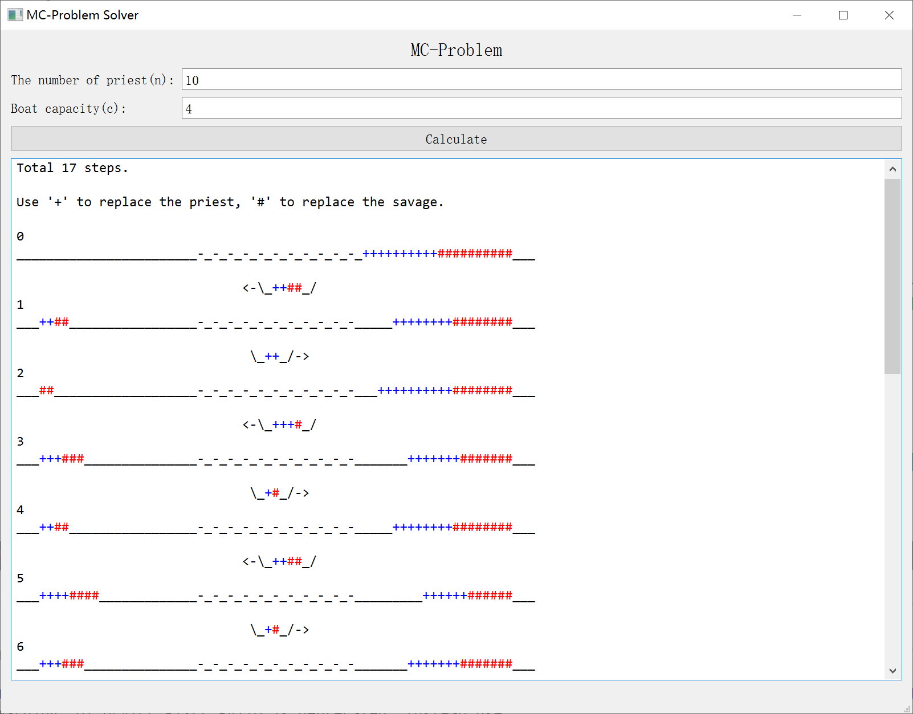
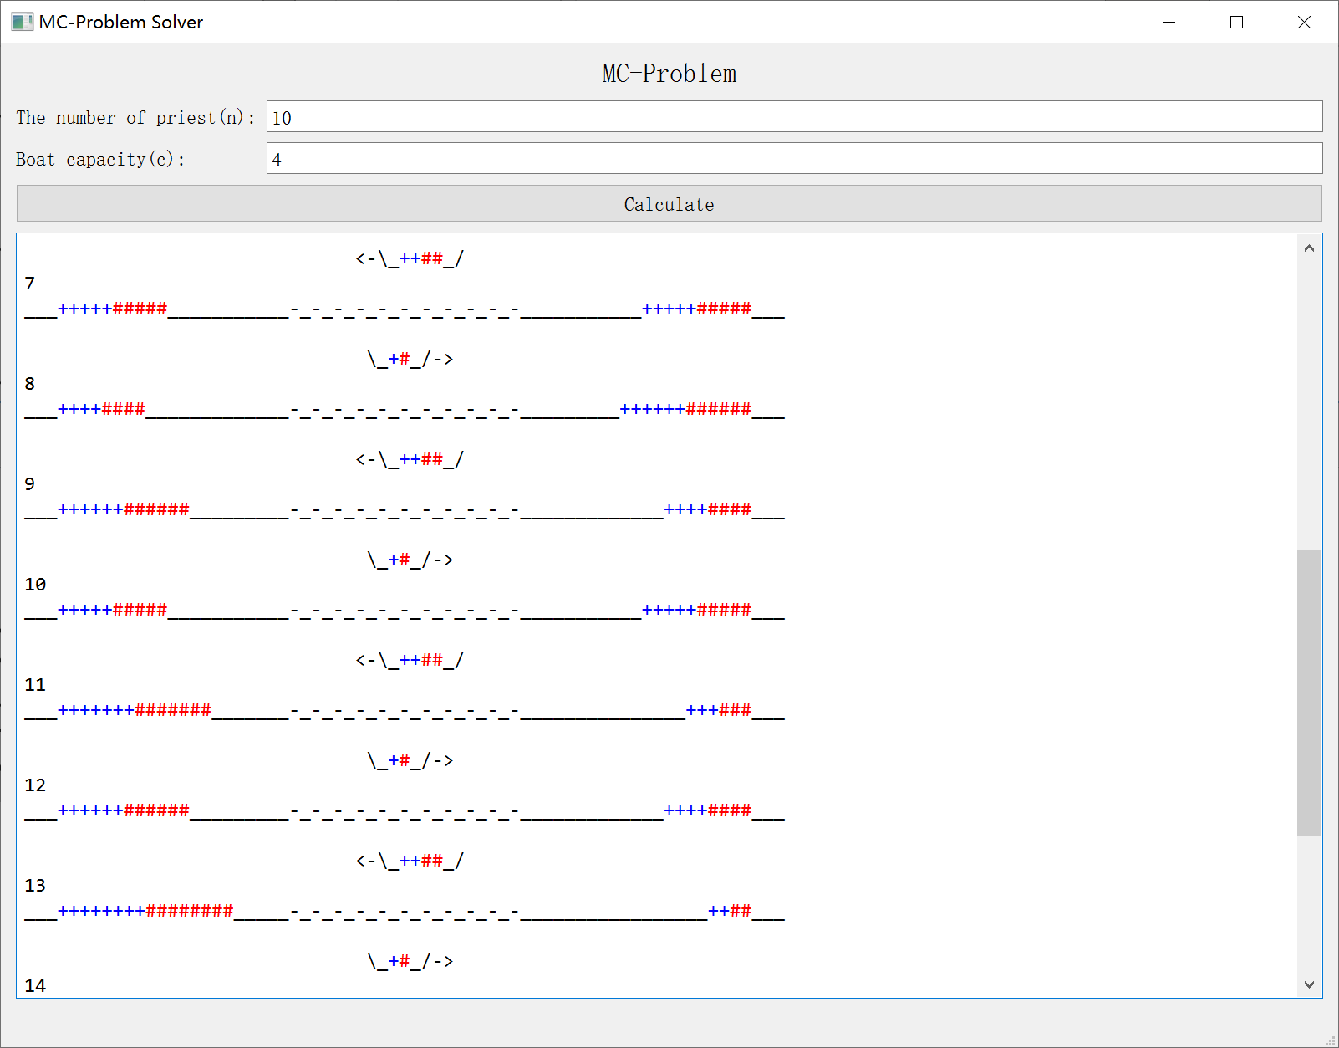
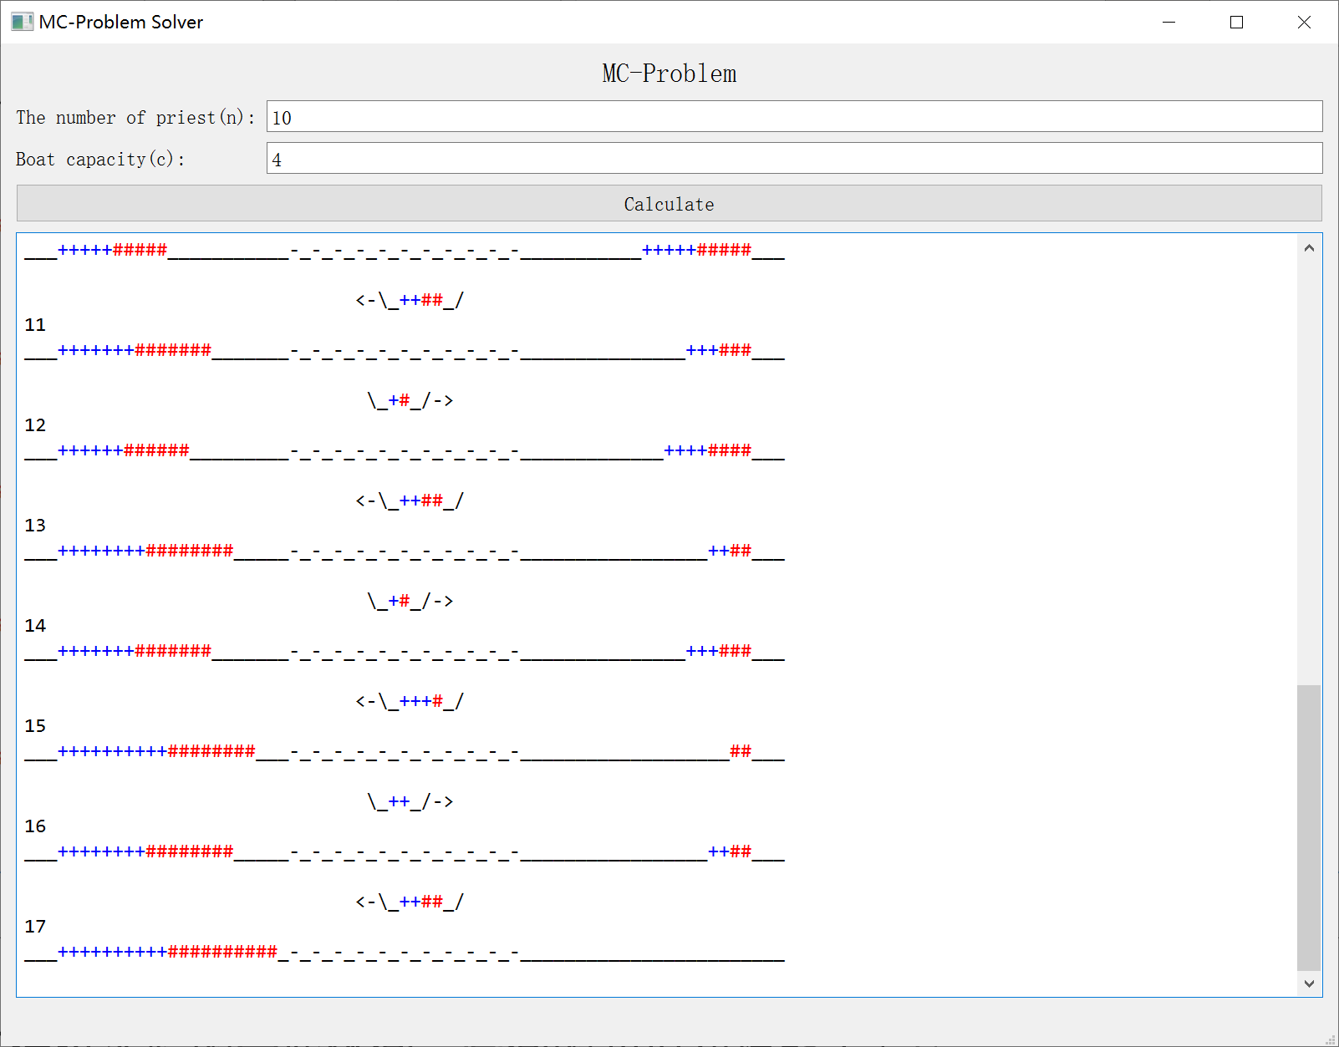
5．讨论（通过实验的一些体会、学会的知识和技能等）
通过此次实验，学到了如何使用A*搜索解决M-C问题，学到了如何设计估价函数，优化搜索过程。

