软件质量保证与测试 上机实验报告
学号： 1908090117 姓名： 李泉志 所在学院： 信息学院 班级： 惠普测试191
实验名称： 逻辑覆盖法综合及EclEmma覆盖率分析 实验日期 2021/11/11
实验指导教师 张俊虎 实验机房及机号 D-318
-----------------------------------------------------------------------------------------------------
一、实验目的：
1.巩固使用常用的逻辑覆盖方法设计测试用例
2.熟练掌握自动化测试框架
3.熟悉覆盖率分析工具EclEmma的使用
二、实验内容：
1.分别用语句覆盖、判定覆盖、条件覆盖、条件判定覆盖、条件组合覆盖、MC/DC覆盖、以及路径覆盖技术对commision方法进行用例设计
2.使用Eclipse的Junit单元测试工具进行自动化测试
三、实验步骤
0.代码仓库
https://github.com/ZlycerQan/SoftwareTesting
1.编写函数commission()
// Main.java
package experiment5;
public class Main {
public float commission(int headphones, int shells, int protectors) {
float salary;
float total;
if (headphones <= 0 || shells < 0 || protectors < 0) {
return (float) -1;
}
total = headphones * 80 + shells * 10 + protectors * 8;
if (total < 1000) {
salary = total * (float) 0.1;
} else if (total < 1800) {
salary = 1000 * (float) 0.1 + (total - 1000) * (float) 0.15;
} else {
salary = 1000 * (float) 0.1 + (800) * (float) 0.15 + (total - 1800) * (float) 0.2;
}
return salary;
}
}
2.绘制程序流程图
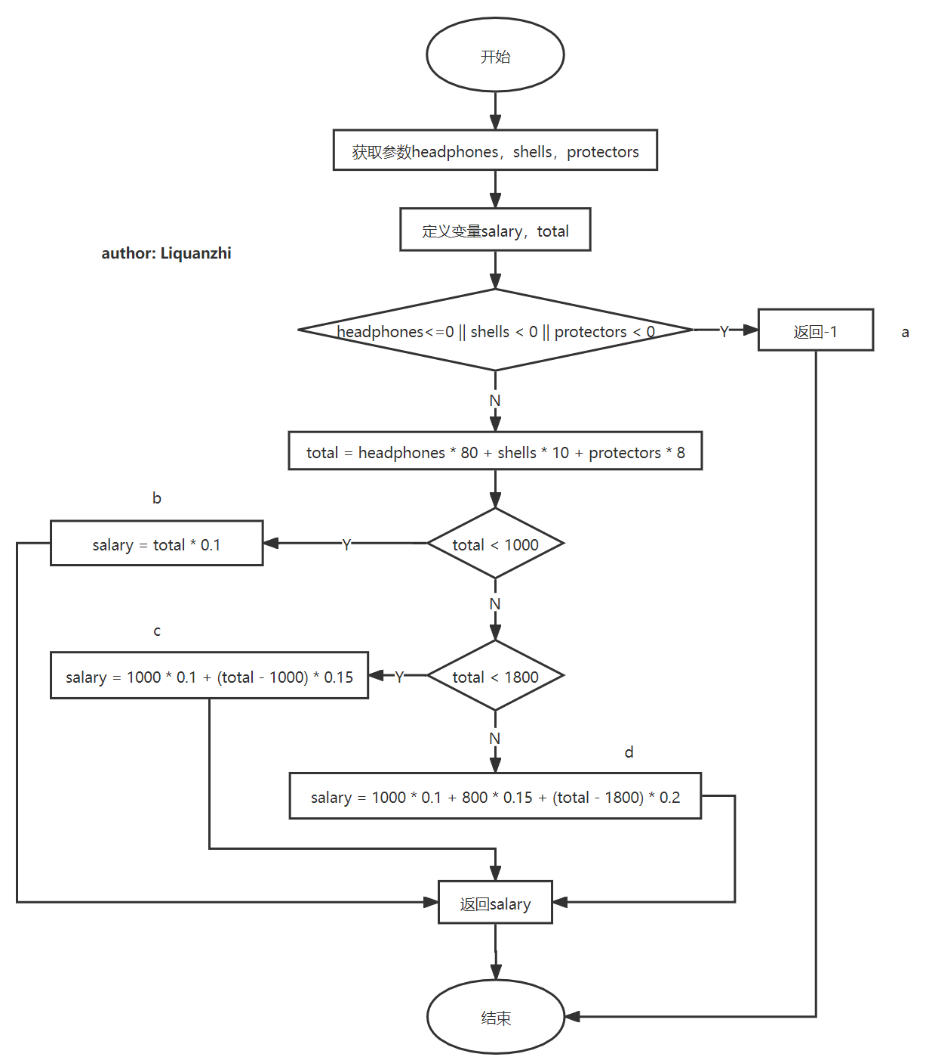
3.设计测试用例
令headphones = x，shells = y，protectors = z
（1）语句覆盖
序号 | 覆盖语句 | 测试用例 | 期望
1 | a | x = 0, y = 0, z = 0 | 返回 -1
2 | b | x = 1, y = 1, z = 1 | 返回9.8
3 | c | x = 20, y = 1, z = 1 | 返回192.7
4 | d | x = 30, y = 1, z = 1 | 返回343.6
（2）判定覆盖
序号 | 覆盖判定 | 测试用例 | 期望
1 | [headphones <= 0 || shells < 0 || protectors < 0]=1 | x = 0, y = 0, z = 0 | 返回 -1
2 | [headphones <= 0 || shells < 0 || protectors < 0]=0  [total < 1000]=1 | x = 1, y = 1, z = 1 | 返回9.8
3 | [headphones <= 0 || shells < 0 || protectors < 0]=0  [total < 1000]=0  [total < 1800]=1 | x = 20, y = 1, z = 1 | 返回192.7
4 | [headphones <= 0 || shells < 0 || protectors < 0]=1  [total < 1000]=0  [total < 1800]=0 | x = 30, y = 1, z = 1 | 返回343.6
（3）条件覆盖
序号 | 覆盖条件 | 测试用例 | 期望
1 | [headphones<=0]=1  [shells<0]=0  [protectors<0]=0 | x = 0, y = 0, z = 0 | 返回 -1
2 | [headphones<=0]=0  [shells<0]=0  [protectors<0]=0  [total < 1000]=1 | x = 1, y = 1, z = 1 | 返回9.8
3 | [headphones<=0]=0  [shells<0]=0  [protectors<0]=0  [total < 1000]=0  [total < 1800]=1 | x = 20, y = 1, z = 1 | 返回192.7
4 | [headphones<=0]=0  [shells<0]=0  [protectors<0]=0  [total < 1000]=0  [total < 1800]=0 | x = 30, y = 1, z = 1 | 返回343.6
5 | [headphones<=0]=0  [shells<0]=1  [protectors<0]=1 | x = 2, y = -1, z = -1 | 返回 -1
（4）条件判定覆盖
序号 | 覆盖 | 测试用例 | 期望
1 | 条件：  [headphones<=0]=1  [shells<0]=0  [protectors<0]=0  判定：  [headphones <= 0 || shells < 0 || protectors < 0]=1 | x = 0, y = 0, z = 0 | 返回 -1
2 | 条件：  [total < 1000]=1  判定：  [headphones <= 0 || shells < 0 || protectors < 0]=0  [total < 1000]=1 | x = 1, y = 1, z = 1 | 返回9.8
3 | 条件：  [total < 1000]=0  [total < 1800]=1  判定：  [headphones <= 0 || shells < 0 || protectors < 0]=0  [total < 1000]=0  [total < 1800]=1 | x = 20, y = 1, z = 1 | 返回192.7
4 | 条件  [total < 1000]=0  [total < 1800]=0  判定：  [headphones <= 0 || shells < 0 || protectors < 0]=1  [total < 1000]=0  [total < 1800]=0 | x = 30, y = 1, z = 1 | 返回343.6
（5）条件组合覆盖
序号 | 条件组合 | 测试用例 | 期望
1 | [headphones<=0]=1  [shells<0]=0  [protectors<0]=0 | x = 0, y = 0, z = 0 | 返回 -1
2 | [headphones<=0]=0  [shells<0]=0  [protectors<0]=0  [total < 1000]=1 | x = 1, y = 1, z = 1 | 返回9.8
3 | [headphones<=0]=0  [shells<0]=0  [protectors<0]=0  [total < 1000]=0  [total < 1800]=1 | x = 20, y = 1, z = 1 | 返回192.7
4 | [headphones<=0]=0  [shells<0]=0Z  [protectors<0]=0  [total < 1000]=0  [total < 1800]=0 | x = 30, y = 1, z = 1 | 返回343.6
5 | [headphones<=0]=0  [shells<0]=0  [protectors<0]=1 | x = 1, y = 0, z = -1 | 返回 -1
6 | [headphones<=0]=0  [shells<0]=1  [protectors<0]=0 | x = 1, y = -1, z = 1 | 返回 -1
7 | [headphones<=0]=0  [shells<0]=1  [protectors<0]=1 | x = 1, y = -1, z = -1 | 返回 -1
8 | [headphones<=0]=1  [shells<0]=0  [protectors<0]=1 | x = 0, y =0, z = -1 | 返回 -1
9 | [headphones<=0]=1  [shells<0]=1  [protectors<0]=0 | x = 0, y = -1, z = 1 | 返回 -1
10 | [headphones<=0]=1  [shells<0]=1  [protectors<0]=1 | x = -1, y = -1, z = -1 | 返回 -1
（6）MC/DC覆盖
序号 | 条件组合 | 测试用例 | 期望
1 | [headphones<=0]=1  [shells<0]=0  [protectors<0]=0 | x = 0, y = 0, z = 0 | 返回 -1
2 | [headphones<=0]=0  [shells<0]=0  [protectors<0]=0  [total < 1000]=1 | x = 1, y = 1, z = 1 | 返回9.8
3 | [headphones<=0]=0  [shells<0]=0  [protectors<0]=0  [total < 1000]=0  [total < 1800]=1 | x = 20, y = 1, z = 1 | 返回192.7
4 | [headphones<=0]=0  [shells<0]=0Z  [protectors<0]=0  [total < 1000]=0  [total < 1800]=0 | x = 30, y = 1, z = 1 | 返回343.6
5 | [headphones<=0]=0  [shells<0]=0  [protectors<0]=1 | x = 1, y = 0, z = -1 | 返回 -1
6 | [headphones<=0]=0  [shells<0]=1  [protectors<0]=0 | x = 1, y = -1, z = 1 | 返回 -1
4.编写测试代码
（1）语句覆盖
// StatementCoverageTest.java
package experiment5;
import static org.junit.jupiter.api.Assertions.*;
import org.junit.jupiter.api.Test;
class StatementCoverageTest {
private final Main main = new Main();
private final double eps = 1e-4;
@Test
public void testExample_Statement_a() {
assertEquals(-1, main.commission(0, 0, 0), eps);
}
@Test
public void testExample_Statement_b() {
assertEquals(9.8, main.commission(1, 1, 1), eps);
}
@Test
public void testExample_Statement_c() {
assertEquals(192.7, main.commission(20, 1, 1), eps);
}
@Test
public void testExample_Statement_d() {
assertEquals(343.6, main.commission(30, 1, 1), eps);
}
}
（2）判定覆盖
// DecisionCoverageTest.java
package experiment5;
import org.junit.jupiter.api.Test;
import static org.junit.jupiter.api.Assertions.*;
public class DecisionCoverageTest {
private final Main main = new Main();
private final double eps = 1e-4;
@Test
public void test1() {
assertEquals(-1, main.commission(0, 0, 0), eps);
}
@Test
public void test2() {
assertEquals(9.8, main.commission(1, 1, 1), eps);
}
@Test
public void test3() {
assertEquals(192.7, main.commission(20, 1, 1), eps);
}
@Test
public void test4() {
assertEquals(343.6, main.commission(30, 1, 1), eps);
}
}
（3）条件覆盖
// ConditionCoverageTest.java
package experiment5;
import org.junit.jupiter.api.Test;
import static org.junit.jupiter.api.Assertions.*;
class ConditionCoverageTest {
private final Main main = new Main();
private final double eps = 1e-4;
@Test
public void test1() {
assertEquals(-1, main.commission(0, 0, 0), eps);
}
@Test
public void test2() {
assertEquals(9.8, main.commission(1, 1, 1), eps);
}
@Test
public void test3() {
assertEquals(192.7, main.commission(20, 1, 1), eps);
}
@Test
public void test4() {
assertEquals(343.6, main.commission(30, 1, 1), eps);
}
@Test
public void test5() {
assertEquals(-1, main.commission(0, -1, -1), eps);
}
}
（4）条件判定覆盖
// ConditionDecisionCoverageTest.java
package experiment5;
import org.junit.jupiter.api.Test;
import static org.junit.jupiter.api.Assertions.assertEquals;
public class ConditionDecisionCoverageTest {
private final Main main = new Main();
private final double eps = 1e-4;
@Test
public void test1() {
assertEquals(-1, main.commission(0, 0, 0), eps);
}
@Test
public void test2() {
assertEquals(9.8, main.commission(1, 1, 1), eps);
}
@Test
public void test3() {
assertEquals(192.7, main.commission(20, 1, 1), eps);
}
@Test
public void test4() {
assertEquals(343.6, main.commission(30, 1, 1), eps);
}
}
（5）条件组合覆盖
// ConditionCombinationCoverageTest.java
package experiment5;
import org.junit.jupiter.api.Test;
import static org.junit.jupiter.api.Assertions.*;
public class ConditionCombinationCoverageTest {
private final Main main = new Main();
private final double eps = 1e-4;
@Test
public void test1() {
assertEquals(-1, main.commission(0, 0, 0), eps);
}
@Test
public void test2() {
assertEquals(9.8, main.commission(1, 1, 1), eps);
}
@Test
public void test3() {
assertEquals(192.7, main.commission(20, 1, 1), eps);
}
@Test
public void test4() {
assertEquals(343.6, main.commission(30, 1, 1), eps);
}
@Test
public void test5() {
assertEquals(-1, main.commission(1, 0, -1), eps);
}
@Test
public void test6() {
assertEquals(-1, main.commission(1, -1, 1), eps);
}
@Test
public void test7() {
assertEquals(-1, main.commission(1, -1, -1), eps);
}
@Test
public void test8() {
assertEquals(-1, main.commission(0, 0, -1), eps);
}
@Test
public void test9() {
assertEquals(-1, main.commission(0, -1, 1), eps);
}
@Test
public void test10() {
assertEquals(-1, main.commission(-1, -1, -1), eps);
}
}
（6）MC/DC覆盖
// ModifiedConditionDecisionCoverageTest.java
package experiment5;
import org.junit.jupiter.api.Test;
import static org.junit.jupiter.api.Assertions.*;
public class ModifiedConditionDecisionCoverageTest {
private final Main main = new Main();
private final double eps = 1e-4;
@Test
public void test1() {
assertEquals(-1, main.commission(0, 0, 0), eps);
}
@Test
public void test2() {
assertEquals(9.8, main.commission(1, 1, 1), eps);
}
@Test
public void test3() {
assertEquals(192.7, main.commission(20, 1, 1), eps);
}
@Test
public void test4() {
assertEquals(343.6, main.commission(30, 1, 1), eps);
}
@Test
public void test5() {
assertEquals(-1, main.commission(1, 0, -1), eps);
}
@Test
public void test6() {
assertEquals(-1, main.commission(1, -1, 1), eps);
}
}
5.分析覆盖率
（1）语句覆盖
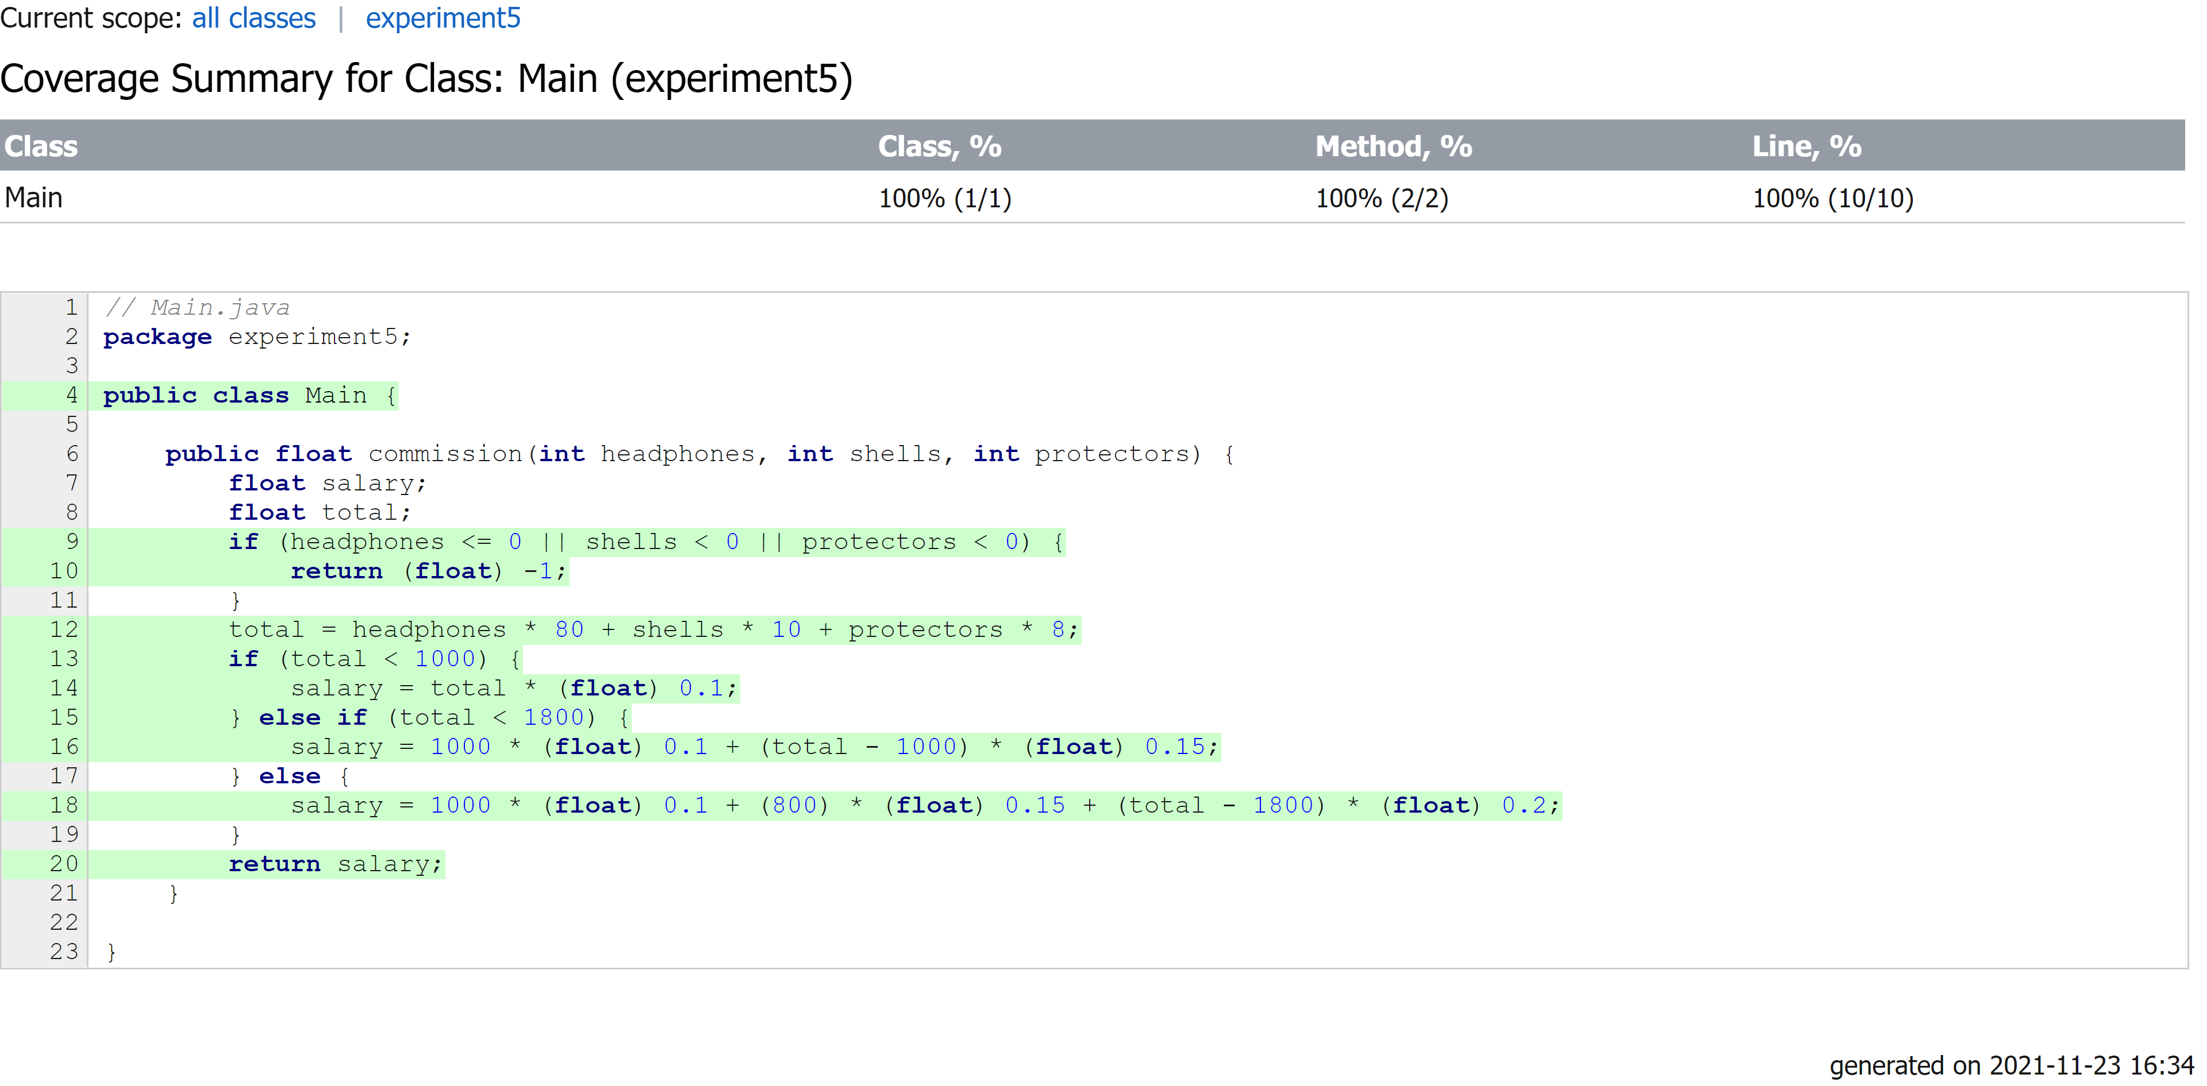
（2）判定覆盖
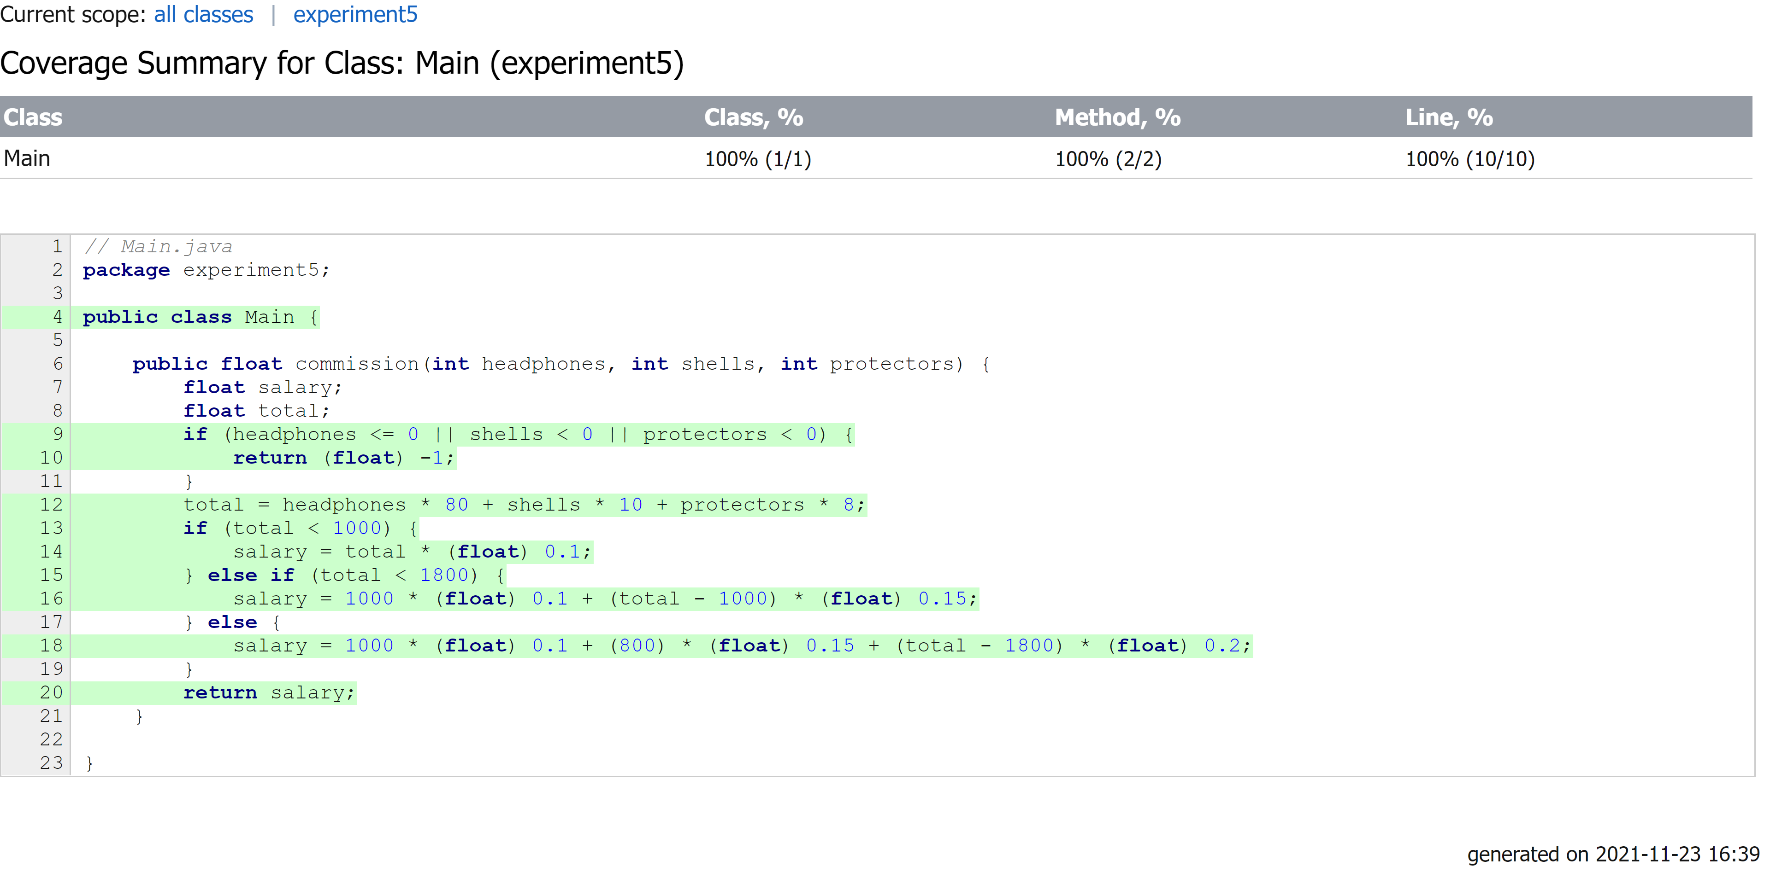
（3）条件覆盖
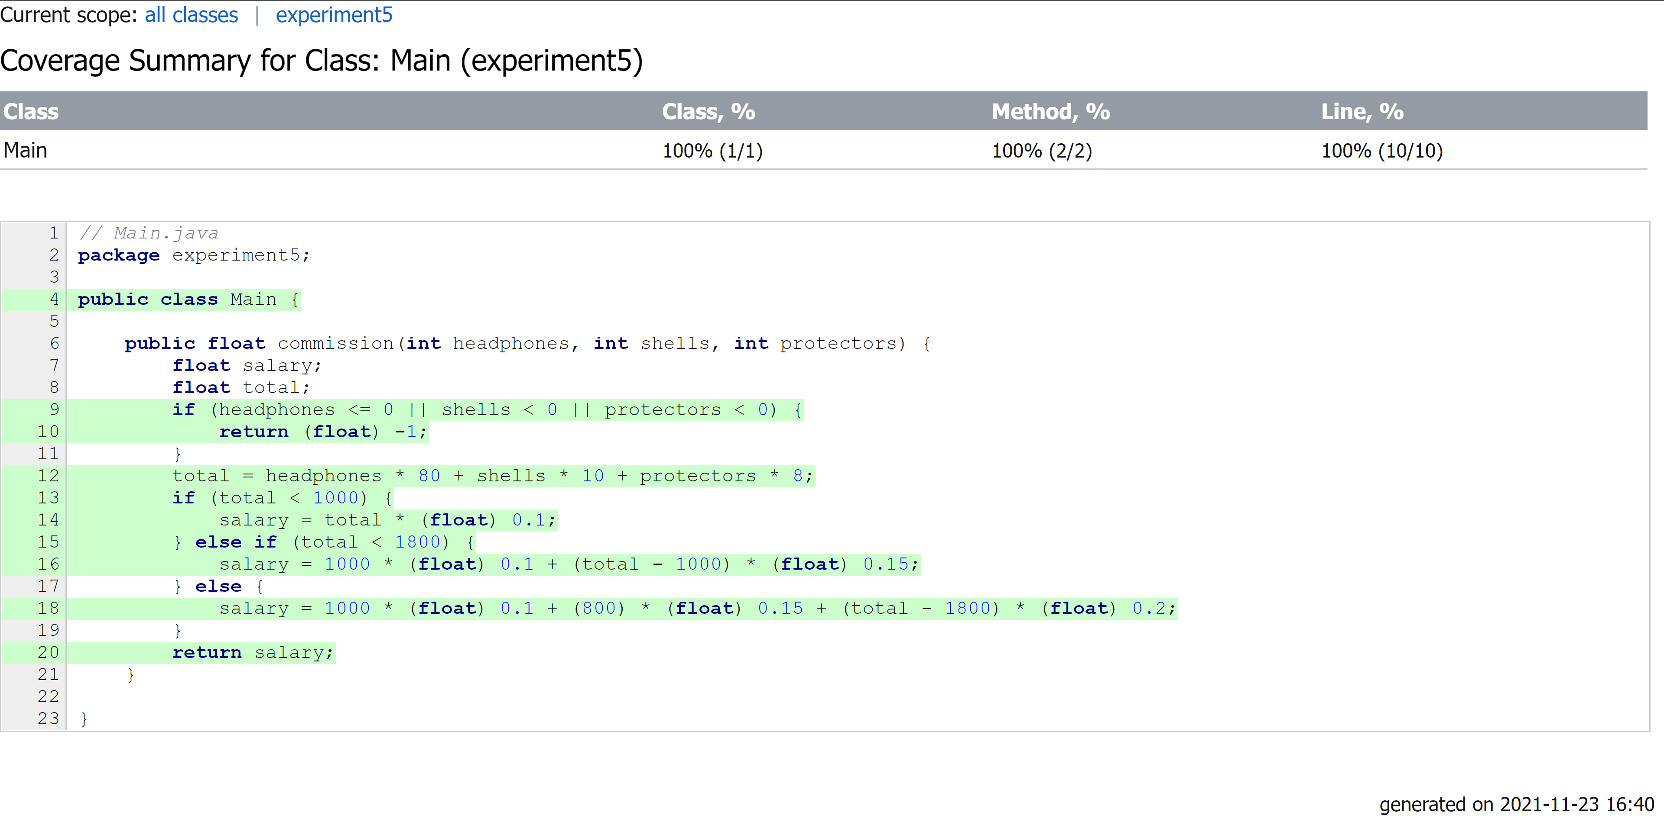
（4）条件判定覆盖
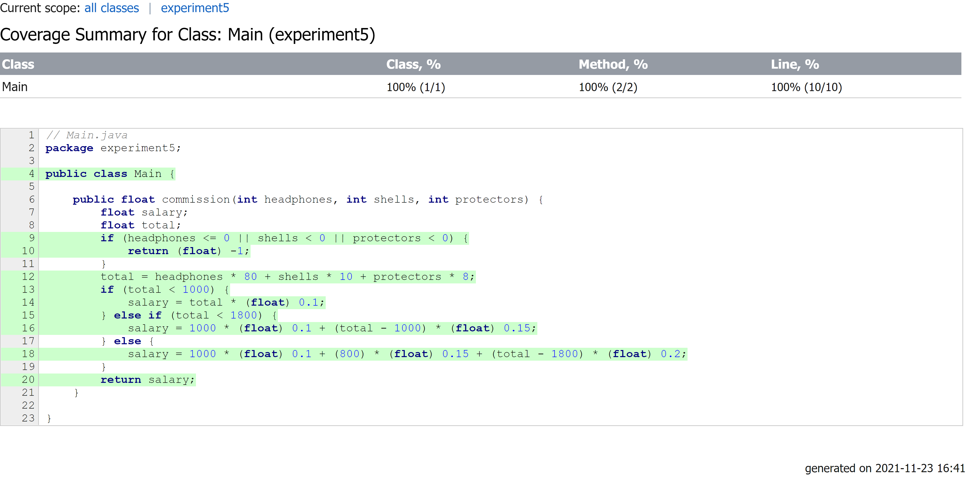
（5）条件组合覆盖
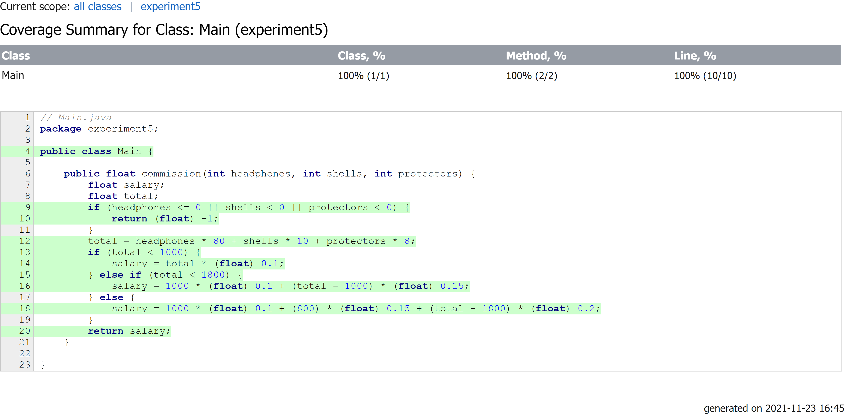
（6）MC/DC覆盖
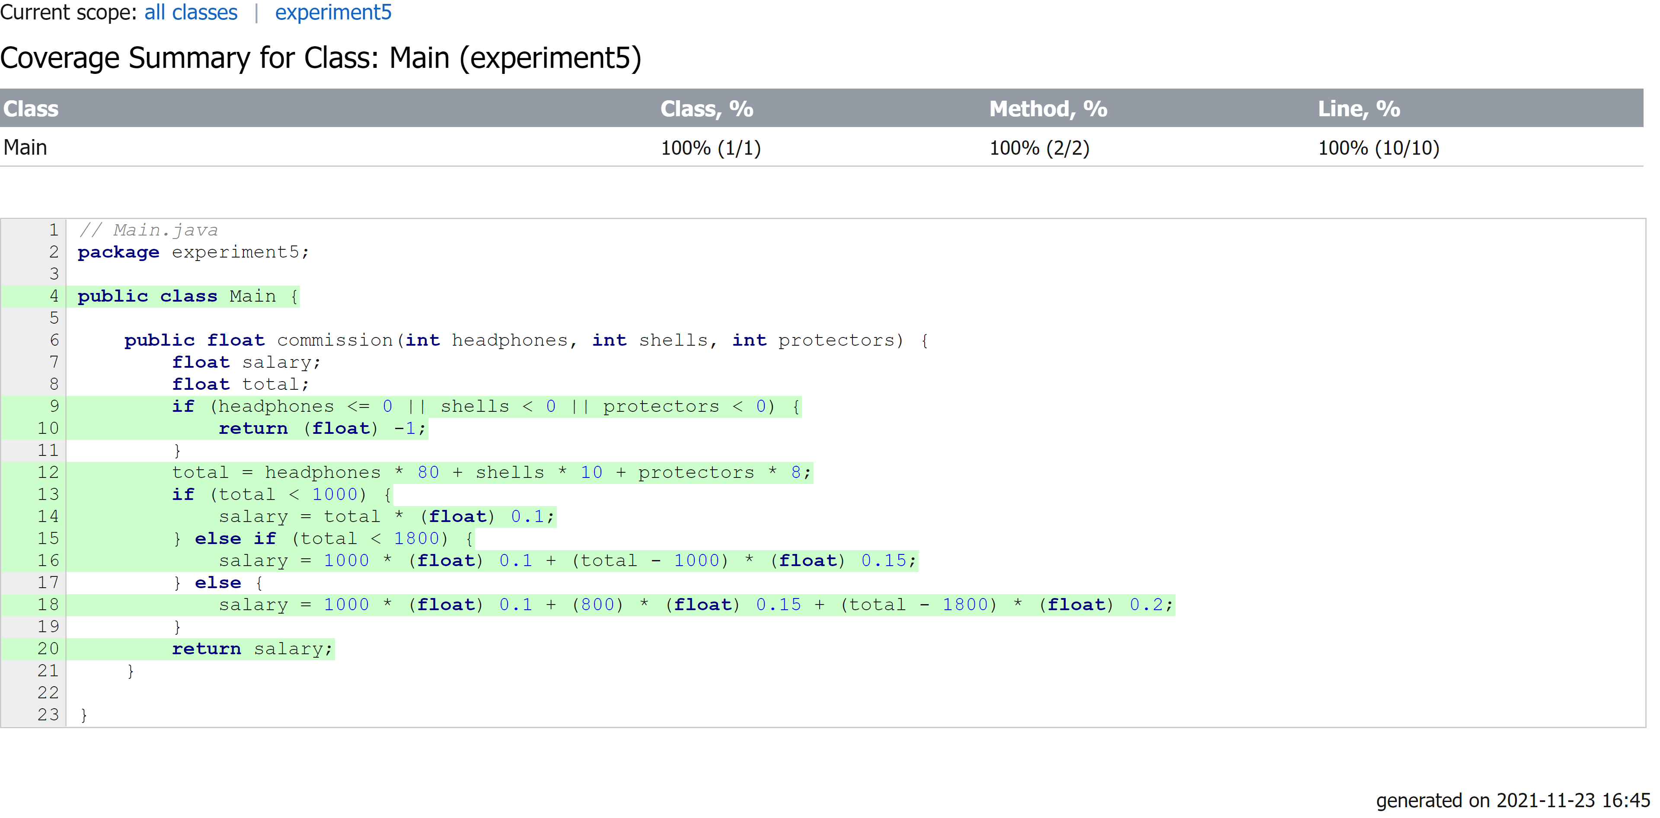
6.执行测试
（1）语句覆盖
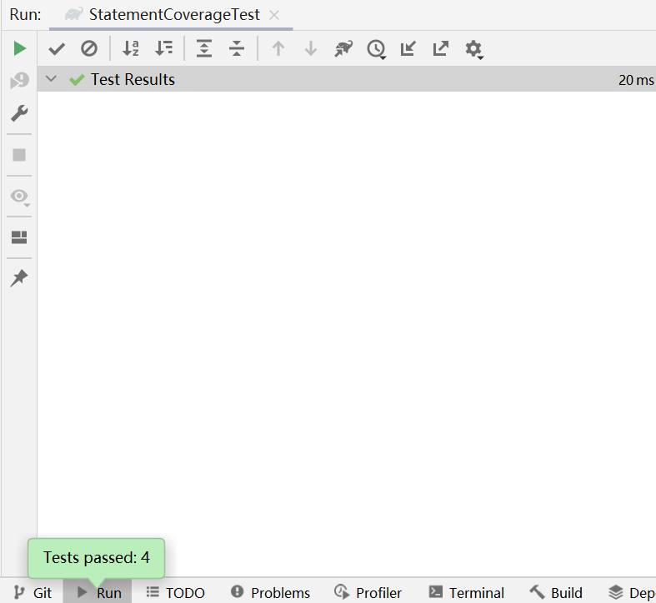
（2）判定覆盖
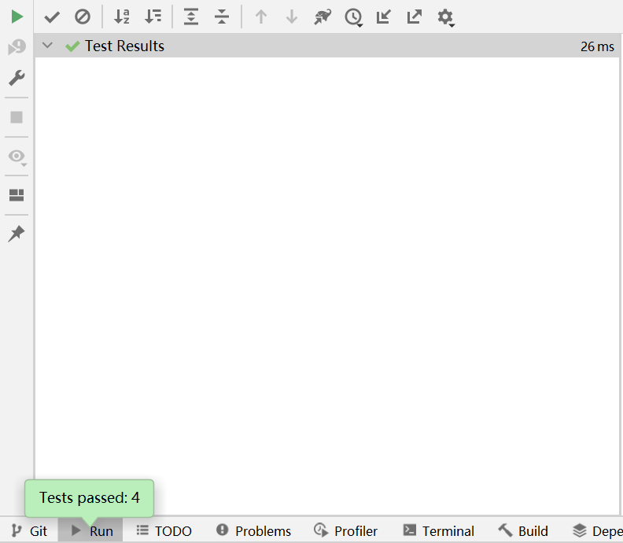
（3）条件覆盖
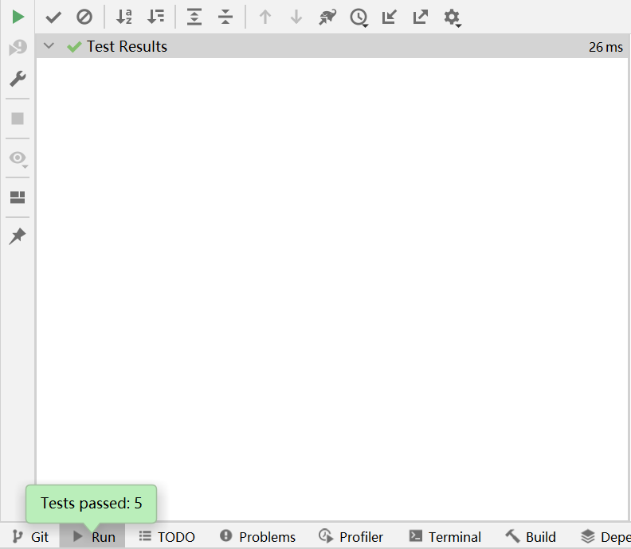
（4）条件判定覆盖
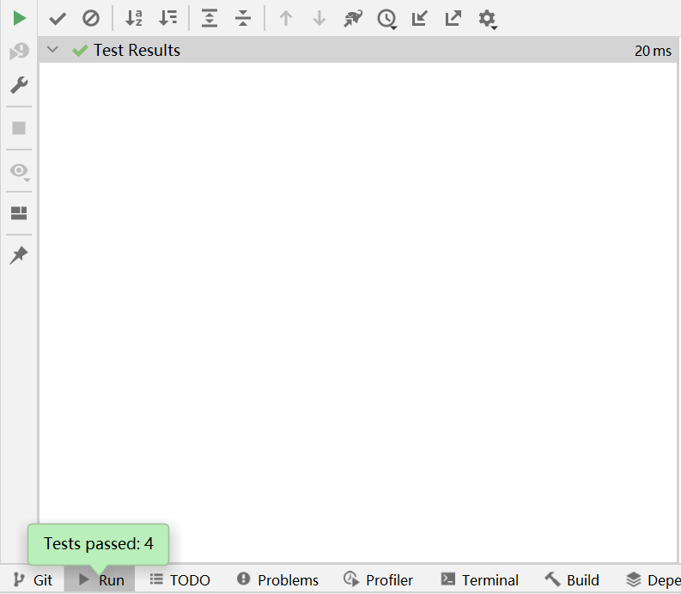
（5）条件组合覆盖
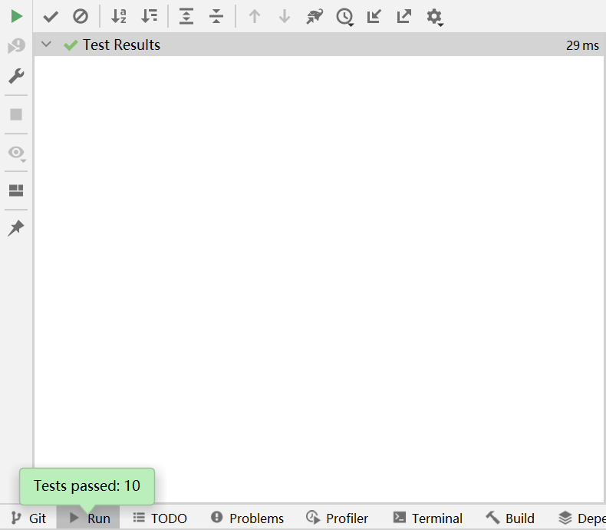
（6）MC/DC覆盖
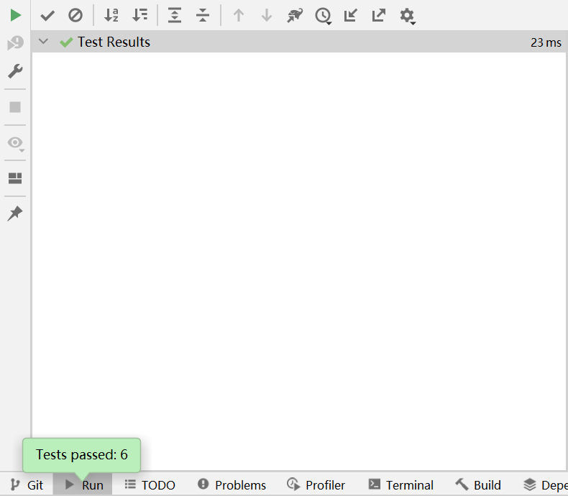
四、讨论
此次实验使用了Idea内置的代码覆盖率工具，用于分析待测代码在不同的测试数据下的代码覆盖率。待测代码判定的情况稍显简单，使得有几种覆盖方法设计的用例差别不大，没有体现出几种覆盖方法的优劣，之后应当设计更复杂一点的待测代码进行测试。

