Zhengming Wang

Zhw78

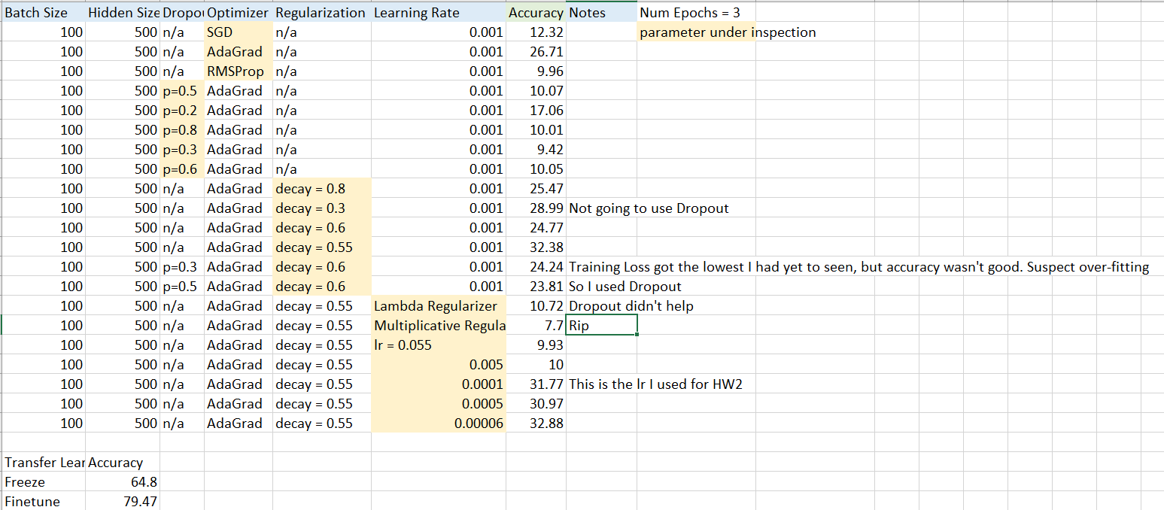

I didn’t realize we were supposed to also record our loss. Freezing and Finetuning got losses less than one, and in the last few runs I was able to get losses lower than two (1.8 – 2.1). The decay also resulted in very low loss, but didn’t translate to high accuracy.