**Part I**

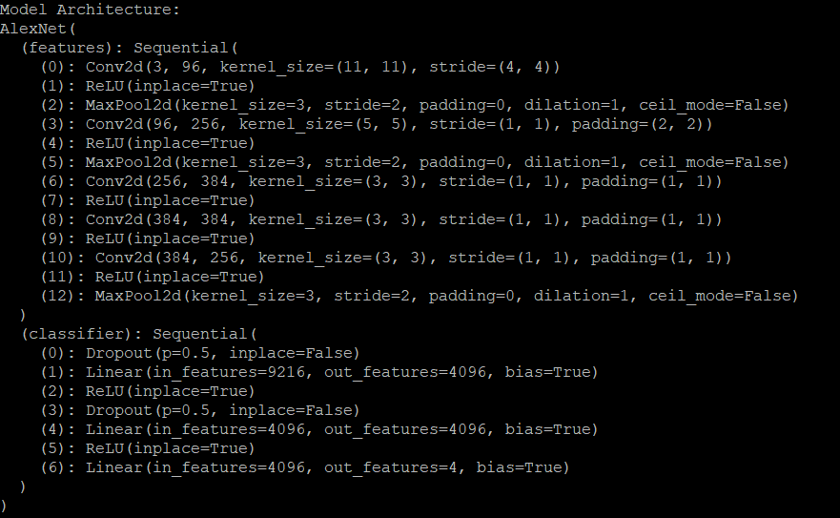

[Epoch 100] train accuracy: 0.9956, loss: 0.0166

[Epoch 100] eval accuracy: 0.9004, loss: 0.7200

**Part II**

AlexNetLargeKernel:

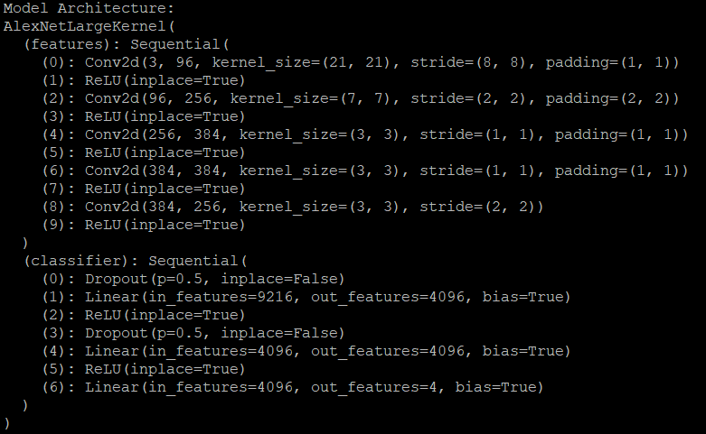



AlexNetTiny:

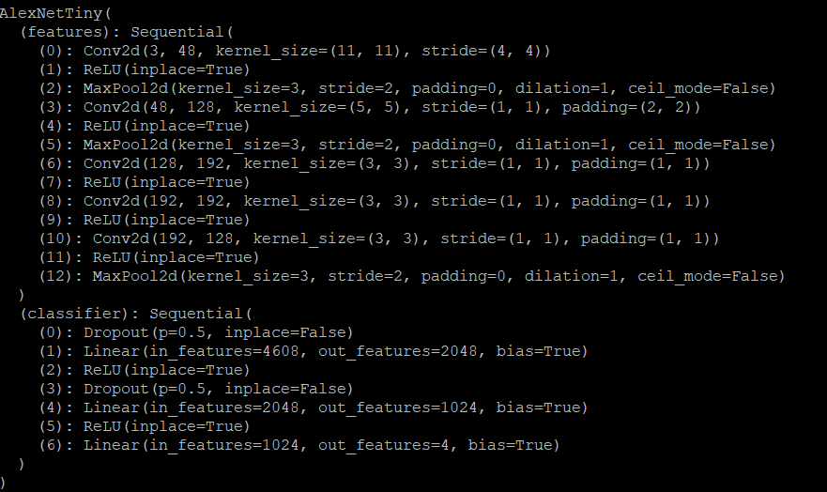

[Epoch 100] train accuracy: 0.9969, loss: 0.0107

[Epoch 100] eval accuracy: 0.9066, loss: 0.6590

AlexNetAvgPooling:

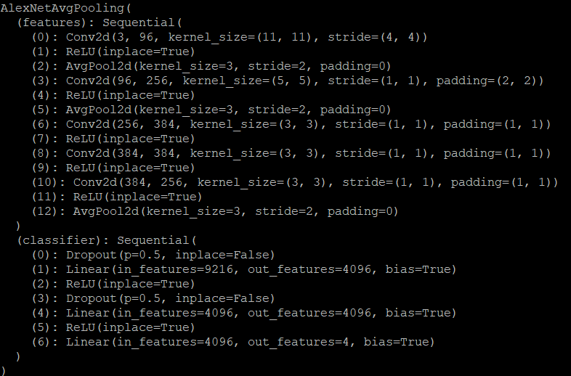



AlexNetDilation

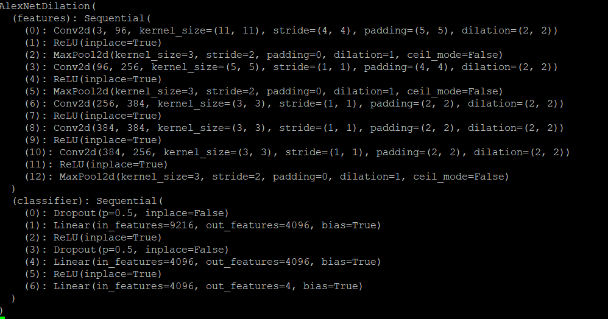

[Epoch 100] train accuracy: 0.9843, loss: 0.0511

[Epoch 100] eval accuracy: 0.8932, loss: 0.7845

Part III

Domain Kernels:

Conv2d-0

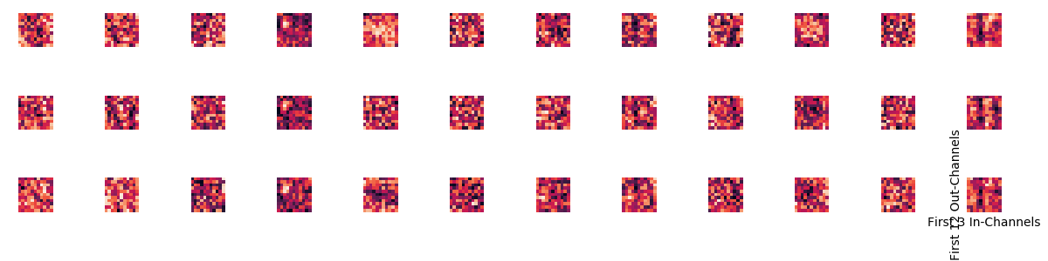

Conv2d-3

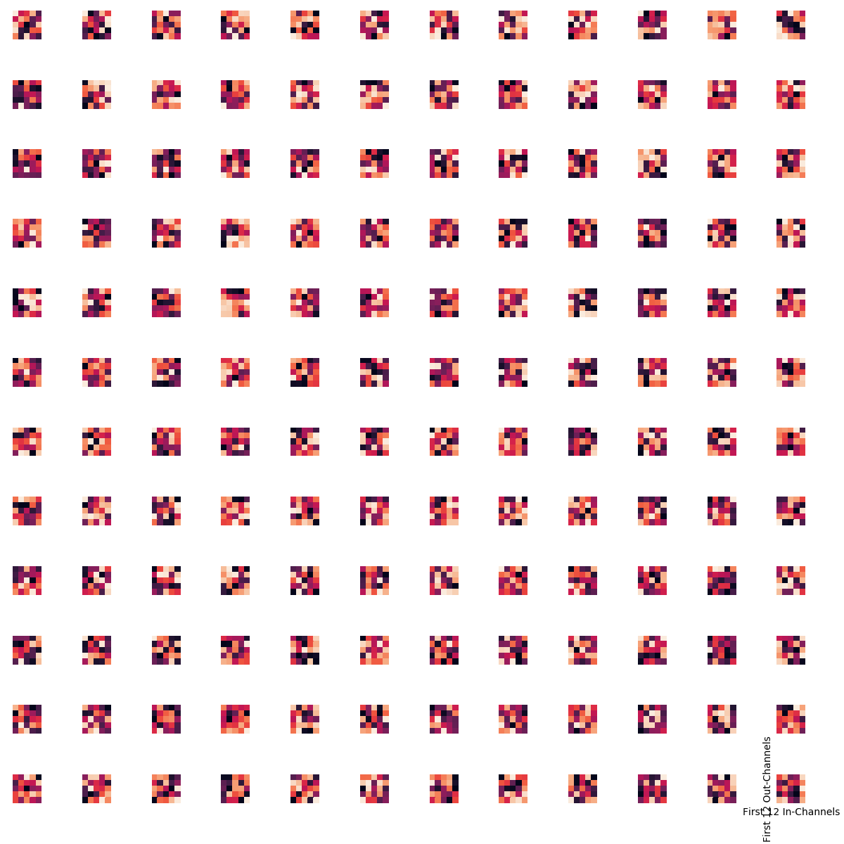

Conv2d-6

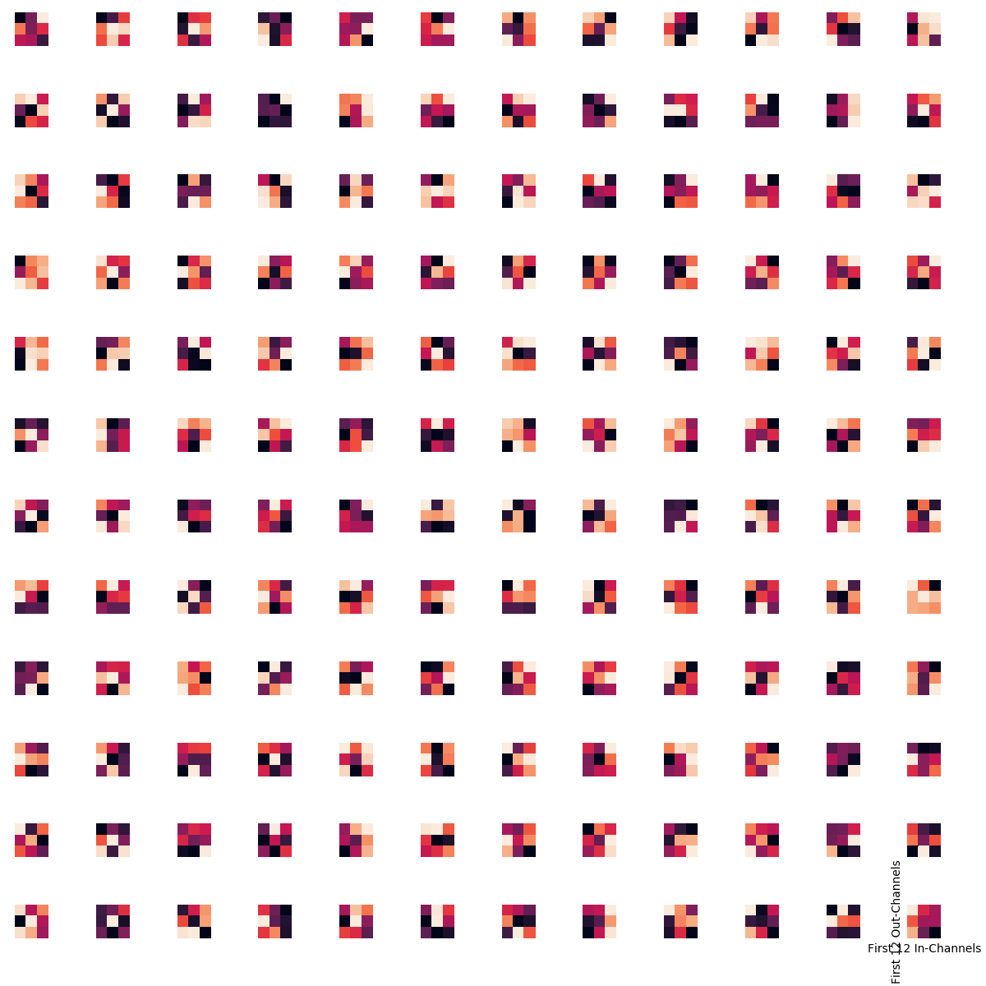

Conv2d-8

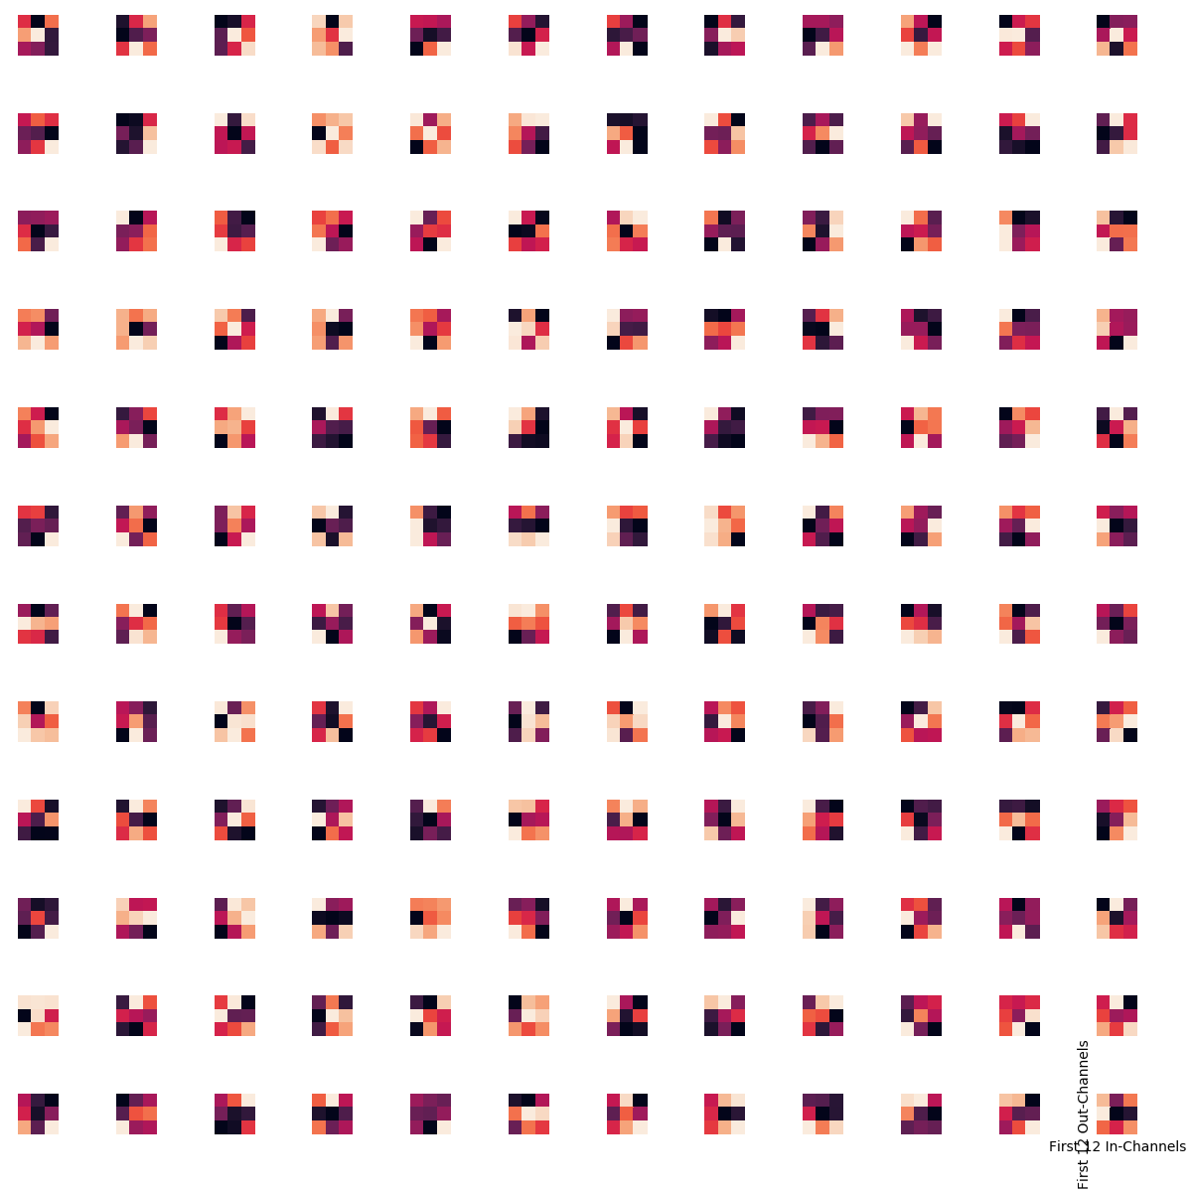

Conv2d-10

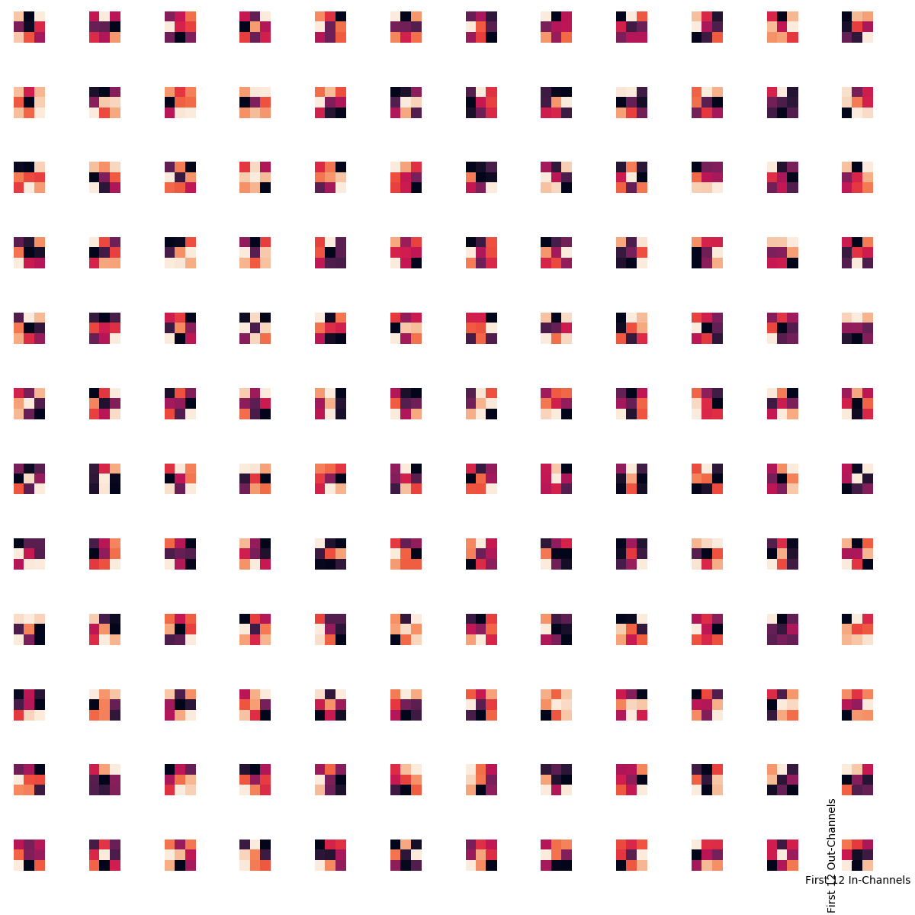

Category Kernels:

Conv2d-0



Conv2d-3



Conv2d-6



Conv2d-8



Conv2d-10

