Zhengming Wang

Part 1: Sentiment analysis on IMDB reviews

The label numbers are auto-generated and are incorrect (should be 1) , 2) , 3) not 2), 1), 3) )

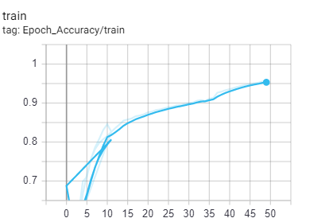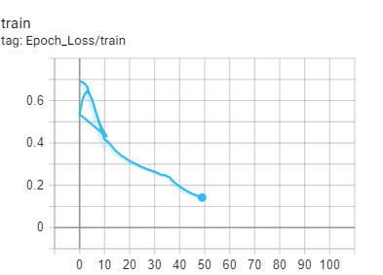GRU: Around 3it/s

) Training Loss

) Training Accuracy

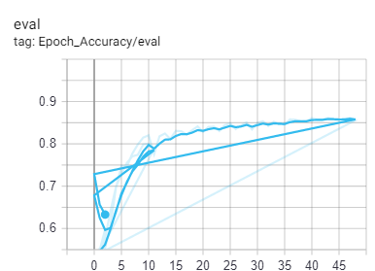

) Validation Accuracy

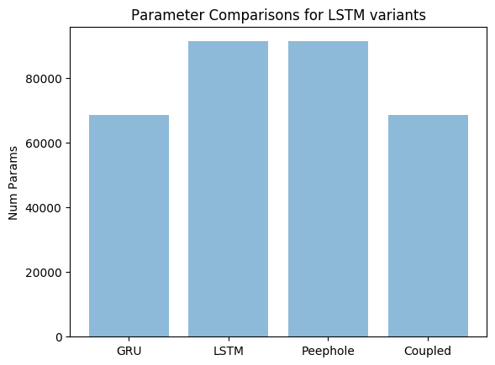Parameter Comparisons:

LSTMCell (Average 4it/s)

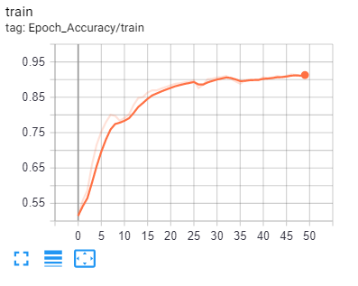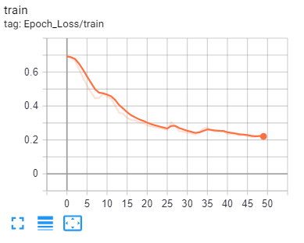

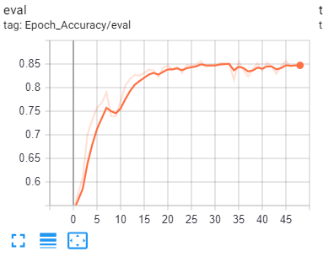

Peepholed LSTM