无线通信中的人工智能
案例实践报告
案例： 一种基于KNN的调制识别
班级： 20232111XX
学号： 2023210XXX
姓名： XXX
2025年 5 月 31 日

实验目的
本实验旨在掌握无线通信中基于机器学习的调制识别技术。具体目标包括：理解AMC（自适应调制编码）技术的工作原理，学习kNN算法在信号分类中的应用，以及通过编程实践实现BPSK、QPSK、16QAM三种调制方式的自动识别。

实验内容
本次实验围绕基于kNN的调制识别系统展开。实验要求利用高阶累积量作为信号特征，构建kNN分类器对调制信号进行识别。具体参数设置为：每组数据包含500个调制符号用于特征计算，训练集每种调制方式包含10个样本，测试集每种调制方式包含1000个测试数据，kNN的k值设为10。
实验包含两部分任务：必做部分要求完成编程实现、参数调试及性能分析；选做部分要求将特征从4阶累积量扩展到6阶累积量，对比识别效果的提升。此外还需调整参数进行对比实验，包括将每组符号数从500改为200，以及将k值改为3和50。

实验方法和算法原理

AMC技术原理
AMC（自适应调制编码）技术根据信道质量动态调整调制方式。当信噪比较高时采用高阶调制（如16QAM）以提高频谱效率，当信噪比较低时采用低阶调制（如BPSK）以保证传输可靠性。该技术通过CQI（信道质量指示）反馈机制实现，接收机将信道质量信息通过信令反馈给发射机，发射机据此选择合适的调制编码方案。

kNN算法
kNN（k-Nearest Neighbor）是一种基于实例的监督学习算法。其核心思想是：给定一个待分类样本，计算它与训练集中所有样本的距离，选取距离最近的k个样本，统计这k个样本中出现频率最高的类别作为分类结果。算法的关键参数包括特征提取方法、距离度量方式和k值选择。

高阶累积量特征
高阶累积量是描述信号统计特性的重要工具。对于零均值复随机过程，其高阶矩定义为M_pq = E[X(t)^(p-q) * X*(t)^q]，高阶累积量可由高阶矩推导得到。高阶累积量的优势在于：对于高斯分布的随机变量，其3阶及以上累积量恒为零，因此具有良好的抗噪声干扰能力。

不同调制信号的高阶累积量具有明显差异，这为调制识别提供了特征基础。实验中常用的特征包括4阶累积量（C40, C41, C42）和6阶累积量（C60, C61, C62, C63）。

实验平台
组件 | 版本 | 用途
macOS | Darwin (arm64) | 操作系统
Python | 3.12.13 | 编程语言
uv | — | 包管理与虚拟环境
matlab | 2024a | 数据生成

实验步骤
补全Matlab中关于六阶累积量的代码，随后调整参数，运行Jupyter Notebook，得到结果并整理。

实验代码
六阶累积量生成的代码
function [cumulants] = func_get_cumulants(signalData)

shape = size(signalData);
H = shape(1);
L = shape(2);
cumulants = zeros(H, L);

for row = 1:H
M20 = sum(signalData(row,:).^2)/L;
M21 = sum(abs(signalData(row,:)).^2)/L;
M40 = sum(signalData(row,:).^4)/L;
M41 = sum(abs(signalData(row,:)).^2.*signalData(row,:).^2)/L;
M42 = sum(abs(signalData(row,:)).^4)/L;

% 补充的 Mpq
M60 = sum(signalData(row,:).^6) / L; % p=6,q=0 -> X^6
M61 = sum(signalData(row,:).^4 .* abs(signalData(row,:)).^2) / L; % p=6,q=1 -> X^5 X^*
M62 = sum(signalData(row,:).^2 .* abs(signalData(row,:)).^4) / L; % p=6,q=2 -> X^4 (X^*)^2
M63 = sum(abs(signalData(row,:)).^6) / L; % p=6,q=3 -> |X|^6

M22 = sum(conj(signalData(row,:)).^2) / L; % p=2,q=2 -> (X^*)^2
M43 = sum(signalData(row,:) .* conj(signalData(row,:)).^3) / L; % p=4,q=3 -> X (X^*)^3

C20 = M20;
C21 = M21;
C40 = M40 - 3*M20^2;
C41 = M41 - 3*M20*M21;
C42 = M42 - abs(M20)^2 - 2*M21^2;
C60 = M60 - 15*M20*M40 + 30*M20^3;
C61 = M61 - 5*M21*M40 - 10*M20*M41 + 30*M21*M20^2;
C62 = M62 - 6*M20*M42 - 8*M21*M41 - M22*M40 + 6*M22*M20^2 + 24*M20*M21^2;
C63 = M63 - 9*M21*M42 + 12*M21^3 -3*M20*M43 - 3*M22*M41 + 18*M20*M21*M22;

C21_modify = C21;
C20_norm = C20/(C21_modify^2);
C21_norm = C21/(C21_modify^2);
C40_norm = C40/(C21_modify^2);
C41_norm = C41/(C21_modify^2);
C42_norm = C42/(C21_modify^2);

C60_norm = C60 / (C21_modify^3);
C61_norm = C61 / (C21_modify^3);
C62_norm = C62 / (C21_modify^3);
C63_norm = C63 / (C21_modify^3);

cumulants(row, 1) = abs(C20_norm);
cumulants(row, 2) = abs(C21_norm);
cumulants(row, 3) = abs(C40_norm);
cumulants(row, 4) = abs(C41_norm);
cumulants(row, 5) = abs(C42_norm);

cumulants(row, 6) = abs(C60_norm);
cumulants(row, 7) = abs(C61_norm);
cumulants(row, 8) = abs(C62_norm);
cumulants(row, 9) = abs(C63_norm);

end

实验结果

默认参数

相关参数
样本sample.dat 的md5：71538ce351a79374a5705b2f08ced2ac
高阶累积量 | 每组数据 | 样本集每种调制的样本数量 | 测试集每种调制的测试数据量 | KNN算法参数
4阶 | N=500 | M=10 | P=1000 | 10

运行结果
 | KNN | BPSK | QPSK | 16QAM
运行日志 |  | the total correct rate on -4 dB SNR is: 0.0  正确判断为BPSK: 0.0  判断为QPSK: 0.0  判断为16QAM: 0.0  判断为64QAM: 1000.0  the total correct rate on -2 dB SNR is: 0.0  正确判断为BPSK: 0.0  判断为QPSK: 0.0  判断为16QAM: 1.0  判断为64QAM: 999.0  the total correct rate on 0 dB SNR is: 0.0  正确判断为BPSK: 0.0  判断为QPSK: 0.0  判断为16QAM: 127.0  判断为64QAM: 873.0  the total correct rate on 2 dB SNR is: 0.0  正确判断为BPSK: 0.0  判断为QPSK: 25.0  判断为16QAM: 975.0  判断为64QAM: 0.0  the total correct rate on 4 dB SNR is: 0.0  正确判断为BPSK: 0.0  判断为QPSK: 1000.0  判断为16QAM: 0.0  判断为64QAM: 0.0  the total correct rate on 6 dB SNR is: 0.893  正确判断为BPSK: 893.0  判断为QPSK: 107.0  判断为16QAM: 0.0  判断为64QAM: 0.0  the total correct rate on 8 dB SNR is: 1.0  正确判断为BPSK: 1000.0  判断为QPSK: 0.0  判断为16QAM: 0.0  判断为64QAM: 0.0  the total correct rate on 10 dB SNR is: 1.0  正确判断为BPSK: 1000.0  判断为QPSK: 0.0  判断为16QAM: 0.0  判断为64QAM: 0.0  OrderedDict({-4: 0.0, -2: 0.0, 0: 0.0, 2: 0.0, 4: 0.0, 6: 0.893, 8: 1.0, 10: 1.0}) | the total correct rate on -4 dB SNR is: 0.0  判断为BPSK: 0.0  正确判断为QPSK: 0.0  判断为16QAM: 0.0  判断为64QAM: 1000.0  the total correct rate on -2 dB SNR is: 0.0  判断为BPSK: 0.0  正确判断为QPSK: 0.0  判断为16QAM: 0.0  判断为64QAM: 1000.0  the total correct rate on 0 dB SNR is: 0.0  判断为BPSK: 0.0  正确判断为QPSK: 0.0  判断为16QAM: 0.0  判断为64QAM: 1000.0  the total correct rate on 2 dB SNR is: 0.0  判断为BPSK: 0.0  正确判断为QPSK: 0.0  判断为16QAM: 0.0  判断为64QAM: 1000.0  the total correct rate on 4 dB SNR is: 0.0  判断为BPSK: 0.0  正确判断为QPSK: 0.0  判断为16QAM: 4.0  判断为64QAM: 996.0  the total correct rate on 6 dB SNR is: 0.0  判断为BPSK: 0.0  正确判断为QPSK: 0.0  判断为16QAM: 879.0  判断为64QAM: 121.0  the total correct rate on 8 dB SNR is: 0.0  判断为BPSK: 0.0  正确判断为QPSK: 0.0  判断为16QAM: 1000.0  判断为64QAM: 0.0  the total correct rate on 10 dB SNR is: 0.441  判断为BPSK: 0.0  正确判断为QPSK: 441.0  判断为16QAM: 559.0  判断为64QAM: 0.0  OrderedDict({-4: 0.0, -2: 0.0, 0: 0.0, 2: 0.0, 4: 0.0, 6: 0.0, 8: 0.0, 10: 0.441}) | the total correct rate on 0 dB SNR is: 0.0  判断为BPSK: 0.0  判断为QPSK: 0.0  正确判断为16QAM: 0.0  判断为64QAM: 1000.0  the total correct rate on 5 dB SNR is: 0.0  判断为BPSK: 0.0  判断为QPSK: 0.0  正确判断为16QAM: 0.0  判断为64QAM: 1000.0  the total correct rate on 10 dB SNR is: 0.01  判断为BPSK: 0.0  判断为QPSK: 0.0  正确判断为16QAM: 10.0  判断为64QAM: 990.0  the total correct rate on 15 dB SNR is: 0.693  判断为BPSK: 0.0  判断为QPSK: 0.0  正确判断为16QAM: 693.0  判断为64QAM: 307.0  the total correct rate on 20 dB SNR is: 0.957  判断为BPSK: 0.0  判断为QPSK: 0.0  正确判断为16QAM: 957.0  判断为64QAM: 43.0  the total correct rate on 25 dB SNR is: 0.99  判断为BPSK: 0.0  判断为QPSK: 0.0  正确判断为16QAM: 990.0  判断为64QAM: 10.0  the total correct rate on 30 dB SNR is: 0.995  判断为BPSK: 0.0  判断为QPSK: 0.0  正确判断为16QAM: 995.0  判断为64QAM: 5.0  the total correct rate on 35 dB SNR is: 0.995  判断为BPSK: 0.0  判断为QPSK: 0.0  正确判断为16QAM: 995.0  判断为64QAM: 5.0  the total correct rate on 40 dB SNR is: 0.992  判断为BPSK: 0.0  判断为QPSK: 0.0  正确判断为16QAM: 992.0  判断为64QAM: 8.0  OrderedDict({0: 0.0, 5: 0.0, 10: 0.01, 15: 0.693, 20: 0.957, 25: 0.99, 30: 0.995, 35: 0.995, 40: 0.992})
结果截图 | 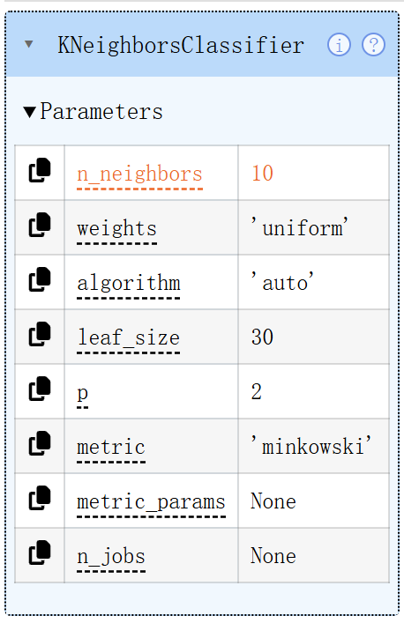 | 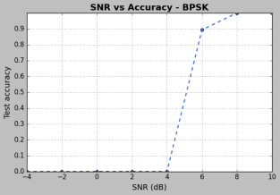 | 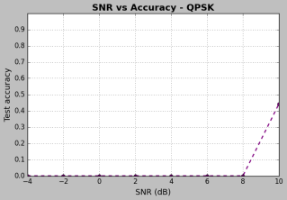 | 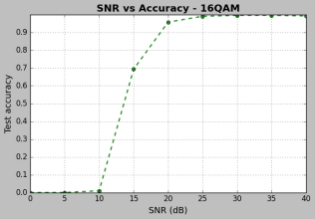

参数N=200

相关参数
样本sample.dat 的md5：9abcaa4aa12b35f0beb16cea9fcb9b4b
高阶累积量 | 每组数据 | 样本集每种调制的样本数量 | 测试集每种调制的测试数据量 | KNN算法参数
4阶 | N=200 | M=10 | P=1000 | 10

运行结果
 | KNN | BPSK | QPSK | 16QAM
运行日志 |  | the total correct rate on -4 dB SNR is: 0.0  正确判断为BPSK: 0.0  判断为QPSK: 0.0  判断为16QAM: 74.0  判断为64QAM: 926.0  the total correct rate on -2 dB SNR is: 0.0  正确判断为BPSK: 0.0  判断为QPSK: 0.0  判断为16QAM: 105.0  判断为64QAM: 895.0  the total correct rate on 0 dB SNR is: 0.0  正确判断为BPSK: 0.0  判断为QPSK: 0.0  判断为16QAM: 339.0  判断为64QAM: 661.0  the total correct rate on 2 dB SNR is: 0.0  正确判断为BPSK: 0.0  判断为QPSK: 179.0  判断为16QAM: 722.0  判断为64QAM: 99.0  the total correct rate on 4 dB SNR is: 0.0  正确判断为BPSK: 0.0  判断为QPSK: 996.0  判断为16QAM: 4.0  判断为64QAM: 0.0  the total correct rate on 6 dB SNR is: 0.765  正确判断为BPSK: 765.0  判断为QPSK: 235.0  判断为16QAM: 0.0  判断为64QAM: 0.0  the total correct rate on 8 dB SNR is: 1.0  正确判断为BPSK: 1000.0  判断为QPSK: 0.0  判断为16QAM: 0.0  判断为64QAM: 0.0  the total correct rate on 10 dB SNR is: 1.0  正确判断为BPSK: 1000.0  判断为QPSK: 0.0  判断为16QAM: 0.0  判断为64QAM: 0.0  OrderedDict({-4: 0.0, -2: 0.0, 0: 0.0, 2: 0.0, 4: 0.0, 6: 0.765, 8: 1.0, 10: 1.0}) | the total correct rate on -4 dB SNR is: 0.0  判断为BPSK: 0.0  正确判断为QPSK: 0.0  判断为16QAM: 24.0  判断为64QAM: 976.0  the total correct rate on -2 dB SNR is: 0.0  判断为BPSK: 0.0  正确判断为QPSK: 0.0  判断为16QAM: 12.0  判断为64QAM: 988.0  the total correct rate on 0 dB SNR is: 0.0  判断为BPSK: 0.0  正确判断为QPSK: 0.0  判断为16QAM: 21.0  判断为64QAM: 979.0  the total correct rate on 2 dB SNR is: 0.0  判断为BPSK: 0.0  正确判断为QPSK: 0.0  判断为16QAM: 58.0  判断为64QAM: 942.0  the total correct rate on 4 dB SNR is: 0.0  判断为BPSK: 0.0  正确判断为QPSK: 0.0  判断为16QAM: 348.0  判断为64QAM: 652.0  the total correct rate on 6 dB SNR is: 0.0  判断为BPSK: 0.0  正确判断为QPSK: 0.0  判断为16QAM: 906.0  判断为64QAM: 94.0  the total correct rate on 8 dB SNR is: 0.0  判断为BPSK: 0.0  正确判断为QPSK: 0.0  判断为16QAM: 1000.0  判断为64QAM: 0.0  the total correct rate on 10 dB SNR is: 0.338  判断为BPSK: 0.0  正确判断为QPSK: 338.0  判断为16QAM: 662.0  判断为64QAM: 0.0  OrderedDict({-4: 0.0, -2: 0.0, 0: 0.0, 2: 0.0, 4: 0.0, 6: 0.0, 8: 0.0, 10: 0.338}) | the total correct rate on 0 dB SNR is: 0.004  判断为BPSK: 0.0  判断为QPSK: 0.0  正确判断为16QAM: 4.0  判断为64QAM: 996.0  the total correct rate on 5 dB SNR is: 0.011  判断为BPSK: 0.0  判断为QPSK: 0.0  正确判断为16QAM: 11.0  判断为64QAM: 989.0  the total correct rate on 10 dB SNR is: 0.242  判断为BPSK: 0.0  判断为QPSK: 0.0  正确判断为16QAM: 242.0  判断为64QAM: 758.0  the total correct rate on 15 dB SNR is: 0.649  判断为BPSK: 0.0  判断为QPSK: 0.0  正确判断为16QAM: 649.0  判断为64QAM: 351.0  the total correct rate on 20 dB SNR is: 0.764  判断为BPSK: 0.0  判断为QPSK: 0.0  正确判断为16QAM: 764.0  判断为64QAM: 236.0  the total correct rate on 25 dB SNR is: 0.832  判断为BPSK: 0.0  判断为QPSK: 0.0  正确判断为16QAM: 832.0  判断为64QAM: 168.0  the total correct rate on 30 dB SNR is: 0.829  判断为BPSK: 0.0  判断为QPSK: 0.0  正确判断为16QAM: 829.0  判断为64QAM: 171.0  the total correct rate on 35 dB SNR is: 0.833  判断为BPSK: 0.0  判断为QPSK: 0.0  正确判断为16QAM: 833.0  判断为64QAM: 167.0  the total correct rate on 40 dB SNR is: 0.85  判断为BPSK: 0.0  判断为QPSK: 0.0  正确判断为16QAM: 850.0  判断为64QAM: 150.0  OrderedDict({0: 0.004, 5: 0.011, 10: 0.242, 15: 0.649, 20: 0.764, 25: 0.832, 30: 0.829, 35: 0.833, 40: 0.85})
结果截图 |  | 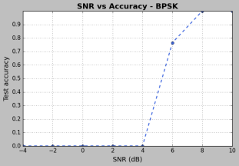 | 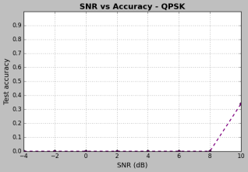 | 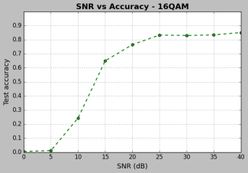

变换K参数

K=3
样本sample.dat 的md5：71538ce351a79374a5705b2f08ced2ac
高阶累积量 | 每组数据 | 样本集每种调制的样本数量 | 测试集每种调制的测试数据量 | KNN算法参数
4阶 | N=500 | M=10 | P=1000 | 3

运行结果
 | KNN | BPSK | QPSK | 16QAM
运行日志 |  | the total correct rate on -4 dB SNR is: 0.0  正确判断为BPSK: 0.0  判断为QPSK: 0.0  判断为16QAM: 0.0  判断为64QAM: 1000.0  the total correct rate on -2 dB SNR is: 0.0  正确判断为BPSK: 0.0  判断为QPSK: 0.0  判断为16QAM: 0.0  判断为64QAM: 1000.0  the total correct rate on 0 dB SNR is: 0.0  正确判断为BPSK: 0.0  判断为QPSK: 0.0  判断为16QAM: 2.0  判断为64QAM: 998.0  the total correct rate on 2 dB SNR is: 0.0  正确判断为BPSK: 0.0  判断为QPSK: 168.0  判断为16QAM: 826.0  判断为64QAM: 6.0  the total correct rate on 4 dB SNR is: 0.0  正确判断为BPSK: 0.0  判断为QPSK: 1000.0  判断为16QAM: 0.0  判断为64QAM: 0.0  the total correct rate on 6 dB SNR is: 0.734  正确判断为BPSK: 734.0  判断为QPSK: 266.0  判断为16QAM: 0.0  判断为64QAM: 0.0  the total correct rate on 8 dB SNR is: 1.0  正确判断为BPSK: 1000.0  判断为QPSK: 0.0  判断为16QAM: 0.0  判断为64QAM: 0.0  the total correct rate on 10 dB SNR is: 1.0  正确判断为BPSK: 1000.0  判断为QPSK: 0.0  判断为16QAM: 0.0  判断为64QAM: 0.0  OrderedDict({-4: 0.0, -2: 0.0, 0: 0.0, 2: 0.0, 4: 0.0, 6: 0.734, 8: 1.0, 10: 1.0}) | the total correct rate on -4 dB SNR is: 0.0  判断为BPSK: 0.0  正确判断为QPSK: 0.0  判断为16QAM: 0.0  判断为64QAM: 1000.0  the total correct rate on -2 dB SNR is: 0.0  判断为BPSK: 0.0  正确判断为QPSK: 0.0  判断为16QAM: 0.0  判断为64QAM: 1000.0  the total correct rate on 0 dB SNR is: 0.0  判断为BPSK: 0.0  正确判断为QPSK: 0.0  判断为16QAM: 0.0  判断为64QAM: 1000.0  the total correct rate on 2 dB SNR is: 0.0  判断为BPSK: 0.0  正确判断为QPSK: 0.0  判断为16QAM: 0.0  判断为64QAM: 1000.0  the total correct rate on 4 dB SNR is: 0.0  判断为BPSK: 0.0  正确判断为QPSK: 0.0  判断为16QAM: 0.0  判断为64QAM: 1000.0  the total correct rate on 6 dB SNR is: 0.0  判断为BPSK: 0.0  正确判断为QPSK: 0.0  判断为16QAM: 44.0  判断为64QAM: 956.0  the total correct rate on 8 dB SNR is: 0.0  判断为BPSK: 0.0  正确判断为QPSK: 0.0  判断为16QAM: 998.0  判断为64QAM: 2.0  the total correct rate on 10 dB SNR is: 0.102  判断为BPSK: 0.0  正确判断为QPSK: 102.0  判断为16QAM: 898.0  判断为64QAM: 0.0  OrderedDict({-4: 0.0, -2: 0.0, 0: 0.0, 2: 0.0, 4: 0.0, 6: 0.0, 8: 0.0, 10: 0.102}) | the total correct rate on 0 dB SNR is: 0.0  判断为BPSK: 0.0  判断为QPSK: 0.0  正确判断为16QAM: 0.0  判断为64QAM: 1000.0  the total correct rate on 5 dB SNR is: 0.0  判断为BPSK: 0.0  判断为QPSK: 0.0  正确判断为16QAM: 0.0  判断为64QAM: 1000.0  the total correct rate on 10 dB SNR is: 0.0  判断为BPSK: 0.0  判断为QPSK: 0.0  正确判断为16QAM: 0.0  判断为64QAM: 1000.0  the total correct rate on 15 dB SNR is: 0.134  判断为BPSK: 0.0  判断为QPSK: 0.0  正确判断为16QAM: 134.0  判断为64QAM: 866.0  the total correct rate on 20 dB SNR is: 0.757  判断为BPSK: 0.0  判断为QPSK: 0.0  正确判断为16QAM: 757.0  判断为64QAM: 243.0  the total correct rate on 25 dB SNR is: 0.902  判断为BPSK: 0.0  判断为QPSK: 0.0  正确判断为16QAM: 902.0  判断为64QAM: 98.0  the total correct rate on 30 dB SNR is: 0.943  判断为BPSK: 0.0  判断为QPSK: 0.0  正确判断为16QAM: 943.0  判断为64QAM: 57.0  the total correct rate on 35 dB SNR is: 0.957  判断为BPSK: 0.0  判断为QPSK: 0.0  正确判断为16QAM: 957.0  判断为64QAM: 43.0  the total correct rate on 40 dB SNR is: 0.959  判断为BPSK: 0.0  判断为QPSK: 0.0  正确判断为16QAM: 959.0  判断为64QAM: 41.0  OrderedDict({0: 0.0, 5: 0.0, 10: 0.0, 15: 0.134, 20: 0.757, 25: 0.902, 30: 0.943, 35: 0.957, 40: 0.959})
结果截图 | 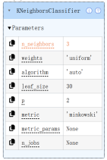 | 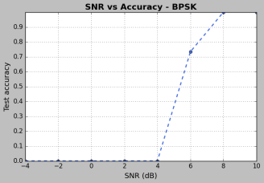 | 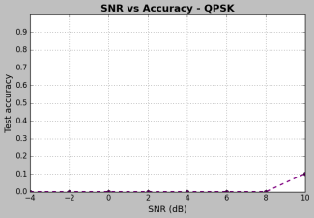 | 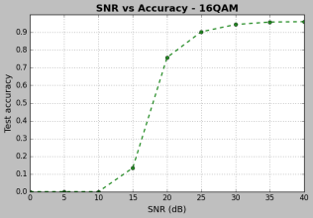

K=35
样本sample.dat 的md5：71538ce351a79374a5705b2f08ced2ac
高阶累积量 | 每组数据 | 样本集每种调制的样本数量 | 测试集每种调制的测试数据量 | KNN算法参数
4阶 | N=500 | M=10 | P=1000 | 35

运行结果
 | KNN | BPSK | QPSK | 16QAM
运行日志 |  | the total correct rate on -4 dB SNR is: 0.0  正确判断为BPSK: 0.0  判断为QPSK: 1000.0  判断为16QAM: 0.0  判断为64QAM: 0.0  the total correct rate on -2 dB SNR is: 0.0  正确判断为BPSK: 0.0  判断为QPSK: 1000.0  判断为16QAM: 0.0  判断为64QAM: 0.0  the total correct rate on 0 dB SNR is: 0.0  正确判断为BPSK: 0.0  判断为QPSK: 1000.0  判断为16QAM: 0.0  判断为64QAM: 0.0  the total correct rate on 2 dB SNR is: 0.0  正确判断为BPSK: 0.0  判断为QPSK: 1000.0  判断为16QAM: 0.0  判断为64QAM: 0.0  the total correct rate on 4 dB SNR is: 0.0  正确判断为BPSK: 0.0  判断为QPSK: 1000.0  判断为16QAM: 0.0  判断为64QAM: 0.0  the total correct rate on 6 dB SNR is: 0.999  正确判断为BPSK: 999.0  判断为QPSK: 1.0  判断为16QAM: 0.0  判断为64QAM: 0.0  the total correct rate on 8 dB SNR is: 1.0  正确判断为BPSK: 1000.0  判断为QPSK: 0.0  判断为16QAM: 0.0  判断为64QAM: 0.0  the total correct rate on 10 dB SNR is: 1.0  正确判断为BPSK: 1000.0  判断为QPSK: 0.0  判断为16QAM: 0.0  判断为64QAM: 0.0  OrderedDict({-4: 0.0, -2: 0.0, 0: 0.0, 2: 0.0, 4: 0.0, 6: 0.999, 8: 1.0, 10: 1.0}) | the total correct rate on -4 dB SNR is: 1.0  判断为BPSK: 0.0  正确判断为QPSK: 1000.0  判断为16QAM: 0.0  判断为64QAM: 0.0  the total correct rate on -2 dB SNR is: 1.0  判断为BPSK: 0.0  正确判断为QPSK: 1000.0  判断为16QAM: 0.0  判断为64QAM: 0.0  the total correct rate on 0 dB SNR is: 1.0  判断为BPSK: 0.0  正确判断为QPSK: 1000.0  判断为16QAM: 0.0  判断为64QAM: 0.0  the total correct rate on 2 dB SNR is: 1.0  判断为BPSK: 0.0  正确判断为QPSK: 1000.0  判断为16QAM: 0.0  判断为64QAM: 0.0  the total correct rate on 4 dB SNR is: 1.0  判断为BPSK: 0.0  正确判断为QPSK: 1000.0  判断为16QAM: 0.0  判断为64QAM: 0.0  the total correct rate on 6 dB SNR is: 1.0  判断为BPSK: 0.0  正确判断为QPSK: 1000.0  判断为16QAM: 0.0  判断为64QAM: 0.0  the total correct rate on 8 dB SNR is: 1.0  判断为BPSK: 0.0  正确判断为QPSK: 1000.0  判断为16QAM: 0.0  判断为64QAM: 0.0  the total correct rate on 10 dB SNR is: 1.0  判断为BPSK: 0.0  正确判断为QPSK: 1000.0  判断为16QAM: 0.0  判断为64QAM: 0.0  OrderedDict({-4: 1.0, -2: 1.0, 0: 1.0, 2: 1.0, 4: 1.0, 6: 1.0, 8: 1.0, 10: 1.0}) | the total correct rate on 0 dB SNR is: 0.0  判断为BPSK: 0.0  判断为QPSK: 1000.0  正确判断为16QAM: 0.0  判断为64QAM: 0.0  the total correct rate on 5 dB SNR is: 0.0  判断为BPSK: 0.0  判断为QPSK: 1000.0  正确判断为16QAM: 0.0  判断为64QAM: 0.0  the total correct rate on 10 dB SNR is: 0.0  判断为BPSK: 0.0  判断为QPSK: 1000.0  正确判断为16QAM: 0.0  判断为64QAM: 0.0  the total correct rate on 15 dB SNR is: 0.0  判断为BPSK: 0.0  判断为QPSK: 1000.0  正确判断为16QAM: 0.0  判断为64QAM: 0.0  the total correct rate on 20 dB SNR is: 0.0  判断为BPSK: 0.0  判断为QPSK: 1000.0  正确判断为16QAM: 0.0  判断为64QAM: 0.0  the total correct rate on 25 dB SNR is: 0.0  判断为BPSK: 0.0  判断为QPSK: 1000.0  正确判断为16QAM: 0.0  判断为64QAM: 0.0  the total correct rate on 30 dB SNR is: 0.0  判断为BPSK: 0.0  判断为QPSK: 1000.0  正确判断为16QAM: 0.0  判断为64QAM: 0.0  the total correct rate on 35 dB SNR is: 0.0  判断为BPSK: 0.0  判断为QPSK: 1000.0  正确判断为16QAM: 0.0  判断为64QAM: 0.0  the total correct rate on 40 dB SNR is: 0.0  判断为BPSK: 0.0  判断为QPSK: 1000.0  正确判断为16QAM: 0.0  判断为64QAM: 0.0  OrderedDict({0: 0.0, 5: 0.0, 10: 0.0, 15: 0.0, 20: 0.0, 25: 0.0, 30: 0.0, 35: 0.0, 40: 0.0})
结果截图 | 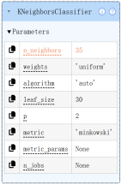 | 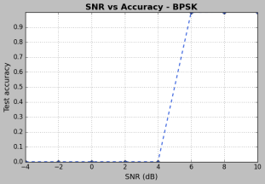 | 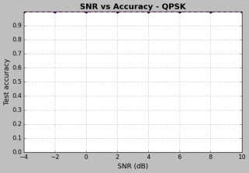 | 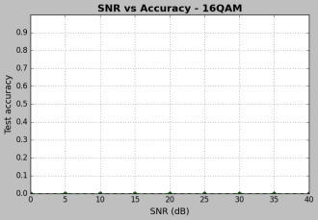

六阶-默认参数

相关参数
样本sample.dat 的md5：e6df415936d34f291f5161f737ce2ad5
高阶累积量 | 每组数据 | 样本集每种调制的样本数量 | 测试集每种调制的测试数据量 | KNN算法参数
6阶 | N=500 | M=10 | P=1000 | 10

运行结果
 | KNN | BPSK | QPSK | 16QAM
运行日志 |  | the total correct rate on -4 dB SNR is: 0.0  正确判断为BPSK: 0.0  判断为QPSK: 0.0  判断为16QAM: 5.0  判断为64QAM: 995.0  the total correct rate on -2 dB SNR is: 0.0  正确判断为BPSK: 0.0  判断为QPSK: 0.0  判断为16QAM: 86.0  判断为64QAM: 914.0  the total correct rate on 0 dB SNR is: 0.0  正确判断为BPSK: 0.0  判断为QPSK: 1.0  判断为16QAM: 961.0  判断为64QAM: 38.0  the total correct rate on 2 dB SNR is: 0.0  正确判断为BPSK: 0.0  判断为QPSK: 964.0  判断为16QAM: 36.0  判断为64QAM: 0.0  the total correct rate on 4 dB SNR is: 0.0  正确判断为BPSK: 0.0  判断为QPSK: 1000.0  判断为16QAM: 0.0  判断为64QAM: 0.0  the total correct rate on 6 dB SNR is: 0.005  正确判断为BPSK: 5.0  判断为QPSK: 995.0  判断为16QAM: 0.0  判断为64QAM: 0.0  the total correct rate on 8 dB SNR is: 1.0  正确判断为BPSK: 1000.0  判断为QPSK: 0.0  判断为16QAM: 0.0  判断为64QAM: 0.0  the total correct rate on 10 dB SNR is: 1.0  正确判断为BPSK: 1000.0  判断为QPSK: 0.0  判断为16QAM: 0.0  判断为64QAM: 0.0  OrderedDict({-4: 0.0, -2: 0.0, 0: 0.0, 2: 0.0, 4: 0.0, 6: 0.005, 8: 1.0, 10: 1.0}) | the total correct rate on -4 dB SNR is: 0.0  判断为BPSK: 0.0  正确判断为QPSK: 0.0  判断为16QAM: 2.0  判断为64QAM: 998.0  the total correct rate on -2 dB SNR is: 0.0  判断为BPSK: 0.0  正确判断为QPSK: 0.0  判断为16QAM: 2.0  判断为64QAM: 998.0  the total correct rate on 0 dB SNR is: 0.0  判断为BPSK: 0.0  正确判断为QPSK: 0.0  判断为16QAM: 1.0  判断为64QAM: 999.0  the total correct rate on 2 dB SNR is: 0.0  判断为BPSK: 0.0  正确判断为QPSK: 0.0  判断为16QAM: 0.0  判断为64QAM: 1000.0  the total correct rate on 4 dB SNR is: 0.0  判断为BPSK: 0.0  正确判断为QPSK: 0.0  判断为16QAM: 4.0  判断为64QAM: 996.0  the total correct rate on 6 dB SNR is: 0.0  判断为BPSK: 0.0  正确判断为QPSK: 0.0  判断为16QAM: 945.0  判断为64QAM: 55.0  the total correct rate on 8 dB SNR is: 0.0  判断为BPSK: 0.0  正确判断为QPSK: 0.0  判断为16QAM: 1000.0  判断为64QAM: 0.0  the total correct rate on 10 dB SNR is: 0.47  判断为BPSK: 0.0  正确判断为QPSK: 470.0  判断为16QAM: 530.0  判断为64QAM: 0.0  OrderedDict({-4: 0.0, -2: 0.0, 0: 0.0, 2: 0.0, 4: 0.0, 6: 0.0, 8: 0.0, 10: 0.47}) | the total correct rate on 0 dB SNR is: 0.0  判断为BPSK: 0.0  判断为QPSK: 0.0  正确判断为16QAM: 0.0  判断为64QAM: 1000.0  the total correct rate on 5 dB SNR is: 0.0  判断为BPSK: 0.0  判断为QPSK: 0.0  正确判断为16QAM: 0.0  判断为64QAM: 1000.0  the total correct rate on 10 dB SNR is: 0.014  判断为BPSK: 0.0  判断为QPSK: 0.0  正确判断为16QAM: 14.0  判断为64QAM: 986.0  the total correct rate on 15 dB SNR is: 0.563  判断为BPSK: 0.0  判断为QPSK: 0.0  正确判断为16QAM: 563.0  判断为64QAM: 437.0  the total correct rate on 20 dB SNR is: 0.891  判断为BPSK: 0.0  判断为QPSK: 0.0  正确判断为16QAM: 891.0  判断为64QAM: 109.0  the total correct rate on 25 dB SNR is: 0.956  判断为BPSK: 0.0  判断为QPSK: 0.0  正确判断为16QAM: 956.0  判断为64QAM: 44.0  the total correct rate on 30 dB SNR is: 0.965  判断为BPSK: 0.0  判断为QPSK: 0.0  正确判断为16QAM: 965.0  判断为64QAM: 35.0  the total correct rate on 35 dB SNR is: 0.968  判断为BPSK: 0.0  判断为QPSK: 0.0  正确判断为16QAM: 968.0  判断为64QAM: 32.0  the total correct rate on 40 dB SNR is: 0.975  判断为BPSK: 0.0  判断为QPSK: 0.0  正确判断为16QAM: 975.0  判断为64QAM: 25.0  OrderedDict({0: 0.0, 5: 0.0, 10: 0.014, 15: 0.563, 20: 0.891, 25: 0.956, 30: 0.965, 35: 0.968, 40: 0.975})
结果截图 |  | 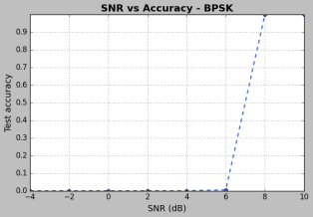 | 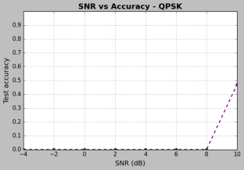 | 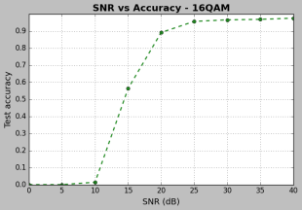

实验总结

四阶结果分析
在四阶累积量下有如下现象
- BPSK在SNR为8dB附近时正确率就可以达到1；QPSK在SNR>10dB时正确率才能达到1；16QAM一般在30dB之后准确率才能达到1
- N=200和N=500时对结果影响不明显
- K=3时，准确率无明显差异；K=35时，高阶调制的准确率明显下降
由上面的内容可以总结出下面几点
- 调制阶数越高，正确率达到1需要的SNR越大
- 偏小的K在训练的时候倾向于过拟合（在N=200和N=500时以及K=3和K=10时差距不明显是因为出现了过拟合），偏大的K在训练的时候偏向于欠拟合（K=35时不能很好的区分）
六阶累积量下有下面的结论
在信噪比比较差的情况下有明显的提升，使用更高阶的累积量意味着更多的参考特征，使得KNN性能有所提升。
改进方向包括：尝试SVM、深度学习等其他分类算法；探索时域、频谱等更多类型的特征；研究多径衰落等复杂信道条件下的识别问题；优化kNN的搜索效率以适应实时应用需求。

