Міністерство освіти і науки України

Національний університет «Львівська політехніка»

Кафедра ЕОМ



Звіт

до лабораторної роботи № 3

з дисципліни «Моделювання комп’ютерних систем»

на тему:

«Поведінковий опис цифрового автомата Перевірка роботи автомата за допомогою стенда Elbert V2 – Spartan 3A FPGA»

**Варіант №3**

Виконав:

ст. гр. КІ-201

Бовтач П.В

Прийняв:

ст. викладач   
каф. ЕОМ  
Козак Н. Б.

Львів 2024

**Мета роботи**: На базі стенда реалізувати цифровий автомат для обчислення значення виразів.

**Виконання роботи:**

*Рис. 1 – Top Level*

|  |
| --- |
| Файл ACC.vhd   1. LIBRARY ieee; 2. USE ieee.std_logic_1164.ALL; 4. -- Uncomment the following library declaration if using 5. -- arithmetic functions with Signed or Unsigned values 6. --USE ieee.numeric_std.ALL; 8. ENTITY ACCTest IS 9. END ACCTest; 11. ARCHITECTURE behavior OF ACCTest IS 13. -- Component Declaration for the Unit Under Test (UUT) 15. COMPONENT ACC 16. PORT( 17. WR : IN std_logic; 18. RESET : IN std_logic; 19. CLK : IN std_logic; 20. INPUT : IN std_logic_vector(7 downto 0); 21. OUTPUT : OUT std_logic_vector(7 downto 0) 22. ); 23. END COMPONENT;  26. --Inputs 27. signal WR : std_logic := '0'; 28. signal RESET : std_logic := '0'; 29. signal CLK : std_logic := '0'; 30. signal INPUT : std_logic_vector(7 downto 0) := (others => '0'); 32. --Outputs 33. signal OUTPUT : std_logic_vector(7 downto 0); 35. -- Clock period definitions 36. constant CLKP: time := 2 ps; 38. BEGIN 40. -- Instantiate the Unit Under Test (UUT) 41. uut: ACC PORT MAP ( 42. WR => WR, 43. RESET => RESET, 44. CLK => CLK, 45. INPUT => INPUT, 46. OUTPUT => OUTPUT 47. ); 49. -- Clock process definitions 50. CLK_process :process 51. begin 52. CLK <= '0'; 53. wait for CLKP/2; 54. CLK <= '1'; 55. wait for CLKP/2; 56. end process;  59. -- Stimulus process 60. stim_proc: process 61. begin 62. RESET <= '1'; 63. wait for 4 * CLKP; 64. RESET <= '0'; 65. WR <= '0'; 66. INPUT <= "00001111"; 67. wait for CLKP; 68. assert OUTPUT = "00000000" severity failure; 69. WR <= '1'; 70. wait for CLKP; 71. assert OUTPUT = "00001111" severity failure; 72. INPUT <= "11110000"; 73. wait for CLKP; 74. assert OUTPUT = "11110000" severity failure; 76. wait; 77. end process; 79. END; |

|  |
| --- |
| Файл ALU.vhd   1. library IEEE; 2. use IEEE.STD_LOGIC_1164.ALL; 4. -- Uncomment the following library declaration if using 5. -- arithmetic functions with Signed or Unsigned values 6. use IEEE.NUMERIC_STD.ALL; 7. use IEEE.STD_LOGIC_UNSIGNED.ALL; 9. -- Uncomment the following library declaration if instantiating 10. -- any Xilinx primitives in this code. 11. --library UNISIM; 12. --use UNISIM.VComponents.all; 14. entity ALU is 15. Port ( A : in STD_LOGIC_VECTOR(7 downto 0); 16. B : in STD_LOGIC_VECTOR(7 downto 0); 17. OP : in STD_LOGIC_VECTOR(1 downto 0); 18. OUTPUT : out STD_LOGIC_VECTOR(7 downto 0); 19. OVERFLOW: out STD_LOGIC); 20. end ALU;  23. architecture ALU_Behavioral of ALU is 24. signal ALUR: STD_LOGIC_VECTOR(15 downto 0) := (others => '0'); 25. signal Carry: STD_LOGIC := '0'; 26. begin 27. process(A, B, OP) 28. begin 29. case (OP) is 30. when "01" => ALUR <= ("00000000" & A) + ("00000000" & B); 31. when "10" => ALUR <= ("00000000" & A) + ("11111111" & not B) + "0000000000000001"; 32. when "11" => ALUR <= ("00000000" & A) and ("00000000" & B); 33. when others => ALUR <= ("00000000" & B); 34. end case; 35. end process; 36. OUTPUT <= ALUR(7 downto 0); 37. OVERFLOW <= ALUR(8) OR ALUR(9) OR ALUR(10) OR ALUR(11) OR ALUR(12) OR ALUR(13) OR ALUR(14) OR ALUR(15); 38. end ALU_Behavioral; |

|  |
| --- |
| Файл CPU.vhd   1. library IEEE; 2. use IEEE.STD_LOGIC_1164.ALL;  5. entity CPU is 6. port( ENTER_OP1 : IN STD_LOGIC; 7. ENTER_OP2 : IN STD_LOGIC; 8. CALCULATE : IN STD_LOGIC; 9. RESET : IN STD_LOGIC; 10. CLOCK : IN STD_LOGIC; 11. RAM_WR : OUT STD_LOGIC; 12. RAM_ADDR : OUT STD_LOGIC_VECTOR(1 DOWNTO 0); 13. CONST : OUT STD_LOGIC_VECTOR(7 DOWNTO 0); 14. ACC_WR : OUT STD_LOGIC; 15. ACC_RST : OUT STD_LOGIC; 16. IN_SEL : OUT STD_LOGIC_VECTOR(1 downto 0); 17. OP : OUT STD_LOGIC_VECTOR(1 DOWNTO 0)); 18. end CPU; 20. architecture CPU_arch of CPU is 22. type STATE_TYPE is (RST, IDLE, LOAD_OP1, LOAD_OP2, RUN_CALC0, RUN_CALC1, RUN_CALC2, RUN_CALC3, RUN_CALC4, FINISH); 23. signal CUR_STATE : STATE_TYPE; 24. signal NEXT_STATE : STATE_TYPE; 26. begin 27. SYNC_PROC: process (CLOCK) 28. begin 29. if (rising_edge(CLOCK)) then 30. if (RESET = '1') then 31. CUR_STATE <= RST; 32. else 33. CUR_STATE <= NEXT_STATE; 34. end if; 35. end if; 36. end process;  39. NEXT_STATE_DECODE: process (CLOCK, ENTER_OP1, ENTER_OP2, CALCULATE) 40. begin 41. NEXT_STATE <= CUR_STATE; 43. case(CUR_STATE) is 44. when RST => 45. NEXT_STATE <= IDLE; 46. when IDLE => 47. if (ENTER_OP1 = '1') then 48. NEXT_STATE <= LOAD_OP1; 49. elsif (ENTER_OP2 = '1') then 50. NEXT_STATE <= LOAD_OP2; 51. elsif (CALCULATE = '1') then 52. NEXT_STATE <= RUN_CALC0; 53. else 54. NEXT_STATE <= IDLE; 55. end if; 56. when LOAD_OP1 => 57. NEXT_STATE <= IDLE; 58. when LOAD_OP2 => 59. NEXT_STATE <= IDLE; 60. when RUN_CALC0 => 61. NEXT_STATE <= RUN_CALC1; 62. when RUN_CALC1 => 63. NEXT_STATE <= RUN_CALC2; 64. when RUN_CALC2 => 65. NEXT_STATE <= RUN_CALC3; 66. when RUN_CALC3 => 67. NEXT_STATE <= RUN_CALC4; 68. when RUN_CALC4 => 69. NEXT_STATE <= FINISH; 70. when FINISH => 71. NEXT_STATE <= FINISH; 72. when others => 73. NEXT_STATE <= IDLE; 74. end case; 75. end process; 77. OUTPUT_DECODE: process (CUR_STATE) 78. begin 79. case (CUR_STATE) is 80. when RST => 81. RAM_WR <= '0'; 82. RAM_ADDR <= "00"; 83. CONST <= "00000000"; 84. ACC_WR <= '0'; 85. ACC_RST <= '1'; 86. IN_SEL <= "00"; 87. OP <= "00"; 88. when LOAD_OP1 => 89. RAM_WR <= '1'; 90. RAM_ADDR <= "00"; 91. CONST <= "00000000"; 92. ACC_WR <= '0'; 93. ACC_RST <= '1'; 94. IN_SEL <= "00"; 95. OP <= "00"; 96. when LOAD_OP2 => 97. RAM_WR <= '1'; 98. RAM_ADDR <= "01"; 99. CONST <= "00000000"; 100. ACC_WR <= '0'; 101. ACC_RST <= '1'; 102. IN_SEL <= "00"; 103. OP <= "00"; 104. when RUN_CALC0 => 105. RAM_WR <= '0'; 106. RAM_ADDR <= "01"; 107. CONST <= "00000000"; 108. ACC_WR <= '1'; 109. ACC_RST <= '0'; 110. IN_SEL <= "01"; 111. OP <= "00"; 112. when RUN_CALC1 => 113. RAM_WR <= '0'; 114. RAM_ADDR <= "00"; 115. CONST <= "00000101"; 116. ACC_WR <= '1'; 117. ACC_RST <= '0'; 118. IN_SEL <= "10"; 119. OP <= "11"; 120. when RUN_CALC2 => 121. RAM_WR <= '0'; 122. RAM_ADDR <= "01"; 123. CONST <= "00000000"; 124. ACC_WR <= '1'; 125. ACC_RST <= '0'; 126. IN_SEL <= "01"; 127. OP <= "01"; 128. when RUN_CALC3 => 129. RAM_WR <= '0'; 130. RAM_ADDR <= "00"; 131. CONST <= "00001010"; 132. ACC_WR <= '1'; 133. ACC_RST <= '0'; 134. IN_SEL <= "10"; 135. OP <= "01"; 136. when RUN_CALC4 => 137. RAM_WR <= '0'; 138. RAM_ADDR <= "00"; 139. CONST <= "00000000"; 140. ACC_WR <= '1'; 141. ACC_RST <= '0'; 142. IN_SEL <= "01"; 143. OP <= "10"; 144. when IDLE => 145. RAM_WR <= '0'; 146. RAM_ADDR <= "00"; 147. CONST <= "00000000"; 148. ACC_WR <= '0'; 149. ACC_RST <= '0'; 150. IN_SEL <= "00"; 151. OP <= "00"; 152. when others => 153. RAM_WR <= '0'; 154. RAM_ADDR <= "00"; 155. CONST <= "00000000"; 156. ACC_WR <= '0'; 157. ACC_RST <= '0'; 158. IN_SEL <= "00"; 159. OP <= "00"; 160. end case; 161. end process; 162. end CPU_arch; |

|  |
| --- |
| Файл MUX.vhd   1. library IEEE; 2. use IEEE.STD_LOGIC_1164.ALL; 4. entity MUX is 5. PORT( 6. SEL: in STD_LOGIC_VECTOR(1 downto 0); 7. CONST: in STD_LOGIC_VECTOR(7 downto 0); 8. --CONST1: in STD_LOGIC_VECTOR() 9. DATA_IN0: in STD_LOGIC_VECTOR(7 downto 0); 10. DATA_IN1: in STD_LOGIC_VECTOR(7 downto 0); 11. OUTPUT: out STD_LOGIC_VECTOR(7 downto 0) 12. ); 13. end MUX; 15. architecture Behavioral of MUX is 16. begin 17. process (SEL, DATA_IN0, DATA_IN1, CONST) 18. begin 19. if (SEL = "00") then 20. OUTPUT <= DATA_IN0; 21. elsif (SEL = "01") then 22. OUTPUT <= DATA_IN1; 23. else 24. OUTPUT <= CONST; 25. end if; 26. end process; 27. end Behavioral; |

|  |
| --- |
| Файл RAM.vhd   1. library IEEE; 2. use IEEE.STD_LOGIC_1164.ALL; 3. use IEEE.NUMERIC_STD.ALL; 4. use IEEE.STD_LOGIC_UNSIGNED.ALL;  7. entity RAM is 8. port( 9. WR : IN STD_LOGIC; 10. ADDR : IN STD_LOGIC_VECTOR(1 DOWNTO 0); 11. DATA : IN STD_LOGIC_VECTOR(7 DOWNTO 0); 12. CLOCK: IN STD_LOGIC; 13. OUTPUT : OUT STD_LOGIC_VECTOR(7 DOWNTO 0) 14. ); 15. end RAM; 17. architecture RAM_arch of RAM is 18. type ram_type is array (3 downto 0) of STD_LOGIC_VECTOR(7 downto 0); 19. signal UNIT : ram_type; 21. begin 22. process(ADDR, CLOCK, UNIT) 23. begin 24. if(rising_edge(CLOCK)) then 25. if (WR = '1') then 26. UNIT(conv_integer(ADDR)) <= DATA; 27. end if; 28. end if; 29. OUTPUT <= UNIT(conv_integer(ADDR)); 30. end process; 31. end RAM_arch; |

|  |
| --- |
| Файл SEG_DECODER.vhd   1. library IEEE; 2. use IEEE.STD_LOGIC_1164.ALL; 3. use IEEE.STD_LOGIC_ARITH.ALL; 4. use IEEE.STD_LOGIC_UNSIGNED.ALL;  7. entity SEG_DECODER is 8. port( CLOCK : IN STD_LOGIC; 9. RESET : IN STD_LOGIC; 10. ACC_DATA_OUT_BUS : IN STD_LOGIC_VECTOR(7 DOWNTO 0); 11. COMM_ONES : OUT STD_LOGIC; 12. COMM_DECS : OUT STD_LOGIC; 13. COMM_HUNDREDS : OUT STD_LOGIC; 14. SEG_A : OUT STD_LOGIC; 15. SEG_B : OUT STD_LOGIC; 16. SEG_C : OUT STD_LOGIC; 17. SEG_D : OUT STD_LOGIC; 18. SEG_E : OUT STD_LOGIC; 19. SEG_F : OUT STD_LOGIC; 20. SEG_G : OUT STD_LOGIC; 21. DP : OUT STD_LOGIC); 22. end SEG_DECODER; 24. architecture Behavioral of SEG_DECODER is 26. signal ONES_BUS : STD_LOGIC_VECTOR(3 downto 0) := "0000"; 27. signal DECS_BUS : STD_LOGIC_VECTOR(3 downto 0) := "0001"; 28. signal HONDREDS_BUS : STD_LOGIC_VECTOR(3 downto 0) := "0000"; 30. begin 31. BIN_TO_BCD : process (ACC_DATA_OUT_BUS) 32. variable hex_src : STD_LOGIC_VECTOR(7 downto 0) ; 33. variable bcd : STD_LOGIC_VECTOR(11 downto 0) ; 34. begin 35. bcd := (others => '0') ; 36. hex_src := ACC_DATA_OUT_BUS; 38. for i in hex_src'range loop 39. if bcd(3 downto 0) > "0100" then 40. bcd(3 downto 0) := bcd(3 downto 0) + "0011" ; 41. end if ; 42. if bcd(7 downto 4) > "0100" then 43. bcd(7 downto 4) := bcd(7 downto 4) + "0011" ; 44. end if ; 45. if bcd(11 downto 8) > "0100" then 46. bcd(11 downto 8) := bcd(11 downto 8) + "0011" ; 47. end if ; 49. bcd := bcd(10 downto 0) & hex_src(hex_src'left) ; -- shift bcd + 1 new entry 50. hex_src := hex_src(hex_src'left - 1 downto hex_src'right) & '0' ; -- shift src + pad with 0 51. end loop ; 53. HONDREDS_BUS <= bcd (11 downto 8); 54. DECS_BUS <= bcd (7 downto 4); 55. ONES_BUS <= bcd (3 downto 0); 57. end process BIN_TO_BCD; 59. INDICATE : process(CLOCK) 60. type DIGIT_TYPE is (ONES, DECS, HUNDREDS); 62. variable CUR_DIGIT : DIGIT_TYPE := ONES; 63. variable DIGIT_VAL : STD_LOGIC_VECTOR(3 downto 0) := "0000"; 64. variable DIGIT_CTRL : STD_LOGIC_VECTOR(6 downto 0) := "0000000"; 65. variable COMMONS_CTRL : STD_LOGIC_VECTOR(2 downto 0) := "000"; 67. begin 68. if (rising_edge(CLOCK)) then 69. if(RESET = '0') then 70. case CUR_DIGIT is 71. when ONES => 72. DIGIT_VAL := ONES_BUS; 73. CUR_DIGIT := DECS; 74. COMMONS_CTRL := "001"; 75. when DECS => 76. DIGIT_VAL := DECS_BUS; 77. CUR_DIGIT := HUNDREDS; 78. COMMONS_CTRL := "010"; 79. when HUNDREDS => 80. DIGIT_VAL := HONDREDS_BUS; 81. CUR_DIGIT := ONES; 82. COMMONS_CTRL := "100"; 83. when others => 84. DIGIT_VAL := ONES_BUS; 85. CUR_DIGIT := ONES; 86. COMMONS_CTRL := "000"; 87. end case; 89. case DIGIT_VAL is --abcdefg 90. when "0000" => DIGIT_CTRL := "1111110"; 91. when "0001" => DIGIT_CTRL := "0110000"; 92. when "0010" => DIGIT_CTRL := "1101101"; 93. when "0011" => DIGIT_CTRL := "1111001"; 94. when "0100" => DIGIT_CTRL := "0110011"; 95. when "0101" => DIGIT_CTRL := "1011011"; 96. when "0110" => DIGIT_CTRL := "1011111"; 97. when "0111" => DIGIT_CTRL := "1110000"; 98. when "1000" => DIGIT_CTRL := "1111111"; 99. when "1001" => DIGIT_CTRL := "1111011"; 100. when others => DIGIT_CTRL := "0000000"; 101. end case; 102. else 103. DIGIT_VAL := ONES_BUS; 104. CUR_DIGIT := ONES; 105. COMMONS_CTRL := "000"; 106. end if; 108. COMM_ONES <= not COMMONS_CTRL(0); 109. COMM_DECS <= not COMMONS_CTRL(1); 110. COMM_HUNDREDS <= not COMMONS_CTRL(2); 112. SEG_A <= not DIGIT_CTRL(6); 113. SEG_B <= not DIGIT_CTRL(5); 114. SEG_C <= not DIGIT_CTRL(4); 115. SEG_D <= not DIGIT_CTRL(3); 116. SEG_E <= not DIGIT_CTRL(2); 117. SEG_F <= not DIGIT_CTRL(1); 118. SEG_G <= not DIGIT_CTRL(0); 119. DP <= '1'; 121. end if; 122. end process INDICATE; 124. end Behavioral; |

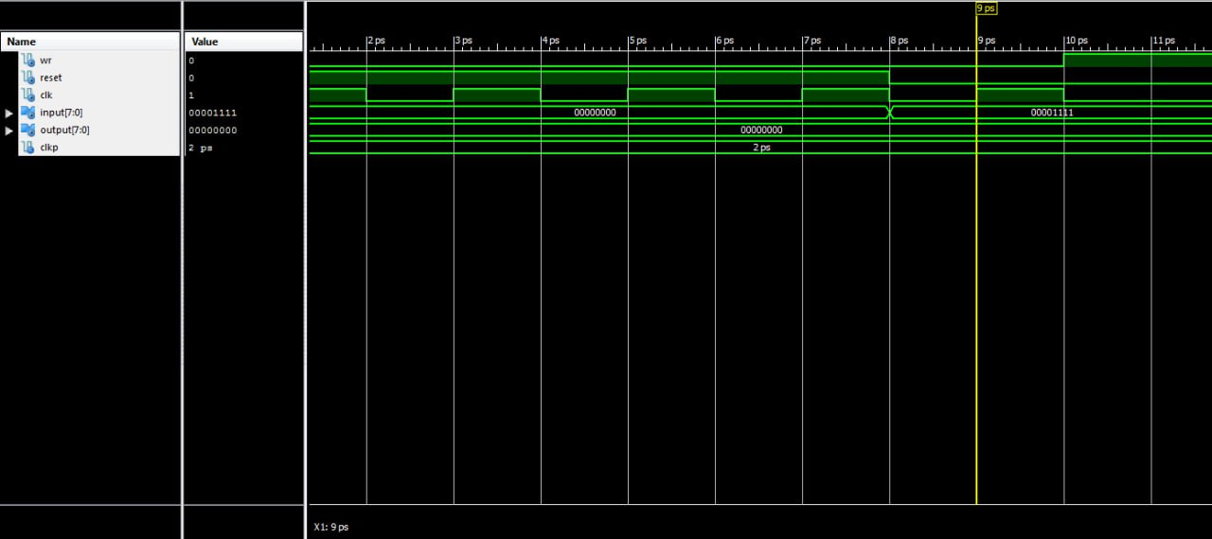

*Рис. 2 – Часова діаграма ACC*

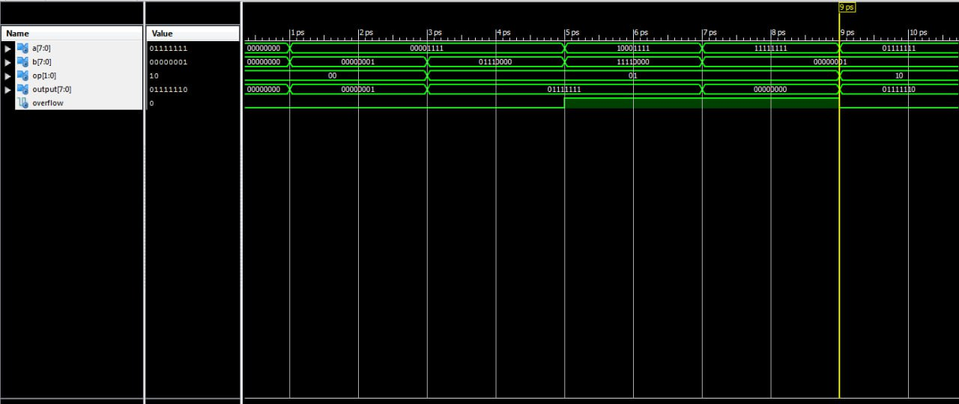

*Рис. 3 – Часова діаграма ALU*

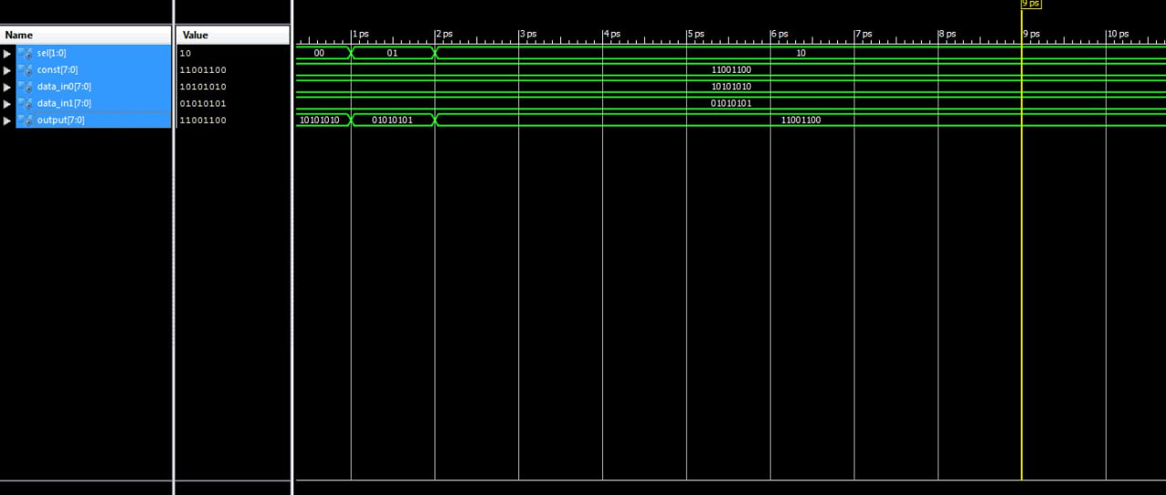

*Рис. 4 – Часова діаграма MUX*

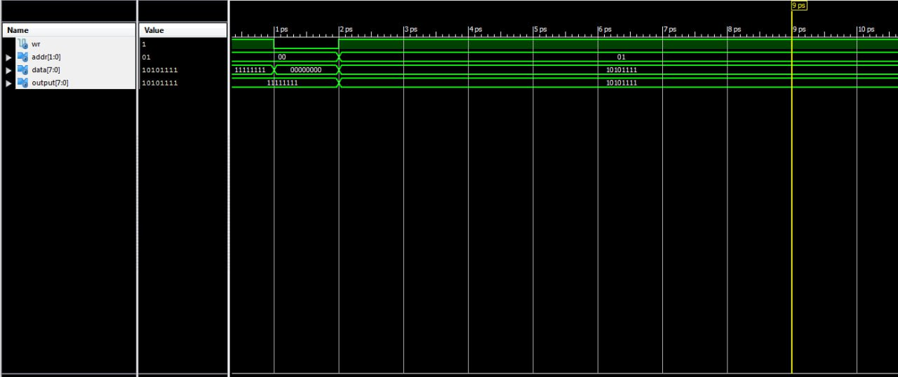

*Рис. 5 – Часова діаграма RAM*

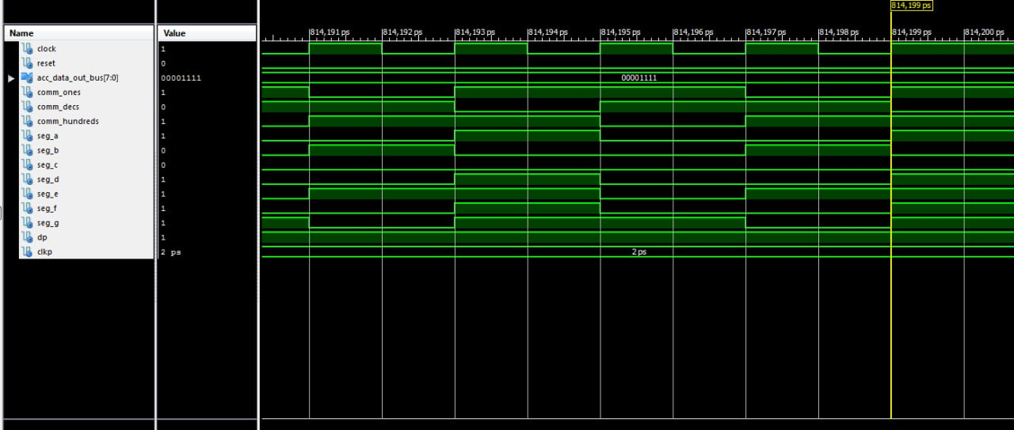

*Рис 6. – Часова діграма SEG_DECODER*

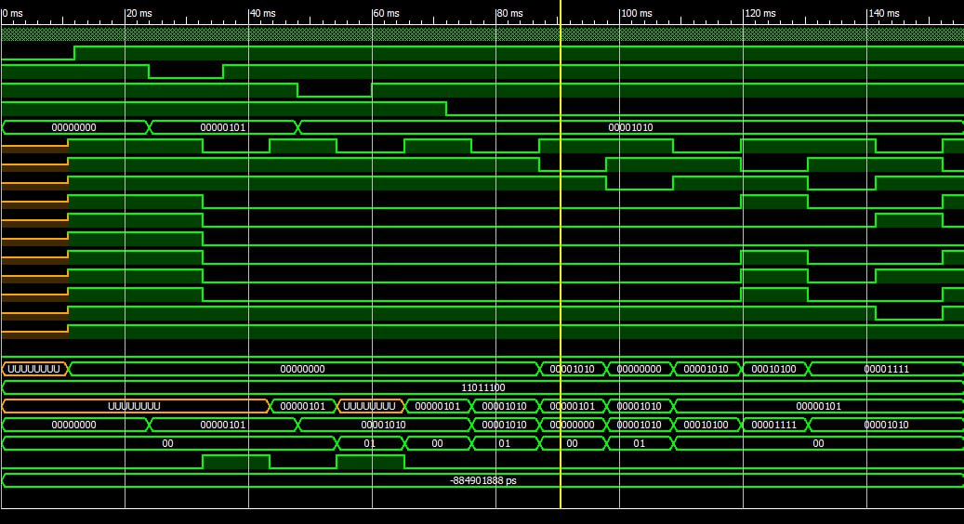

*Рис 7. – Часова діграма TopLevel*

|  |
| --- |
| *Файл TopLevelTest.vhd*   1. LIBRARY ieee; 2. USE ieee.std_logic_1164.ALL; 3. USE ieee.numeric_std.ALL; 4. LIBRARY UNISIM; 5. USE UNISIM.Vcomponents.ALL; 6. ENTITY TopLevel_TopLevel_sch_tb IS 7. END TopLevel_TopLevel_sch_tb; 8. ARCHITECTURE behavioral OF TopLevel_TopLevel_sch_tb IS 10. COMPONENT TopLevel 11. PORT( CLOCK : IN STD_LOGIC; 12. RESET : IN STD_LOGIC; 13. ENTER_OP1 : IN STD_LOGIC; 14. ENTER_OP2 : IN STD_LOGIC; 15. CALCULATE : IN STD_LOGIC; 16. DATA_IN : IN STD_LOGIC_VECTOR (7 DOWNTO 0); 17. COMMON_0_OUT : OUT STD_LOGIC; 18. COMMON_1_OUT : OUT STD_LOGIC; 19. COMMON_2_OUT : OUT STD_LOGIC; 20. TEST: OUT STD_LOGIC_VECTOR(7 downto 0); 21. A_OUT : OUT STD_LOGIC; 22. B_OUT : OUT STD_LOGIC; 23. C_OUT : OUT STD_LOGIC; 24. D_OUT : OUT STD_LOGIC; 25. E_OUT : OUT STD_LOGIC; 26. F_OUT : OUT STD_LOGIC; 27. G_OUT : OUT STD_LOGIC; 28. DP_OUT : OUT STD_LOGIC; 29. RAMOUT: OUT STD_LOGIC_VECTOR(7 downto 0); 30. ALUOUT: OUT STD_LOGIC_VECTOR(7 downto 0); 31. RAMA: OUT STD_LOGIC_VECTOR(1 downto 0); 32. RAMWR: OUT STD_LOGIC; 33. OVERFLOW : OUT STD_LOGIC); 34. END COMPONENT; 36. SIGNAL CLOCK : STD_LOGIC := '0'; 37. SIGNAL RESET : STD_LOGIC; 38. SIGNAL ENTER_OP1 : STD_LOGIC; 39. SIGNAL ENTER_OP2 : STD_LOGIC; 40. SIGNAL CALCULATE : STD_LOGIC; 41. SIGNAL DATA_IN : STD_LOGIC_VECTOR (7 DOWNTO 0); 42. SIGNAL COMMON_0_OUT : STD_LOGIC; 43. SIGNAL COMMON_1_OUT : STD_LOGIC; 44. SIGNAL COMMON_2_OUT : STD_LOGIC; 45. SIGNAL A_OUT : STD_LOGIC; 46. SIGNAL B_OUT : STD_LOGIC; 47. SIGNAL C_OUT : STD_LOGIC; 48. SIGNAL D_OUT : STD_LOGIC; 49. SIGNAL E_OUT : STD_LOGIC; 50. SIGNAL F_OUT : STD_LOGIC; 51. SIGNAL G_OUT : STD_LOGIC; 52. SIGNAL DP_OUT : STD_LOGIC; 53. SIGNAL OVERFLOW : STD_LOGIC; 54. SIGNAL TEST: STD_LOGIC_VECTOR(7 downto 0); 55. SIGNAL TEST2: STD_LOGIC_VECTOR(7 downto 0); 56. signal RAMOUT: STD_LOGIC_VECTOR(7 downto 0); 57. signal ALUOUT: STD_LOGIC_VECTOR(7 downto 0); 58. signal RAMA: STD_LOGIC_VECTOR(1 downto 0); 59. signal RAMWR: STD_LOGIC; 61. -- constant CLOCK_period : time := 166ns; 62. constant CLKP: time := 12ms;--24ms; 64. BEGIN 66. UUT: TopLevel PORT MAP( 67. CLOCK => CLOCK, 68. RESET => RESET, 69. ENTER_OP1 => ENTER_OP1, 70. ENTER_OP2 => ENTER_OP2, 71. CALCULATE => CALCULATE, 72. DATA_IN => DATA_IN, 73. COMMON_0_OUT => COMMON_0_OUT, 74. COMMON_1_OUT => COMMON_1_OUT, 75. COMMON_2_OUT => COMMON_2_OUT, 76. A_OUT => A_OUT, 77. B_OUT => B_OUT, 78. C_OUT => C_OUT, 79. D_OUT => D_OUT, 80. E_OUT => E_OUT, 81. F_OUT => F_OUT, 82. G_OUT => G_OUT, 83. DP_OUT => DP_OUT, 84. OVERFLOW => OVERFLOW, 85. TEST => TEST, 86. RAMOUT => RAMOUT, 87. ALUOUT => ALUOUT, 88. RAMA => RAMA, 89. RAMWR => RAMWR 90. ); 92. CLOCK_process: process 93. begin 94. CLOCK <= '0'; 95. wait for 83ns; 96. CLOCK <= '1'; 97. wait for 83ns; 98. end process; 100. -- *** Test Bench - User Defined Section *** 101. tb : PROCESS 102. BEGIN 103. lp1: for i in 5 to 5 loop 104. lp2: for j in 10 to 10 loop 105. TEST2 <= std_logic_vector(to_unsigned(to_integer(to_unsigned(i, 8) sll 2) * j + j + 10, 8)); 106. ENTER_OP1 <= '1'; 107. ENTER_OP2 <= '1'; 108. CALCULATE <= '1'; 109. DATA_IN <= (others => '0'); 110. RESET <= '0'; 111. wait for CLKP; 112. RESET <= '1'; 113. wait for CLKP; 114. DATA_IN <= std_logic_vector(to_unsigned(i, 8)); -- A 115. ENTER_OP1 <= '0'; 116. wait for CLKP; 117. ENTER_OP1 <= '1'; 118. wait for CLKP; 119. DATA_IN <= std_logic_vector(to_unsigned(j, 8)); -- B 120. ENTER_OP2 <= '0'; 121. wait for CLKP; 122. ENTER_OP2 <= '1'; 123. wait for CLKP; 124. CALCULATE <= '0'; -- START CALCULATION 125. wait for CLKP* 7; 126. assert TEST = TEST2 severity FAILURE; 127. wait for CLKP; 128. end loop; 129. end loop; 131. WAIT; -- will wait forever 132. END PROCESS; 133. -- *** End Test Bench - User Defined Section *** 135. END; |

*Рис.8 – 7-сегментний індикатор*

*Рис.9 – Успішна прошивка*

**Висновок:** Виконуючи дану лабораторну роботу я навчився реалізовувати цифровий автомат для обчислення значення виразів використовуючи засоби VHDL.