CSC422 Fall 2024 – Midterm Report
Group Number: 6
Student Names: Zachary Boston, Eswar Talasila, Elijah Nipper
Student ID: znboston, ectalasi, ennipper
Email: znboston@ncsu.edu, ectalasi@ncsu.edu, ennipper@ncsu.edu
Introduction:

Our project is centered around visualizing Earth surface temperatures given datasets pulled from Kaggle.

Objectives:

- Process given datasets
- Develop visualizations of said processed data based on temperatures and localities of said data (i.e. city, state, country, global)
- Also develop readable and easy to understand graphical interpretations of said data to go along with the visualizations
- Finally develop a predictive model to help interpret and develop predictions of temperatures for a given time period such as 5 – 10 years.

Methodology:

Statistical analysis: basic statistics used to help analyze and interpret the data to then form a visualization.

Libraries: Since we are using python for this project, we intend to use given libraries to help form these visualizations and we are using the following.

Matplotlib: For graphics and visualizations
NumPy: For help with analysis of the data
Pandas: For help with databasing the data and dealing with the datasets as a whole
Scikit Learn: For help with predictive modelling using linear regression
Dash: For web-based integration
Plotly: For more help with graphical interfaces and visualizations

These are what we will be using but may be subject to change as we develop our project.

Machine Learning:
K-NN Classification: This will be used to help possibly fill in missing information from the datasets given they will statistically significant which we will test with comparisons.
Linear Regression: This will be used to help interpret and predict 5 to 10 years of temperatures following the most recent data point that we will have
Dimension Reduction: importantly used to help define what to keep and use in our datasets as the datasets that we have differ a little bit based on their attributes. For some we intend to keep the basics like min temps, avg temps, max temps but others like the attributes of temperature Uncertainty can be useful but only in the preprocessing stages when comparing noise of the data which it has proved its uses.

Preliminary Results:

The following is a result of our checking of noise (uncertainty) in the data to see whether or not some of the data is worth while to keep or just to prune it from our data all together, this is going to be graphs of a measured uncertainty that was provided in the original .csv files we got from Kaggle

GlobalTemperatures.csv
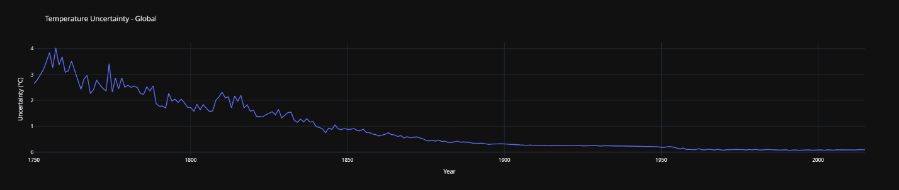

GlobalLandTemperaturesCountry.csv
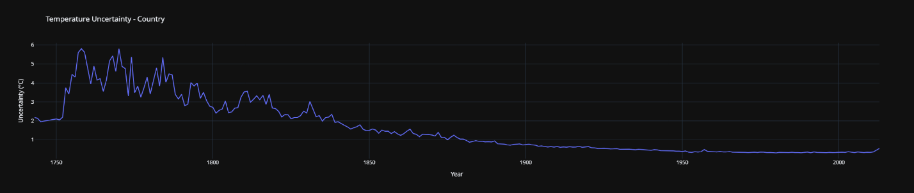

GlobalLandTemperaturesState.csv
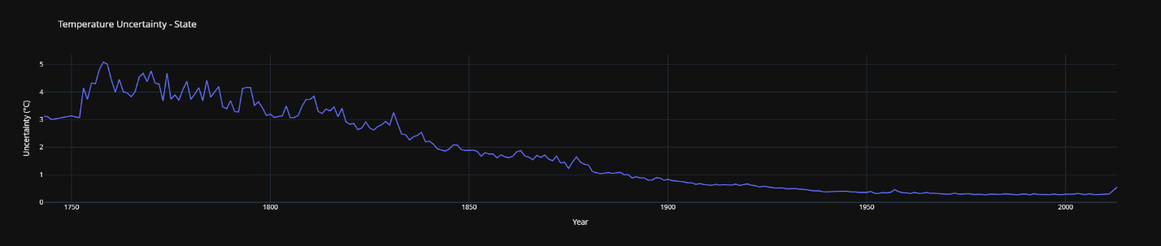

GlobalLandTemperaturesMajorCity.csv
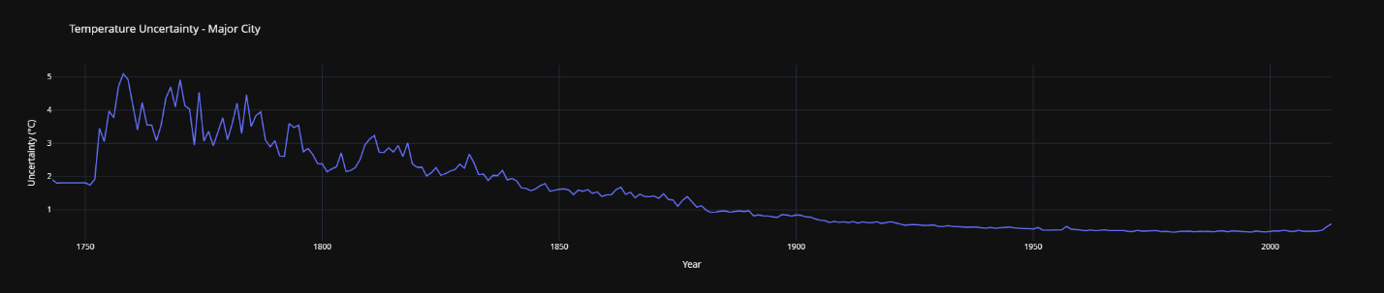

GlobalLandTemperaturesCity.csv
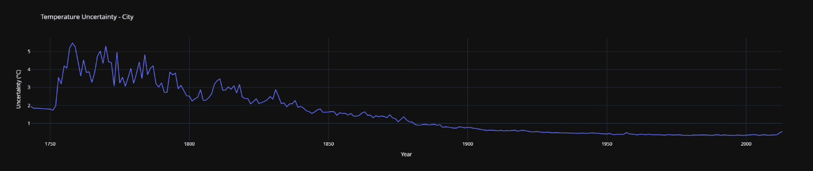

Total

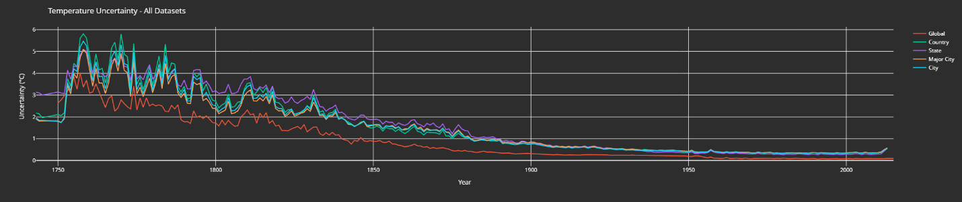

Based on these graphs and the data received from them we can just go ahead and understand that most data in the years < 1850, are around 1 – 5 degrees lower or higher than actual temperatures. So with these we have now come to determine if we want to keep this data or cut the data out and just base our project on data from 1850 and up.

Next Steps:

- We need to further process this data to finally either merge all the data together or just leave them be and just cut the data we can’t use due to its uncertainty
- After this we can start to deal with reductions in the attributes if needed but this will be done at the same time if we merge or cut data as we can only use the location, uncertainty, min, avg and max temps
- We then need to build the visualization just like how we did these graphs showing the temperatures
- Finally build the prediction model to help show future trends of temperature
- Polish and then write the final report / presentation

Contributions:

Zachary contributed by creating python scripts and programs to illustrate the uncertainty of the data based on the given data. Elijah contributed to the css and web interfacing of the program to help allow easier updating and gathering of the tables and graphs through exporting them. Eswar helped with sifting through the data and determining the uses of each attribute and determining the use of testing the noise of the data. All of us contributed to the midterm report.

