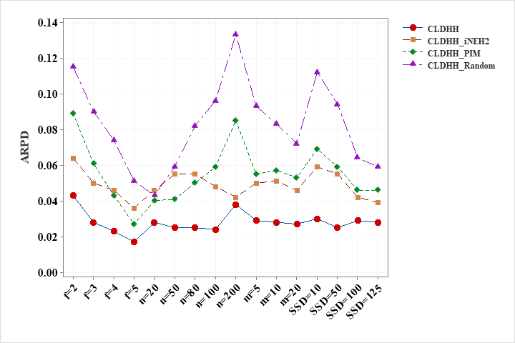

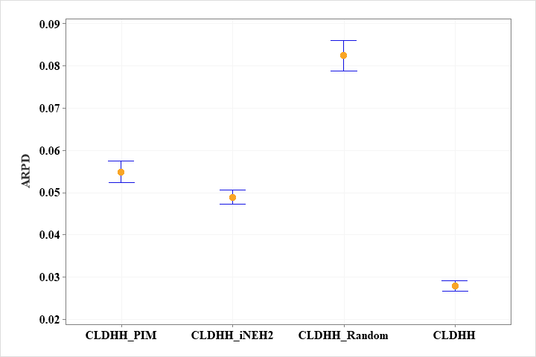

|  |  |  |  |  |  |
| --- | --- | --- | --- | --- | --- |
|  |  | CLDHH_PIM | CLDHH_iNEH2 | CLDHH_Random | CLDHH |
| $$f$$ | 2 | 0.089 | 0.064 | 0.115 | **0.043** |
| 3 | 0.061 | 0.050 | 0.090 | **0.028** |
| 4 | 0.043 | 0.046 | 0.074 | **0.023** |
| 5 | 0.027 | 0.036 | 0.051 | **0.017** |
| $$n$$ | 20 | 0.040 | 0.046 | 0.043 | **0.028** |
| 50 | 0.041 | 0.055 | 0.059 | **0.025** |
| 80 | 0.050 | 0.055 | 0.082 | **0.025** |
| 100 | 0.059 | 0.048 | 0.096 | **0.024** |
| 200 | 0.085 | 0.042 | 0.133 | **0.038** |
| $$m$$ | 5 | 0.055 | 0.050 | 0.093 | **0.029** |
| 10 | 0.057 | 0.051 | 0.083 | **0.028** |
| 20 | 0.053 | 0.046 | 0.072 | **0.027** |
| $$SSD$$ | 10 | 0.069 | 0.059 | 0.112 | **0.030** |
| 50 | 0.059 | 0.055 | 0.094 | **0.025** |
| 100 | 0.046 | 0.042 | 0.064 | **0.029** |
| 125 | 0.046 | 0.039 | 0.059 | **0.028** |
| Mean |  | 0.055 | 0.049 | 0.083 | **0.028** |