**Analysis of Performance of the model:**

For a model to work efficiently, the values of residual errors should be close to zero (straight line). But looking at the output of our model, it is not even working well with the training data.

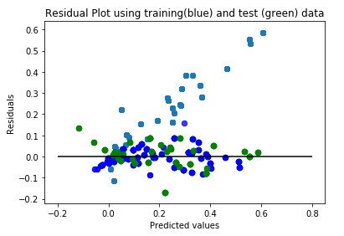

**Model Selection:**

In this task, we had to predict the MPI from the 4 features. Since, the values of MPI are real numbers I chose Linear Regression model.