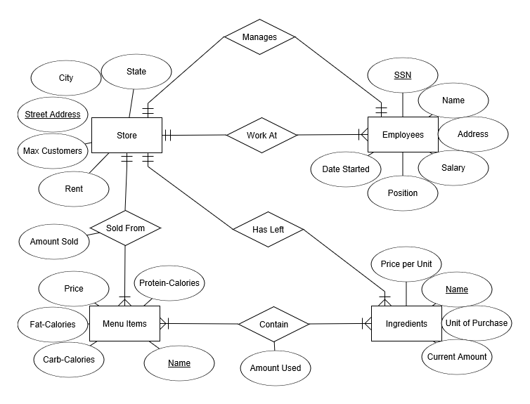

2.1. πSenator.name(σamount > 100,000 ((σparty == “Democrat” Rich Person) ⋈ Contribution ⋈ (σparty == “Republican” Senator)))

2.2. πSenator.name(Senator ÷ (πceo-ssn(Business) ⋈ Contribution))

2.3. πRichPerson.name(σactualTaxRate < .10 from (Rich Person ⋈ Business))

2.4. SELECT name

FROM Senator

INNER JOIN Contribution ON Senator.SID=Contribution.SID

INNER JOIN RichPerson ON Contribution.SSN=RichPerson.SSN

WHERE Contribution.amount>100000 AND Senator.party=‘Republican’ AND RichPerson.party=‘Democrat’;

2.5. SELECT name

FROM Senator

INNER JOIN Alliance ON Senator.SID=Alliance.SID1 OR Senator.SID=Alliance.SID2

INNER JOIN Cause ON Alliance.cause-name=Cause.cause-name

WHERE Senator.party=‘Democrat’ AND Cause.politicalAlignment=‘right’ AND Senator.SID=Alliance.SID1 OR Senator.SID=Alliance.SID2;

2.6. SELECT Contribution.cause-name, SUM(amount)

FROM Contribution

GROUP BY Contribution.cause-name

HAVING SUM(amount)>=1000000;

3.1. Minimal Cover of F: {A 🡪 B, B 🡪 C, B 🡪 D, D 🡪 E}

3.2. Closure A+: ABCDE

3.3. Closure B+: BCDE

4.1. BCNF:

R1: (C, E) F1: {C 🡪 E}

R2: (D, B) F2: {D 🡪 B}

R3: (A, C, D) F3: {AD 🡪 C}

4.2. BCNF:

R1: (C, E) F1: {C 🡪 E}

R2: (D, B) F2: {D 🡪 B}

R3: (A, C, D) F3: {A 🡪 DC}