COMP 3421 PDA

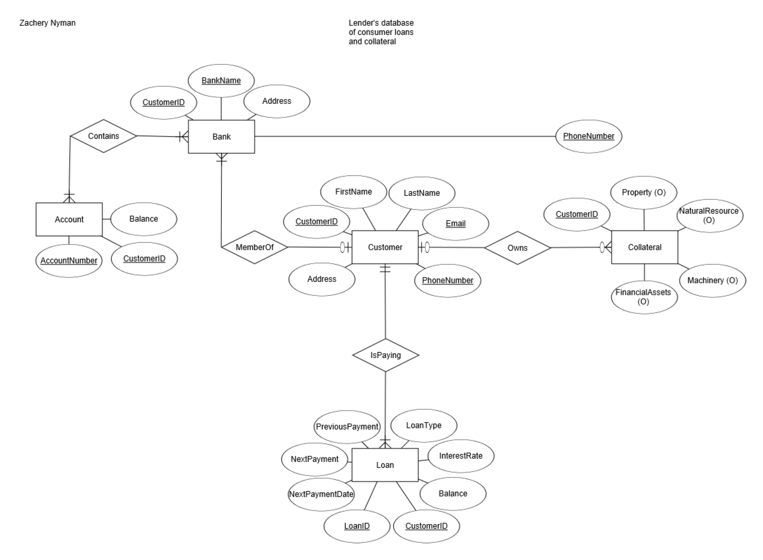 The database application I plan to use is from the point of view of a financial institution. The employee from the financial institution will have access to a customer’s loan and financial asset information. This is done with the purpose of ensuring payments to the financial institution. Some high-level interactions I would like the employee to have would be to add a customer and edit all of their bank, collateral, and loan information. This includes, but isn’t limited to, adding and removing bank accounts, financial assets, and loans. Below is the revised ER model: