Project #3 Image Enhancement in the Frequency Domain

- You are given two images (‘letter.bmp’ and ‘tunnel.bmp’) with non-uniform background as below. (1) Design a high-frequency emphasis filter (Slide 3, Lecture 16) and a homomorphic filter (Slide 10, Lecture 17) to enhance its overall visual quality and contrast. Compare the results from two different filters under different parameters and discuss your findings. (2) Find a color image with similar problems (non-uniform background and low contrast) and try to enhance it with the homomorphic filter and discuss your results.


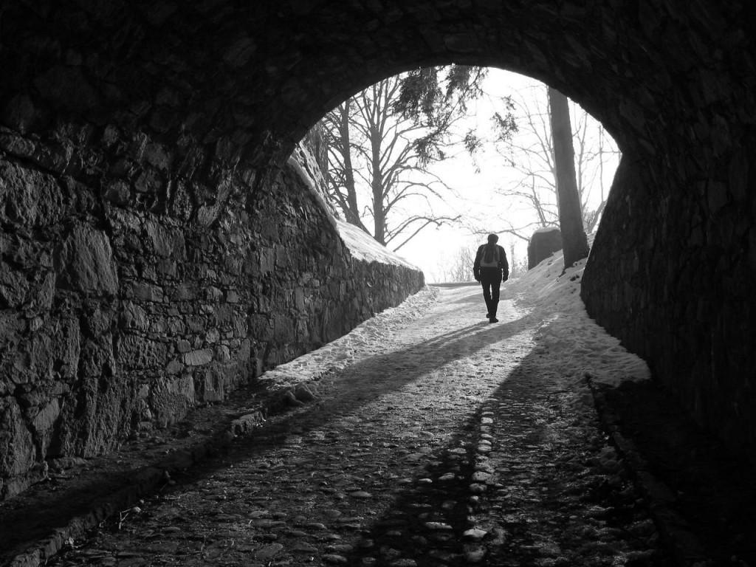
- You are given three images (‘clowngray.bmp’, ‘MoonLanding.bmp’, ‘letter_bar.bmp’) corrupted by different periodic noise. (1) Design an appropriate frequency-domain notch filter or special notch filter for each of them to remove the periodic noise according to Slides 12-16 in Lecture 16. Two sample Matlab codes are provided which produce some initial results for ‘MoonLanding.bmp’ and ‘letter bar.bmp’, based on which you are expected to develop your own code to further improve the results. It is suggested other enhancement techniques (such as histogram processing) can also be used after frequency-domain filtering to further improve the visual quality.
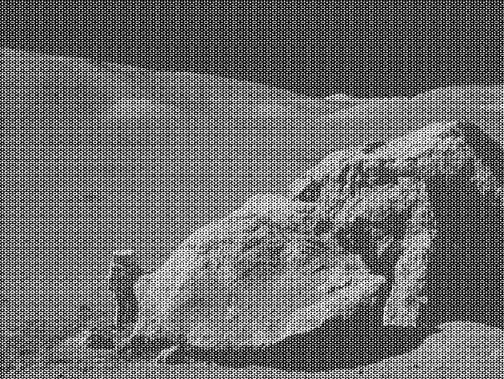

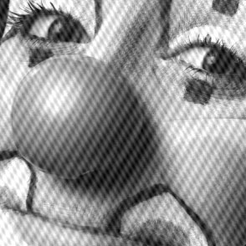
Note: In the class, we learned that the frequency-domain filter is equivalent to the circular convolution in the spatial domain which may result in some artifacts around image boundaries. Zero-padding is a simple and effective technique that enables the circular convolution to produce the desired linear convolution effect. However, in many cases, the advantages of zero-padding are usually around boundaries and may not be visually prominent. Thus you could implement frequency-domain filters without using zero-padding in this project, as mentioned in the Third Edition textbook page 295 (the bottom paragraph).

