Customer Purchase Behavior and Revenue Trends in Online Retail Transactions
Student name: Your Name
Student ID: Your Student ID
Dataset: Online Retail
Source: https://archive.ics.uci.edu/dataset/352/online+retail
Citation: Chen, D. (2015). Online Retail [Dataset]. UCI Machine Learning Repository. https://doi.org/10.24432/C5BW33

1. Project objective
The objective of this project is to analyze customer purchase behavior and revenue trends using a real online retail transaction dataset. The analysis focuses on revenue trends, country and product contribution, customer behavior, and unusual high-value transactions.

2. Analytical questions
- How does online retail revenue change over time?
- Which countries and products contribute most to total revenue?
- What patterns exist in customer purchase behavior, and which transactions look unusually large?

3. Dataset description
The raw dataset contains 541,909 rows and 8 columns. After cleaning, the analysis-ready sales dataset contains 524,878 rows. The transaction period is from 2010-12-01 to 2011-12-09.

4. Data cleaning and preparation
- Standardized column names: Lowercase snake_case names are easier and safer to use in Python code.
- Converted data types: Dates and numeric fields must have correct types before time-series and revenue calculations.
- Removed exact duplicate rows: Duplicates can overstate sales revenue and transaction counts.
- Separated cancelled/returned transactions: The project focuses on positive completed sales, so cancellations and returns are excluded from the main analysis.
- Kept only positive quantities and prices: Revenue trend analysis requires valid sales values.
- Cleaned product descriptions: Consistent product names improve product-level grouping and charts.

5. Feature engineering
- total_revenue = quantity × unit_price
- invoice_month, invoice_year, invoice_day_name, and invoice_hour
- market_group for United Kingdom vs International comparison
- day_type for Weekday vs Weekend comparison
- basket_value and basket_distinct_items for invoice-level analysis
- basket_value_category and line_revenue_zscore using NumPy calculations

6. Analysis and visualizations
Total positive sales revenue is £10,642,110.80, with 19,960 unique invoices and an average order value of £533.17.

Monthly revenue trend
The highest revenue month is 2011-11 with revenue of £1,503,866.78.
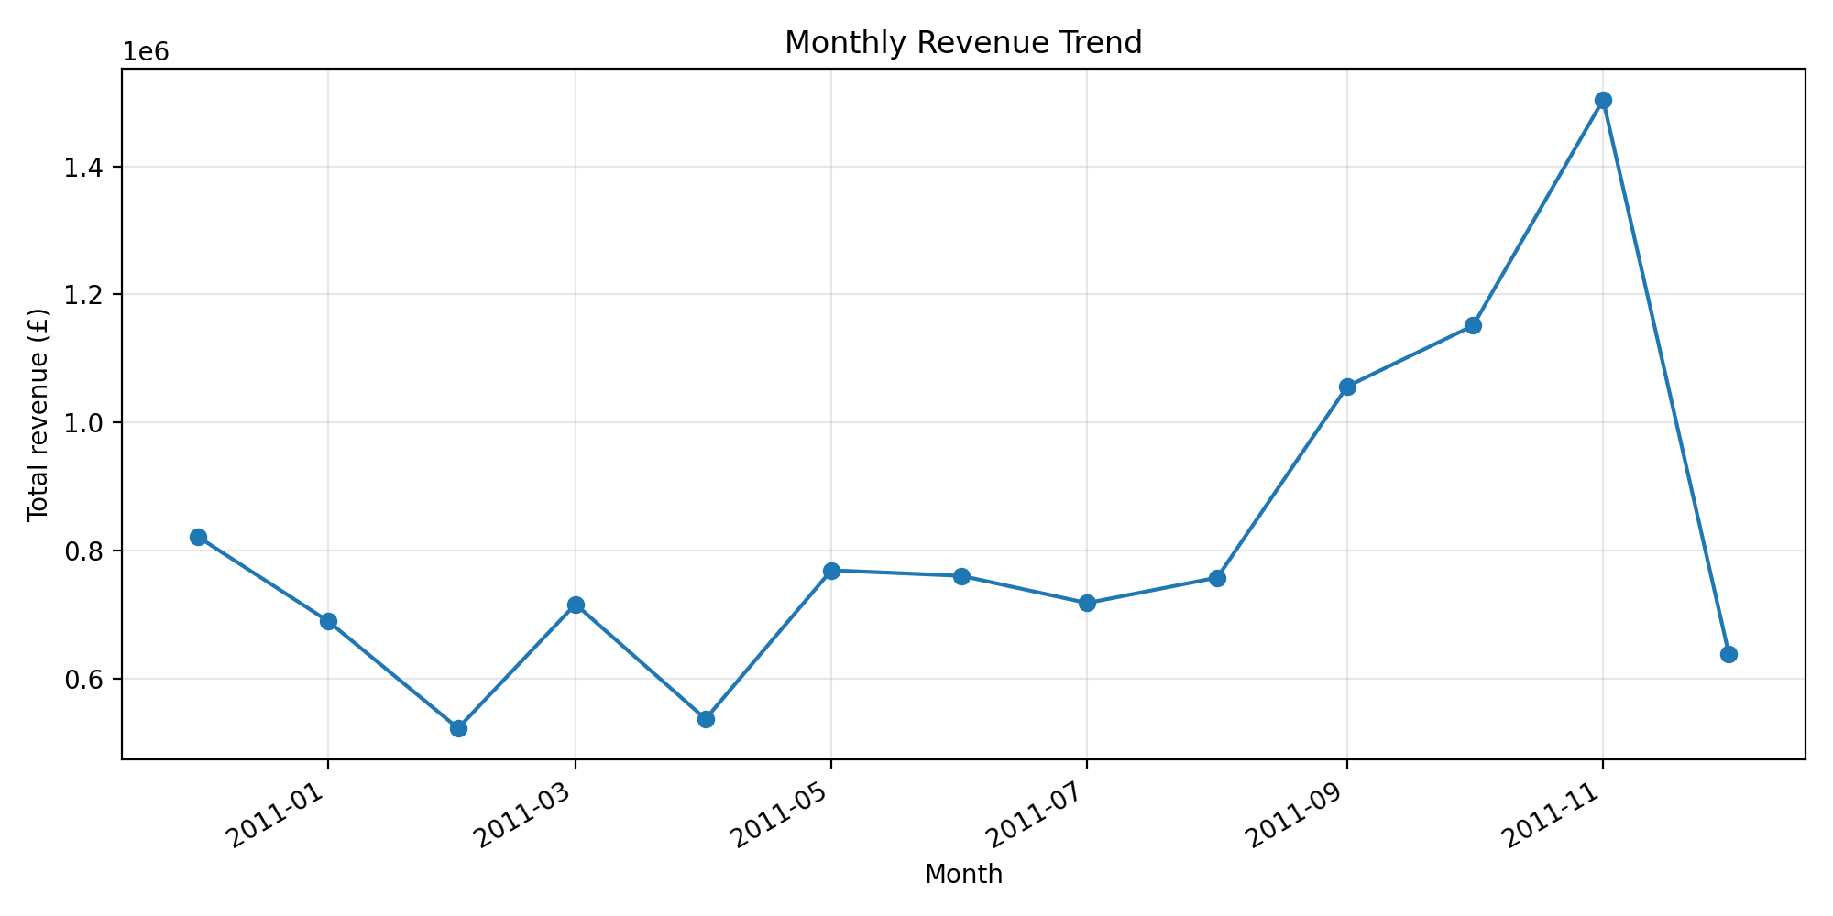

Top countries by revenue
The top country is United Kingdom, contributing 84.59% of revenue.
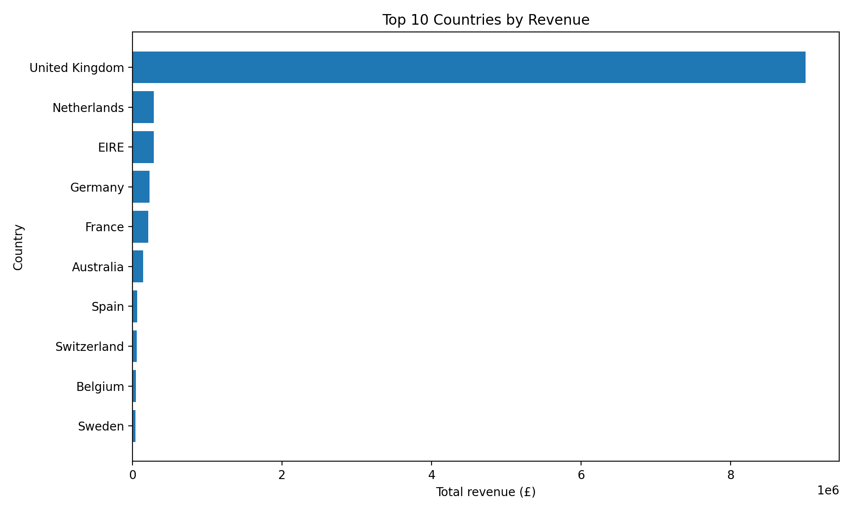

Top products by revenue
The top product is DOTCOM POSTAGE with revenue of £206,248.77.
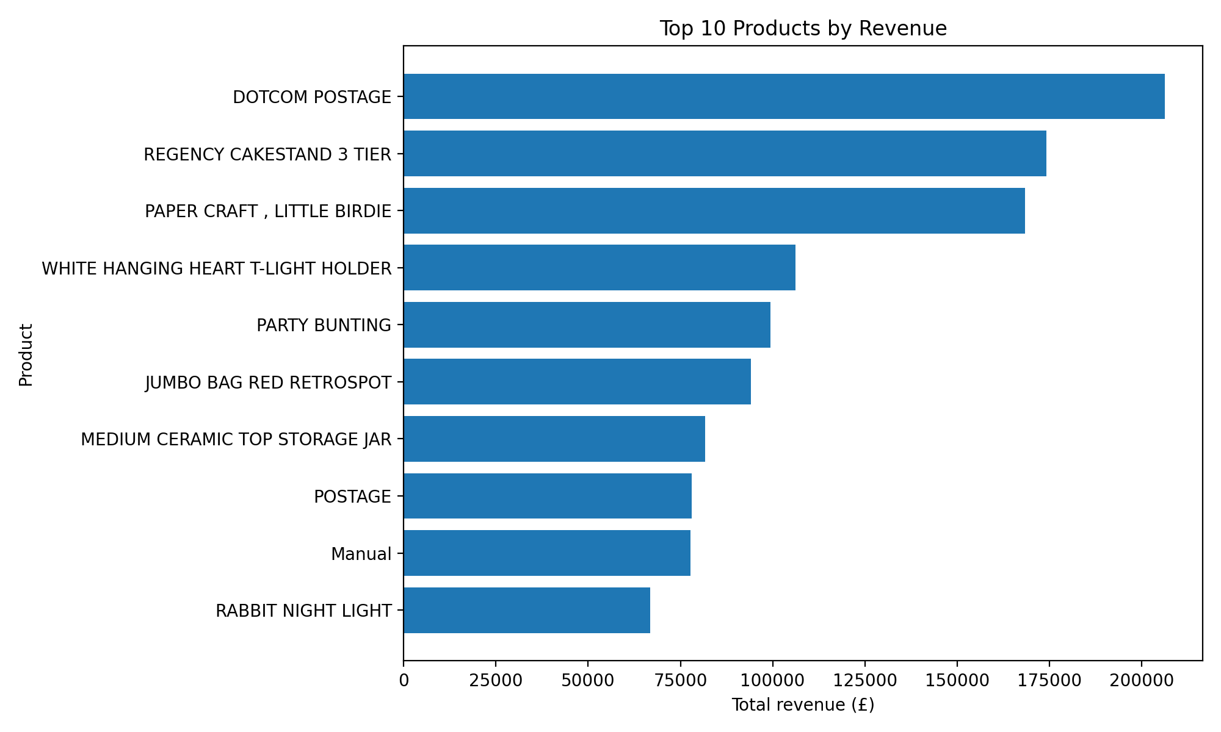

Invoice value distribution
The IQR method identified 1,811 high-value invoice outliers.
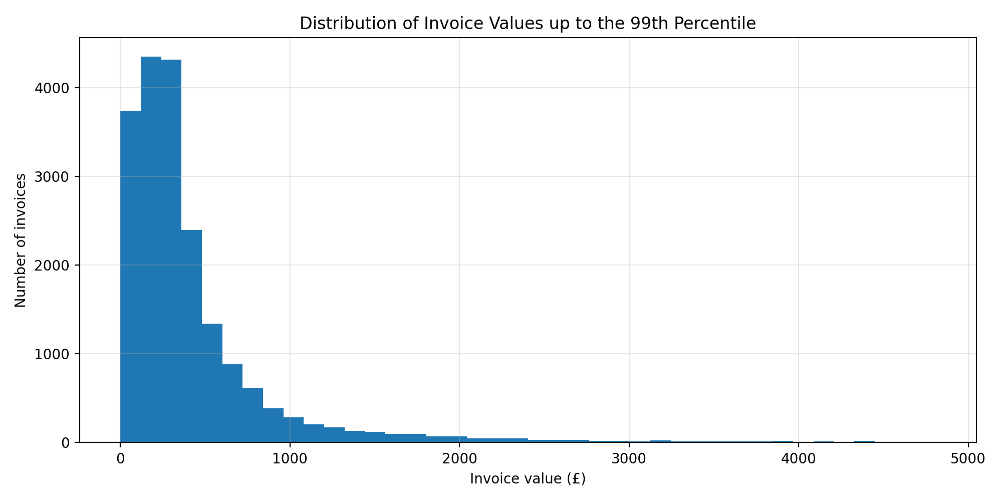

Relationship analysis
The correlation between distinct products and invoice value is 0.265.
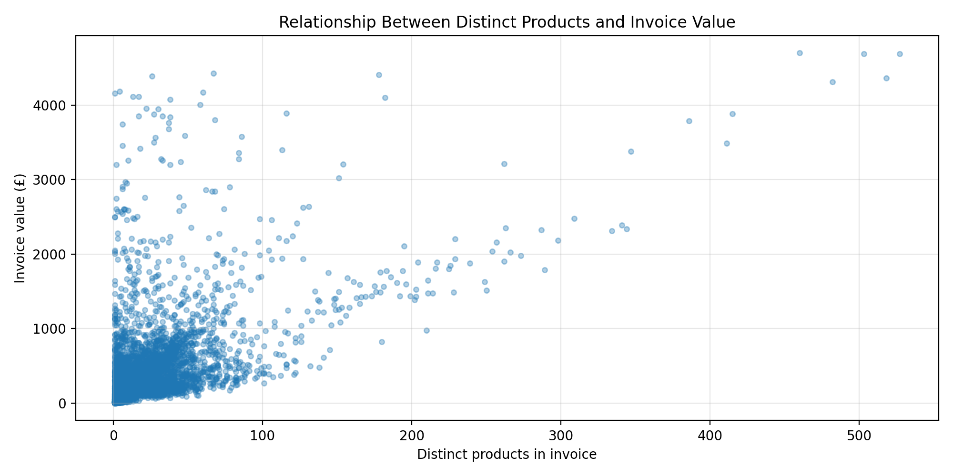

UK vs international comparison
The UK accounts for 84.59% of cleaned revenue.
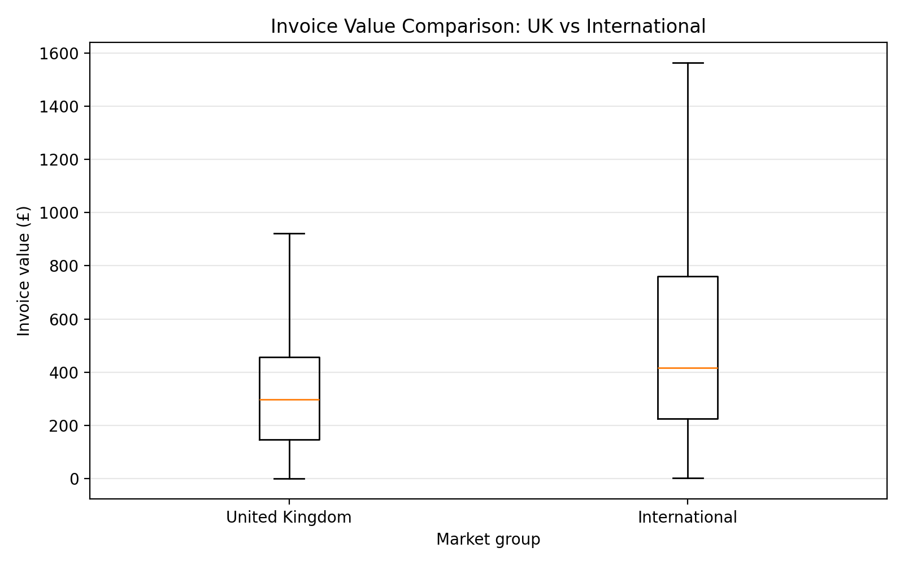

7. Key findings
- The cleaned data contains 524,878 positive-sales rows.
- United Kingdom is the strongest revenue country.
- 2011-11 is the highest revenue month.
- DOTCOM POSTAGE is the highest revenue product.
- Basket size and invoice value have a correlation of 0.265.
- The IQR method found 1,811 high-value invoice outliers.

8. Limitations
- The dataset covers a limited time period.
- Some customer IDs are missing, limiting customer-level analysis.
- The business is UK-based, so results may be biased toward the UK market.
- The analysis removes cancellations and returns from positive-sales analysis.
- Correlation does not prove causation.

9. Conclusion
This project used Pandas, NumPy, and Matplotlib to analyze online retail transactions. The results show revenue trends, important countries and products, customer purchasing patterns, and high-value outliers that can support business decisions.

