**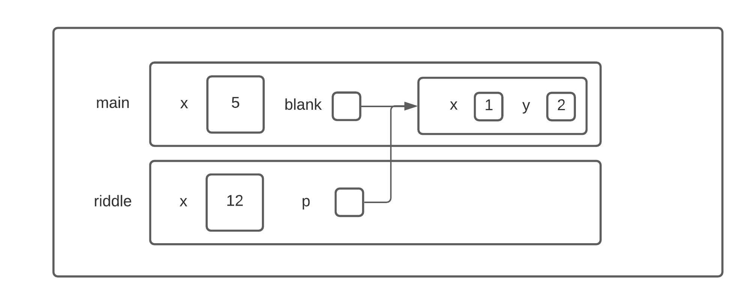*Think Java – Chapter 10: Exercise 1***

Question 1

Question 2

This program outputs the following numbers to the console on different lines:

15

5

1

2

Question 3

The blank object is mutable. This is because it is a Point object, and point objects allow for their attributes to be changed.