***Think Java – Chapter 10: Exercise 2***

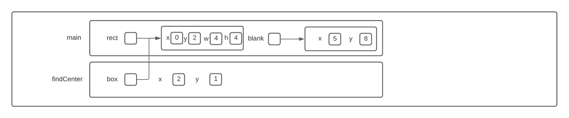Question 1

Question 2

I cba making another one of these things

Question 3

The program computes and prints to the console, the distance between a point at (5,8) and another point at the center of a Rectangle object.