1. Total inside the project

* If we have this, no need to go back to the project list to see the total amount of this project
* We need also to have inside the project separate for the summary

See sample:

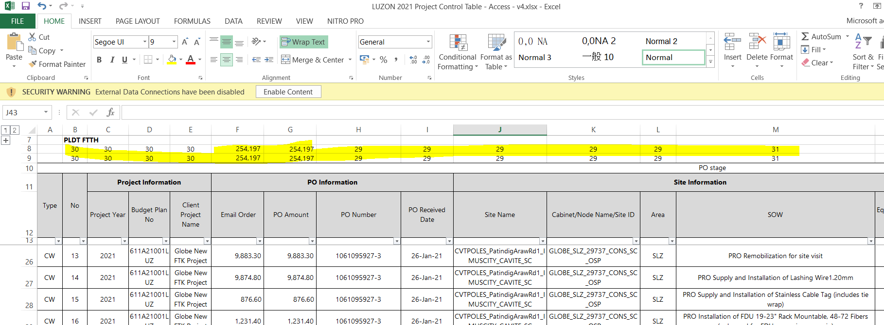

EEP now:

* 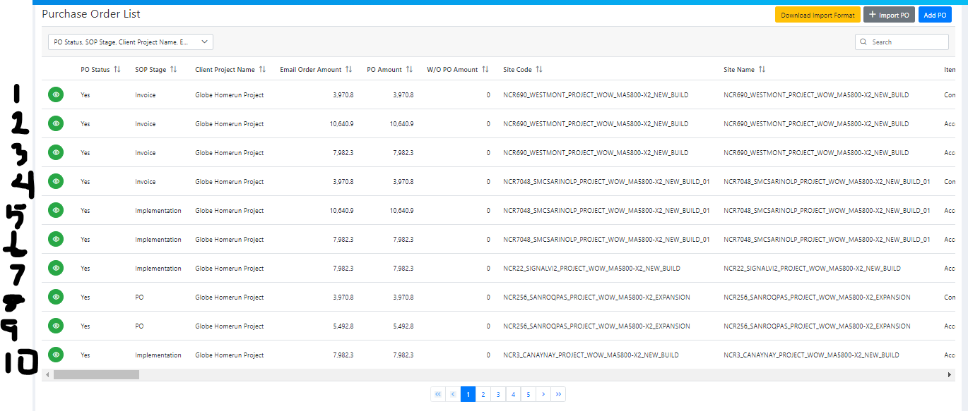No numbers and the total amount for every projects not yet see here inside the project.

1. See all the data in 1 slide if we select the bars/page that we want to see

* If we have this on system, we can easily see all the line items.
* If we have 283 record, you can select 500 to see all. So meaning if your site that you need to find is in the center, you don’t need to next page, next page. Just select all the record items then scroll down only

Sample: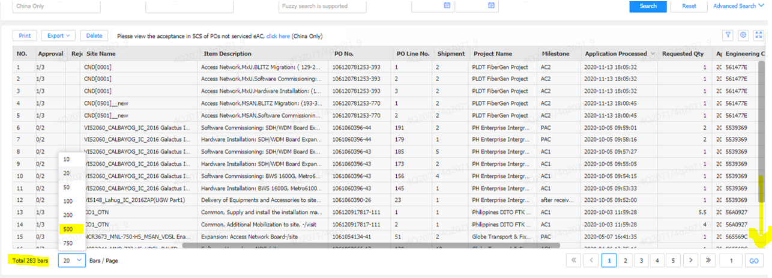

EEP:

* If we need to find the site in the center, you need to next page, next page because you don’t know the exact page. We can search but if we need to see the 2 sites or 3 sites, we can’t compare it
* IT do before show all sites but the system is Log but I think we need to have a selection only like the sample above. Because other system can do it and faster if we do it like that, we can improve more our system.

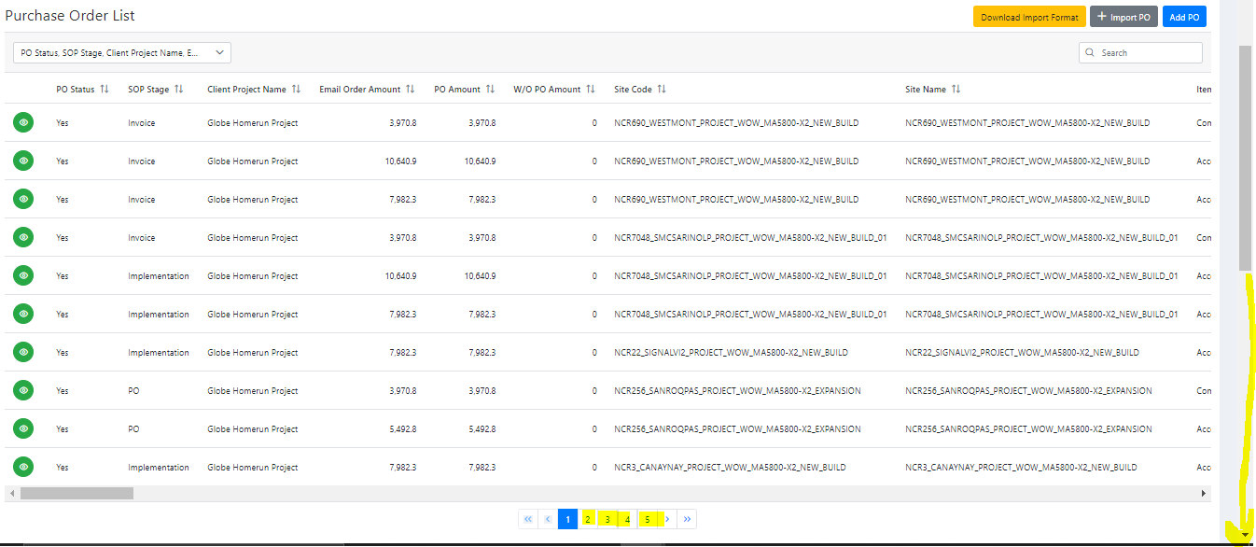

1. Record numbers

* If we have this, we can easily now how many sites we have or records that we received on our client for this project

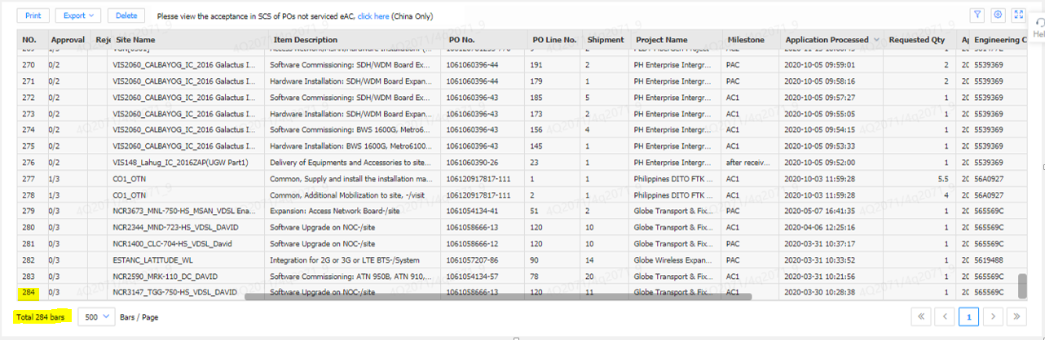Sample:

EEP:

* Even if we have so many page, we don’t know how many records or awarded sites we have

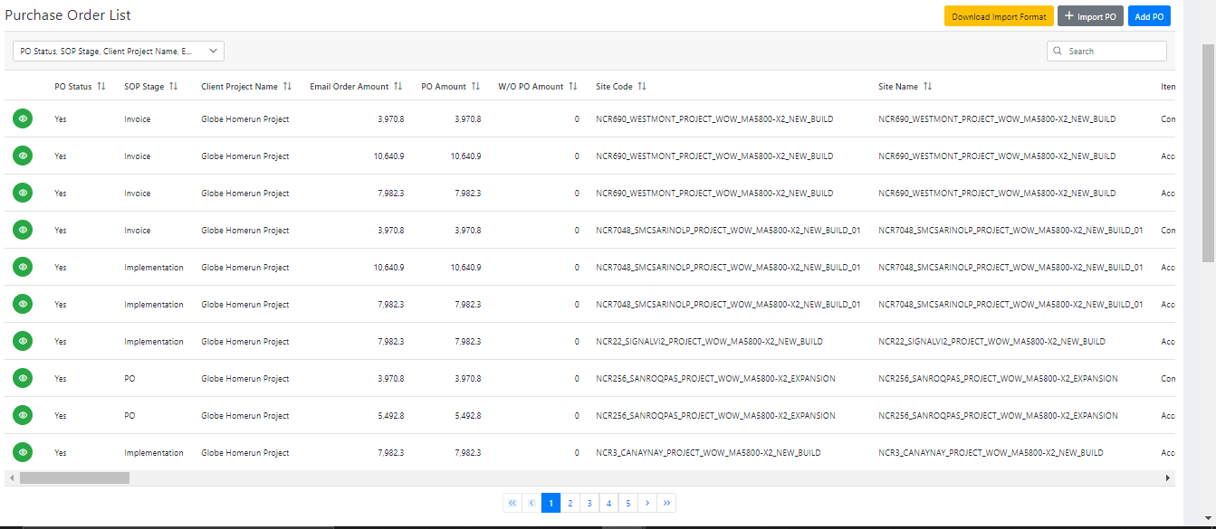

Status

1. Done - Existing

2. Done – NOT YET DEPLOYED #PoList.vue

3. Done - Existing