Dynamic Coffee Shop Sales Dashboard – Excel
A comprehensive and interactive sales performance dashboard built using Microsoft Excel. This project is designed to transform raw sales data into actionable, real-time insights for multi-location coffee shop management.

Dashboard Preview
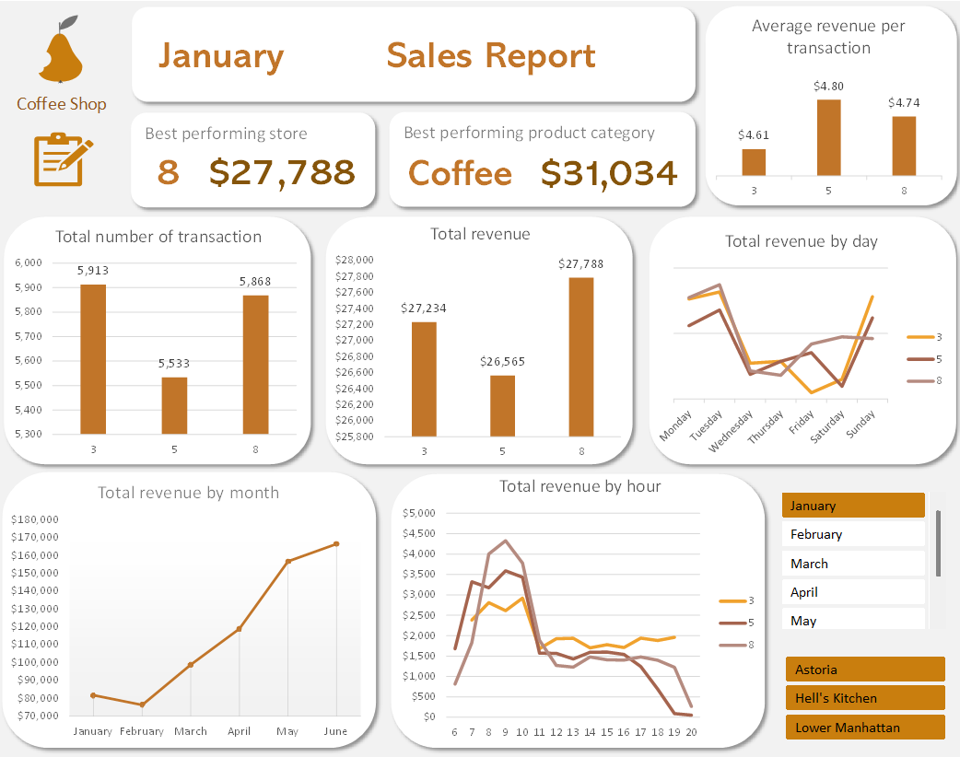

🧩 Problem Statement
Design and develop a dynamic reporting solution in Excel aimed at providing stakeholders (management, operational staff) with immediate, at-a-glance visibility into core sales performance. The dashboard is specifically built to help users:
- Identify Top Performers: Quickly pinpoint the best-performing store locations and product categories by revenue.
- Analyze Time-Based Trends: Understand peak sales periods by day of the week and hour of the day to optimize staffing and resource allocation.
- Track Monthly Progress: Monitor total revenue and transaction volume trends across multiple months.
- Interact with Data Dynamically: Use simple slicers to filter performance by specific month or location.

🛠️ Tools & Features Used
- Microsoft Excel (for development and visualization)
- Pivot Tables (for aggregation and calculation of key metrics)
- Slicers (for dynamic, non-VBA based interactivity)
- UX-focused Dashboard Design (alignment, color theory, hierarchy)
- Branding and Navigation Elements (Company Logo, Hyperlinked Icons)

✅ Project Steps
1. Data Import and Preparation
- Import sales data from a dedicated folder source, ensuring the dashboard can be automatically refreshed with new monthly data.
- Performed data type cleansing and consistency checks.
- Validated existing time-series fields (Month, Day of Week, and Hour of Day) to ensure they were correctly formatted and ready for Pivot Table analysis.
2. Data Analysis & Metrics Definition
- Created multiple Pivot Tables to calculate necessary KPIs and aggregations.
- Employed XLOOKUP to efficiently link calculated metrics (e.g., finding the name of the top-performing store based on total revenue).
- Finalized color themes and visual hierarchy to ensure clarity and professional presentation.
3. Dashboard Design and Interactivity
- Built the interactive dashboard layout, ensuring optimal viewing across standard screen sizes.
- Integrated the Company Logo for professional branding and added a navigation icon hyperlinked to the content sheet, allowing stakeholders easy access to the detailed summary tables.
- Integrated all Pivot Charts and connected them to Slicers for dynamic filtering by Month and Location.
- Structured the layout to prioritize Key Metrics Cards (KPIs) at the top, followed by Volume Charts, and finally Time-Series Trend Charts.

📌 Key Highlights
- Stakeholder-Focused Insight: Designed specifically for quick consumption by management, allowing them to assess sales performance and identify operational issues within seconds.
- Enhanced User Experience (UX): Includes a clear company logo for branding and a direct, one-click link for easy access to the detailed content sheet for data validation.
- Data Automation: The report is designed for scalability and minimal maintenance, allowing users to simply drop new data files into the source folder and click 'Refresh All'.
- Operational Focus: The inclusion of the "Total revenue by hour" chart directly supports operational decision-making, such as scheduling staff during peak periods.
- Modern Excel Functions: Leveraging functions like XLOOKUP for enhanced performance and calculation flexibility.
- Design Thinking: Strong emphasis on visual hierarchy and clean design to make complex data immediately understandable by non-technical stakeholders.

Usage and Data Refresh
To use this dynamic report:
- Download: Clone this repository or download the Excel file directly.
- Open: Open the file in Microsoft Excel (version 2013 or newer is recommended).
- Navigate: Go to the Dashboard sheet.
- Interact: Use the filter buttons (Months and Locations) on the right to dynamically update all charts and KPIs.
- Data Refresh: To update the report with new data, paste new sales transactions into the designated source folder (if set up) or the Raw data sheet, ensuring column headers match. Then, navigate to the Data tab in Excel and click Refresh All.

Data Source and Attribution
The raw data used to generate this dashboard is sourced from a public dataset on Kaggle, which is acknowledged and attributed here:
- Dataset: Coffee Shop Sales Analysis
- Source: Divu Saxena / Kaggle

🔗 Inspiration and Reference
The dashboard design principles, utilization of interactive Excel features (like Slicers and Pivot Charts), and layout planning were inspired by the following learning resource:
- Video: Make an Awesome Excel Dashboard in Just 15 Minutes
- Source: YouTube

License
This project is licensed under the MIT License - see the LICENSE.md file for details.

📬 Contact
If you have any questions, feedback, or collaboration ideas regarding this dashboard, feel free to reach out:
- LinkedIn: https://www.linkedin.com/in/zoe-j-39599234a/
- Email: zjhuang.gy@gmail.com

