R Notebook

Zoe Berling & Daniel Valverde

This is an [R Markdown](http://rmarkdown.rstudio.com) Notebook. When you execute code within the notebook, the results appear beneath the code.

Try executing this chunk by clicking the *Run* button within the chunk or by placing your cursor inside it and pressing *Ctrl+Shift+Enter*.

library(ltm)

## Warning: package 'ltm' was built under R version 4.0.5

## Loading required package: MASS

## Loading required package: msm

## Warning: package 'msm' was built under R version 4.0.5

## Loading required package: polycor

## Warning: package 'polycor' was built under R version 4.0.5

library(mokken)

## Warning: package 'mokken' was built under R version 4.0.5

## Loading required package: poLCA

## Warning: package 'poLCA' was built under R version 4.0.5

## Loading required package: scatterplot3d

library(car)

## Warning: package 'car' was built under R version 4.0.5

## Loading required package: carData

## Error : 'format_warning' is not an exported object from 'namespace:cli'

## Warning: replacing previous import 'ellipsis::check_dots_unnamed' by  
## 'rlang::check_dots_unnamed' when loading 'hms'

## Warning: replacing previous import 'ellipsis::check_dots_used' by  
## 'rlang::check_dots_used' when loading 'hms'

## Warning: replacing previous import 'ellipsis::check_dots_empty' by  
## 'rlang::check_dots_empty' when loading 'hms'

## Warning: replacing previous import 'ellipsis::check_dots_unnamed' by  
## 'rlang::check_dots_unnamed' when loading 'tibble'

## Warning: replacing previous import 'ellipsis::check_dots_used' by  
## 'rlang::check_dots_used' when loading 'tibble'

## Warning: replacing previous import 'ellipsis::check_dots_empty' by  
## 'rlang::check_dots_empty' when loading 'tibble'

## Warning: replacing previous import 'ellipsis::check_dots_unnamed' by  
## 'rlang::check_dots_unnamed' when loading 'pillar'

## Warning: replacing previous import 'ellipsis::check_dots_used' by  
## 'rlang::check_dots_used' when loading 'pillar'

## Warning: replacing previous import 'ellipsis::check_dots_empty' by  
## 'rlang::check_dots_empty' when loading 'pillar'

##   
## Attaching package: 'car'

## The following object is masked from 'package:mokken':  
##   
## recode

library(tidyverse)

## -- Attaching packages --------------------------------------- tidyverse 1.3.0 --

## v ggplot2 3.3.5 v purrr 0.3.4  
## v tibble 3.1.0 v dplyr 1.0.8  
## v tidyr 1.1.3 v stringr 1.4.0  
## v readr 1.4.0 v forcats 0.5.1

## Warning: package 'ggplot2' was built under R version 4.0.5

## Warning: package 'dplyr' was built under R version 4.0.5

## -- Conflicts ------------------------------------------ tidyverse_conflicts() --  
## x dplyr::filter() masks stats::filter()  
## x dplyr::lag() masks stats::lag()  
## x dplyr::recode() masks car::recode(), mokken::recode()  
## x dplyr::select() masks MASS::select()  
## x purrr::some() masks car::some()

library(latticeExtra)

## Warning: package 'latticeExtra' was built under R version 4.0.5

## Loading required package: lattice

##   
## Attaching package: 'latticeExtra'

## The following object is masked from 'package:ggplot2':  
##   
## layer

data <- read.csv("q1Throughq6andGender.csv", header=TRUE)   
data<- data[c('Q1A', 'Q2A', 'Q3A', 'Q4A', 'Q5A', 'Q6A', 'gender')]  
head(data)

## Q1A Q2A Q3A Q4A Q5A Q6A gender  
## 1 4 4 2 4 4 4 2  
## 2 4 1 2 3 4 4 2  
## 3 3 1 4 1 4 3 2  
## 4 2 3 2 1 3 3 2  
## 5 2 2 3 4 4 2 2  
## 6 1 1 2 1 3 1 2

data$gender[data$gender==1]<-0  
data$gender[data$gender==2]<-1  
# converting the data to binary for dichotomous purposes  
questions = c('Q1A', 'Q2A', 'Q3A', 'Q4A', 'Q5A', 'Q6A')  
  
for (c in questions) {  
data[[c]] <- car::recode(data[[c]],"c(1, 2)='0';c(3, 4)='1'")  
  
}  
  
head(data)

## Q1A Q2A Q3A Q4A Q5A Q6A gender  
## 1 1 1 0 1 1 1 1  
## 2 1 0 0 1 1 1 1  
## 3 1 0 1 0 1 1 1  
## 4 0 1 0 0 1 1 1  
## 5 0 0 1 1 1 0 1  
## 6 0 0 0 0 1 0 1

dat_base <-data[c('Q1A', 'Q2A', 'Q3A', 'Q4A', 'Q5A', 'Q6A')]  
head(dat_base)

## Q1A Q2A Q3A Q4A Q5A Q6A  
## 1 1 1 0 1 1 1  
## 2 1 0 0 1 1 1  
## 3 1 0 1 0 1 1  
## 4 0 1 0 0 1 1  
## 5 0 0 1 1 1 0  
## 6 0 0 0 0 1 0

datM <- data[data$gender == 0,]  
datM <- datM[c('Q1A', 'Q2A', 'Q3A', 'Q4A', 'Q5A', 'Q6A')]  
datF <- data[data$gender == 1,]  
datF <- datF[c('Q1A', 'Q2A', 'Q3A', 'Q4A', 'Q5A', 'Q6A')]

#at first glance the mean of each question seems to be good because not everyone is answering one way to these wquestions  
summary(dat_base)

## Q1A Q2A Q3A Q4A   
## Min. :0.0000 Min. :0.0000 Min. :0.0000 Min. :0.0000   
## 1st Qu.:0.0000 1st Qu.:0.0000 1st Qu.:0.0000 1st Qu.:0.0000   
## Median :1.0000 Median :0.0000 Median :0.0000 Median :0.0000   
## Mean :0.5117 Mean :0.3491 Mean :0.3558 Mean :0.2738   
## 3rd Qu.:1.0000 3rd Qu.:1.0000 3rd Qu.:1.0000 3rd Qu.:1.0000   
## Max. :1.0000 Max. :1.0000 Max. :1.0000 Max. :1.0000   
## Q5A Q6A   
## Min. :0.0000 Min. :0.0000   
## 1st Qu.:0.0000 1st Qu.:0.0000   
## Median :0.0000 Median :0.0000   
## Mean :0.4769 Mean :0.4817   
## 3rd Qu.:1.0000 3rd Qu.:1.0000   
## Max. :1.0000 Max. :1.0000

#testing for monotonicity  
#z1 implies that we have one latent variable that we are predicting   
#IRT.param=TRUE is how we set this IRT Model to 2PL (difficulty and discrimination)  
model<-ltm(dat_base~z1, IRT.param=TRUE)  
  
# the steeper the slope the more   
## discriminable an item is  
plot(model, type="ICC", xlab='ability')

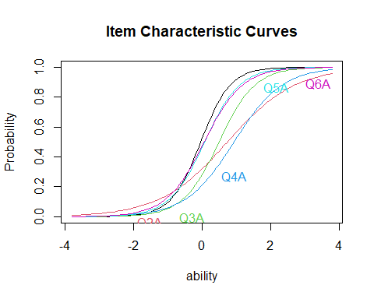

#difficulty is a zcore of whatever the latent variable is (anxiety)  
#discriminable is the slope or how good the question is at figuring a person out  
model<-ltm(dat_base~z1, IRT.param=TRUE)  
print(coef(model))

## Dffclt Dscrmn  
## Q1A -0.03346154 2.317070  
## Q2A 0.74285394 1.016176  
## Q3A 0.49802722 1.908842  
## Q4A 0.93501859 1.423853  
## Q5A 0.07939943 1.953463  
## Q6A 0.06521985 1.790820

plot(model, type="ICC", items=c(1,2,3,4,5, 6), xlab='Tendency Towards Depression')  
abline(.5,0)

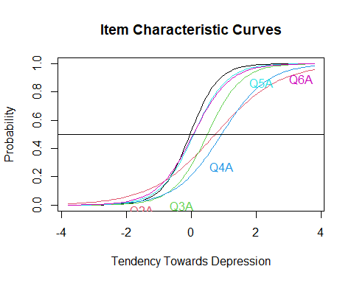

plot(model, type="IIC", xlab='Tendency Towards Depression') #test information function

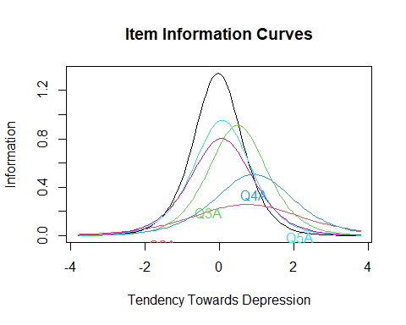

#gives you every combination of response patterns  
  
factor.scores(model)

##   
## Call:  
## ltm(formula = dat_base ~ z1, IRT.param = TRUE)  
##   
## Scoring Method: Empirical Bayes  
##   
## Factor-Scores for observed response patterns:  
## Q1A Q2A Q3A Q4A Q5A Q6A Obs Exp z1 se.z1  
## 1 0 0 0 0 0 0 8336 8061.059 -1.001 0.617  
## 2 0 0 0 0 0 1 1421 1595.205 -0.472 0.486  
## 3 0 0 0 0 1 0 1407 1406.395 -0.435 0.479  
## 4 0 0 0 0 1 1 514 733.086 -0.067 0.435  
## 5 0 0 0 1 0 0 478 592.888 -0.562 0.504  
## 6 0 0 0 1 0 1 240 245.247 -0.169 0.443  
## 7 0 0 0 1 1 0 216 228.727 -0.137 0.440  
## 8 0 0 0 1 1 1 135 208.194 0.196 0.428  
## 9 0 0 1 0 0 0 539 649.741 -0.445 0.481  
## 10 0 0 1 0 0 1 204 332.363 -0.076 0.435  
## 11 0 0 1 0 1 0 729 315.288 -0.045 0.433  
## 12 0 0 1 0 1 1 390 343.448 0.285 0.431  
## 13 0 0 1 1 0 0 78 104.066 -0.146 0.441  
## 14 0 0 1 1 0 1 51 93.161 0.188 0.428  
## 15 0 0 1 1 1 0 164 92.694 0.218 0.429  
## 16 0 0 1 1 1 1 144 172.037 0.559 0.450  
## 17 0 1 0 0 0 0 1325 1419.015 -0.671 0.529  
## 18 0 1 0 0 0 1 496 484.756 -0.250 0.452  
## 19 0 1 0 0 1 0 416 445.380 -0.218 0.448  
## 20 0 1 0 0 1 1 224 347.805 0.121 0.428  
## 21 0 1 0 1 0 0 262 163.498 -0.327 0.462  
## 22 0 1 0 1 0 1 190 103.961 0.024 0.430  
## 23 0 1 0 1 1 0 128 100.407 0.054 0.429  
## 24 0 1 0 1 1 1 160 133.124 0.385 0.436  
## 25 0 1 1 0 0 0 142 203.466 -0.226 0.449  
## 26 0 1 1 0 0 1 98 156.215 0.113 0.428  
## 27 0 1 1 0 1 0 312 153.332 0.143 0.428  
## 28 0 1 1 0 1 1 180 243.723 0.478 0.442  
## 29 0 1 1 1 0 0 43 45.249 0.046 0.429  
## 30 0 1 1 1 0 1 57 59.007 0.376 0.435  
## 31 0 1 1 1 1 0 152 60.781 0.407 0.437  
## 32 0 1 1 1 1 1 193 168.497 0.777 0.477  
## 33 1 0 0 0 0 0 1329 1496.169 -0.353 0.466  
## 34 1 0 0 0 0 1 1389 905.690 0.001 0.431  
## 35 1 0 0 0 1 0 650 871.137 0.031 0.430  
## 36 1 0 0 0 1 1 1190 1103.485 0.362 0.434  
## 37 1 0 0 1 0 0 206 274.704 -0.068 0.435  
## 38 1 0 0 1 0 1 408 286.120 0.263 0.430  
## 39 1 0 0 1 1 0 199 288.631 0.293 0.431  
## 40 1 0 0 1 1 1 502 627.505 0.644 0.459  
## 41 1 0 1 0 0 0 244 393.023 0.023 0.430  
## 42 1 0 1 0 0 1 500 489.689 0.353 0.434  
## 43 1 0 1 0 1 0 683 502.266 0.384 0.436  
## 44 1 0 1 0 1 1 1800 1324.440 0.749 0.473  
## 45 1 0 1 1 0 0 77 128.527 0.285 0.431  
## 46 1 0 1 1 0 1 194 274.591 0.634 0.458  
## 47 1 0 1 1 1 0 248 296.457 0.669 0.463  
## 48 1 0 1 1 1 1 1224 1454.930 1.106 0.533  
## 49 1 1 0 0 0 0 500 517.788 -0.146 0.441  
## 50 1 1 0 0 0 1 663 463.626 0.188 0.428  
## 51 1 1 0 0 1 0 337 461.311 0.218 0.429  
## 52 1 1 0 0 1 1 716 856.360 0.560 0.450  
## 53 1 1 0 1 0 0 202 130.238 0.121 0.428  
## 54 1 1 0 1 0 1 410 197.776 0.455 0.441  
## 55 1 1 0 1 1 0 234 206.667 0.486 0.443  
## 56 1 1 0 1 1 1 742 679.121 0.873 0.492  
## 57 1 1 1 0 0 0 139 206.199 0.210 0.428  
## 58 1 1 1 0 0 1 271 376.292 0.551 0.449  
## 59 1 1 1 0 1 0 381 400.139 0.584 0.453  
## 60 1 1 1 0 1 1 1360 1625.403 0.995 0.513  
## 61 1 1 1 1 0 0 78 91.141 0.478 0.442  
## 62 1 1 1 1 0 1 238 293.882 0.862 0.490  
## 63 1 1 1 1 1 0 380 330.550 0.901 0.496  
## 64 1 1 1 1 1 1 2857 2759.328 1.431 0.601

#measures person ability for each pearson who responded a specific way  
person.fit(model)

##   
## Person-Fit Statistics and P-values  
##   
## Call:  
## ltm(formula = dat_base ~ z1, IRT.param = TRUE)  
##   
## Alternative: Inconsistent response pattern under the estimated model  
##   
## Q1A Q2A Q3A Q4A Q5A Q6A L0 Lz Pr(<Lz)  
## 1 0 0 0 0 0 0 -0.6278 0.7994 0.788  
## 2 0 0 0 0 0 1 -2.4153 0.4719 0.6815  
## 3 0 0 0 0 1 0 -2.5445 0.4472 0.6726  
## 4 0 0 0 0 1 1 -3.1919 0.6408 0.7392  
## 5 0 0 0 1 0 0 -3.3937 -0.4043 0.343  
## 6 0 0 0 1 0 1 -4.2938 -0.7237 0.2346  
## 7 0 0 0 1 1 0 -4.3618 -0.7762 0.2188  
## 8 0 0 0 1 1 1 -4.4135 -0.7438 0.2285  
## 9 0 0 1 0 0 0 -3.3159 -0.1785 0.4292  
## 10 0 0 1 0 0 1 -3.9836 -0.3027 0.381  
## 11 0 0 1 0 1 0 -4.0336 -0.3324 0.3698  
## 12 0 0 1 0 1 1 -3.8947 0.0272 0.5109  
## 13 0 0 1 1 0 0 -5.1498 -1.6241 0.0522  
## 14 0 0 1 1 0 1 -5.2192 -1.9399 0.0262  
## 15 0 0 1 1 1 0 -5.2185 -1.9413 0.0261  
## 16 0 0 1 1 1 1 -4.5118 -0.9074 0.1821  
## 17 0 1 0 0 0 0 -2.4993 0.0646 0.5257  
## 18 0 1 0 0 0 1 -3.6148 -0.1411 0.4439  
## 19 0 1 0 0 1 0 -3.6989 -0.1744 0.4308  
## 20 0 1 0 0 1 1 -3.9136 -0.0347 0.4862  
## 21 0 1 0 1 0 0 -4.7015 -1.1988 0.1153  
## 22 0 1 0 1 0 1 -5.1354 -1.7229 0.0425  
## 23 0 1 0 1 1 0 -5.1662 -1.7881 0.0369  
## 24 0 1 0 1 1 1 -4.8190 -1.3039 0.0961  
## 25 0 1 1 0 0 0 -4.4825 -0.9480 0.1716  
## 26 0 1 1 0 0 1 -4.7153 -1.1862 0.1178  
## 27 0 1 1 0 1 0 -4.7290 -1.2099 0.1132  
## 28 0 1 1 0 1 1 -4.1888 -0.4750 0.3174  
## 29 0 1 1 1 0 0 -5.9644 -2.8564 0.0021  
## 30 0 1 1 1 0 1 -5.6347 -2.4455 0.0072  
## 31 0 1 1 1 1 0 -5.5972 -2.3556 0.0092  
## 32 0 1 1 1 1 1 -4.4445 -0.9540 0.17  
## 33 1 0 0 0 0 0 -2.4869 0.6690 0.7483  
## 34 1 0 0 0 0 1 -2.9734 1.0677 0.8572  
## 35 1 0 0 0 1 0 -3.0086 1.0923 0.8626  
## 36 1 0 0 0 1 1 -2.7098 1.6659 0.9521  
## 37 1 0 0 1 0 0 -4.1735 -0.5188 0.302  
## 38 1 0 0 1 0 1 -4.0822 -0.2466 0.4026  
## 39 1 0 0 1 1 0 -4.0669 -0.2279 0.4099  
## 40 1 0 0 1 1 1 -3.1873 0.4953 0.6898  
## 41 1 0 1 0 0 0 -3.8056 0.0258 0.5103  
## 42 1 0 1 0 0 1 -3.5243 0.5242 0.6999  
## 43 1 0 1 0 1 0 -3.4914 0.5382 0.7048  
## 44 1 0 1 0 1 1 -2.3957 1.0960 0.8635  
## 45 1 0 1 1 0 0 -4.8777 -1.4218 0.0775  
## 46 1 0 1 1 0 1 -4.0174 -0.3965 0.3459  
## 47 1 0 1 1 1 0 -3.9273 -0.3347 0.3689  
## 48 1 0 1 1 1 1 -2.0851 0.6663 0.7474  
## 49 1 1 0 0 0 0 -3.5453 0.0927 0.5369  
## 50 1 1 0 0 0 1 -3.6145 0.4408 0.6703  
## 51 1 1 0 0 1 0 -3.6137 0.4504 0.6738  
## 52 1 1 0 0 1 1 -2.9067 0.9804 0.8366  
## 53 1 1 0 1 0 0 -4.8960 -1.4469 0.074  
## 54 1 1 0 1 0 1 -4.4045 -0.7430 0.2287  
## 55 1 1 0 1 1 0 -4.3514 -0.6852 0.2466  
## 56 1 1 0 1 1 1 -3.0008 0.2821 0.6111  
## 57 1 1 1 0 0 0 -4.4206 -0.7529 0.2258  
## 58 1 1 1 0 0 1 -3.7321 0.0208 0.5083  
## 59 1 1 1 0 1 0 -3.6594 0.0632 0.5252  
## 60 1 1 1 0 1 1 -2.0536 0.8908 0.8135  
## 61 1 1 1 1 0 0 -5.1726 -1.7290 0.0419  
## 62 1 1 1 1 0 1 -3.8444 -0.4702 0.3191  
## 63 1 1 1 1 1 0 -3.7044 -0.3910 0.3479  
## 64 1 1 1 1 1 1 -1.1452 0.8861 0.8122

item.fit(model)

##   
## Item-Fit Statistics and P-values  
##   
## Call:  
## ltm(formula = dat_base ~ z1, IRT.param = TRUE)  
##   
## Alternative: Items do not fit the model  
## Ability Categories: 10  
##   
## X^2 Pr(>X^2)  
## Q1A 3789.449 <0.0001  
## Q2A 9243.511 <0.0001  
## Q3A 1704.668 <0.0001  
## Q4A 3804.557 <0.0001  
## Q5A 2943.172 <0.0001  
## Q6A 1302.295 <0.0001

library(glue)

##   
## Attaching package: 'glue'

## The following object is masked from 'package:dplyr':  
##   
## collapse

# graphing both genders ICC  
modelM<-ltm(datM~z1, IRT.param=TRUE)  
modelF<-ltm(datF~z1, IRT.param=TRUE)  
  
for (i in 1:6) {  
 g<- ggplot()  
 p1 = as.data.frame(plot(modelM,type="ICC",item = {i}))  
 p2= as.data.frame(plot(modelF,type="ICC", item = {i}))  
   
 # p1<- as.data.frame(pm)  
 # p2 <- as.data.frame(pf)  
  
 g<- g+ geom_line(aes(x=p1$z, y=p1$V2, color = 'Male', size = .5)) + geom_line(aes(x=p2$z, y=p2$V2, color = 'Female', size=.5)) + labs(title=glue("Item ",{i}) ,  
 x ="Probability", y = "Ability")  
print(g)  
}

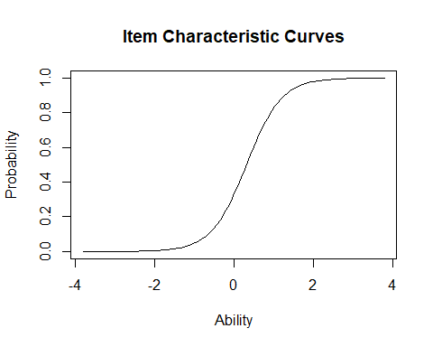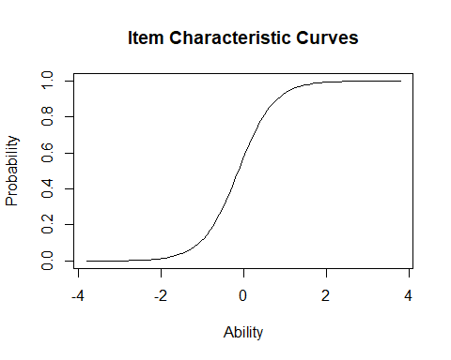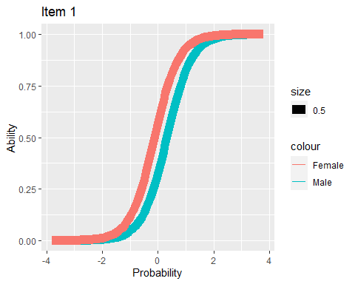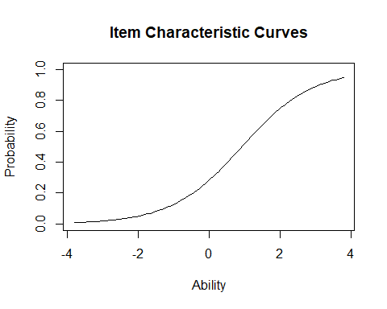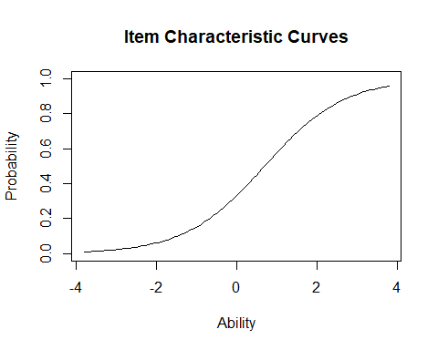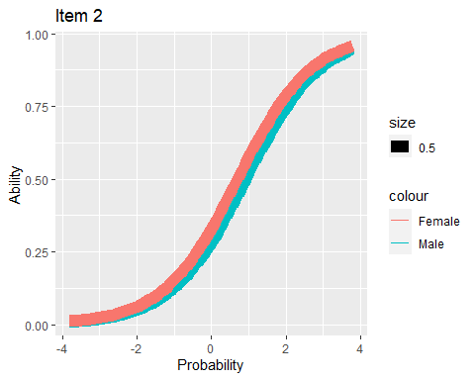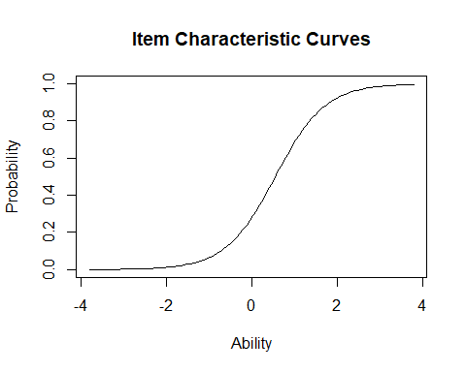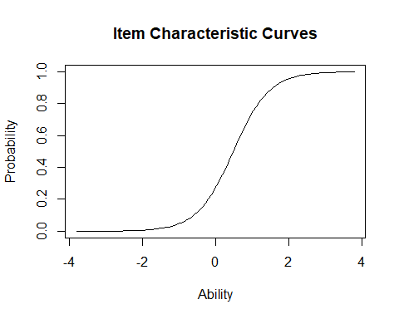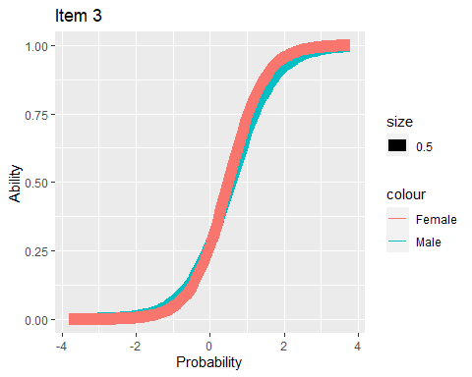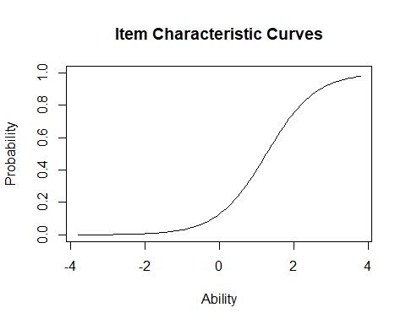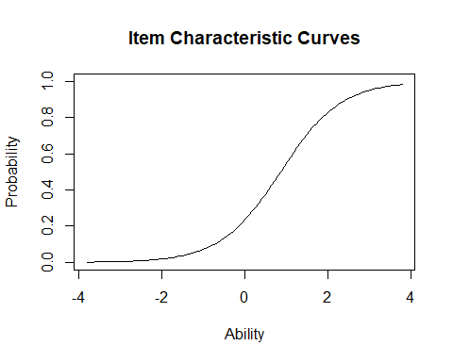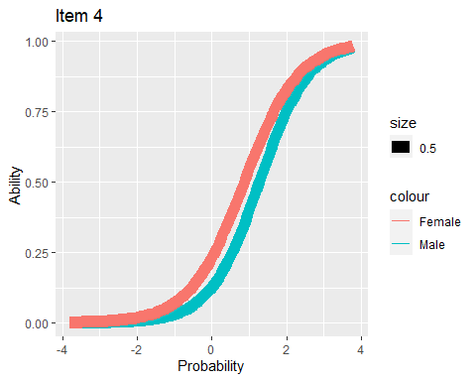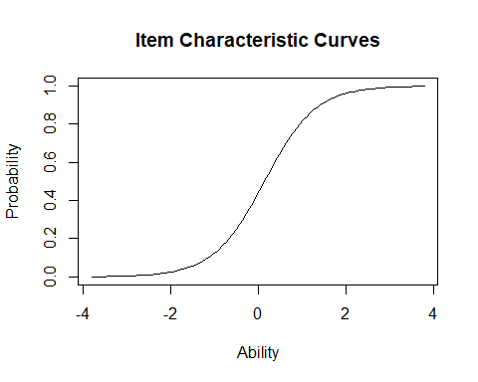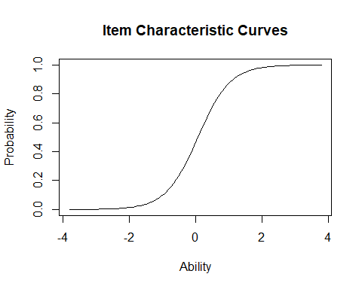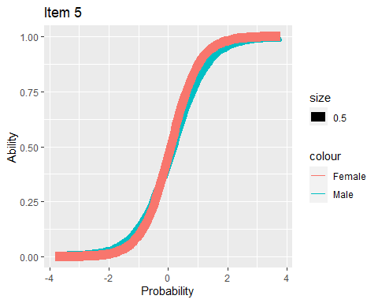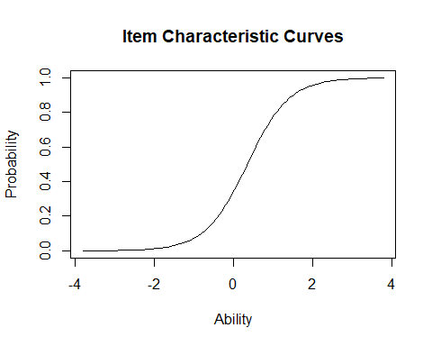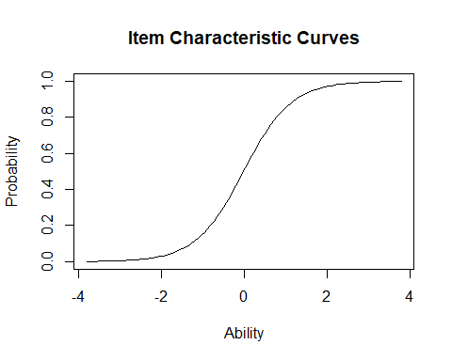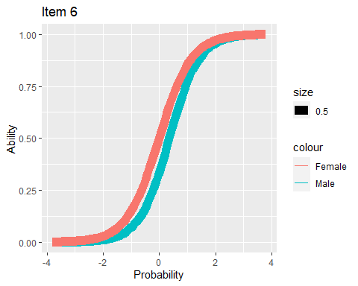

mod1pl<-rasch(dat_base)  
mod2pl<-ltm(dat_base~z1, IRT.param=TRUE)  
anova(mod1pl, mod2pl)

##   
## Likelihood Ratio Table  
## AIC BIC log.Lik LRT df p.value  
## mod1pl 279537.2 279597.4 -139761.6   
## mod2pl 277908.5 278011.5 -138942.2 1638.79 5 <0.001

# anova(mod2pl, mod3pl)  
# anova(mod2pl, mod1pl)

Add a new chunk by clicking the *Insert Chunk* button on the toolbar or by pressing *Ctrl+Alt+I*.

When you save the notebook, an HTML file containing the code and output will be saved alongside it (click the *Preview* button or press *Ctrl+Shift+K* to preview the HTML file).

The preview shows you a rendered HTML copy of the contents of the editor. Consequently, unlike *Knit*, *Preview* does not run any R code chunks. Instead, the output of the chunk when it was last run in the editor is displayed.