Mission Prep Hub Site Plan

Zoe Christison

WDD 130-03

Overview

Purpose
Ease mission preparation by putting everything I need to do in one place. This will also aid those who are helping me prepare to know how to help me.

Audience
This website will be used by myself, as well as those helping me prepare for my mission, namely my family and friends.

Branding

Website Logo
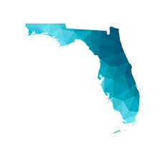

Style Guide

Color Palette
Primary—  Alabaster Grey | Secondary—  Dusty Denim | Accent 1—  Ink Black | Accent 2—  Prussian Blue
# E0E1DD | #778DA9 | #0D1B2A | #1B263B
Accent 2—  Dusk Blue | #415A77

Typography

Heading Font: ['Trebuchet MS', 'Lucida Sans Unicode', 'Lucida Grande', 'Lucida Sans', Arial, sans-serif]

Paragraph Font: [Helvetica, Arial, sans-serif]

Navigation
Home Checklist Mission Contact Information

Content

Page 1: Home
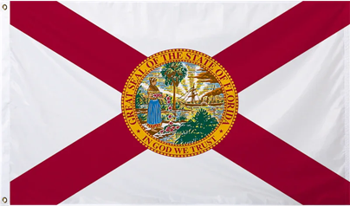 Hero Image; Hero msg: “Florida Tampa Mission”

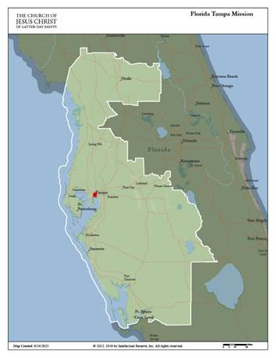Mission map

Countdown to Report Day (Days until Apr. 29, 2026)
Timeline:
Home MTC start date: April 29, 2026
Provo MTC start date: May 6, 2026
Mission arrival date: May 20, 2026

Page 2: Mission Checklist
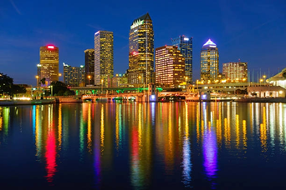 Hero Image; hero msg: “Checklist”

Clothing:
Outfits (6-8). Dresses, skirts and blouses.
Dress slacks (3-4).
Sunday shoes (1-2).
Comfortable dress shoes (2).
Sweaters (1-2).
Raincoat: With a zip-out liner for warmth.
Exercise clothing.
Other activities: One set of clothing for activities where regular missionary attire is not appropriate; pants must be full length.
Pajamas (1)

Study Materials:

Scriptures in your native language.
Your personal copy of Preach My Gospel.
Pens, pencils, a notebook, highlighters, and any other materials you think you may need for taking notes and writing letters.
A personal journal, and a study journal (see Preach My Gospel, p. viii) (see "Study Journal" in "Introduction: How Can I Best Use Preach My Gospel?", Preach My Gospel [2019], xi).
Shoulder bags should be in conservative colors with no apparent logos or insignias. (Note: Backpacks are no longer allowed.) Shoulder bags should be waterproof or sprayed with a product to make them water-proof.

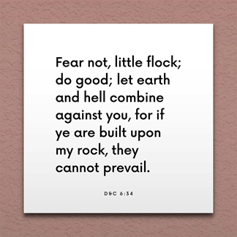 Second image (my mission scripture)

Page 3: Contact info
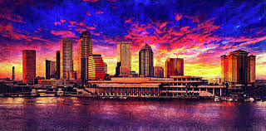 Hero image; hero msg: “Contact info”

Letters and Packages
In MTC
2005 N 900 E
Provo UT 84602
UNITED STATES

In Mission
2120 W Fletcher Ave
Tampa FL 33612
UNITED STATES

Electronic contact info
Mission email: [redacted for privacy]
Facebook: [redacted for privacy]
Instagram: [redacted for privacy]

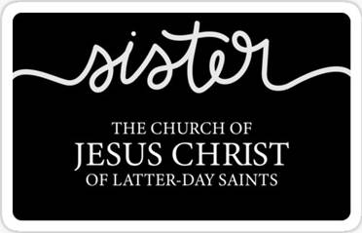 Second Image

Wireframes

Home
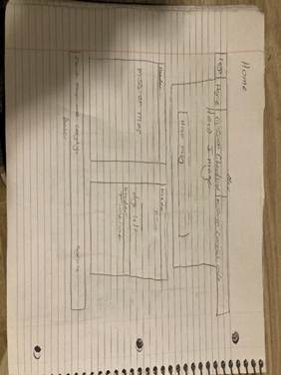

Checklist
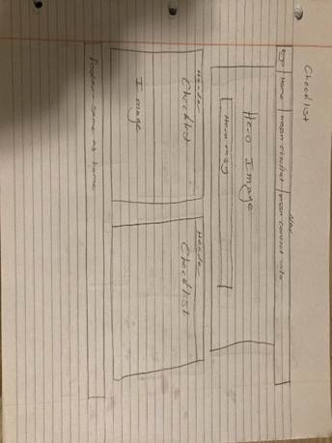

Contact Info
