Oasis 3D Printer
Operations Report & Standard Operating Procedure (SOP)
Document Version: 1.0 | Date: 2026-03-31
Software: Oasis_printer_260327.py + Study_params_loader_and_print.py

1. System Overview

1.1 Oasis_printer_260327.py
A PyQt5-based GUI application that simultaneously controls an HP45 inkjet printhead and a GRBL motion controller, implementing Binder Jetting 3D printing onto ceramic powder layers.
Component | Description
MainWindow | Main GUI. Split into self.ui (separate window from .ui file) and self.form (widget references)
CameraController | Per-layer image capture (separate widget)
GRBL | Motion serial communication (XY + Z/A rollers)
HP45 | Inkjet printhead serial communication
ImageConverter | SVG/image → print array conversion
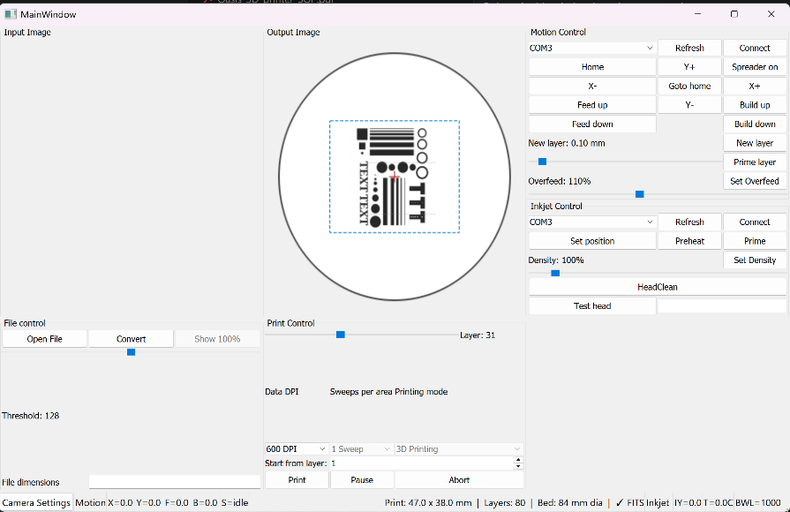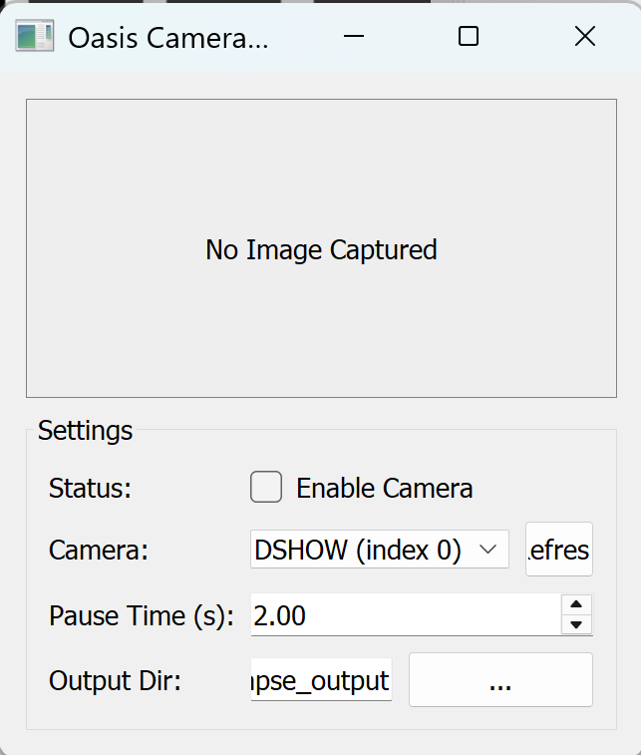
Example image for MainWindow.UI

1.2 Study_params_loader_and_print.py
An experiment automation script that reads parameters from oasis_change_parameters.csv and automatically injects them into the Oasis GUI. Guarantees a reproducible parameter set per run and saves execution records to the runs/ directory.

2. SOP — Standard Operating Procedure

2.1 Pre-Run Checklist
Step | Check Item
1 | Review parameter values in oasis_change_parameters.csv (especially variance entries)
2 | Confirm GRBL motion controller COM port (Device Manager)
3 | Confirm HP45 inkjet controller COM port
4 | Visually inspect powder fill level and printhead condition

2.2 GUI Startup Sequence
⚠️ The following sequence must be followed.
Step | Action | Detail
1 | Load SVG File (First Priority) | File control panel : Open File → Select the target SVG file.
2 | Connect Motor COM Port | Motion tab → Select COM port → Click Connect
3 | Run Homing | Click Home button — confirm machine returns to origin position
4 | Connect Printhead COM Port | Inkjet tab → Select COM port → Click Connect
5 | Verify Temperature Reading | Confirm T (temperature) value appears in the bottom-right of the UI — indicates successful printhead connection

2.3 Printhead cleaning procedure before printing
Printhead Nozzle Check & Priming Procedure
Perform the following procedure before every print to ensure print quality.
Step 0 | Cleaning Procedure (if poor jetting is observed)  1) Sonicate printhead in IPA (isopropyl alcohol) for 1 minute  2) Remove all moisture using a fine-cleaner (lint-free wiper recommended)  3) Reinstall the printhead  4) Click “HeadClean” in UI and wait for 40s  5) See the binder is jetting when click “Prime” and re-verify jetting performance

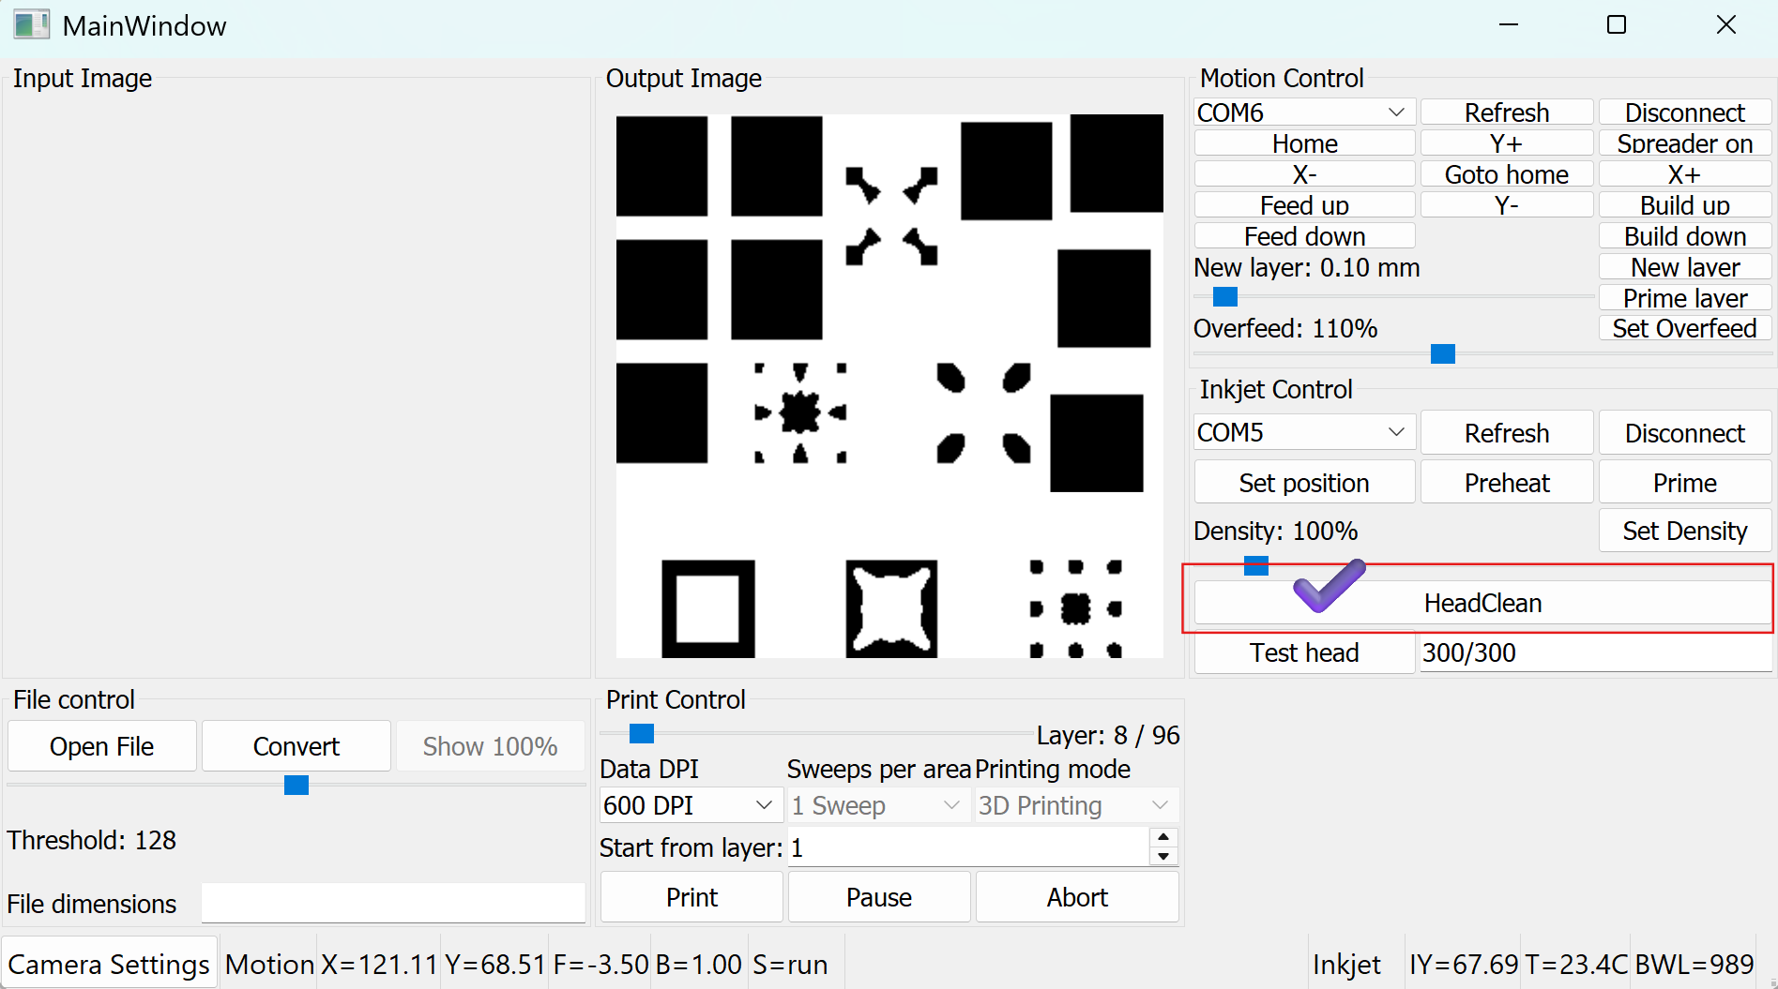

Cleaning Sequence The sequence executes automatically with a 1000 ms interval between each burst:
Preheat x10 prime x10 Preheat x10 prime x5 preheat x5 Total 40burst (40seconds)

Important Notes
- Ensure the inkjet is connected (Connect button shows "Disconnect").
- Ensure the printer is not currently printing.
- The button is silently blocked if the inkjet is not connected or if a print is in progress.
- The cleaning sequence runs in a background thread (daemon=True) and does not block the UI.
- Preheat pulse count and Prime pulse count follow the values set in oasis_change_parameters.csv (preheat_pulses, prime_pulses). Defaults: 5000 / 100.
- It is recommended to run HeadClean before the first print of the day or after the printhead has been idle for an extended period.

2.4 Start-Layer Control (Mid-Print Resume)
If the printer stopped in the middle of the layer restart the current layer for the next print run
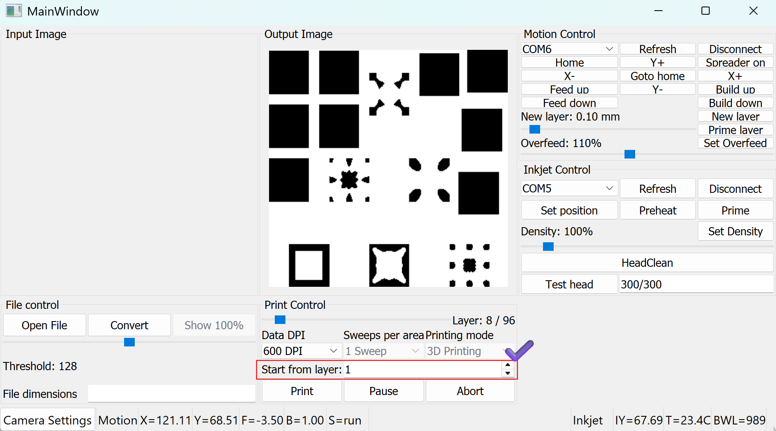
1. Start-Layer Control (Mid-Print Resume)
Overview A new UI control has been added to allow printing to begin from a specified layer rather than always starting from Layer 1. This is useful when resuming a failed or interrupted print job.
Location in UI Inkjet / File Control panel → "Start from layer" spinbox (above the Print button)
How to Use
- Load an SVG file as normal. The spinbox will activate automatically once the file is loaded.
- The spinbox maximum is automatically set to the total number of layers in the loaded file.
- Enter the desired start layer number (minimum: 1).
- Click Print — the printer will begin from the specified layer.

Important Notes
- The spinbox is disabled until an SVG file is loaded. It cannot be edited for bitmap files.
- The entered value is automatically clamped: if a value exceeds the total layer count, it is silently reduced to the last valid layer.
- When starting from a middle layer, ensure that the powder bed has already been manually prepared up to the correct height before pressing Print. The software does not verify physical bed state.
- The current_layer_height is initialized from svg_layer_height[start_layer - 1], so Z-height calculations remain accurate regardless of start layer.

3. Print parameter study information

3.1 Parameter Configuration (oasis_change_parameters.csv)
Parameter | Type | Default | Unit | Range | Description
print_speed | variance | 2200 | mm/min | 100–10000 | Inkjet sweep speed
dpi | variance | 300 | dpi | 100–1200 | Print resolution
layer_passes | variance | 3 | — | 1–5 | Repeat passes per layer
density | variance | 500 | permille | 0–1000 | Ink firing density
layer_thickness | variance | 0.1 | mm | 0.05–2 | Layer thickness
overfeed_percent | variance | 100 | % | 175–500 | Default (100) is outside valid range — update to ≥ 175
dwell_time | fixed | 5 | s | — | Wait time before camera capture

3.2 Experiment Record Management
Each run automatically saves to runs/<RUN_ID>/:
File | Contents
manifest.json | Timestamp, git hash, source CSV path, full resolved config
resolved_params.csv | Original CSV values vs. actually applied values (resolved_value column)

To reproduce an experiment: copy the resolved_value column from resolved_params.csv into the value column of oasis_change_parameters.csv and re-run.

