Oasis 3D Printer
Operations Report & Standard Operating Procedure (SOP)
Document Version: 3.0 | Date: 2026-06-03
Software: Oasis_printer_v3.0.py

1. System Overview

1.1 Oasis_printer_v3.0.py
A PyQt5-based GUI application that simultaneously controls an HP45 inkjet printhead and a GRBL motion controller, implementing Binder Jetting 3D printing onto ceramic powder layers.
Component | Description
MainWindow | Main GUI. Split into self.ui (separate window from .ui file) and self.form (widget references)
CameraController | Per-layer image capture (separate widget)
GRBL | Motion serial communication (XY + Z/A rollers)
HP45 | Inkjet printhead serial communication
ImageConverter | SVG/image → print array conversion
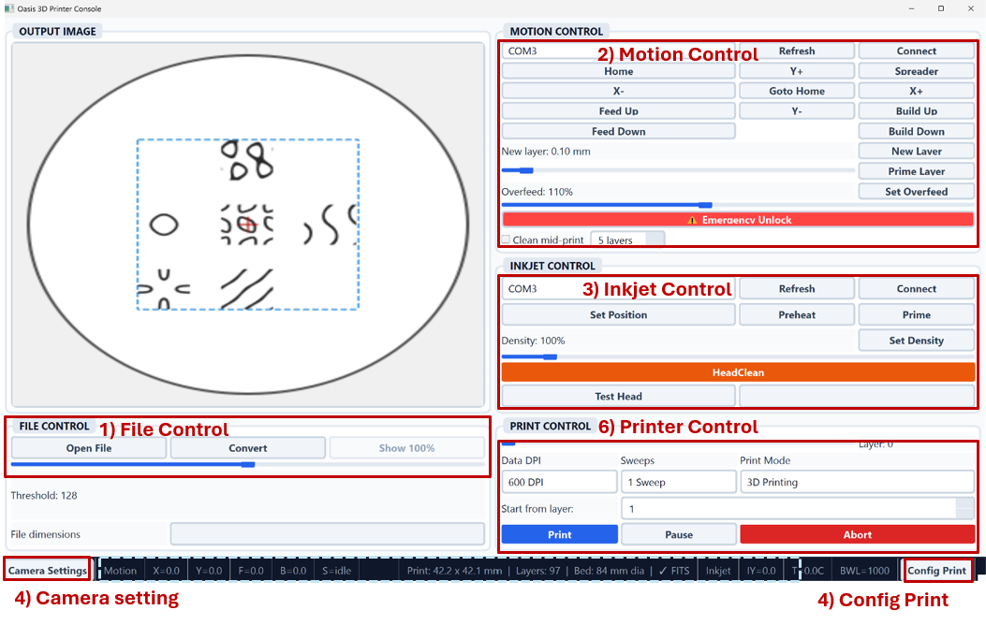
Image for MainWindow.UI

2. SOP — Standard Operating Procedure

2.1 Pre-Run Checklist
Step | Check Item
1 | Review parameter values in print_config.csv (especially variance entries)
2 | Confirm GRBL motion controller COM port (Device Manager)
3 | Confirm HP45 inkjet controller COM port
4 | Visually inspect powder fill level and printhead condition

Note : Additionally, the system must monitor the powder reservoir levels (should be around 70mm below) to ensure adequate supply and confirm that the build substrate is cleared of any previously fabricated structures

Command : you need to type on the terminal
- Cd Oasis_3DPrinter
- venv\Script\activate.ps1
- Python Oasis_printer_v3.0.py

2.2 GUI Startup Sequence
⚠️ The following sequence must be followed.
Step | Action | Detail
1 | Load SVG File | File control panel  - Open File → Select the target SVG file.  - Need to check the maximum height will be fit in the range (middle of the bottom UI)  Select the svg file you want to print out  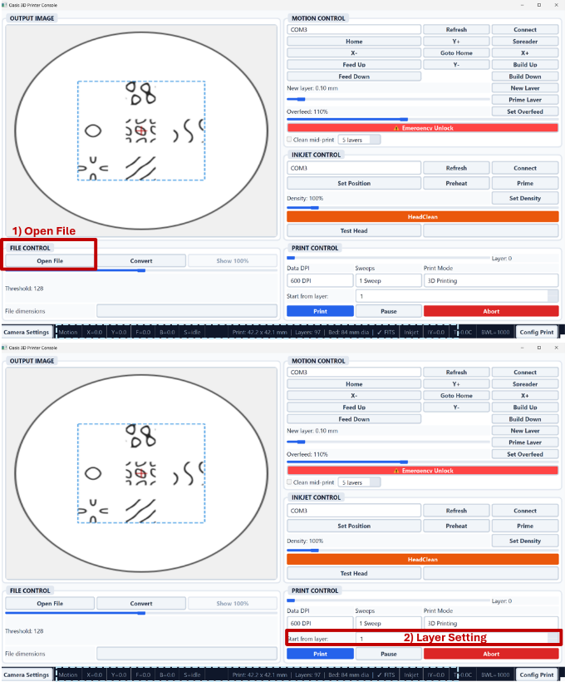  Check the printing part size in the middle bottom of UI  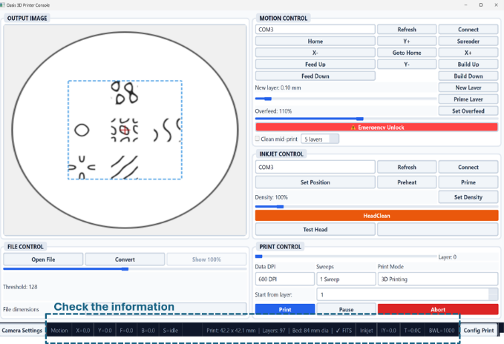
2 | Connect Motor COM Port | Motion Control Panel  → Select COM port (for Zwick laptop, COM3)  → Click Connect  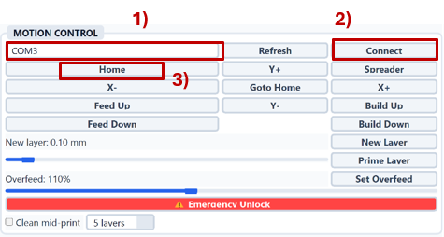  ** CRITICAL CAUTION: Emergency Unlock should be avoided, the system must be homed first under normal operation.  But if a motion control bypass is required without homing (troubleshooting a print failure mid-process or managing an aborted restart) , the Emergency Unlock feature may be engaged to enable manual axis movement.
3 | Run Homing | Click Home button — confirm machine returns to origin position before moving the part (there will be error message if you try to move others before click Home button)
4 | Connect Printhead COM Port | Inkjet Control Panel  → Select COM port (for Zwick laptop, COM4) → Click Connect  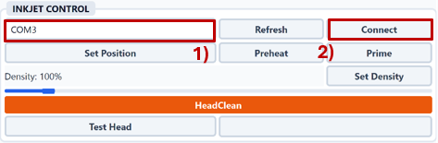
5 | Verify Temperature Reading | Confirm T (temperature) value appears in the bottom-right of the information panel — indicates successful printhead connection  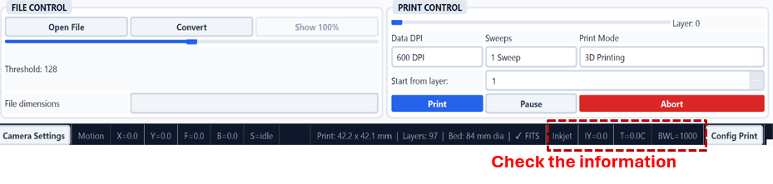
6 | Test printhead working | Click Test head and see 300/300 (meaning all 300 point works okay)  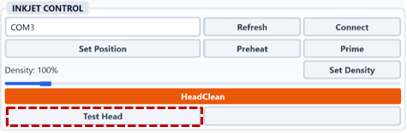
7 | Printhead cleaning | Cleaning Procedure (if poor jetting is observed)  1) Pink solution sprayed onto fine-cleaner  2) Softly remove clogged binder at the surface of the prinhead  3) Reinstall the printhead  4) Click “HeadClean” in UI and wait for 40s  5) See the binder is jetting when click “Prime” and re-verify jetting performance  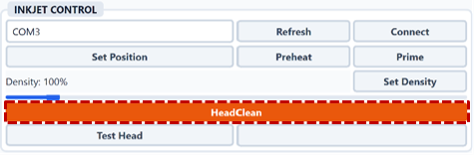
8 | Camera setting | Camera Configuration:  1) Open the Camera Panel and select Enable Camera.  2) Set the camera to Index 1 (Index 0 uses the integrated webcam for Zwick laptop).  3) Set the capture interval to 0.50 s or 1.00 s.  4) exposure setting ( -7 ~ -1, depending on the light setup)  4) Define the Save Directory on the hardware drive (Organize folders by “Date_SampleName”).  NOTE: Always re-verify camera settings when resuming after a printing error.  5) Run calibration  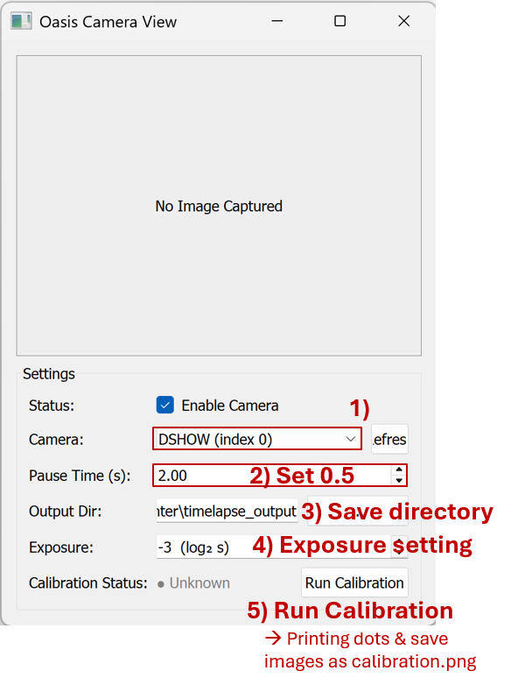
10 | Start Print | - Without config ; Click Print (everything is setting up ), and verify stable processing  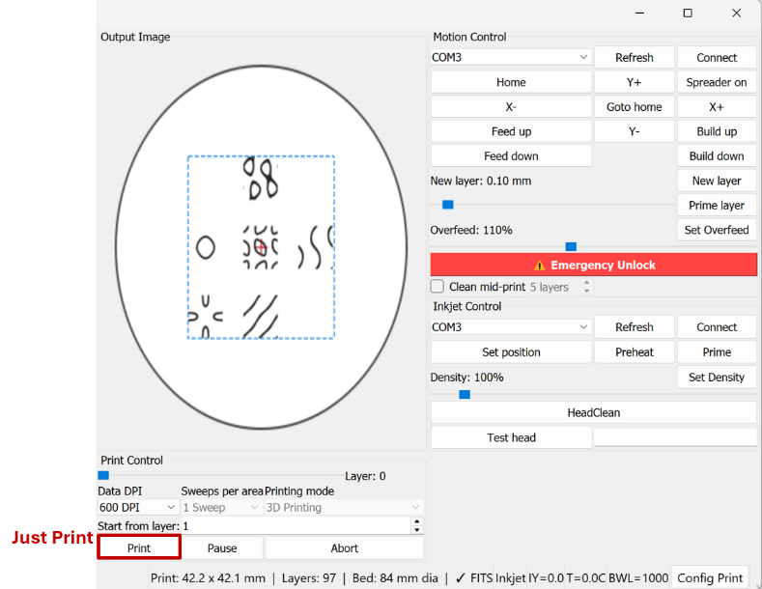  - With config ; Click Config  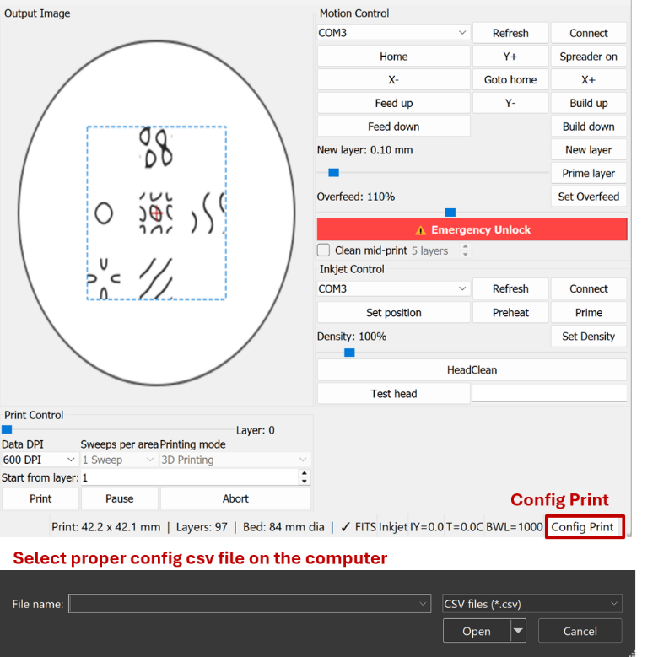

Cleaning Sequence The sequence executes automatically with a 1000 ms interval between each burst:
Preheat x5prime x5 Preheat x5 prime x5 preheat Total 20burst (20seconds)

Important Notes for Cleaning
- Ensure the inkjet is connected (Connect button shows "Disconnect").
- Ensure the printer is not currently printing.
- The button is silently blocked if the inkjet is not connected or if a print is in progress.
- The cleaning sequence runs in a background thread (daemon=True) and does not block the UI.
- Preheat pulse count and Prime pulse count follow the values set in oasis_change_parameters.csv (preheat_pulses, prime_pulses). Defaults: 5000 / 100.
- It is recommended to run HeadClean before the first print of the day or after the printhead has been idle for an extended period.

2.4 Start-Layer Control (Mid-Print Resume)
If the printer stopped in the middle of the layer restart the current layer for the next print run
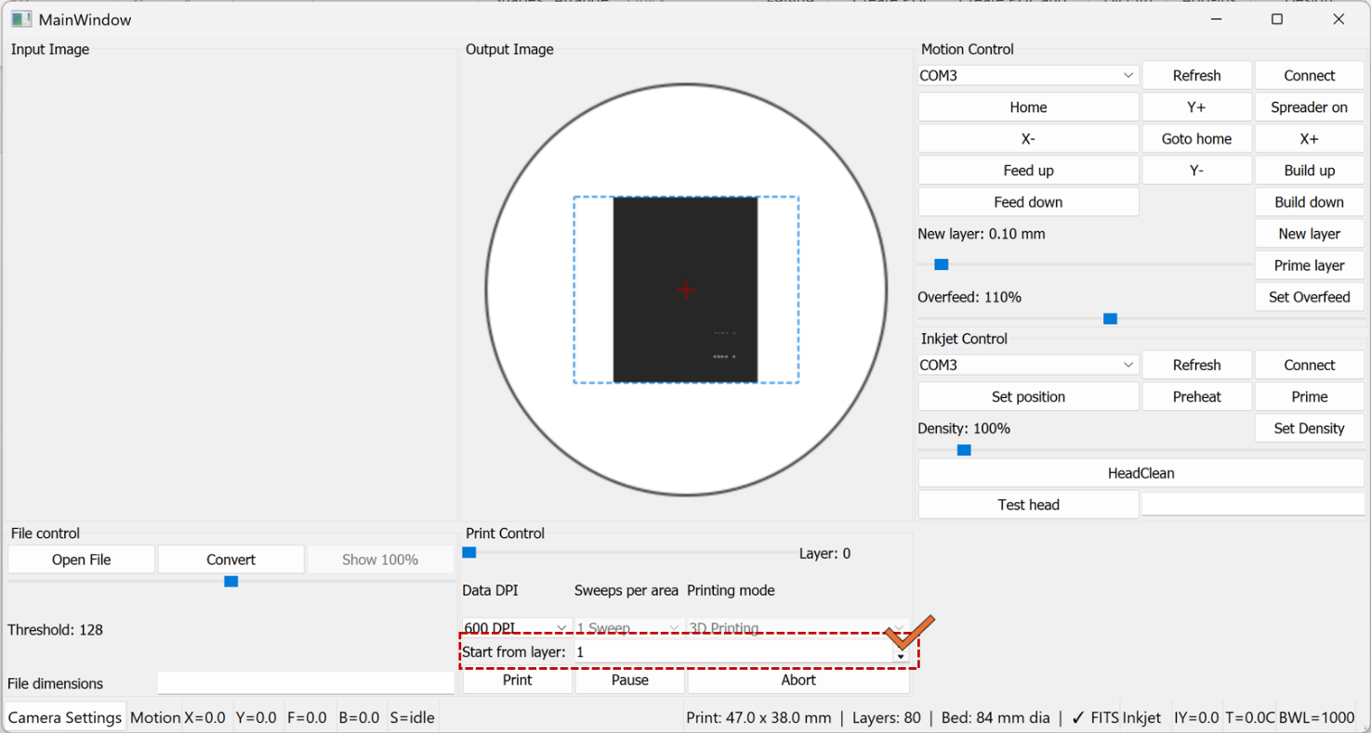
1. Start-Layer Control (Mid-Print Resume)
Overview A new UI control has been added to allow printing to begin from a specified layer rather than always starting from Layer 1. This is useful when resuming a failed or interrupted print job.
Location in UI Inkjet / File Control panel → "Start from layer" spinbox (above the Print button)
How to Use
- Load an SVG file as normal. The spinbox will activate automatically once the file is loaded.
- The spinbox maximum is automatically set to the total number of layers in the loaded file.
- Enter the desired start layer number (minimum: 1).
- Click Print — the printer will begin from the specified layer.

Important Notes
- The spinbox is disabled until an SVG file is loaded. It cannot be edited for bitmap files.
- The entered value is automatically clamped: if a value exceeds the total layer count, it is silently reduced to the last valid layer.
- When starting from a middle layer, ensure that the powder bed has already been manually prepared up to the correct height before pressing Print. The software does not verify physical bed state.
- The current_layer_height is initialized from svg_layer_height[start_layer - 1], so Z-height calculations remain accurate regardless of start layer.
- For each 5 layer, the printhead cleaning procedure is added (3 preheat+ 3 prime)

3. Print parameter study information
If you want to run large printing campaigns, using this buttons (right below : Config Print)
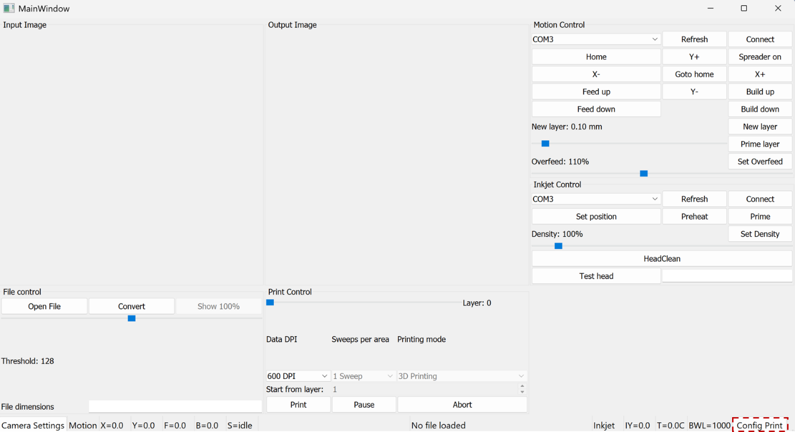
Load config file (csv), it run automatically after loading the files (always start from the first layer)

3.1 Parameter Configuration (oasis_change_parameters.csv)
Parameter | Type | Default | Unit | Range | Description
print_speed | variance | 2200 | mm/min | 100–10000 | Inkjet sweep speed
dpi | variance | 300 | dpi | 100–1200 | Print resolution
layer_passes | variance | 3 | — | 1–5 | Repeat passes per layer
density | variance | 500 | permille | 0–1000 | Ink firing density
layer_thickness | variance | 0.1 | mm | 0.05–2 | Layer thickness
overfeed_percent | variance | 100 | % | 175–500 | Default (100) is outside valid range — update to ≥ 175
dwell_time | fixed | 5 | s | — | Wait time before camera capture

3.2 Experiment Record Management
Each run automatically saves to runs/<RUN_ID>/:
File | Contents
manifest.json | Timestamp, git hash, source CSV path, full resolved config
resolved_params.csv | Original CSV values vs. actually applied values (resolved_value column)
campaign_log.csv | Per-image log: timestamp, step_id, layer_idx, pre_or_post, note, image_filename, and all applied parameter values

To reproduce an experiment: copy the resolved_value column from resolved_params.csv into the value column of oasis_change_parameters.csv and re-run.

3.3 Print Campaign CSV Schema (print_config.csv)
Each row defines one step (a group of layers printed under identical parameters). Coworkers edit this file directly to define DOE sequences. Empty cells carry over the previous step’s value; step 1 defaults to medium values below.
Column | Code Variable | Low | Medium (default) | High | Notes
step_id | — | — | — | — | Unique integer, sequential
layers | loop count | 10 | 15 | 20 | Layers per step (adjustable per row)
print_speed | self.print_speed | 1100 | 2200 | 3300 | mm/min
travel_speed | self.travel_speed | 1800 | 3000 | 5000 | mm/min
layer_thickness | motion_layer_thickness | 0.05 mm | 0.1 mm | 0.2 mm | mm
dpi | inkjet.SetDPI() | 600 | 600 | 600 | dpi
density | inkjet.SetDensity() | 100% | 250% | 500% | percent
preheat | inkjet.Preheat() | 0 | 1 | 10 | pulse count
prime | inkjet.Prime() | 0 | 15 | 100 | pulse count
layer_passes | layer_passes | 1 | 3 | 5 | passes per layer
overfeed | motion_overfeed | 1.75 | 2.5 | 5.0 | dimensionless multiplier
note | free text label | — | — | — | e.g. “baseline”

3.4 Running a Print Campaign (campaign_runner.py)
campaign_runner.py reads print_campaign.csv and drives the printer autonomously through all steps. Parameters are applied once at the start of each step; existing image capture runs normally every layer. Campaigns can run overnight without intervention.
Pre-campaign checklist
1. Complete standard Pre-Run Checklist (Section 2.1) and GUI Startup Sequence (Section 2.2).
2. Open print_campaign.csv and verify step_id sequence, layers count (10–20), and note labels.
3. Confirm powder reservoir level and image save directory (organized as Date_SampleName).
4. Run a 1-step dry-run (layers=2, note=“smoke_test”) to confirm parameter injection before the full overnight run.
Execution
python campaign_runner.py --csv print_campaign.csv
The runner logs progress to the terminal and writes campaign_log.csv in real time. Image filenames include step_id, layer index, pre/post tag, and note slug (e.g. s001_L003_pre_baseline.png).
Post-campaign
1. Verify campaign_log.csv row count matches expected total images.
2. Review images by step_id to qualitatively confirm defect appearance vs. expected conditions.
3. Copy runs/<RUN_ID>/ and campaign_log.csv to the project archive folder.
4. If mask validation confirms expected defects, proceed to segmentation. Otherwise revise print_campaign.csv and re-run.
Important Notes
• Parameters are applied once per step (at step start), not per layer.
• An empty cell carries over the previous step’s value. Step 1 defaults to medium values.
• A validation warning prints if a value is outside the known range. The print is NOT aborted.
• Do NOT edit print_campaign.csv while the campaign is running.

