Acme Pharmaceuticals

Lestaro
  - How to Create: Stability Sample Tracker
Version 1.0

Table of Contents
Instruction Guide 3
Creating the Stabillty Sample Tracker 4

Instruction Guide
The stability tracker is a tool created in Excel spreadsheet that tracks samples during the stability study of a pharmaceutical product.
The sample tracker will consist of information about the product as follows:
- Product
- Product Description
- Lot Number(s)
- Product Type
- Initiation and End Time
- Total Storage Period
- Pull Schedule
- Pull Date

- Definitions of Terms
Name | Description
Product | Drug Substance or Drug Product in the stability study (for example, Acetaminophen (Drug Substance) Tylenol (Drug Product).
Product Description | Actual name of the active ingredient (DS) or brand label (DP).
Lot Number(s) | Unique identification number assigned to the product for DS or DP.
Drug Substance (DS) | Active raw ingredient of the product.
Drug Product (DP) | Complete, ready-to-use medication (for example, tablet, capsule, or liquid).
Initiation | Start date of the stability study.
End Time | Final time (date) which the product is tested
Total Storage Period | Entire duration of storage for the product during stability study.
Pull Schedule | Date when the product is scheduled to be pulled for testing
Pull Date | Number of months is based on the pull schedule date.

Creating the Stabillty Sample Tracker
- Entering the Labels
- Entering the Data
To create the tracker, you will enter the labels and data. When you are finished, your result should look like Figure 1.
- Completed Spreadsheet
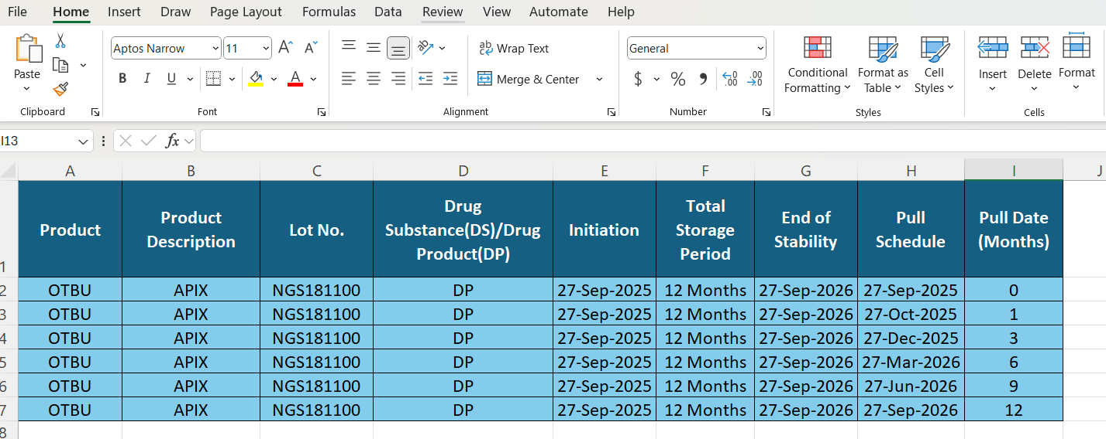
- Entering the Labels
Cell | Text
A1 | Product
B1 | Product Description
C1 | Lot No.
D1 | Drug Substance (DS) / Drug Product (DP)
E1 | Initiation
F1 | Total Storage Period
G1 | End of Stability
H1 | Pull Schedule
I1 | Pull Date

Note: To avoid entering the labels every time, save a copy to use as a template for future Stability Sample Tracker spreadsheets.

- Entering the Data
Cell | Text
A2-A7 | OTBU
B2-B7 | APIX
C2-C7 | NGS181100
D2-D7 | DP
E2-E7 | 27-Sep-2025
F2-F7 | 12 Months
G2-G7 | 27-Sep-2026
H2 | 27-Sep-2025
H3 | 27-Oct-2025
H4 | 27-Dec-2025
H5 | 27-Dec-2025
H6 | 27-Jun-2026
H7 | 27-Sep-2026
I2 | 0
I3 | 1
I4 | 3
I5 | 6
I6 | 9
I7 | 12

Note: To add products, follow the instructions as explained above

