**Project Plan**

**Project Name:**

Doodle Adventure

**Project Description:**

The project is a game inspired by Doodle Jump (https://doodlejump.io/). In the game, the player controls the doodle to go left or right, so that the doodle can jump on a platform and go upward. If the doodle doesn’t step on a platform, it will fall, and the game is over. The doodle can collect the coins that appear on the platform. The doodle will also get a 20-coin reward for every 1000 pixels it jumps up. While the doodle is jumping up, monsters may appear. If the doodle bumps on a monster, the game is over. Doodle can kill the monster by shooting bullets toward it. To win the game, the doodle needs to collect 100 coins.

**Structural Plan**:

The Doodle Adventure can be divided into several small features, and those features interact with each other to build up the game. Here is a list of the features:

**Basic features:**

1. **Platforms Generation and Renew:**

At the beginning of the game, 20 platforms will be generated on canvas. The position of the platforms is random, yet the game is still winnable. That’s to say, there is at least one platform that the doodle can continue jumping on.

With the doodle going up, the canvas can scroll up infinitely. As the old platforms get out of the bound of the canvas, the new platforms will be generated, while the number of the platform will always be the same. Every 1000 pixels the doodle goes up, the number of the platform will decrease by one or two.

1. **Doodle Movement:**

The doodle’s movement mimics elasticity and gravity. It is always experiencing the downward acceleration of 10 pixels per timerFired. If the doodle jumps on a platform, it will experience an upward acceleration of 50 per timerFired. Meanwhile, the vertical and horizontal speed is set to zero. The player controls the doodle by pressing the Left key or Right key. Pressing the key will generate a 20 pixel per timerFired acceleration. If the horizontal speed is not zero, the doodle will experience a horizontal resistance opposite to the movement direction.

1. **Coins:**

3 to 5 coins randomly appear on the platforms. If the doodle jumps on a platform with a coin, the doodle will get that coin, and the coin will be disappeared on the platform. As the old coins are collected by the doodle or getting out of the canvas bound, new coins will be generated. The number of coins will always be the same.

1. **Monster:**

When the doodle gets more than 20 coins, a monster will appear every 1000 pixels while the doodle gets up. If the doodle bumps a monster while jumping up, the game is over.

**Advanced Function:**

(I will create those features if I have enough time)

1. **Path Finding:**

When pressing “r”, the best path will be shown. The best path is the path that helps the doodle get more coins and avoid the monster.

1. **More Kinds of Platforms:**

As the doodle collects more and more coins, different kinds of platforms will appear. For instance, there may be platforms moving back and forth. I will create a platform class, and different kinds of platform will be different subclasses.

1. **More Kinds of Monsters:**

Different kinds of monsters may appear as the doodle collects more and more coins. For instance, monsters may be able to move around or may need more bullets to be killed.

**Algorithmic Plan:**

The most complex part will be the Path Finding. There are two methods I can use. First, I can use nested for loops, counts the number of coins the doodle will get on every possible path, and return the best one. Second, I can use backtracking.

The other complex part will be stimulating the physical movement of the doodle. As I mentioned in *Doodle Movement*, I will calculate the movement by setting the horizontal and vertical acceleration. As a result, I will be able to accurately calculate the speed of the doodle, and letting it move according to the law of physics.

**Version Control Plan:**

I start by creating the basic features one by one. After creating a feature or a group of interconnected features, I will upload the file on google drive. If I don’t finish a feature in a day, I will also upload what I got on google drive.

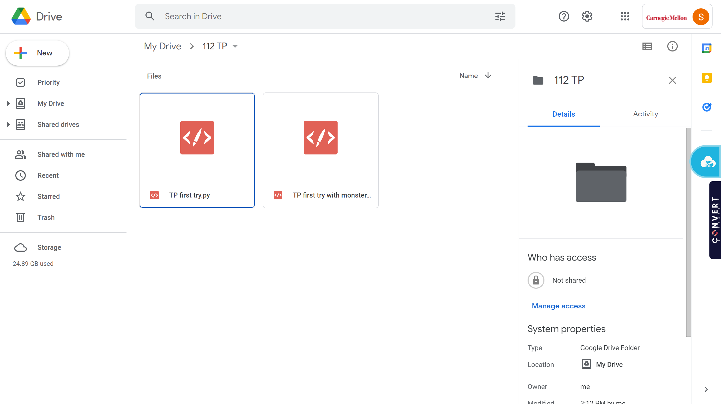

The Folder I build For Storing the TP File

**TP 2 Update:**

I am not going to do the path finding.

I will create more interesting features, such as breakable platform, if I have time.

I will focus on improving the UI, replacing the geometric figure with images.

**TP3 Update:**

I create “Flying Hat” feature.

When the canvas is not scrolling, a flying hat will appear. The flying hat will give the doodle an upward acceleration of 90.

I also load image to the game to make it look nicer.