1.

**Do you prefer going shopping or shopping online? Why?**

I do not like to go shopping because I dislike crowded public spaces. I’d rather browse and buy things from the comfort of my own home.

**What do you like shopping for most?**

I usually shop for devices like headphones and phones, but I don’t really do that often, because I usually don’t buy new devices every month.

**Which photo above do you most associate with “shopping”? Explain why.**

Photo A. I usually associate “shopping” with going to a store. I don’t consider buying things from an online store shopping.

My favorite online store is amazon. Mostly because it offers many products and has a great refund policy.

I don’t really have many positive things to say. Amazon has a monopoly in this sector and barely has any competition. The UI is bad, very bad. I also don’t really like amazon as a company, due to their business practices.

I rather rarely buy things from there. My parents use it a lot more than me. The last thing I bought from Amazon was a pair of wireless earphones.

2.

**Advantages of online shopping:**

* You don’t have to go to a store to buy things.
* You have all purchasable items available to buy without needing to go to different stores.
* Usually cheaper than normal stores (it’s easy to check different sites for cheaper prices or use add-ons to find coupon codes)
* You can order things not available in your country.
* You can buy products from everywhere and have them delivered to your home.
* No need to wait in queues.
* Way faster and easier to find more niche products.

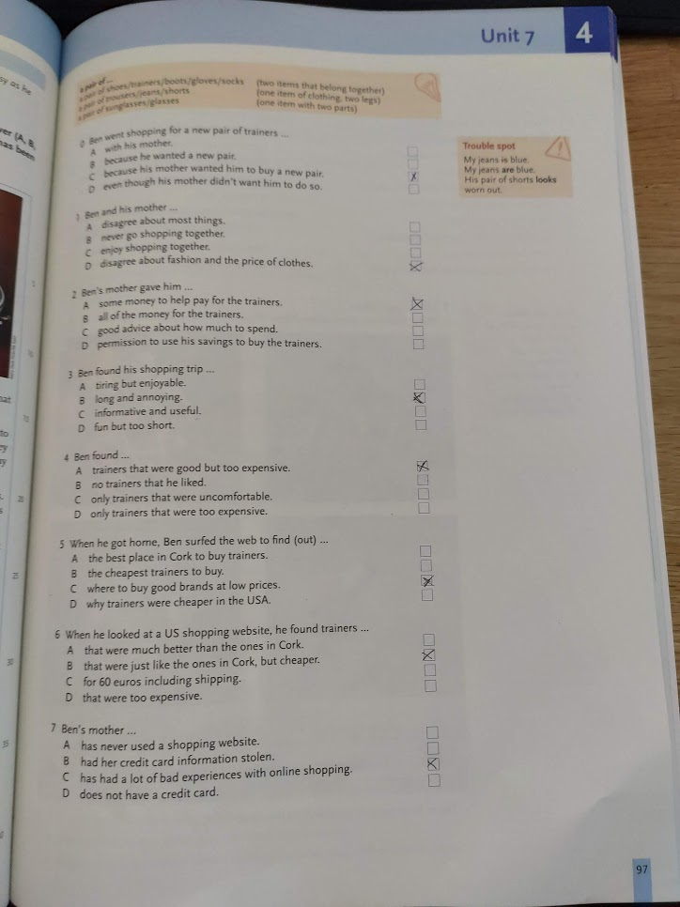3.