**Task 7**

I would prefer my school. In the US there are many school shootings and there’s easy access to guns or drugs. Because of that I wouldn’t feel safe at a US school. I also heard a lot of bad things about the US school system, which isn’t a good thing. Switching classes after every lesson is not that great. I would probably get lost in the first couple of weeks at school. Tech wise, our school is decent, so no complaints there. Language wise, I would prefer American schools, because I prefer English more than German. In the end, I think a more capable and robust school system is more important, so I’d rather stay at here in Austria, than go to an American high school.

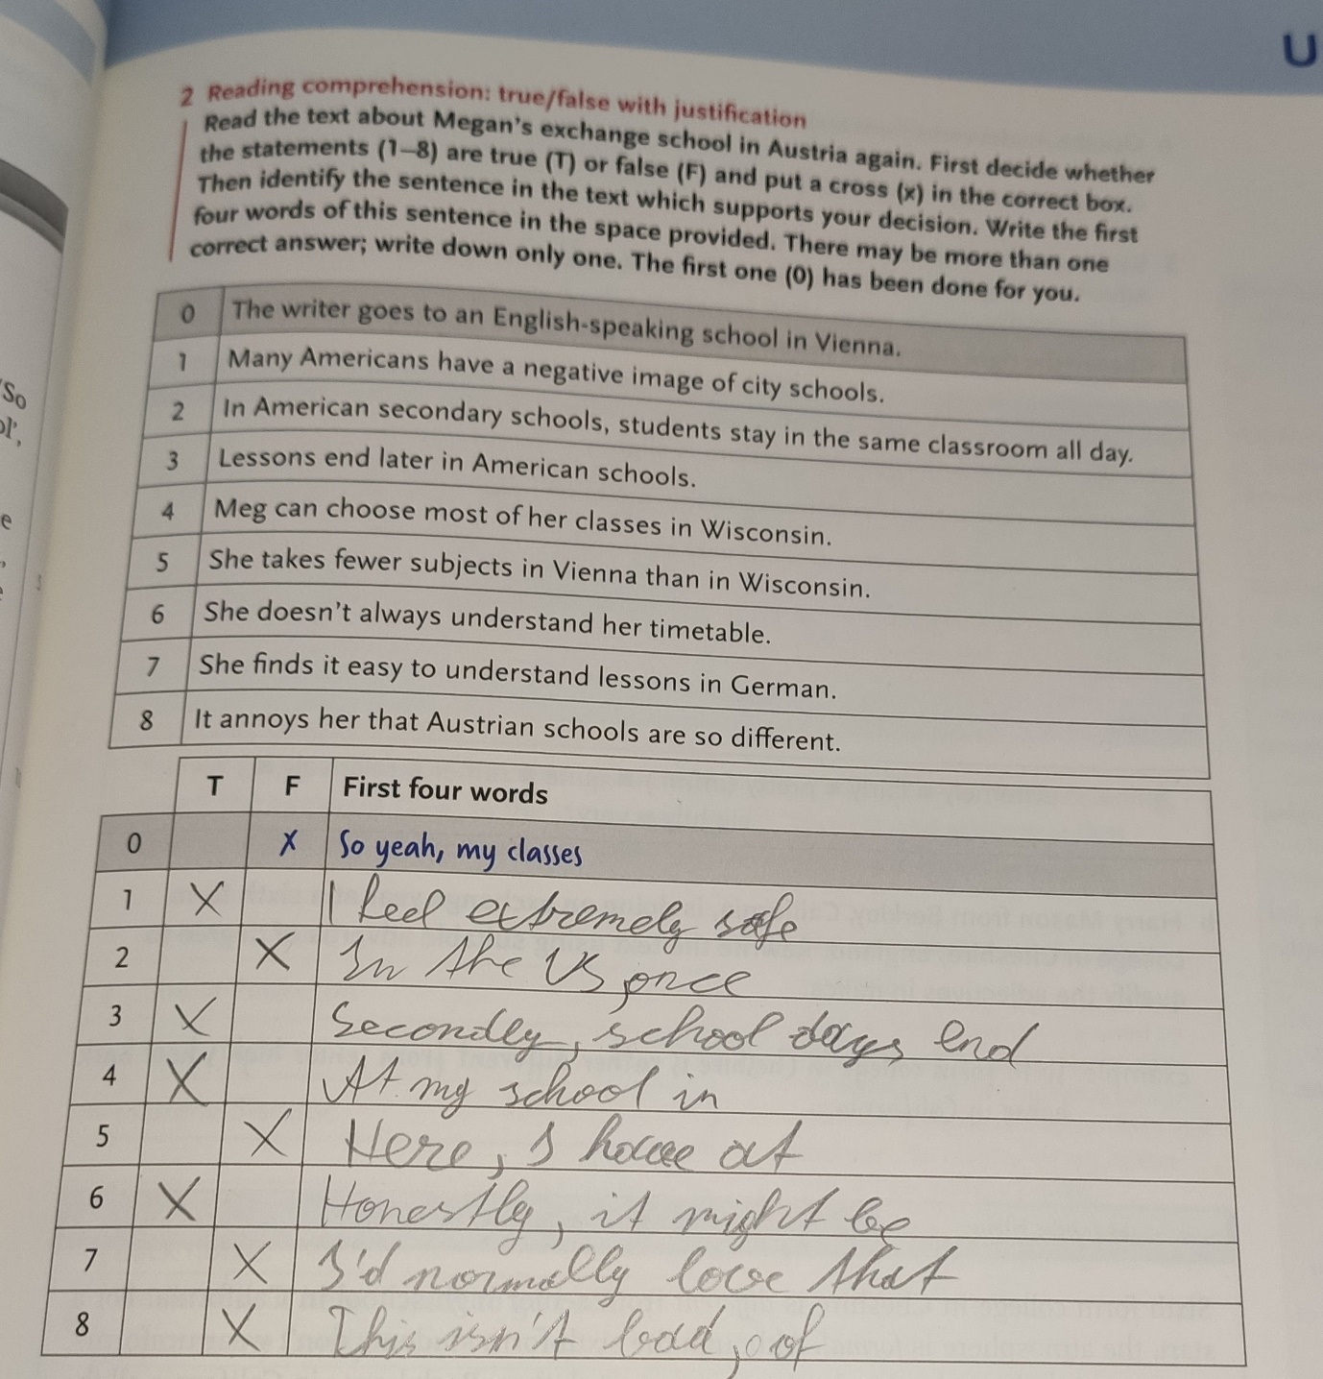Page 71: