1º Add two new groups named “daw” and “crey”

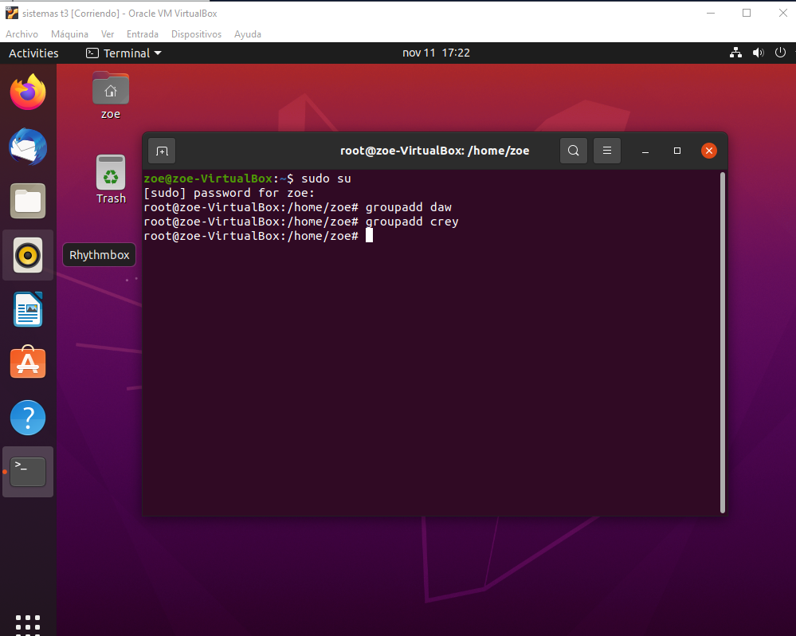

For add new groups we need the command groupadd “new group name”

2º Change “daw” and “crey” GIDS to 2001 and 2002, respectively.

Frist I loow what was the id of the groups and then for change their i use the command groupmod -g “the new id” “group name”



3º Create a new group called “profesores” with GID of 2000. Then, modify the group name to teachers

For create a group with a specify id we need to use the command groupadd -g “id” “group name” and for change the name we need to use groupmod -n “new name group” “group name”

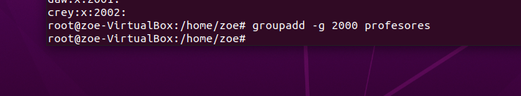

4º Verify that you have correctly created the groups named “daw”, “crey” and “teachers”

for see the comans and the id togethers i look it with the command cat /etc/group



5º Add a new user named “john” whose primary group is “crey”. Has the home directory been created with the default command?

The home directory has been created by default you don't need a command



6º Add a new user named “mary”, whose primary group is “daw” and the home directory /home/mary



7º Add a new user named “martha”, whose primary group is “teachers”, the home directory /home/martha and belonging to the secondary group “crey”



8. Add the following names to the users that you have just created: a. John= “John Doe” b. Mary = “Mary Williams” c. Martha = “Martha Jones”

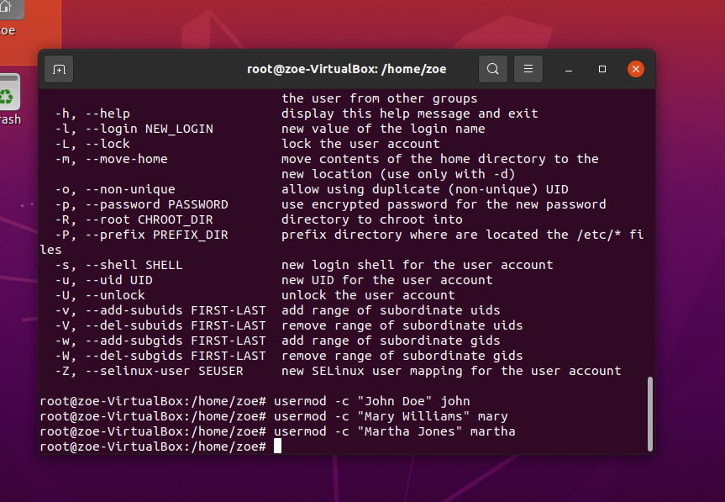

9. How could you check that you have created all the users with the right primary groups?

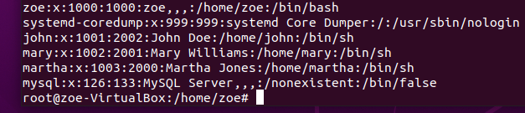

10. Verify if crey group has martha as a member

I change the secondary group of martha because she stay at daw like a secondary group



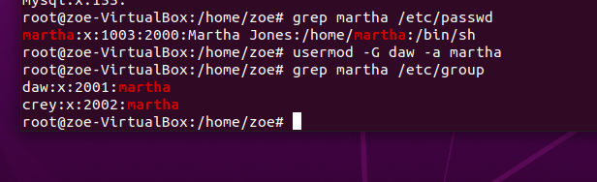

print : id username group user name