- bundle init
- In Gemfile, add gems you need (rspec, sinatra, sinatra-contrib, guard, guard-rspec, rack, rack-test etc)
- bundle install
- Create folders: models, spec, views
- In root folder, create file called .rspec which contains “–color --format documentation”
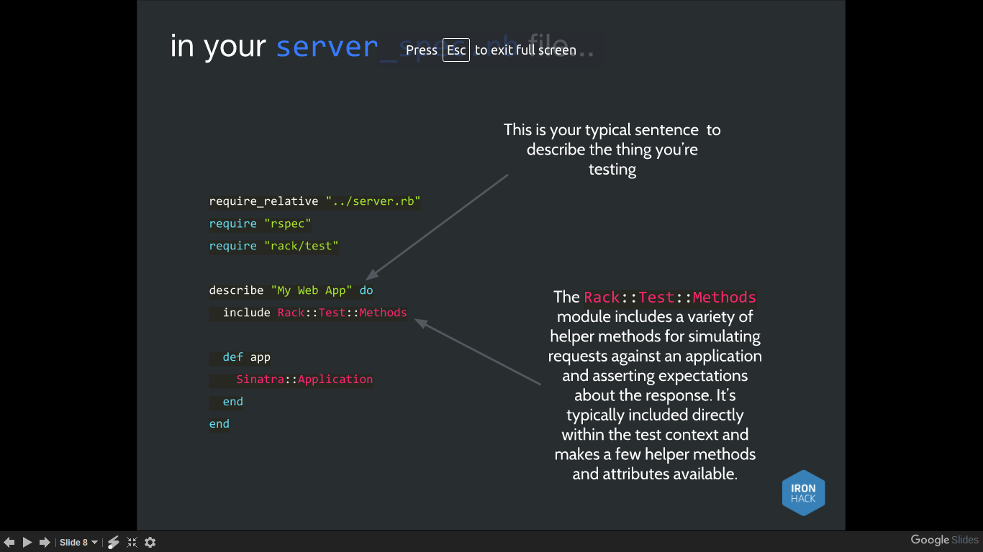
- Write tests in your spec file
- Make server.rb file that begins require “sinatra” , require 'sinatra/reloader' if development?and require_relative
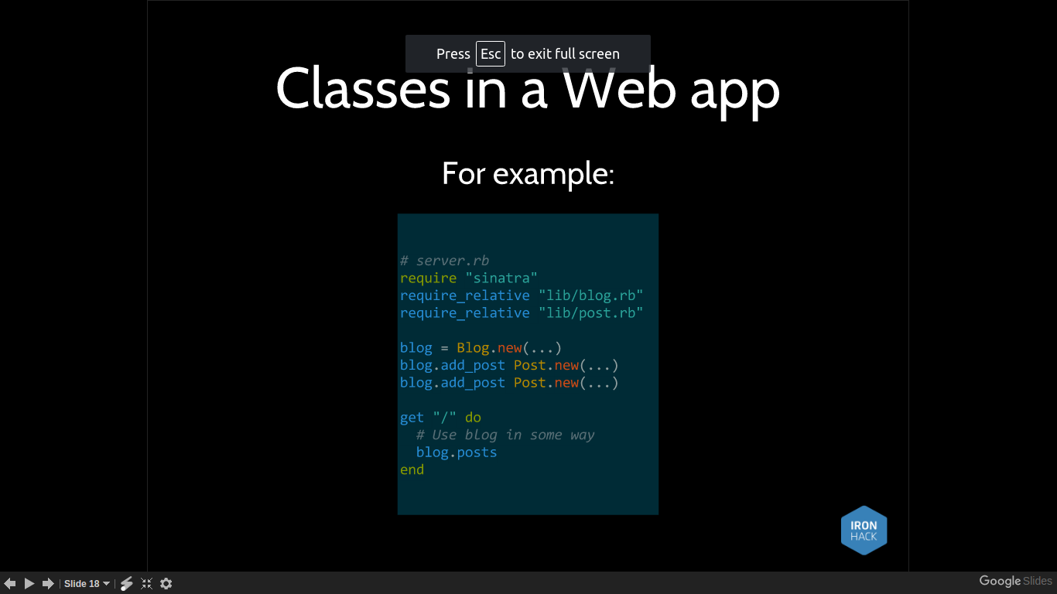
- Optional for automated tests:
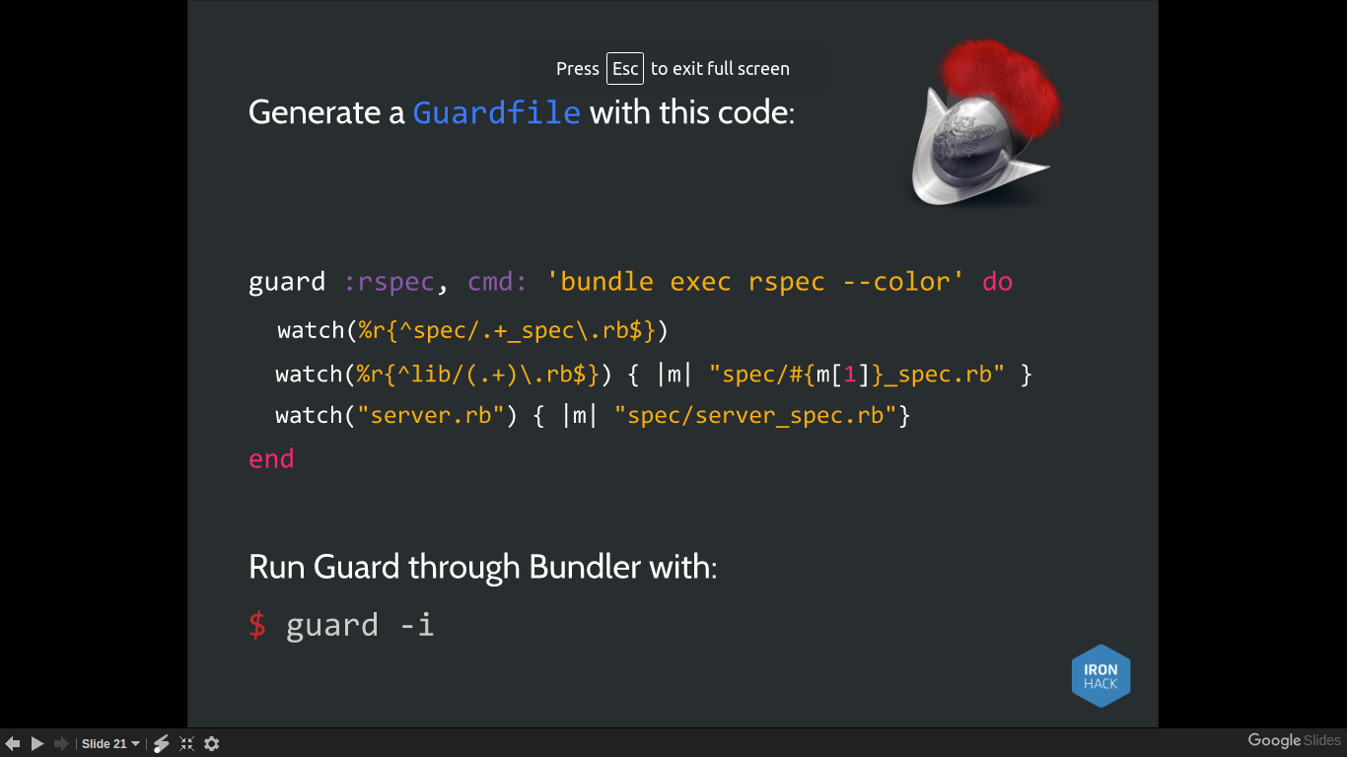
- Create .rb files in ‘models’ (or ‘lib’) for all your classes

