**Evaluation – Interactive Prototype 2**

**Objective and Validation Metrics**

The purpose of this evaluation is to assess the second version of *Discord XR: Galaxy Social Hub*. This prototype tests a full user flow. Participants first join a planet that represents a voice channel. After entering the channel, they find a table where other virtual participants are seated. They then sit down, change seats, and pick up the microphone. The goal is to find out how clearly participants can discover each function, how efficiently they can complete the actions, and how easy each task is to perform.

The test uses the Meta Quest headset to deliver an immersive XR experience. The prototype is built in Unity and tested on the Meta Quest headset, allowing participants to experience real XR interaction. This setup provides a clear sense of space and depth and helps identify possible issues such as motion discomfort or limited spatial feedback. It gives a more accurate view of how the system performs in a realistic 3D environment compared with flat-screen testing.

Success is measured by task completion rate, time taken, number of errors, and participant perception from the System Usability Scale (SUS). After all tasks, participants share comments about what they are satisfied with and what they think needs improvement. These combined methods offer a balanced view of both performance and user satisfaction.

**Results**

All five participants completed every task successfully, and the prototype remained stable without any crash or delay during testing. In the Task 1, participants joined a planet (voice channel), taking an average of about 10.6 seconds to complete the action. Two participants hesitated because they were unsure whether the system had recognised their selection, which showed that the joining process lacked a clear confirmation cue. When asked to sit at the virtual table in the Task 2, participants required around 7.0 seconds on average, and everyone completed the step smoothly. Many described the movement as natural and realistic, suggesting that the sitting interaction was intuitive and comfortable. For Task 3, participants change seats within the same scene. This task took the longest time, averaging 16.6 seconds. One participant reported slight dizziness when moving to another seat, while others finished without difficulty. This indicates that smoother transitions could help reduce motion discomfort. In the final task, participants picked up the microphone placed at the centre of the table, with an average completion time of 15.0 seconds. All participants succeeded without assistance. Several mentioned that the interaction felt realistic and satisfying, and two suggested dividing the long table into smaller ones to make group discussions more focused and personal.

The System Usability Scale (SUS) results were 67.5, 37.5, 75.0, 87.5, and 92.5 for participants one to five, giving an average of 72.0. Two scores below the benchmark of 68 reflected hesitation in the joining process and mild dizziness during seat changes. The other three scores met or exceeded expectations, showing that most participants found the prototype easy to use and realistic. In general, the SUS results indicate a moderate to high level of usability, with clear strengths in realism and control flexibility but with room for improvement in entry feedback and motion comfort.

|  |  |  |  |  |
| --- | --- | --- | --- | --- |
| **Task** | **Avg. Time (s)** | **Total Errors** | **Completion (%)** | **Notes** |
| **Task 1: Join Planet (Voice Channel)** | 10.6 | 2 | 100 | Some hesitation, unclear confirmation |
| **Task 2: Sit at Table** | 7.0 | 0 | 100 | Smooth and realistic motion |
| **Task 3: Change Seat** | 16.6 | 1 | 100 | One participant reported mild dizziness; others had no issues completing the task |
| **Task 4: Pick up Microphone** | 15.0 | 0 | 100 | Users found it fun and realistic |

Table 1: Summary of Quantitative Results

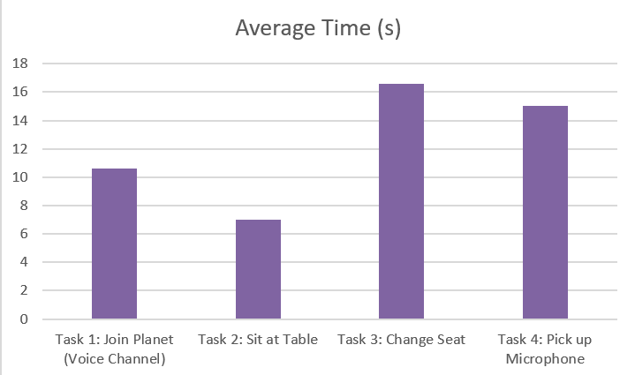 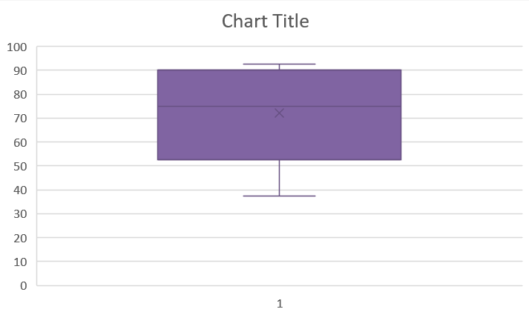

Figure 1 & 2: Average Task Completion Time for Four Tasks & Distribution of SUS Scores Across Participants

**Analysis and Insights**

The evaluation results can be interpreted through four main themes.

Discoverability remained a key challenge since several participants took longer to complete the joining process. Although everyone managed to enter a planet that represented a voice channel, two participants hesitated, showing that unclear confirmation slowed their progress. The system worked correctly, yet participants were unsure when the channel had been entered. This indicates that clearer cues such as short text or visual effects are necessary to confirm completion and reduce confusion. Realism appeared as a major strength supported by both quantitative and qualitative data. Tasks that involved sitting and picking up the microphone were completed more quickly and without errors. Participants described these actions as natural and enjoyable, saying that the microphone felt real to hold. Their feedback, supported by higher SUS scores, showed that realism and responsive feedback increased satisfaction and ease of use. Comfort was another important theme. The low number of errors showed that participants performed tasks accurately, though one participant reported slight dizziness when changing seats, which was slower than other interactions. This suggests that smoother transitions could improve stability. Also, the long table limited interaction, whereas smaller tables could create a more natural and comfortable setting for group discussions. Feedback remained a recurring issue. Although overall usability was acceptable, participants lacked confidence when cues were missing, and the absence of sound or visual signals after joining or sitting often led to trial and error. Adding short sound cues or simple animations could make responses clearer and reduce mistakes.

These insights reveal that while the prototype provided realistic and engaging experiences, further improvement is needed in clarity, feedback, and comfort. Enhancing visual and audio responses would make interaction smoother and help users perform actions with greater certainty.

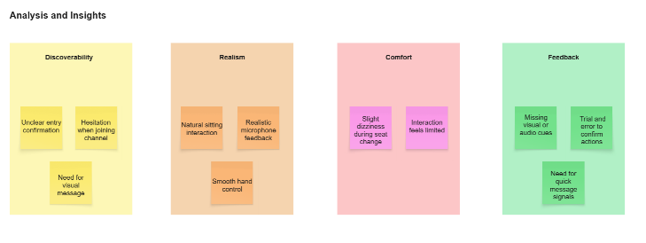

Figure 3: Key Themes Identified in User Evaluation

**Evaluation of Aims**

The results confirmed that the prototype met most of its testing goals. The assumption that participants could complete all four tasks was fully supported, as everyone finished successfully and demonstrated understanding of each action. The expectation that the system would be efficient was also validated through short completion times and the absence of task failures. The goal related to comfort was only partly achieved, since one participant reported mild dizziness during seat changes. The assumption that participants could easily discover how to join a voice channel (planet), was also partially confirmed. Some participants showed hesitation at this step rather than a complete pause, suggesting that the discoverability of the joining process still requires improvement. However, their quick completion once they received minimal guidance indicated that the interaction design was close to intuitive. The belief that realism would enhance engagement was strongly supported, as participants repeatedly praised the microphone and seating interactions. Their feedback demonstrated that tactile and spatial realism helped maintain focus and made the experience more enjoyable.

Overall, the aims of this test were achieved in terms of functionality and performance but were not fully reached in clarity and guidance. These findings provide a strong basis for refining the next iteration of the prototype.

**Concept Iteration**

Based on the valuable quantitative and qualitative data gathered from this evaluation, the next prototype will focus on improving guidance, realism, and comfort. The joining voice channel process will include clearer confirmation cues, like short on-screen messages when a channel is entered. The improvement is expected to reduce hesitation and help participants complete the action with more certainty. The scene layout will be redesigned into several smaller round tables to reflect natural conversation clusters and encourage smoother communication between users. Both hand gestures and controller input will continue to be supported, and a small icon will be added to show the current microphone status, helping participants recognise whether they are muted or unmuted and preventing confusion during interaction.

To address comfort, gradual fade transitions and slower camera movement will be introduced to make motion steadier and reduce dizziness. Visual and sound feedback will be synchronised to provide immediate responses to user actions, such as a small microphone icon appearing when picking up the microphone, or a short message notification when entering a new voice channel. Overall, these changes help participants recognise successful interaction without breaking immersion, making the system more intuitive and consistent with real-world communication cues.

**Reflection**

Reflecting on the concept and design, this evaluation showed me that clarity and user guidance are the foundation of a successful XR experience. The prototype performed as intended, but several participants hesitated when joining a planet that represented a voice channel. Their feedback made me realise that clear confirmation and visible status indicators are essential for smooth interaction. These small details strongly influence how confident users feel when navigating the system. I also recognised that the current table layout limits social engagement, and that dividing it into smaller sections would better support communication and comfort.

From a methodological view, combining quantitative and qualitative data proved valuable. Completion rates and error counts showed that all core functions worked, yet they could not explain the hesitation or uncertainty observed during tasks. Open-ended questions after testing filled this gap and revealed why users reacted as they did. However, I noticed that my note-taking process lacked structure, and some subtle reactions were missed. In future sessions, I will prepare a detailed observation sheet to record actions, gaze focus, and comments, so data collection is consistent and easier to analyse.

This evaluation also showed what did not work as expected. A few participants required extra clarification of task instructions, suggesting that the briefings were too general. For future testing, I plan to create step-by-step task cards and provide a short visual example before the trial begins. These adjustments can reduce hesitation and help participants stay focused on the prototype rather than on remembering instructions.

Looking ahead, the next testing round will focus on validating the revised feedback and spatial design. I will measure whether new confirmation cues shorten hesitation and whether smaller tables improve comfort and group engagement. This process reminded me that iteration is not only about fixing issues but also about improving the way I collect and interpret data. The insights from this round will directly inform the next version of the prototype and shape how I plan and conduct future evaluations.

**Appendix**

**Testing Result IP2**

**Task 1:** Join a channel: Walk to a planet and touch it for 2 seconds to join. Record success, time, and errors.

**Task 2:** Sit at the long table: Walk to the table and sit. Record data.

**Task 3:** Change seat: Stand up and move to another seat. Record time and success.

**Task 4:** Pick up microphone: Grab the microphone in the middle and check if it can be held. Record success and notes.

**U1**

|  |  |  |  |  |  |
| --- | --- | --- | --- | --- | --- |
| **User ID** | **Task ID** | **Success (Y/N)** | **Errors / Assists** | **Time (s)** | **Observation Notes** |
| 1 | 1 | y | 0 | 11 | Although I explained the task, the user still showed some hesitation when joining the planet (voice channel). |
| 2 | y | 0 | 6 | The participant said that because he was also sitting in real life, he felt very natural and connected when doing Task 2 of sitting at the long table. |
| 3 | y | 0 | 14 |  |
| 4 | y | 0 | 18 | The user tried with both left and right controllers and was very satisfied that both could grab the microphone. |

**SUS**

|  |  |  |  |  |  |  |
| --- | --- | --- | --- | --- | --- | --- |
| **No.** | **Statement** | **1**  **Strongly Disagree** | **2** | **3** | **4** | **5**  **Strongly Agree** |
| **1** | I think that I would like to use this system frequently. |  |  |  | x |  |
| **2** | I found the system unnecessarily complex. |  |  | x |  |  |
| **3** | I thought the system was easy to use. |  |  | x |  |  |
| **4** | I think that I would need the support of a technical person to use this. |  | x |  |  |  |
| **5** | I found the various functions in this system were well integrated. |  |  | x |  |  |
| **6** | I thought there was too much inconsistency in this system. |  | x |  |  |  |
| **7** | I would imagine that most people would learn to use this system quickly. |  |  |  | x |  |
| **8** | I found the system very cumbersome to use. |  | x |  |  |  |
| **9** | I felt very confident using the system. |  |  |  | x |  |
| **10** | I needed to learn a lot of things before I could get going with this. |  | x |  |  |  |

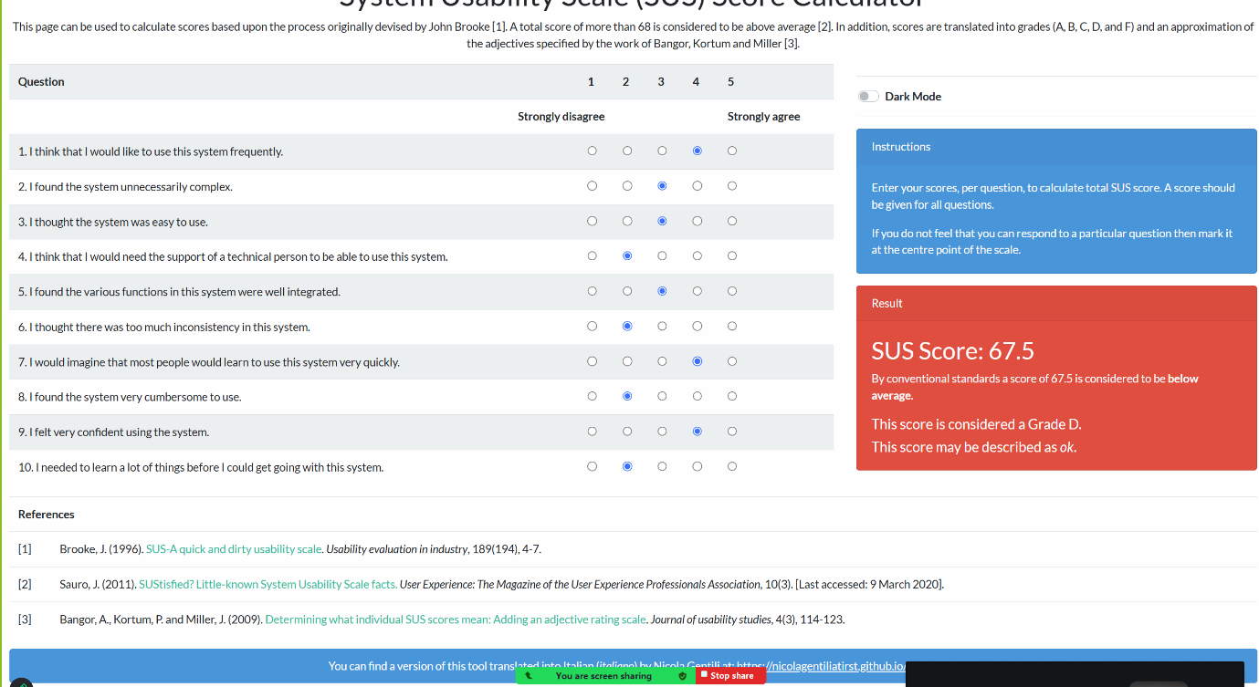

**Open Questions**

**What is one thing you would want me to fix?**

The main thing I want you to fix is the process of entering a planet. I hope it could be changed to remote selection of a planet (voice channel), where the user grabs the one they are interested in, pulls it closer, and after a small visual effect, enters the planet (voice channel). What is one thing you are most satisfied with?

**What is one thing you are most satisfied with?**

Transforming Discord’s voice channels into planets in a galaxy, along with the idea of rotating them, is very attractive.

**U2**

|  |  |  |  |  |  |
| --- | --- | --- | --- | --- | --- |
| **User ID** | **Task ID** | **Success (Y/N)** | **Errors / Assists** | **Time (s)** | **Observation Notes** |
| 2 | 1 | y | 0 | 8 | The participant completed this task smoothly. |
| 2 | y | 0 | 7 |  |
| 3 | y | 1 | 21 | Participant feels a bit dizzy, when she was doing this task. |
| 4 | y | 0 | 15 | The participant tested grabbing the microphone more than once, as if checking its reliability, which shows interest in the object’s function. |

**SUS**

|  |  |  |  |  |  |  |
| --- | --- | --- | --- | --- | --- | --- |
| **No.** | **Statement** | **1**  **Strongly Disagree** | **2** | **3** | **4** | **5**  **Strongly Agree** |
| **1** | I think that I would like to use this system frequently. |  |  | x |  |  |
| **2** | I found the system unnecessarily complex. |  |  |  | x |  |
| **3** | I thought the system was easy to use. |  | x |  |  |  |
| **4** | I think that I would need the support of a technical person to use this. |  |  | x |  |  |
| **5** | I found the various functions in this system were well integrated. |  |  | x |  |  |
| **6** | I thought there was too much inconsistency in this system. |  |  | x |  |  |
| **7** | I would imagine that most people would learn to use this system quickly. |  |  | x |  |  |
| **8** | I found the system very cumbersome to use. |  |  |  | x |  |
| **9** | I felt very confident using the system. |  | x |  |  |  |
| **10** | I needed to learn a lot of things before I could get going with this. |  |  |  | x |  |

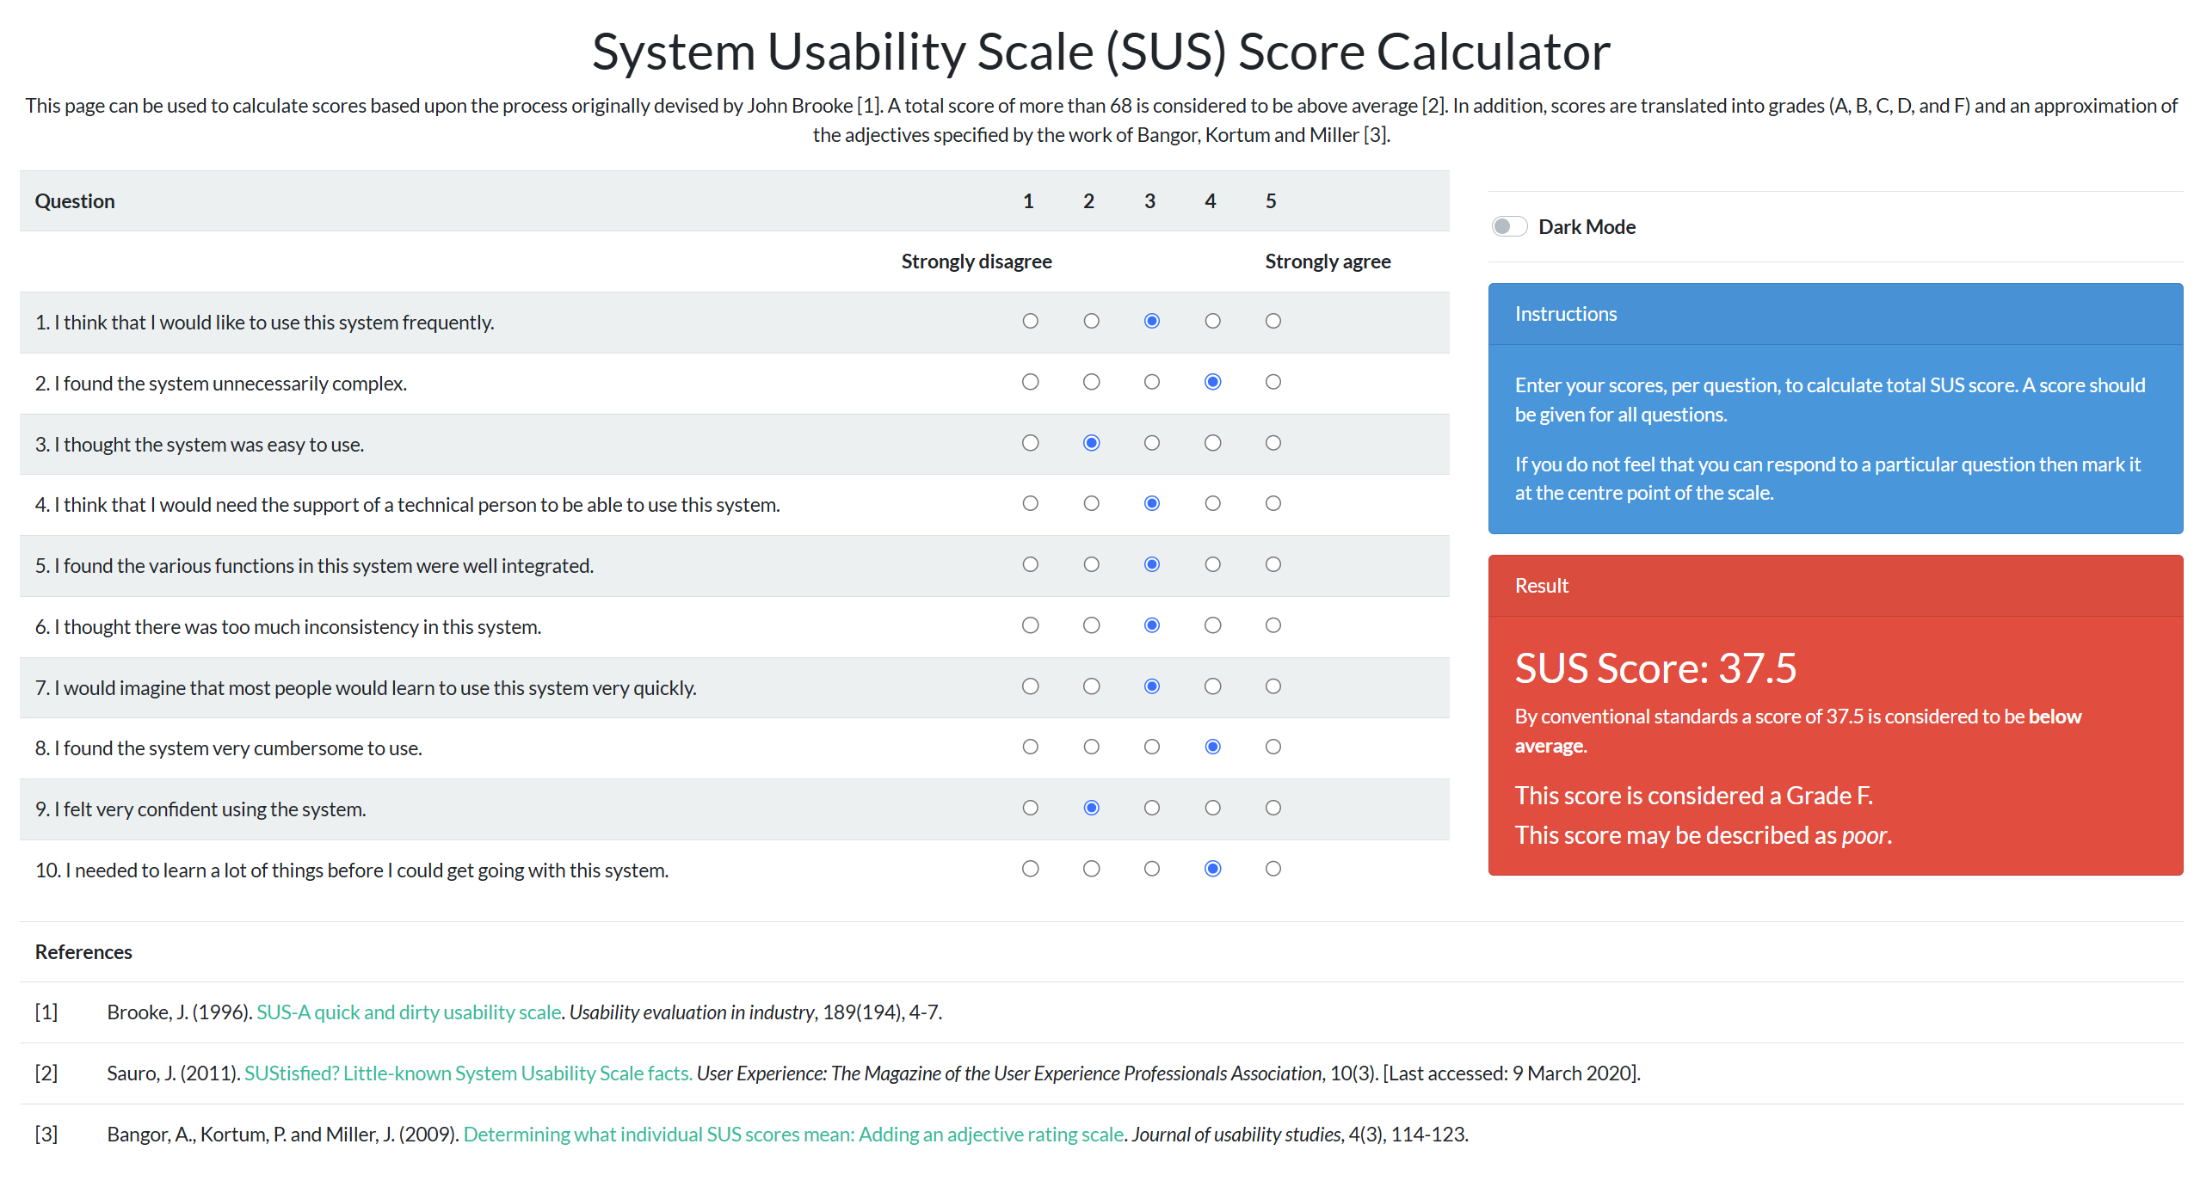

**Open Questions**

**What is one thing you would want me to fix?**

I hope you can change the long table into several smaller tables, so that it shows the idea of only needing to communicate with the people sitting at the same table.

**What is one thing you are most satisfied with?**

I am most satisfied with the interaction of selecting a planet to enter, as it feels very interesting.

**U3**

|  |  |  |  |  |  |
| --- | --- | --- | --- | --- | --- |
| **User ID** | **Task ID** | **Success (Y/N)** | **Errors / Assists** | **Time (s)** | **Observation Notes** |
| 3 | 1 | y | 0 | 9 |  |
| 2 | y | 0 | 9 | The participant paused briefly when entering a new scene, as if searching for cues, which suggests that on-screen text or hints could improve clarity. |
| 3 | y | 0 | 13 | While completing the seating task, the participant moved directly without hesitation, indicating that this action was already clear enough without extra guidance. |
| 4 | y | 0 | 14 | The participant smiled when picking up the microphone, showing that the interaction felt natural and realistic. |

**SUS**

|  |  |  |  |  |  |  |
| --- | --- | --- | --- | --- | --- | --- |
| **No.** | **Statement** | **1**  **Strongly Disagree** | **2** | **3** | **4** | **5**  **Strongly Agree** |
| **1** | I think that I would like to use this system frequently. |  |  |  | x |  |
| **2** | I found the system unnecessarily complex. | x |  |  |  |  |
| **3** | I thought the system was easy to use. |  |  | x |  |  |
| **4** | I think that I would need the support of a technical person to use this. |  | x |  |  |  |
| **5** | I found the various functions in this system were well integrated. |  |  | x |  |  |
| **6** | I thought there was too much inconsistency in this system. |  | x |  |  |  |
| **7** | I would imagine that most people would learn to use this system quickly. |  |  |  |  | x |
| **8** | I found the system very cumbersome to use. |  | x |  |  |  |
| **9** | I felt very confident using the system. |  |  |  | x |  |
| **10** | I needed to learn a lot of things before I could get going with this. |  | x |  |  |  |

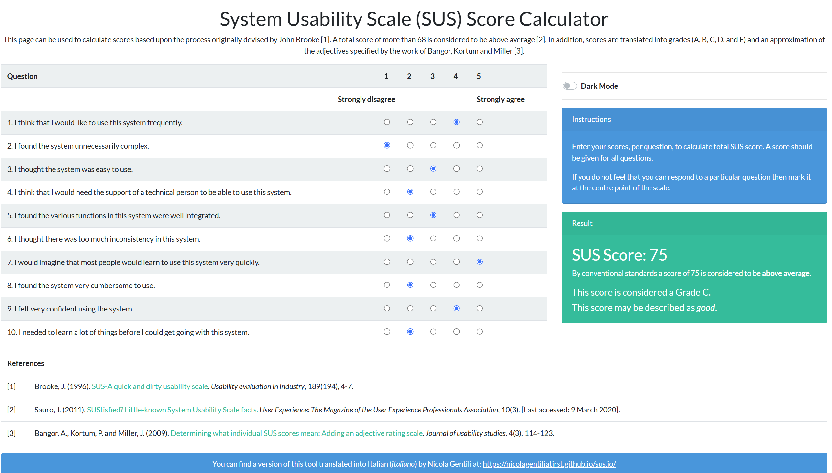

**Open Questions**

**What is one thing you would want me to fix?**

The most important change would be to add hints or prompts in each scene, which can make every task clearer.

**What is one thing you are most satisfied with?**

I am most satisfied with picking up the microphone, as it feels very similar to a real-life situation.

**U4**

|  |  |  |  |  |  |
| --- | --- | --- | --- | --- | --- |
| **User ID** | **Task ID** | **Success (Y/N)** | **Errors / Assists** | **Time (s)** | **Observation Notes** |
| 4 | 1 | y | 1 | 16 | The participant tried 2 times before joining the planet, suggesting that clearer entry instructions might reduce confusion. |
| 2 | y | 0 | 7 |  |
| 3 | y | 0 | 12 |  |
| 4 | y | 0 | 13 |  |

**SUS**

|  |  |  |  |  |  |  |
| --- | --- | --- | --- | --- | --- | --- |
| **No.** | **Statement** | **1**  **Strongly Disagree** | **2** | **3** | **4** | **5**  **Strongly Agree** |
| **1** | I think that I would like to use this system frequently. |  |  |  | x |  |
| **2** | I found the system unnecessarily complex. | x |  |  |  |  |
| **3** | I thought the system was easy to use. |  |  |  | x |  |
| **4** | I think that I would need the support of a technical person to use this. |  |  |  | x |  |
| **5** | I found the various functions in this system were well integrated. |  |  |  |  | x |
| **6** | I thought there was too much inconsistency in this system. | x |  |  |  |  |
| **7** | I would imagine that most people would learn to use this system quickly. |  |  |  |  | x |
| **8** | I found the system very cumbersome to use. | x |  |  |  |  |
| **9** | I felt very confident using the system. |  |  |  |  | x |
| **10** | I needed to learn a lot of things before I could get going with this. | x |  |  |  |  |

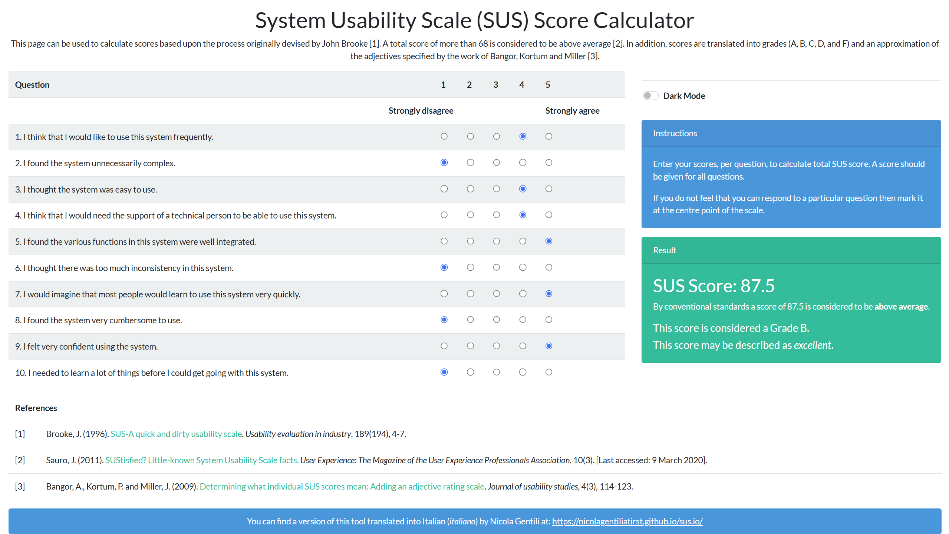

**Open Questions**

**What is one thing you would want me to fix?**

The thing I want you to fix is the process of entering a planet. Without clear prompts or instructions, it feels a bit difficult to know exactly how to join the channel. Sometimes I had to try more than once before being sure that I was doing it correctly. Adding small text reminders or visual feedback would make this step easier and more comfortable for new users.

**What is one thing you are most satisfied with?**

I am most satisfied with the experience of picking up the microphone. It feels very natural and close to how objects behave in real life. Holding it in my hand gave me the sense of actually being in a meeting space, which made the whole XR environment more immersive and realistic.

**U5**

|  |  |  |  |  |  |
| --- | --- | --- | --- | --- | --- |
| **User ID** | **Task ID** | **Success (Y/N)** | **Errors / Assists** | **Time (s)** | **Observation Notes** |
| 5 | 1 | y | 0 | 9 |  |
| 2 | y | 0 | 6 |  |
| 3 | y | 0 | 23 | During task 3, the participant expected to have more seating options. |
| 4 | y | 0 | 15 | The participant experimented with both hand gestures and controllers to grab the microphone, showing curiosity and satisfaction with the flexible interaction design. |

**SUS**

|  |  |  |  |  |  |  |
| --- | --- | --- | --- | --- | --- | --- |
| **No.** | **Statement** | **1**  **Strongly Disagree** | **2** | **3** | **4** | **5**  **Strongly Agree** |
| **1** | I think that I would like to use this system frequently. |  |  |  |  | x |
| **2** | I found the system unnecessarily complex. | x |  |  |  |  |
| **3** | I thought the system was easy to use. |  |  |  |  | x |
| **4** | I think that I would need the support of a technical person to use this. |  |  | x |  |  |
| **5** | I found the various functions in this system were well integrated. |  |  |  |  | x |
| **6** | I thought there was too much inconsistency in this system. | x |  |  |  |  |
| **7** | I would imagine that most people would learn to use this system quickly. |  |  |  |  | x |
| **8** | I found the system very cumbersome to use. | x |  |  |  |  |
| **9** | I felt very confident using the system. |  |  |  |  | x |
| **10** | I needed to learn a lot of things before I could get going with this. |  | x |  |  |  |

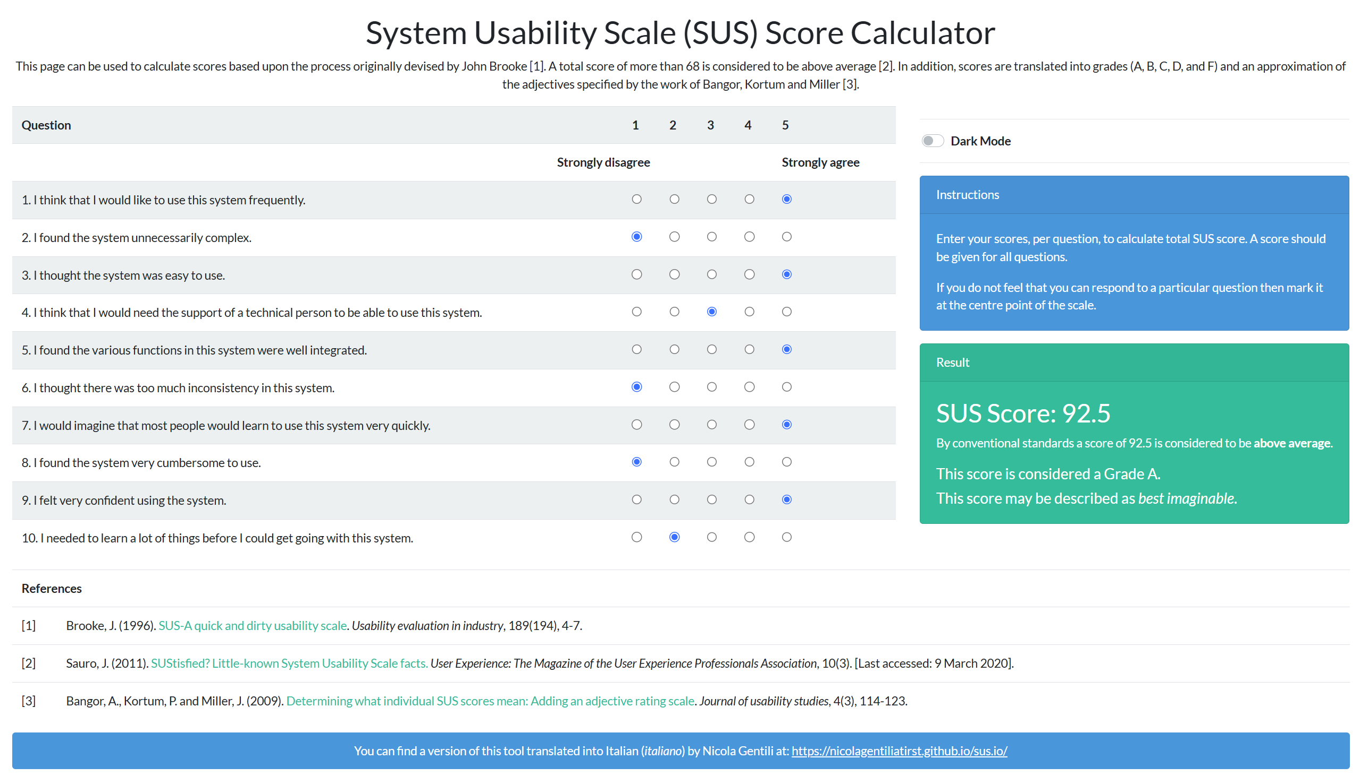

**Open Questions**

**What is one thing you would want me to fix?**

The main improvement I would like to see is the ability to sit on the opposite side of the long table. At the moment, seating feels limited to one side, which makes the space less flexible. Allowing users to freely choose either side would make the interaction feel more natural, give more variety to the experience, and better reflect how people arrange themselves around real tables.

**What is one thing you are most satisfied with?**

I am most satisfied with the microphone interaction, especially that it works with both hand gestures and the controllers. This gave me more freedom to interact in the way I preferred, and it made the experience feel more realistic. Having multiple input options also increased my confidence in using the system because I knew I could rely on different methods if one did not work as expected.

**References**

|  |
| --- |
| **[AI-1 | PlanetInteraction.cs] *“Proximity-based interaction”, Claude (Anthropic AI).* Retrieved via claude.ai, Last Accessed: 25/09/2025.** |
| **[AI-2 | Report grammar editing] ChatGPT (OpenAI), *used to correct grammar and improve sentence structure in the written report*. Retrieved via chat.openai.com, Last Accessed: 08/10/2025.** |
| **[Reference-1 | Meta XR Building Blocks] “Camera Rig and Interactions Rig”, *Unity Meta Tools*. Last Accessed: 25/09/2025.** |

**Statement of Original Work**  
I certify that this project is my own original work, except where otherwise indicated. ChatGPT was used to assist with grammar correction and sentence structure improvements in the written report. Claude was used to provide assistance with some sections of the Unity C# code. All AI-assisted contributions are clearly identified with in-code comments and cross-referenced in the References section. The design concept, testing plan, evaluation, analysis, and the majority of the implementation are entirely my original work. Importantly, all AI-assisted code was reviewed, explained in my own words, and adapted to fit the context of this project, ensuring that it reflects my own understanding and integration.