1. **Use case diagram**

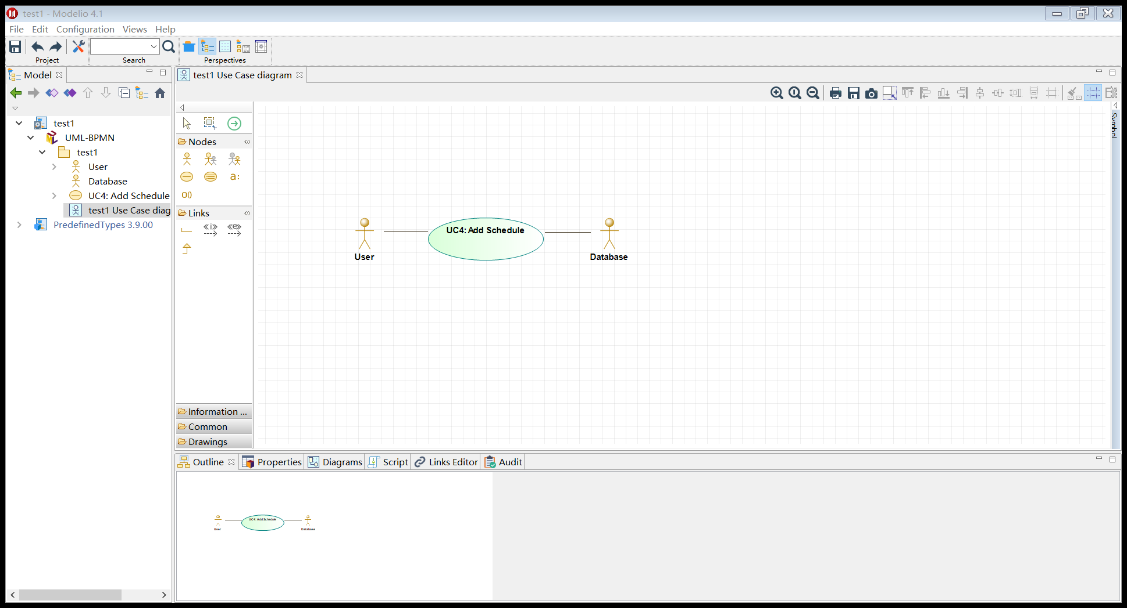

1. **Use case schema**

|  |  |
| --- | --- |
| **Use Case UC–4:** | **Add schedule** |
| **Related Requirements:** | 1. Allow to add today’s schedule 2. Allow to set an alarm as a reminder if necessary 3. Maintain a history log |
| **Initiating Actor:** | User |
| **Actor’s Goal:** | To set and save today’s schedule. To set an alarm as a reminder for schedule if necessary. |
| **Participating Actors:** | User |
| **Preconditions:** | * The user has logged in normally. * The APP has obtained the permission to use the system storage space. |
| **Postconditions:** | * The set to-do list will be displayed in the *Schedule* column. * If an alarm was set, it will be displayed in the *Clock* column and the time starts to countdown. |
| **Flow of Events for Main Success Scenario:** | |
| 🡪 | User clicks the *Add schedule* button |
| 🡨 | The App displays the interface for schedule adding |
| 🡪 | User enters the items for today’s schedule (and set alarms as reminders) |
| 🡨 | The App displays the items set by User in the *Schedule* column.  The App displays the clocks set by User (if there is) in the *Clock* column. |

1. **Acceptance test**

|  |  |
| --- | --- |
| **Test-case Identifier:** | **TC-4** |
| **Use Case Tested:** | UC-4 |
| **Pass/fail Criteria:** | The test passes if the item set is displayed in the *Schedule* column, the clock set correctly is displayed in the *Clock* column and the alarm goes off at the set time. |
| **Input Data:** | Items for the *Schedule* column, times for the *Clock* column |
| **Test Procedure:** | **Expected Result:** |
| Step 1. Enter an item for the Schedule column and invalid time for the Clock column | The APP displays *Invalid Time* to indicate failure;  records unsuccessful attempt in the database;  prompts the user to enter again |
| Step 2. Enter an item for the Schedule column and valid time for the Clock column | The APP displays S*etup Successful* to indicate success;  records successful access in the database;  the item and time can be seen in the *Schedule* column and the *Clock* column respectively;  the alarm goes off at the set time |

1. **System sequence diagram**

