Zoe Blue

November 17th, 2020

Data Analysis in R

Assignment 4b

*Are Small Hospitals Able to Provide Quality Perinatal Care? Analyzing Variance in Facility Indicators Across British Columbian Hospitals*

Introduction

In order to investigate the idea that smaller facilities lead to more adverse perinatal outcomes, I set out to compare the 6 facility indicators as published by perinatal BC during the fiscal year of 2015/2016, across 4 hospitals “peer groups” determined by the number of births that occur at the facility per year. The 6 indicators being analyzed are: vaginal delivery rate for eligible nulliparous women aged 20 to 39 years with a singleton vertex pregnancy at term; early repeat cesarean delivery without medical indication; post-date induction before 41+0 weeks gestation for women under 40 years of age at the time of delivery; exclusive use of intermittent auscultation in laboring women without risk factors who delivered vaginally; healthy full-term singletons receiving exclusively breast milk from birth to discharge; and attempted vaginal birth rate for eligible parous women under 40 years of age with a history of cesarean and a singleton vertex pregnancy at term. These indicators look beyond simply assessing birth-associated mortality rates, which tend to be so low in BC that very little information about quality of care can be deferred, and look to other indicators that facilities are meeting national and international standards of perinatal care. Based on previous literature attesting that smaller facilities have poorer outcomes; I hypothesize that there will be no difference in mean outcome between the larger facilities and the smaller facilities (Grzybowski et al., 2013; Hutcheon et al., 2017; Cameron and Cameron, 2001). This study aims to determine if significant differences do exist and to analyze the effect size of any potential differences. The null hypothesis for this study is that all sample means will be equal (H0: µ1 = µ2=µ3=µ4).

Background

The geography of Canada sets up a substantial challenge in delivering equitable care across provinces, most notably, there are stark inequalities in the ability to access care for populations in remote and rural areas. This is significant as 31.4% of Canadians were living in rural and small population centers, as of the 2016 census (Statistics Canada, 2016). Even more notably, 48.9% of indigenous Canadians live in rural and small population centers (Statistics Canada, 2017). Translating this to the importance of geography in birth, it is known that distance to a hospital is a strong indicator of birth outcomes (Chalmers et al., 2004; Daysal et al., 2015; Grzybowski et al., 2011). Because of geographic boundaries to perinatal care, many people anticipating delivery have to travel to access care, leading to adverse birth outcomes and an increase in medical intervention used during birth due to stress and time constraints associated with having to leave family and community to deliver (Grzybowski et al., 2013).

The idea that smaller hospitals and facilities are unable to offer the same quality of care is one of the justifications, along with staffing and budgetary challenges, for the recent closure of many small birthing facilities across the province (Barklay and Kornelsen, 2016; Hutcheon et al., 2017). The safety of perinatal care in small facilities is extremely important when evaluating whether it is feasible to offer more birthing centers in remote communities. However, the risks of providing perinatal services in small hospitals and birthing centers that may be unable to offer services such as access to surgical intervention and a resident OB/GYN must be balanced with the physical and emotional risks of requiring pregnant people to travel for birth care.

Methods

1. **Data exploration and cleaning**

I utilized the data recorded and shared by Perinatal Services BC (PSBC) (Perinatal Services BC, n.d.). Specifically, data reporting Facility-Level Indicator Data by the hospital was used to compare the 6 indicators to hospitals grouped by peer groups determined by the number of births that take place at the facility each year. This data is presented on an interactive webpage (image 1.), assumingly to show the data in a useful way for visualization (for who, is unclear). However, this presentation of data was in no way helpful to the task of creating tidy and usable data. Many attempts were made to obtain the raw data used for this webpage but as it wasn’t publicly accessible, and given the time constraints of the project, the data was recorded from the site and put into an excel worksheet. The data available through PSBC recorded the percentage of births at the facility that met the facility indicator. Initially, I multiplied the percentage by the total births in the facility in order to record the number of individual births that met the facility indicator criteria. While this may be valuable to have in the raw data file for future analysis, this proved to be obsolete as the only way to compare the four peer groups was to compare the mean percentage of births for which the indicator was met.

Once inputted into a data file, initial assessments were able to be made. The data appears to be normally distributed and upon first glance, no substantial outliers seemed to be present. An important note regarding the data set is that a portion of the small peer-group hospitals does not offer surgical services or OB/GYN services. This is very important when interpreting the data as these facilities meet certain indicators ‘0% of the time’ this is due to the fact that these indicators are not relevant to the facility. Throughout the process of visualizing and analyzing the data, all values equal to 0 were omitted to avoid a significant issue with outliers that do not reflect the situation when in context.

1. **Defining the facility indicators**

To determine the efficacy of the facilities included in this study, 6 indicators are chosen that help to estimate the quality of care. These 6 indicators provide critical information about the quality of care and are also indicators that are widely recorded at all facilities in British Columbia. A breakdown of the six indicators, including extended definitions can be seen in Table 1.

1. **Defining the peer groups**

In order to visualize the variance between outcomes in hospitals of different sizes, the hospitals first had to be grouped into peer groups. Hospitals were grouped into small, medium, large, and extra-large. Peer group was assigned as per the parameters put forth by PSBC wherein “small” is defined as a facility with fewer than 250 deliveries per year, “medium” is a facility with between 250-999 deliveries per year, “large” is a facility with between 1,000-2,499 births per year and “extra-large” is a facility with over 2,499 per year.

1. **Visualizing the data**

In order to show variance between the facilities, in comparison to how frequently they met the facility indicator, the data is shown using boxplots (fig. 1-6).

1. **Analyzing the data**

The data was analyzed to determine whether statistically significant differences arise between the 4 peer groups. To determine differences, standard methods for analyses of variance (ANOVA) were followed. After the completion of the initial ANOVA test, post hoc tests were run to determine the variance between pairs of groups. Specifically, upon the finding of slight statistical significance in the variance of peer group for indicators 1 and 4, Tukey HSD tests were run to determine where in the data the variance occurs and to reiterate the statistical significance of the variance.

Results/Discussion

What the box plots showed is a definite lack of consistency in any type of pattern depicting variance across peer group. Only figures 4 and 6 showed any trend in means from small to xlarge peer group, and even then, the difference in mean was infinitesimal (fig. 4, fig.6). Further, upon running ANOVA tests for each facility indicator, the only ones that showed statistically significant variance were indicators #1 (“vaginal delivery for first time eligible [parents]) (p = 0.047), and indicator #6 (“attempted VBAC”) (p = 0.0118). However, upon running a post-hoc analysis using Tukey’s HSD, these indicators actually showed no significant variance between any two peer groups (all p values were greater than 0.05).

This study shows that there is no significant difference between the outcomes at hospitals of different peer size. In this instance, a failure to reject the null hypothesis speaks volumes. What this data shows is that past justification for the closure of small and rural birth centers based on an assumption that they are of lesser quality than large facilities is potentially unfounded. In fact, in some cases (figure 5) babies born at small facilities seem to have certain advantages, such as a higher likelihood of being fed only breastmilk post-delivery.

This research sets the initial groundwork for a serious reconsideration, both in research and in policy, of the importance and necessity to offer remote and rural populations options to give birth within their own communities.

This small preliminary study used data from only the fiscal year of 2015/2016 and therefore should not be used to make sweeping assumptions about the British Columbian healthcare system at large. This study provides a framework for future studies to be carried out examining data across multiple years as well as examining more recent data. Further research is required to determine whether it can be truly attested that hospitals delivering fewer than 250 births per year pose no significant increase in risk when compared to larger facilities.

A note on the incorporation of feedback

         Throughout this process, I have been able to incorporate the feedback from my peers in order to strengthen the final product. For my paper, I was able to clarify sections that were lacking/unclear to the reader. I also incorporated more analysis and description of the statistical methods used in the paper. I also changed certain sentences to have a more “active voice”. I significantly updated my code to include a “main” and generally put in work, on the recommendation of my peers, to ensure that the repro was, indeed, reproducible. I also broke up my code into multiple files so that it wasn’t as ‘overwhelming’.

Works Cited

Barclay, L., & Kornelsen, J. (2016). The Closure of Rural and Remote Maternity Services: Where are the Midwives? *Midwifery*, *38*.<https://doi.org/10.1016/j.midw.2016.03.007>

Cameron, B., & Cameron, S. (2001). Outcomes in rural obstetrics, Atherton Hospital 1991-2000. *The Australian Journal of Rural Health*, *9 Suppl 1*, S39-42.

Chalmers, B., & Wen, S. W. (2004). Perinatal Care in Canada. *BMC Women’s Health*, *4*(1), S28.<https://doi.org/10.1186/1472-6874-4-S1-S28>

Daysal, N. M., Trandafir, M., & van Ewijk, R. (2015). Saving Lives at Birth: The Impact of Home Births on Infant Outcomes. *American Economic Journal: Applied Economics*, *7*(3), 28–50.<https://doi.org/10.1257/app.20120359>

Government of Canada, S. C. (2016, November 16). *2016 Census Program*.<https://www12.statcan.gc.ca/census-recensement/2016/ref/dict/geo049a-eng.cfm>

Government of Canada, S. C. (2017, November 15). *Birth outcomes among First Nations, Inuit and Métis populations*.<https://www150.statcan.gc.ca/n1/pub/82-003-x/2017011/article/54886-eng.htm>

Grzybowski, S., Stoll, K., & Kornelsen, J. (2011). Distance matters: A population based study examining access to maternity services for rural women. *BMC Health Services Research*, *11*(1), 147.<https://doi.org/10.1186/1472-6963-11-147>

Grzybowski, S., Stoll, K., & Kornelsen, J. (2013). The outcomes of perinatal surgical services in rural British Columbia: A population-based study. *Canadian Journal of Rural Medicine: The Official Journal of the Society of Rural Physicians of Canada = Journal Canadien De La Medecine Rurale: Le Journal Officiel De La Societe De Medecine Rurale Du Canada*, *18*(4), 123–129.

Hutcheon, J. A., Riddell, C. A., Strumpf, E. C., Lee, L., & Harper, S. (2017). Safety of labour and delivery following closures of obstetric services in small community hospitals. *CMAJ : Canadian Medical Association Journal*, *189*(11), E431–E436.<https://doi.org/10.1503/cmaj.160461>

Kornelsen, J., Kotaska, A., Waterfall, P., Willie, L., & Wilson, D. (2010). The geography of belonging: The experience of birthing at home for First Nations women. *Health & Place*, *16*(4), 638–645.<https://doi.org/10.1016/j.healthplace.2010.02.001>

*Perinatal Services BC*. (n.d.). Retrieved November 17, 2020, from <http://www.perinatalservicesbc.ca/>

Appendix A – Images



Image 1. Screen shot of Perinatal Services BC website, from which the data was gathered.

Appendix B – Tables

|  |  |  |
| --- | --- | --- |
| Indicator | Short Title | Definition |
| Vaginal delivery rate for eligible nulliparous women aged 20 to 39 years with a singleton vertex pregnancy at term. | Vaginal Delivery for First-Time Mothers | The proportion of nulliparous women without a medical contraindication to vaginal delivery 20 to 39 years of age with a term, singleton infant in a vertex position who deliver vaginally. |
| Early term repeat cesarean delivery without medical indication. | Early Repeat Cesarean Delivery | Among women with a history of cesarean delivery who deliver at term by repeat cesarean without labor, the proportion who deliver between 37+0 and 38+6 weeks gestation (early term). (Women with a medical indication for early delivery are excluded from this indicator.) |
| Post-date induction before 41+0 weeks gestation for women under 40 years of age at the time of delivery | Post-Date Inductions Done Early | The proportion of women under age 40 whose labour was induced citing the reason that the pregnancy was 41 weeks and over (‘post-date’) but whose gestational age was actually fewer than 41 weeks. |
| Exclusive use of intermittent auscultation in laboring women without risk factors who delivered vaginally | Only Intermittent Auscultation in Low-Risk Deliveries | The proportion of women with a vaginal delivery, but without specific risk factors, whose labour was monitored only using intermittent auscultation (listening to the fetal heart beats at specified intervals during labour). |
| Healthy term singletons receiving exclusively breast milk from birth to discharge | Healthy Babies Fed Only Breastmilk | The proportion of healthy term babies that were fed only breast milk (milk from the breast or expressed breast milk from the mother or a donor) from birth to discharge. |
| Attempted vaginal birth rate for eligible parous women under 40 years of age with a history of cesarean and a singleton vertex pregnancy at term | Attempted VBAC for Eligible Women | The proportion of eligible parous women under 40 years of age with a history of cesarean and a term, singleton infant with a vertex presentation who attempt to give birth vaginally. |

Table 1. Definitions, provided by PSBC, of the six facility indicators analyzed in this study (Perinatal Services BC, n.d.)

Appendix C – Figures

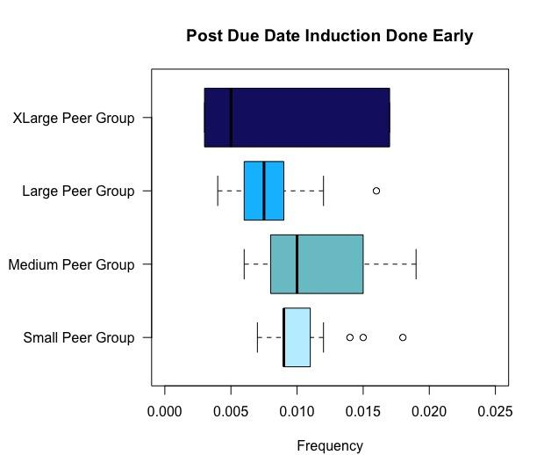

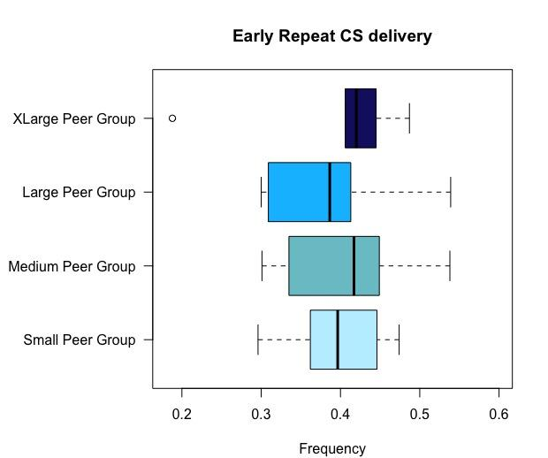Figure 1. Vaginal delivery rate for eligible nulliparous women aged 20 to 39 years with a singleton vertex pregnancy at term, split by hospital peer group.

Figure 2. Early term repeats cesarean delivery without medical indication, split by hospital peer group.



Figure 3. Post-date induction before 41+0 weeks’ gestation for women under 40 years of age at the time of delivery, split by hospital peer group.

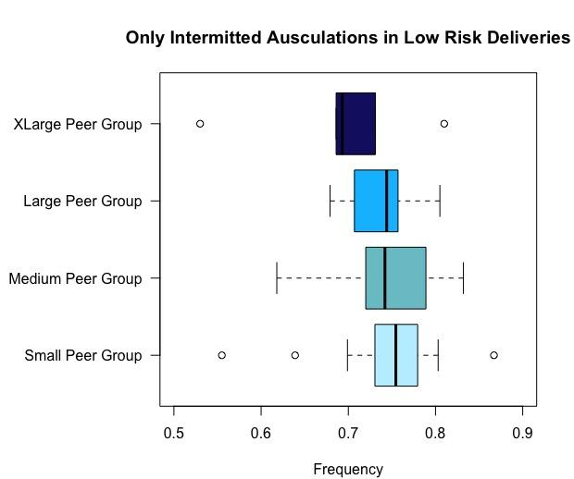

Figure 4. Exclusive use of intermittent auscultation in laboring women without risk factors who delivered vaginally, split by hospital peer group.

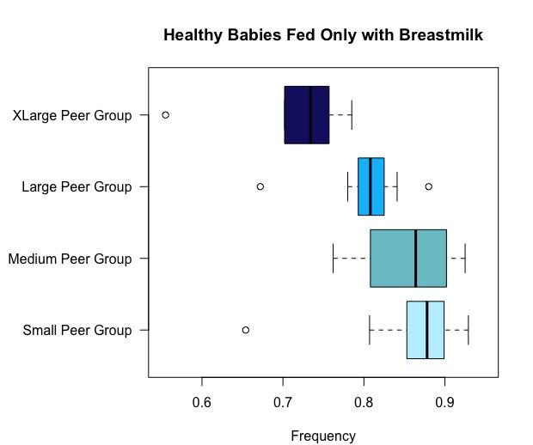

Figure 5. Healthy term singletons receiving exclusively breast milk from birth to discharge, split by hospital peer group.

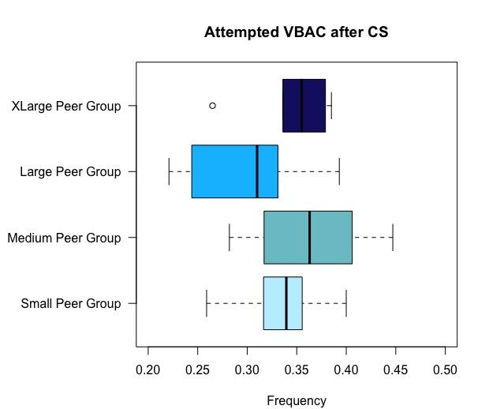

Figure 6. Attempted vaginal birth rate for eligible parous women under 40 years of age with a history of cesarean and a singleton vertex pregnancy at term, split by hospital peer group.