OS: Kali Linux installed on VirtualBox

Project: John the Ripper password cracker

Date: 9/11/2023

1. Creating a user Scooby – ‘useradd -m Scooby -G sudo’ ‘-m’ creates the user home directory and ‘-G’ adds the user to the sudo group

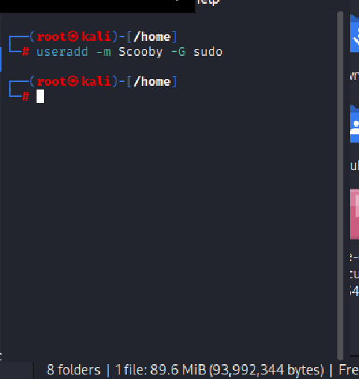

1. List of all users in home directory

1. List users in sudo group

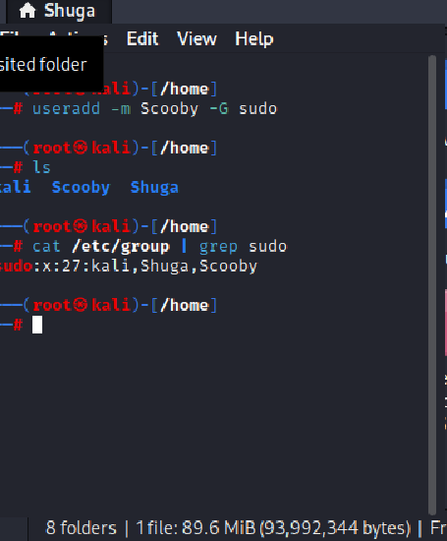

1. Set simple password for Scooby – ‘passwd Scooby’

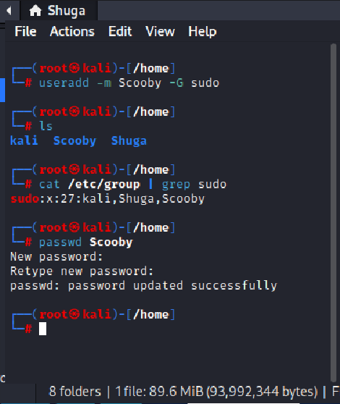

1. Creating a file with username and password details – sudo unshadow /etc/passwd /etc/shadow > userpwds

1. Confirmed password.lst file shows in /usr/share/john directory

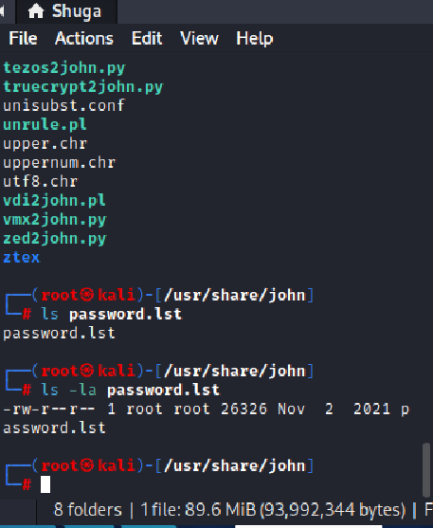

1. Running command from home directory against userpwds file to discover passwords – john –wordlist=/usr/share/john/password.lst userpwds

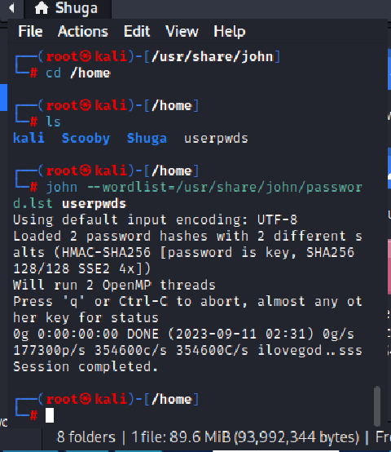

1. Run command ‘John –show userpwds’ to crack hash but no hashes were cracked from either root or Shuga user

