**Bridge Inspection Drone App**

by

Cole Perry

Claire Wallace

Lincoln Patton

Evan Henry

This is a Comprehensive project submitted to the Marshall University graduate faculty in

partial fulfillment for the degree Bachelor of Science.

Major Subject: Computer Science

Approved:

Instructor of Capstone course

Director of Major Department

Chairman of Graduate Programs

Marshall University

Huntington, West Virginia

May, 2019

# Acknowledgements

I would like to thank my advisor Dr. Wook-Sung Yoo, for all his help and guidance. He has guided me through the completion of my masters.

**TABLE OF CONTENTS**

**1. Introduction……………………………………………………………………………5**

1.1 Scope………………………………………………………………………………..5

1.2 Background…………………………………………………………………………6

1.3 Summary……………………………………………………………………………6

1.4 Road map to the report……………………………………………………………...6

**2. Requirement Analysis………………………………………………………………...7**

2.1 System Overview…………………………………………………………………...7

2.2 Specific Requirements……………………………………………………………...8

2.3 Functional Requirements……………………………………………………………8

2.4 Non-Functional Requirements……………………………………………………..9

**3. System Design………………………………………………………………………..10**

3.1 Use Cases……………………………………………………….…………………10

* 1. Product Flow……………………………………………………………………...13
  2. Database Design…………………………………………………………………..14
  3. Functional Design………………………………………………………………...14

**4. Functional Testing…………………………………………………………………...14**

4.1 Test Cases and Results……………………………………………………………14

**5. Research..………………………….…………………………………………………16**

**6. Conclusion……………………………………………………………………………16**

**7. References……………………………………………………………………………16**

**8. Appendix……………………………………………………………………………..16**

**List of Figures:**

Figure 1: Use case diagram

Figure 2: Use case diagram

Figure 3: Use case diagram

Figure 4: Landing Page

Figure 5: Image Gallery

Figure 6: Edit Page

Figure 7: DJI Interface

Figure 8: Pop-up Window

**List of tables:**

Table 3-3: Database

Table 4-1: Test Case

1. INTRODUCTION

There are over 6,000 bridges alone in West Virginia, each of those bridges are used daily by a myriad of individuals and transportation. With all this usage it is imperative that bridges are inspected every year for safety reasons. With the old method man have to hang off bridges and climb around them to inspect. But with drones becoming easily available and the many features they now include; bridge inspectors can now use a drone for bridge inspections. For this reason, our goal is to build a prototype app to pair with a drone to make the inspectors job easier and more time effective.

* 1. **Scope**

This project includes but is not limited to:

1. Database integration
2. Collecting information for each picture taken
3. Ability to send and receive pictures and reports
4. Easy to use user interface

**1.2 Background**

A team in the Computer Science department has begun implementation of the WV DOH Bridge Drone Inspection project which is intended to include a web application coupled with a mobile application and a 3rd party software to generate 3D models of bridges using pictures taken by inspectors with a drone. The purpose of this project is to simplify the process of uploading pictures taken on the drone to the web application so that a report can be made. The web application is currently in development but is running and able to be used for testing. Furthermore, the software controlling the drone and camera on the drone are also fully functional.

**1.3 Summary**

The current app works in synchronization with the proprietary DJI GO 4 app and any DJI drone on Android devices running Android 24 or higher.

* 1. **Road map to the report**

**Section 2:** Requirement Analysis: This section discusses various requirements of the project, some constraints and dependencies of the project, the interfaces of the project.

**Section 3:** Design Procedure: In this section various design issues regarding the project will be discussed. This comprises the top-level design, database design and interface design.

**Section 4:** Functional Testing: This section discusses the testing of the tool and whether all the requirements have been met or not.

**Section 5:** System Integration and validation: System level issues will be discussed.

**Section 6:** Conclusions and Future recommendations.

**Section 7:** References to related documents.

**Section 8:** Appendices

**2. REQUIREMENT ANALYSIS**

* 1. **System Overview**

The objective of the Bridge Inspection App is to increase bridge inspection efficiency and make the bridge inspectors jobs as easy as possible.

The current issue in the project is that for an inspector to complete an inspection they must take a picture, migrate away from the app, enter the correct information, and then migrate back to the app. Our app simply creates a popup window to enter the information when a picture is taken. This makes it easier for the user and more time efficient for the drone battery.

**2.1.1 Problem Position statement**

|  |  |
| --- | --- |
| **Elements** | **Description** |
| For | Department of Highways |
| Who | Bridge Inspectors |
| The Product Name | Bridge Inspection Drone Application |
| That | An Android application for the inspectors to gather photos of bridges and enter relevant information. |
| Unlike | Any existing application including the DJI applications. |
| Bridge Inspection Drone App in Field Inspection Environment | Provide media management tool for bridge inspectors |

**2.2 Specific Requirements**

Android version 26 or higher.

**2.2.1 User Profiles**

The following are the users for this system:

2.1.1.1 Inspector:

An Inspector is the person who is the sole user of this system. He/she has the permissions to enter information attached to the images taken on the drone and extract that information to use in reports.

2.1.1.1.1 Can enter and edit information attached to images take on a drone

2.1.1.1.2 Can view the images taken at that inspection and edit or delete them

2.1.1.1.3 Can extract the photos from the application

**2.3 Functional Requirements**

2.3.1Able to add a title and comment to the picture when an inspector takes a picture with the drone, this will be done in a popup window

2.3.1.1 Title will be a string up to 36 characters long

2.3.1.2 Comment will be a string up to 10 lines long

2.3.2 Able to edit the title and comment previously made in the popup window

2.3.2.1 Title will be a string up to 36 characters long

2.3.2.2 Comment will be a string up to 10 lines long

2.3.3 Obtain GPS coordinates from the meta data of the picture the drone took

2.3.3.1 GPS coordinates consist of longitude (y), latitude (x), and Altitude (z)

2.3.3.2 Note: this is done in the background by the meta data library, the inspector does not have to do anything extra for this to happen

2.3.4 Delete Button to delete picture and metadata in editing screen

2.3.5 Save Button to save information to picture metadata in editing screen

2.3.6 Back button to return to picture gallery without changing information

2.3.7 Download all button to be able to download all pictures and corresponding data to a web application

2.3.8 Enter an inspection number for the purposes of sorting pictures

2.3.8.1 Inspection number is an integer (no limit specified at the moment)

2.3.9 View pictures taken in a gallery

**2.4 Non-Functional Requirements**

Download Speed for pictures - depending on the number between 1 minute and 5 mintue.

Maintainability – no maintenance should be required

Reliability – should be available 24/7

Usability- only works with DJI GO 4 app and DJI drone

### **2.4.1 System Requirements**

To be able to use this application, an inspector will have to enable the storage permission for the application by entering the setting, clicking on application or the equivalent folder for the phone, then finding the bridge inspection application, clicking on it and enabling the storage permission.

### **2.4.1.1 Hardware Requirements**

**2.4.1.2 Software Requirements**

Language Specification **:** Java

Databases  **:** SQLite

Operating Systems **:** Android

**3. DESIGN PROCEDURE**

* 1. **Use Case Diagrams**

**3.1.1 Use case diagram for Instructor Setup**

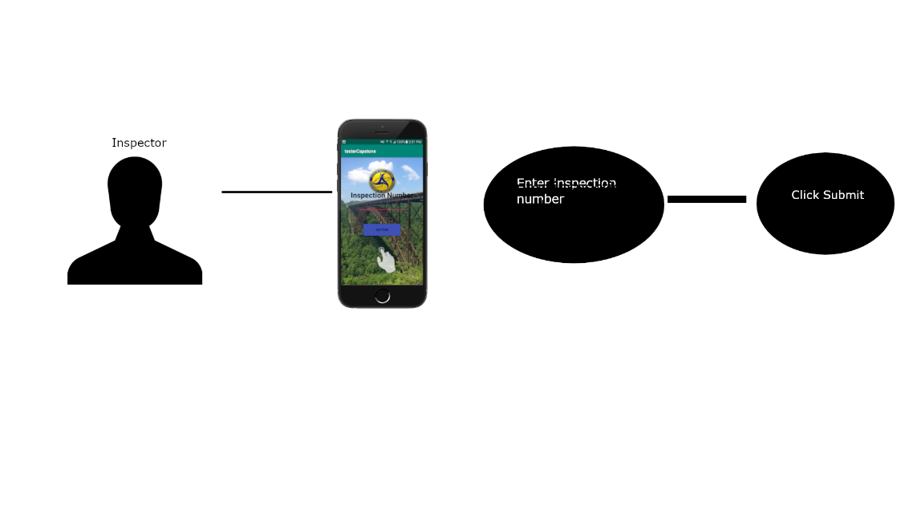

Figure 1: Use case diagram for Inspector Setup.

**Name:** Use Case for Inspector Setup

**Description:** Tocapture images with a drone while simultaneously entering

information for the photos taken

**Actors:** Inspectors

**Preconditions:** 1. the user should have an inspection number to enter into the system.

**Main Flow:** 1. Inspector must first start the DJI GO 4 app and pair it with a drone.

2. Inspector then opens the Mobile Bridge Inspection app and enters

an inspection number.

3. Inspector then switches back to the DJI GO 4 app and

proceeds with inspection.

.

**3.1.2 Use case diagram for Instructor edit page**

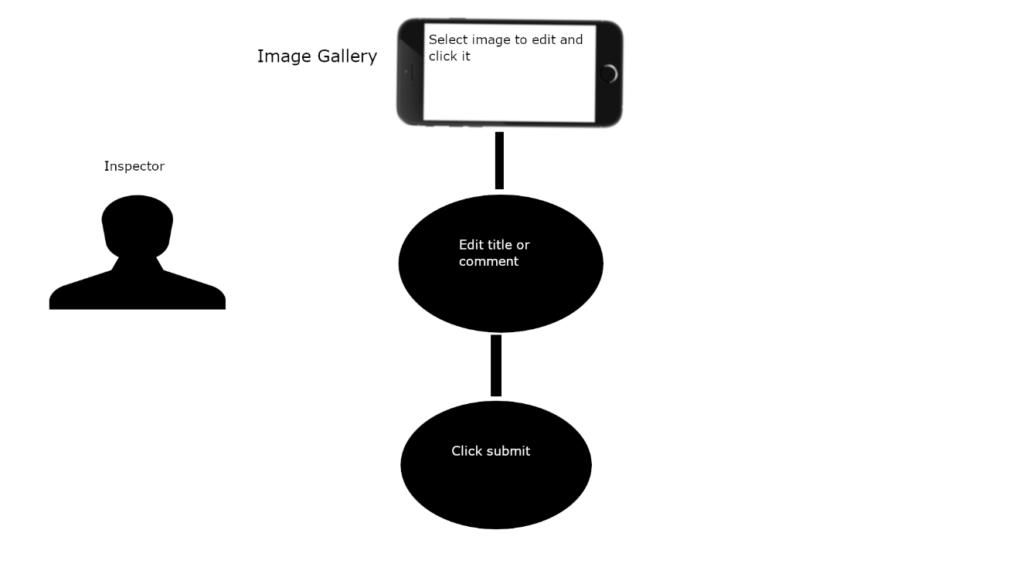

Figure 2: Use case diagram for Inspector edit page.

**Name:** Use Case for Inspector edit page

**Description:** Toedit photo title or comment.

**Actors:** Inspectors

**Preconditions:** 1. The user must have already taken a picture and entered information.

**Main Flow:** 1. The user must click on the photo he/she wishes to edit

from the gallery page.

2. The user then edits the information they wish to change and

clicks the “submit” button.

**3.1.3 Use case diagram for Instructor enter information in pop up window**

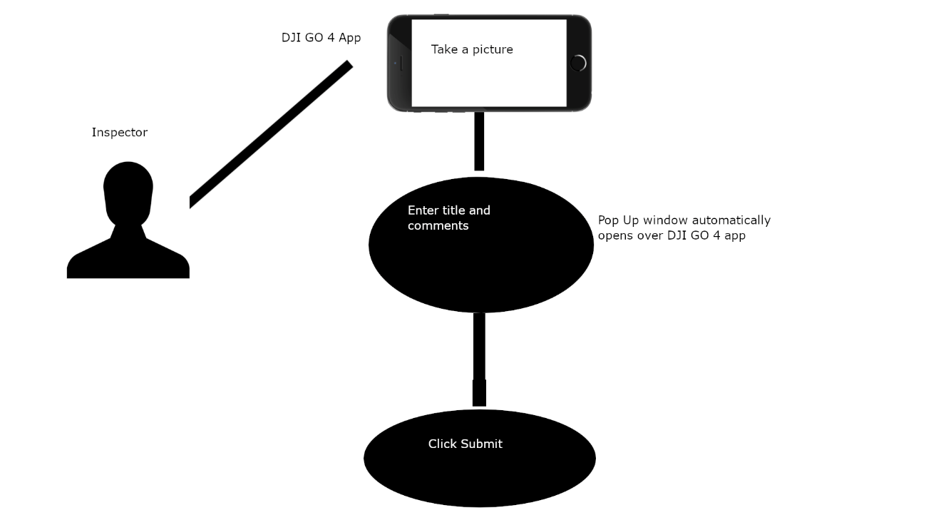

Figure 2: Use case diagram for Instructor enter information in pop up window.

**Name:** Use Case for Instructor enter information in pop up window

**Description:** To enter information into a photo you have just taken on the drone

**Actors:** Inspectors

**Preconditions:** 1. The user should be flying the drone and just have taken a picture

**Main Flow:** 1. The user takes a photo

2. The user enters a title for the photo

3. The user enters comments regarding the photo

4. The user clicks “Submit”

**3.1.4 Use case diagram for Instructor extract photos from phone**

Figure 2: Use case diagram for Inspector extract photos from phone.

**Name:** Use Case for Inspector extract photos from phone

**Description:** Toextract the photos with the information the inspector entered from

user phone to computer.

**Actors:** Inspectors

**Preconditions:** 1. The user should be at a computer with internet access.

2. The user must connect the drone and phone to the computer.

**Main Flow:** 1. From the application the user clicks “Download all”

2. The user then plugs the phone into their work computer

3. The user then transfers the images from the phone to the

web application

**3.2 Product Flow**

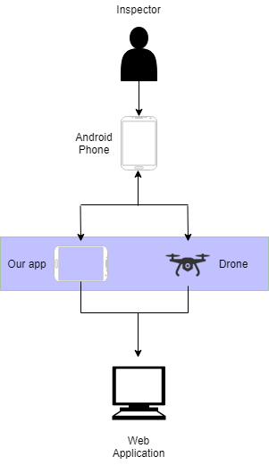

**3.3 Database Design**

Table 3-3: Database

**3.4 Functional Design**

The functions of this application are as follows:

* Able to add a title and comment to the picture when an inspector takes a picture with the drone, this will be done in a popup window
* Able to edit the title and comment previously made in the popup window
* Able to delete pictures
* Able to download all pictures and data to a web application
* Enter an inspection number for the purposes of sorting pictures
* View pictures taken in a gallery

**4. FUNCTIONAL TESTING**

Functional testing covers the testing of the key requirements that form the requirements phase and determines whether the mentioned requirements have been met. Testing was done after the tool was developed. The testing included checking every function and testing of the results.

The key requirements of this project were as follows:

1. Easy to use out in the field

2. Able to add and edit comments and a title to each picture

3. Obtain GPS coordinates for each picture taken by drone

4. Able to send pictures with comments, title, and GPS coordinates

**4.1 Test Cases and Results**

|  |  |  |  |  |  |
| --- | --- | --- | --- | --- | --- |
| **Requirement** | **Condition** | **Input** | **Expected Output** | **Actual Output** | **Result** |
| Ease of Use | Bridge Inspection app must be opened in background | Inspector takes a picture with drone | A popup appears with a picture and spaces to enter information | A popup appears with a picture and spaces to enter information | TRUE |
| Able to add and edit comments and title for each picture | The popup screen must be up or the editing screen | Enter a title in the title section and a comment in comments in the popup or edit the title and comment in editing screen | Information from the popup and editing screen is saved to picture meta data. Information entered in the popup screen is editable in the editing screen | Information from the popup and editing screen is saved to picture meta data. Information entered in the popup screen is editable in the editing screen | TRUE |
| Obtain GPS coordinates | Picture must be taken using the drone with inspection app running in background | Picture is taken using the drone | Using the metadata library the GPS coordinates are able to be accessed and sent with the rest of the information | Using the metadata library the GPS coordinates are able to be accessed and sent with the rest of the information | TRUE |
| Able to send pictures with all the metadata attached to web application | Pictures with meta data must be in gallery | Hit a download all button in the picture gallery | Pictures with the metadata tags of title, comments, and GPS x,y, and z coordinates are sent to a web application to be viewed | Pictures with the metadata tags of title, comments, and GPS x,y, and z coordinates are sent to a web application to be viewed | TRUE |

Table 4-1: Test Cases

**5 Research**

Throughout this project research into the DJI proprietary software was conducted. This app was designed to run in conjunction with this application that controls the drone. Some things that were found out that were not known before are that the phone does not have the full picture from the drone. The DJI app stores it as a thumbnail (or compressed picture file.) Finish at meeting

**6. CONCLUSION AND RECOMMENDATIONS**

The current project was successfully done by meeting all the requirements of the client which were tested in the functional testing phase.

**7. REFERENCES**

[1] “Documentation.” Android Developer, Google, developer.android.com/docs

[2]“Revolutionize Industries with Your Game-Changing App.” DJI Developer, DJI, developer.dji.com/mobile-sdk/

**8. APPENDIX**

**8.1 Screen Snap Shots**

Figure 4: Landing Page

Figure 5: Image Gallery

Figure 6: Editing Page

Figure 7: DJI Interface

Figure 8: Pop-up Window

