DDES9903 – A2 Report Template

Some parts of this template are based on the “Assessment 2 - Advice for Completion” document under the Assessment Hub section on Moodle. If you haven’t already, please review that document for further advice on how to complete this assessment.
Please modify this template as you require. However, make sure that you adhere to the detailed assessment criteria laid out in the official XLSX marking sheet (also from Moodle)
-----------
Summary
[Title of Your Story / Experience]
WebGL Link: [e.g. your Itch.io link]
GitHub Link: [link to your GitHub repository]
Scene Name: [name of your first scene, so we know which one to load]
Name: [your name]
[One paragraph summary of story / experience – Summarise the choices you have provided for your users in this experience. E.g. “Who will you save?” ]
Narrative State Network
Use your favourite diagram tool to create a Narrative State Network. Some suggested ones are: Miro, Canva, Microsoft PowerPoint, Google Slides.
Remember, Narrative State Networks are discussed here:
https://moodle.telt.unsw.edu.au/mod/page/view.php?id=7603523
More generally, incorporating audience agency, or a sense of user freedom is discussed in the Week 8 materials.
Your Narrative State network needs to be clearly legible. Fitting it in this document may be impractical. You are encouraged to submit the Narrative State Network as a separate image file in conjunction with your report. However, please still aim for your experience to be 5 minutes long MAXIMUM (for one playthrough)!
Player Agency
Use this section to discuss how you have given your audience a feeling of freedom? Talk about what options your users have within your story world. Are they real choices? Are they an illusion of choice?
Remember there are several approaches that we have covered in class:
https://moodle.telt.unsw.edu.au/mod/page/view.php?id=7603521
Do you know of more? Perhaps you can incorporate those.
Narrative Coherence
Use this section to discuss how you have tried to maintain narrative coherence. What limits did you put into the experience to make sure that you always followed Freytag’s triangle? Discuss how this effort ran into conflicts with allowing user agency? How did you overcome those conflicts?
Remember there are several approaches that we have covered in class:
https://moodle.telt.unsw.edu.au/mod/page/view.php?id=7603521
Do you know of more? Perhaps you can incorporate those.
Use of Space
Use this section to describe how you’ve used your story environment to enhance and support your foundation story. You might discuss some specific details, for example:
- If you had a chair in your space, what is the significance of “that chair”?
  - Why was it that type of chair?
  - Why was it in that specific location of the space?
- Why did you choose a certain kind of theme or setting?
- Why did you choose to have the specific layout that your space has?
- Etc.
Remember, narrative in space is discussed in Week 2 materials.
Did you make any specific changes for your approach in response to the problem of balancing player agency and narrative coherence?
Use of Sensory Triggers (or Multimodal Elements)
Use this section to describe how you’ve used sensory triggers (e.g. sound, vfx, lighting, haptics, etc.) to enhance and/or support your foundation story.
Remember, the Week 3 materials are relevant for this section.
Did you make any specific changes for your approach in response to the problem of balancing player agency and narrative coherence?
Use of Semiotic Elements
Use this section to describe how you’ve used symbolism and implied meaning to support and/or enhance your story.
Remember, the Week 3 materials are also relevant for this section. Of great help is this video here:
https://moodle.telt.unsw.edu.au/mod/page/view.php?id=7603459
Did you make any specific changes for your approach in response to the problem of balancing player agency and narrative coherence?
Use of Embodied Actions and/or Enacted Elements
Your players and story agents (story characters) can influence your story world with their actions. Use this section to discuss how you’ve taken advantage of this to support and/or enhance your story.
Remember, the Week 4 materials are relevant for this section.
Did you make any specific changes for your approach in response to the problem of balancing player agency and narrative coherence?

Collaborative Practice
Use this section to collate evidence of your collaborative practice in the period relevant to A2 (Weeks 6 – 10). We expect that your evidence will consist of screenshots from our MS Teams site.
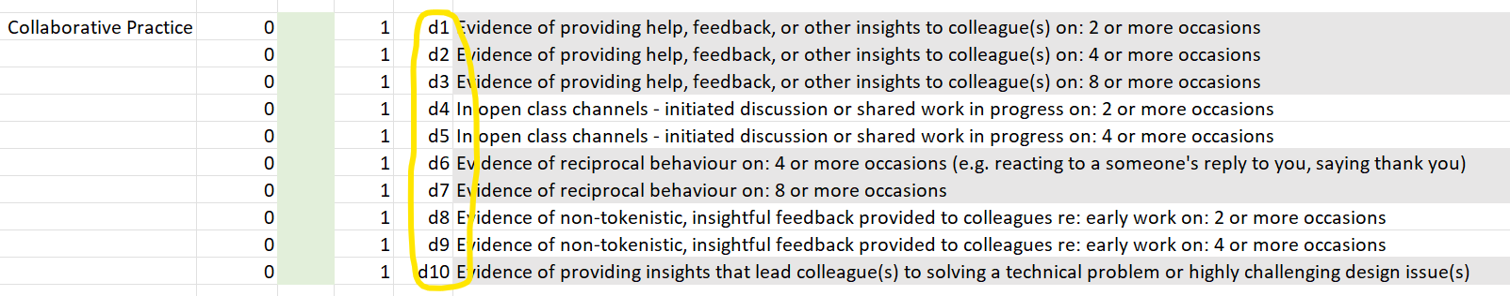
We cannot accept screenshots with languages other than English.
Please use the official class channels for your communication. These are monitored by me (Matt) and your tutors, and we will often respond to your posts. You do not have this advantage outside of official class channels. In order of importance, they are:
1.4) Prototype Sharing and Feedback Giving
1.3) Technical Support Questions (Unity, GitHub)
1.2) Public Assessment Task Queries
When reporting these, please use the labels from the XLSX marking sheet to make it easier for your marker to award you grades.
Academic References
Use this section to list your academic citations, as usual.

Asset Citations
If you use 3rd party assets, remember to put this in this list diligently! It can just be a list of links of the 3rd party assets you have used. E.G:
3rd Party Assets Used:
- https://assetstore.unity.com/packages/essentials/starter-assets-first-person-character-controller-196525
- https://assetstore.unity.com/packages/tools/network/rest-client-for-unity-102501
- https://www.clipartmax.com/download/m2i8H7G6d3K9N4N4_the-mouse-cursor-click-icon-shown-click-icon/
- https://www.pexels.com/photo/brown-brick-wall-1227515/
- https://www.pexels.com/photo/person-holding-white-and-black-frame-4065183/
- https://unsplash.com/photos/2JONUbTfN38
- https://freesound.org/people/sandyrb/sounds/105348/
- https://assetstore.unity.com/packages/tools/network/rest-client-for-unity-102501
- https://github.com/proyecto26/RestClient
- https://freesound.org/people/kwahmah_02/sounds/275072/
AI Acknowledgements
If you used any AI tools, such as image generation, 3d model generation, sound generation, etc – remember to explain your usage of them in this section diligently!

Include details like:
- The name of the service (Copilot, ChatGPT, etc...)
- The prompt you used to generate the asset(s)

