peer assignment1

Zuo Yihui

Thursday, July 16, 2015

This is an R Markdown document. Markdown is a simple formatting syntax for authoring HTML, PDF, and MS Word documents. For more details on using R Markdown see <http://rmarkdown.rstudio.com>.

When you click the **Knit** button a document will be generated that includes both content as well as the output of any embedded R code chunks within the document. You can embed an R code chunk like this: #Loading and processing the data

setwd("E:/Data/reproducible research/repdata-data-activity")  
data<-read.csv("activity.csv")  
data$date<-as.Date(as.character(data$date),"%Y-%m-%d",tz="UTC")#tramform factor to Date

# What is mean total number of steps taken per day

## 1 caculate the total number steps taken per day

sumsteps_day<-rowsum(data[,c("steps")],group=data$date,na.rm=TRUE,recorder=TRUE)

## 2 histogram of the total number of steps taken each day

{r,echo=TRUE}] hist(sumsteps_day,xlab="steps",main="Histogram of steps per day") ## 3 mean and median of the total number of steps taken per day

#mean of the total number of steps taken per day  
avesteps<-aggregate(x=data[,"steps"],by=list(data$date),FUN=mean)  
avesteps

## Group.1 x  
## 1 2012-10-01 NA  
## 2 2012-10-02 0.4375000  
## 3 2012-10-03 39.4166667  
## 4 2012-10-04 42.0694444  
## 5 2012-10-05 46.1597222  
## 6 2012-10-06 53.5416667  
## 7 2012-10-07 38.2465278  
## 8 2012-10-08 NA  
## 9 2012-10-09 44.4826389  
## 10 2012-10-10 34.3750000  
## 11 2012-10-11 35.7777778  
## 12 2012-10-12 60.3541667  
## 13 2012-10-13 43.1458333  
## 14 2012-10-14 52.4236111  
## 15 2012-10-15 35.2048611  
## 16 2012-10-16 52.3750000  
## 17 2012-10-17 46.7083333  
## 18 2012-10-18 34.9166667  
## 19 2012-10-19 41.0729167  
## 20 2012-10-20 36.0937500  
## 21 2012-10-21 30.6284722  
## 22 2012-10-22 46.7361111  
## 23 2012-10-23 30.9652778  
## 24 2012-10-24 29.0104167  
## 25 2012-10-25 8.6527778  
## 26 2012-10-26 23.5347222  
## 27 2012-10-27 35.1354167  
## 28 2012-10-28 39.7847222  
## 29 2012-10-29 17.4236111  
## 30 2012-10-30 34.0937500  
## 31 2012-10-31 53.5208333  
## 32 2012-11-01 NA  
## 33 2012-11-02 36.8055556  
## 34 2012-11-03 36.7048611  
## 35 2012-11-04 NA  
## 36 2012-11-05 36.2465278  
## 37 2012-11-06 28.9375000  
## 38 2012-11-07 44.7326389  
## 39 2012-11-08 11.1770833  
## 40 2012-11-09 NA  
## 41 2012-11-10 NA  
## 42 2012-11-11 43.7777778  
## 43 2012-11-12 37.3784722  
## 44 2012-11-13 25.4722222  
## 45 2012-11-14 NA  
## 46 2012-11-15 0.1423611  
## 47 2012-11-16 18.8923611  
## 48 2012-11-17 49.7881944  
## 49 2012-11-18 52.4652778  
## 50 2012-11-19 30.6979167  
## 51 2012-11-20 15.5277778  
## 52 2012-11-21 44.3993056  
## 53 2012-11-22 70.9270833  
## 54 2012-11-23 73.5902778  
## 55 2012-11-24 50.2708333  
## 56 2012-11-25 41.0902778  
## 57 2012-11-26 38.7569444  
## 58 2012-11-27 47.3819444  
## 59 2012-11-28 35.3576389  
## 60 2012-11-29 24.4687500  
## 61 2012-11-30 NA

#median of the total number of steps taken per day  
medsteps<-aggregate(x=data[,"steps"],by=list(data$date),FUN=median)  
medsteps

## Group.1 x  
## 1 2012-10-01 NA  
## 2 2012-10-02 0  
## 3 2012-10-03 0  
## 4 2012-10-04 0  
## 5 2012-10-05 0  
## 6 2012-10-06 0  
## 7 2012-10-07 0  
## 8 2012-10-08 NA  
## 9 2012-10-09 0  
## 10 2012-10-10 0  
## 11 2012-10-11 0  
## 12 2012-10-12 0  
## 13 2012-10-13 0  
## 14 2012-10-14 0  
## 15 2012-10-15 0  
## 16 2012-10-16 0  
## 17 2012-10-17 0  
## 18 2012-10-18 0  
## 19 2012-10-19 0  
## 20 2012-10-20 0  
## 21 2012-10-21 0  
## 22 2012-10-22 0  
## 23 2012-10-23 0  
## 24 2012-10-24 0  
## 25 2012-10-25 0  
## 26 2012-10-26 0  
## 27 2012-10-27 0  
## 28 2012-10-28 0  
## 29 2012-10-29 0  
## 30 2012-10-30 0  
## 31 2012-10-31 0  
## 32 2012-11-01 NA  
## 33 2012-11-02 0  
## 34 2012-11-03 0  
## 35 2012-11-04 NA  
## 36 2012-11-05 0  
## 37 2012-11-06 0  
## 38 2012-11-07 0  
## 39 2012-11-08 0  
## 40 2012-11-09 NA  
## 41 2012-11-10 NA  
## 42 2012-11-11 0  
## 43 2012-11-12 0  
## 44 2012-11-13 0  
## 45 2012-11-14 NA  
## 46 2012-11-15 0  
## 47 2012-11-16 0  
## 48 2012-11-17 0  
## 49 2012-11-18 0  
## 50 2012-11-19 0  
## 51 2012-11-20 0  
## 52 2012-11-21 0  
## 53 2012-11-22 0  
## 54 2012-11-23 0  
## 55 2012-11-24 0  
## 56 2012-11-25 0  
## 57 2012-11-26 0  
## 58 2012-11-27 0  
## 59 2012-11-28 0  
## 60 2012-11-29 0  
## 61 2012-11-30 NA

## What is the average daily activity pattern?

### 1. Make a time series plot of the 5-minute interval (x-axis) and the average number of steps taken, averaged across all days (y-axis)

library(reshape2)  
data_m<-melt(data,id=c("interval","date"),na.rm=TRUE)  
ave_intersteps<-acast(data_m,interval~variable,mean)  
plot(x=rownames(ave_intersteps),y=ave_intersteps,type="l",xlab="interval",ylab="averaged inteval steps")

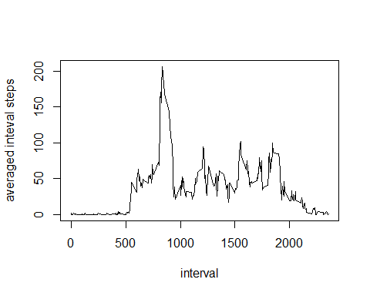 ### 2. Which 5-minute interval, on average across all the days in the dataset, contains the maximum number of steps? rownames(ave_intersteps)[which.max(ave_intersteps)] ``` ##imputing missing value ### 1.Calculate and report the total number of missing values in the dataset (i.e. the total number of rows with NAs

n<-length(data$steps[is.na(data$steps)])  
n

## [1] 2304

### 2-3. fill the missing value with mean of 5-minute interval

### use the mean of 5-minutes interval to fill the missing value

Newdata<-data  
Newdata$steps[is.na(data$steps)]<-ave_intersteps[is.na(data$steps)]

### 4. Make a histogram of the total number of steps taken each day and Calculate and report the mean and median total number of steps taken per day.

#total number of steps taken every day   
New_sumsteps_day<-rowsum(data[,c("steps")],group=Newdata$date,na.rm=TRUE,recorder=TRUE)  
hist(New_sumsteps_day,xlab="steps",main="Histogram of steps per day for new data")

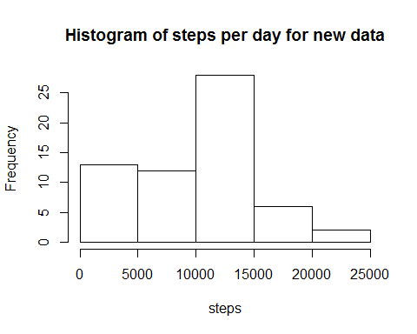

#mean of the total number of steps taken per day  
new_avesteps<-aggregate(x=Newdata[,"steps"],by=list(Newdata$date),FUN=mean)  
  
#median of the total number of steps taken per day  
new_medsteps<-aggregate(x=Newdata[,"steps"],by=list(Newdata$date),FUN=median)

## Are there differences in activity patterns between weekdays and weekends?

library(timeDate)

## Warning: package 'timeDate' was built under R version 3.1.3

library(ggplot2)  
library(grid)  
#1.Create a new factor variable in the dataset with two levels – “weekday” and “weekend”  
Newdata$timeDate[isWeekday(Newdata$date)]<-"weekday"  
Newdata$timeDate[!isWeekday(Newdata$date)]<-"weekend"  
#2.Make a panel plot containing a time series plot (i.e. type = "l") of the 5-minute interval (x-axis) and the average number of steps taken, averaged across all weekday days or weekend days (y-axis).  
ave_weeksteps<-aggregate(x=Newdata[,"steps"],by=list(Newdata$timeDate,Newdata$interval),FUN=mean,na.rm=TRUE)  
colnames(ave_weeksteps)<-c("weekdays","interval","steps")  
p<-ggplot(data=ave_weeksteps,aes(y=steps,x=interval))+geom_line(colour="blue")+facet_wrap(~weekdays,ncol=1)  
p+ylab("Number of steps")+theme(strip.background=element_rect(fill="lightblue"))

