Steps to Connect to pgadmin

Step 1 :
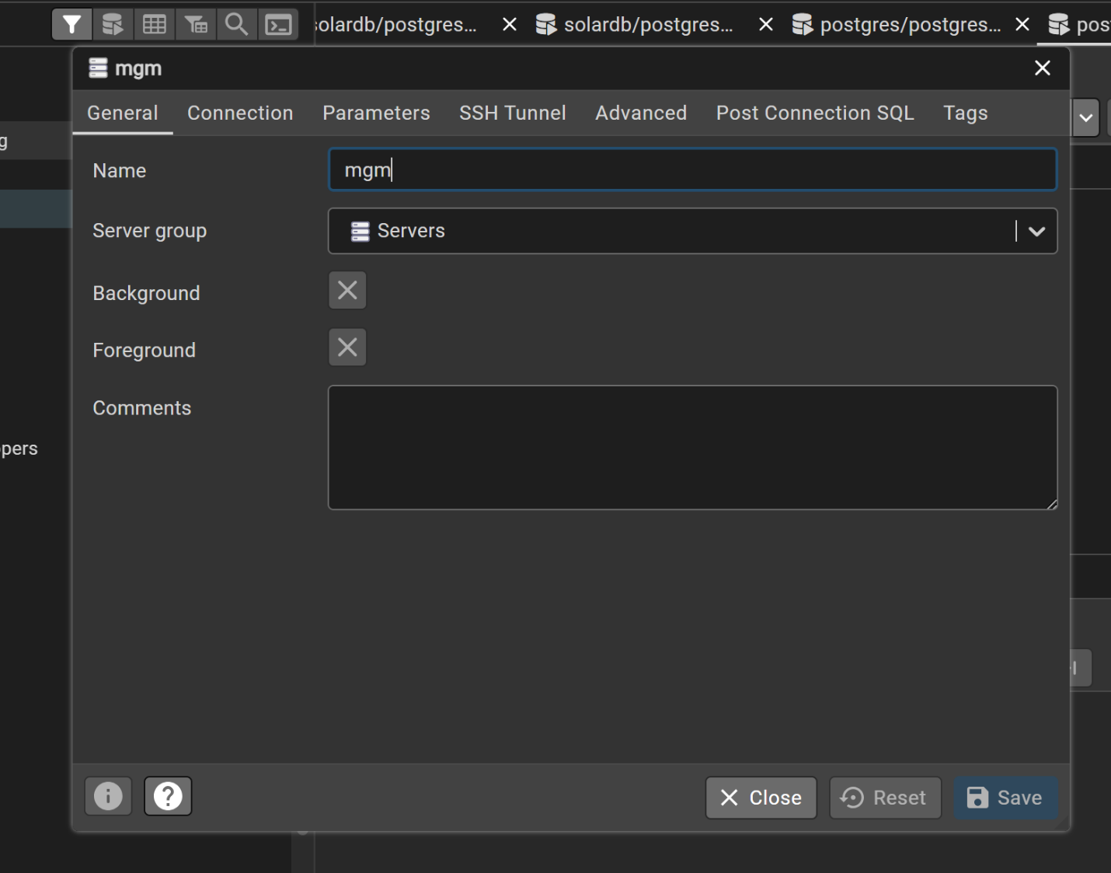

Step 2 :
Host name / Address | boa-prod-rds-db-instance.c2dflue07wl6.ap-south-1.rds.amazonaws.com
Port | 5432
Username | postgres
Password | RARwxd962bT6yOhg

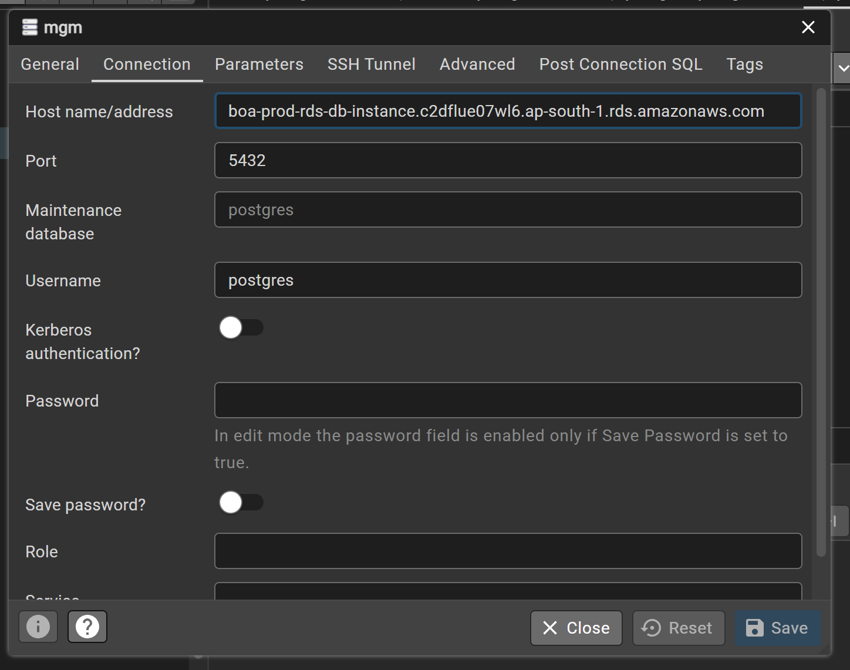
Step 3 :
Tunnel Host | 13.127.24.90
Tunnel Port | 50122
Username | 1ch-db
Password | Admin@123@

