LAB Logbook

Lab 1

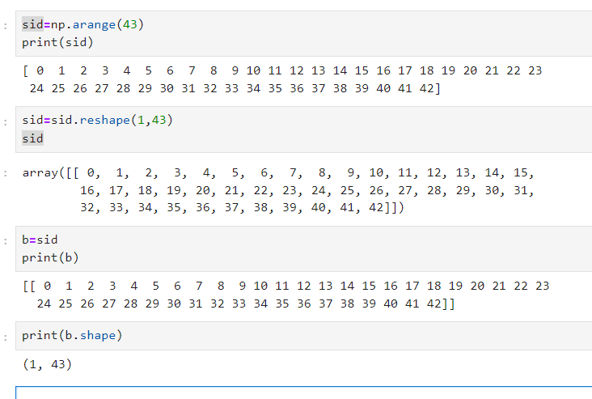

Lab 2

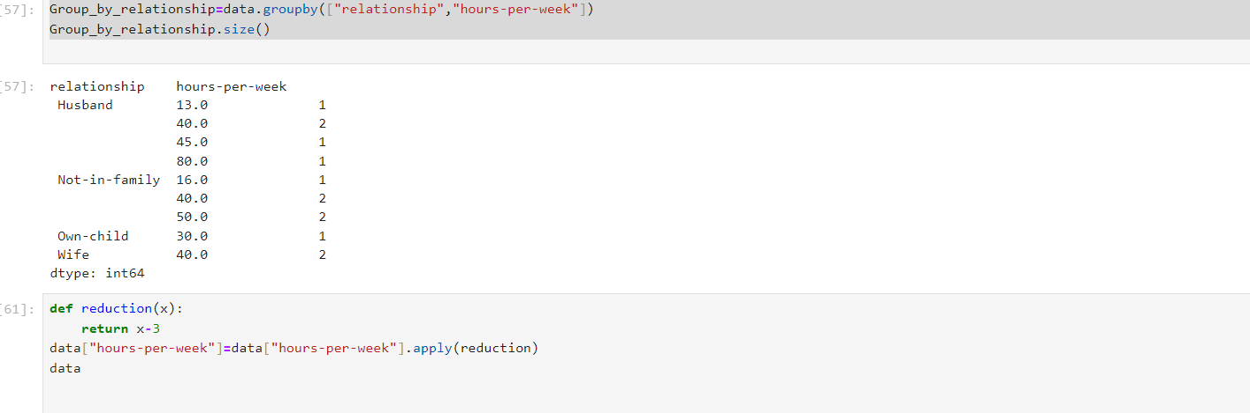

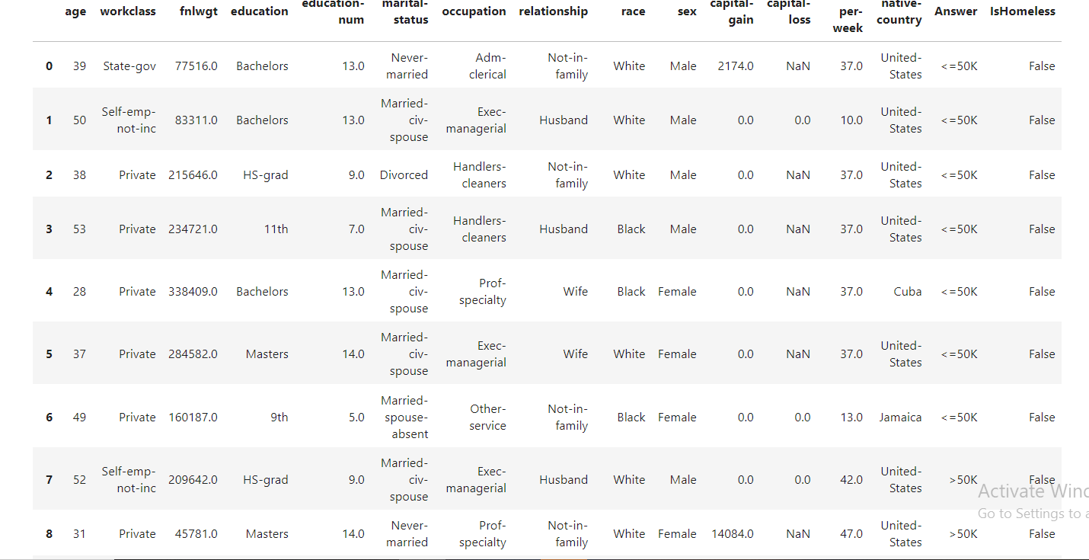

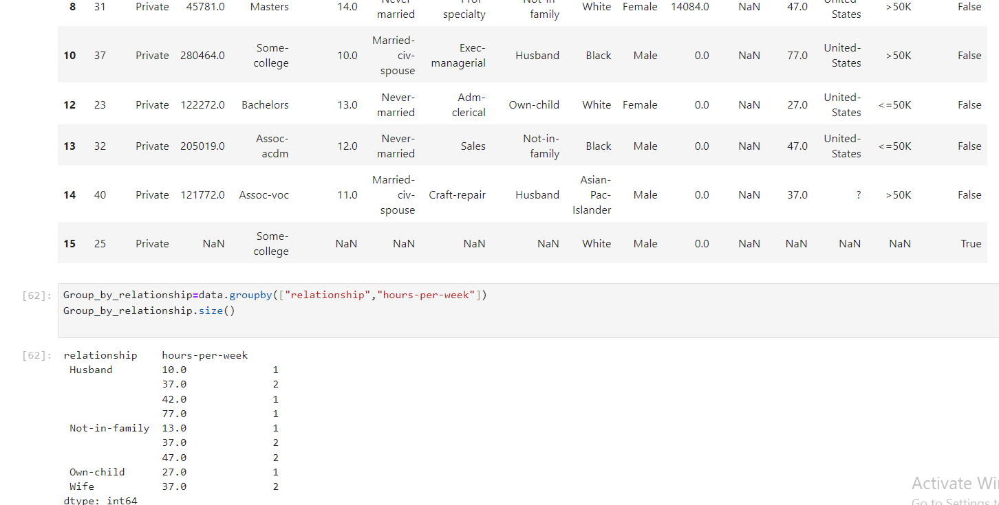

Lab 3

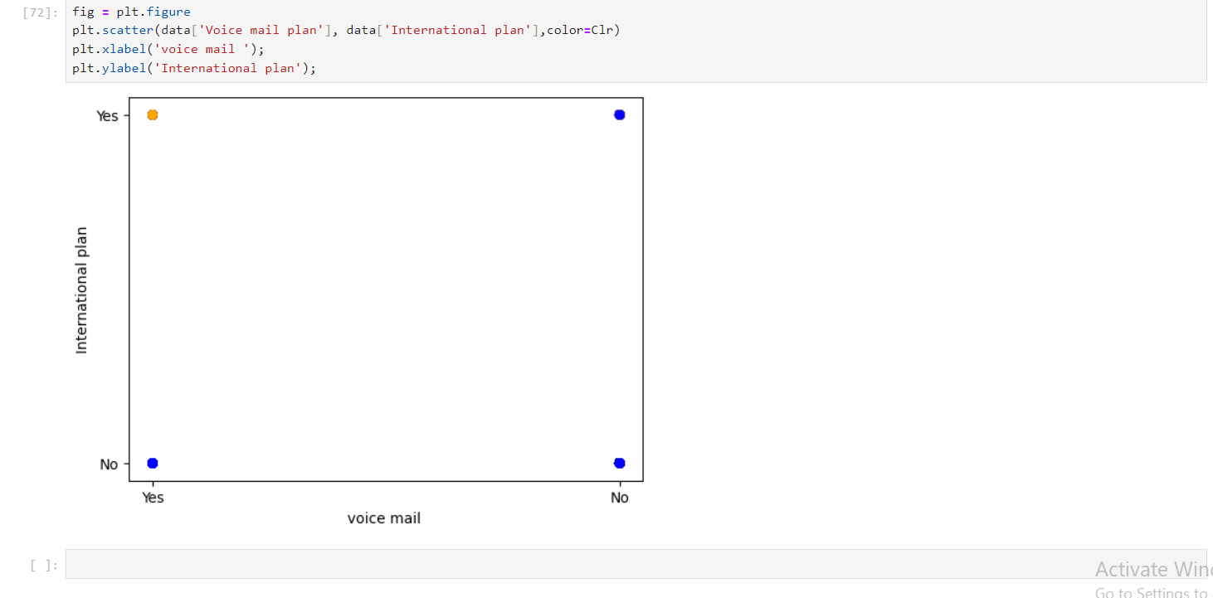

Lab 4

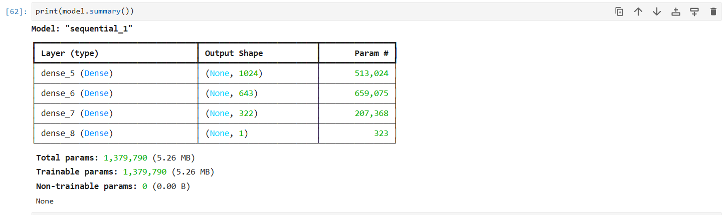

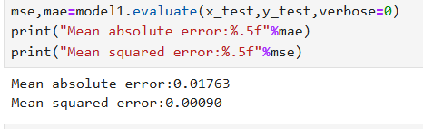

Lab 5

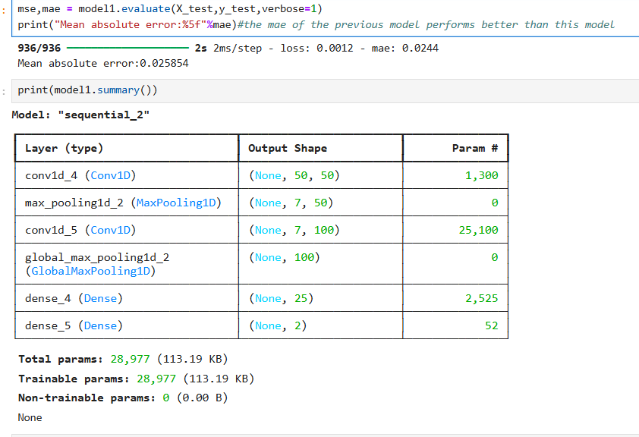

Lab 6

Lab 7

Lab 8

Lab 9

Lab 10

Lab 11

Lab 12