Assignment- 8

Task Description#1
Use AI to generate test cases for is_valid_email(email) and then implement the validator function.

Requirements:

- Must contain @ and . characters.
- Must not start or end with special characters.
- Should not allow multiple @.

Expected Output#1
- Email validation logic passing all test cases
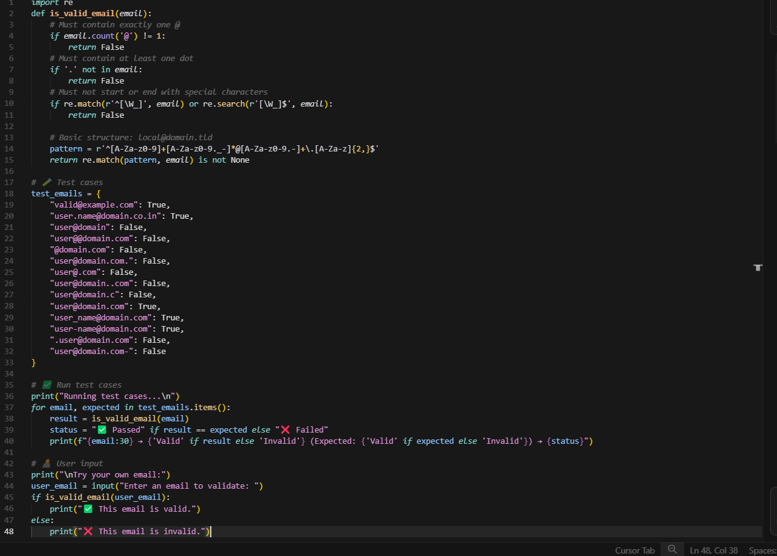

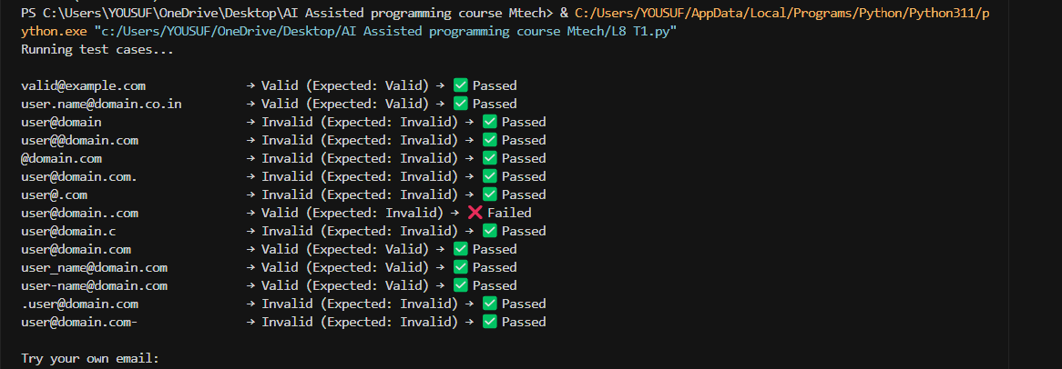
Expected Output#2
Grade assignment function passing test suite

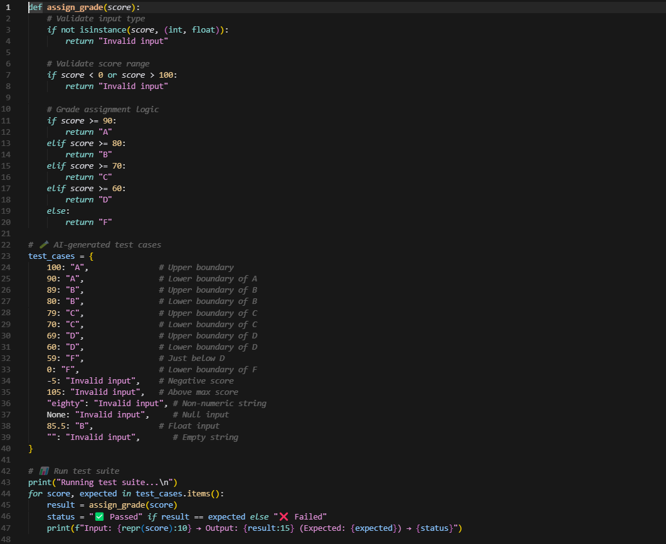

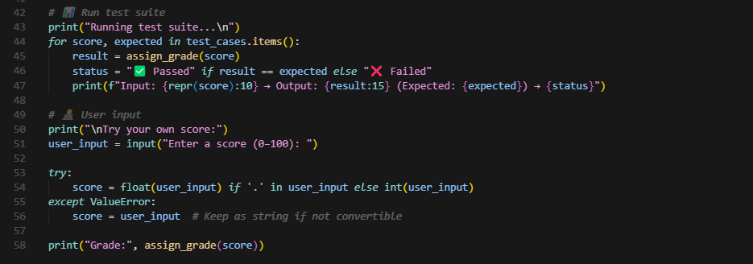

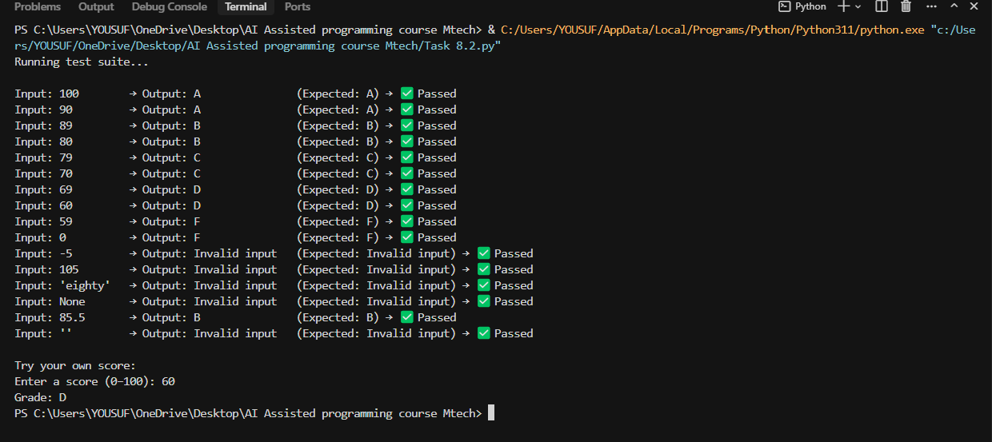

Task Description#3
- Generate test cases using AI for is_sentence_palindrome(sentence). Ignore case, punctuation, and spaces

Requirement
- Ask AI to create test cases for is_sentence_palindrome(sentence)
(ignores case, spaces, and punctuation).

- Example:
"A man a plan a canal Panama" → True

Expected Output#3
- Function returns True/False for cleaned sentences
- Implement the function to pass AI-generated

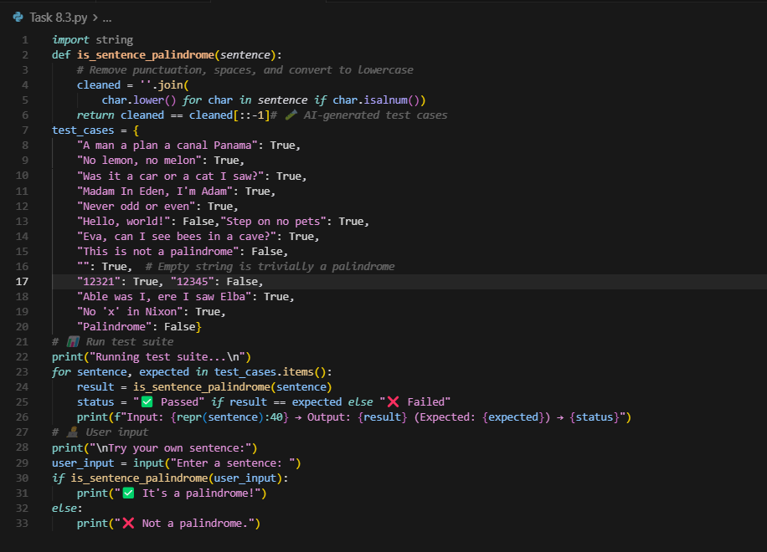

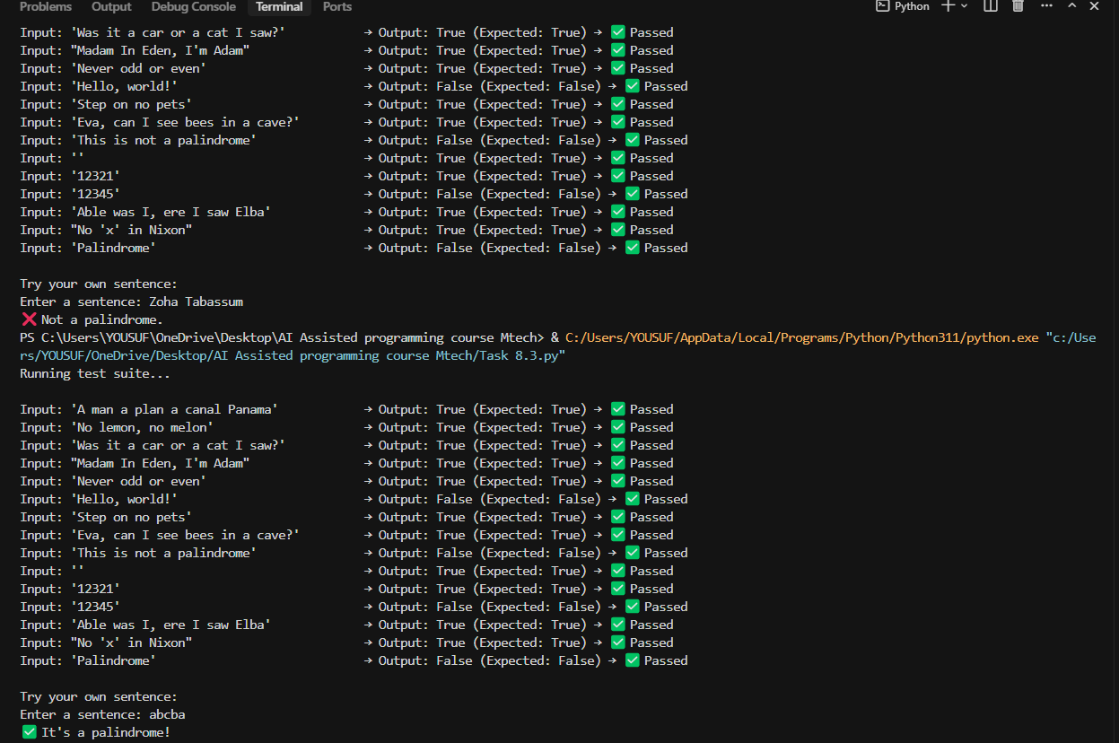

Task Description#4
- Let AI fix it Prompt AI to generate test cases for a ShoppingCart class (add_item, remove_item, total_cost).

Methods:
Add_item(name,orice)
Remove_item(name)
Total_cost()

Expected Output#4
- Full class with tested functionalit

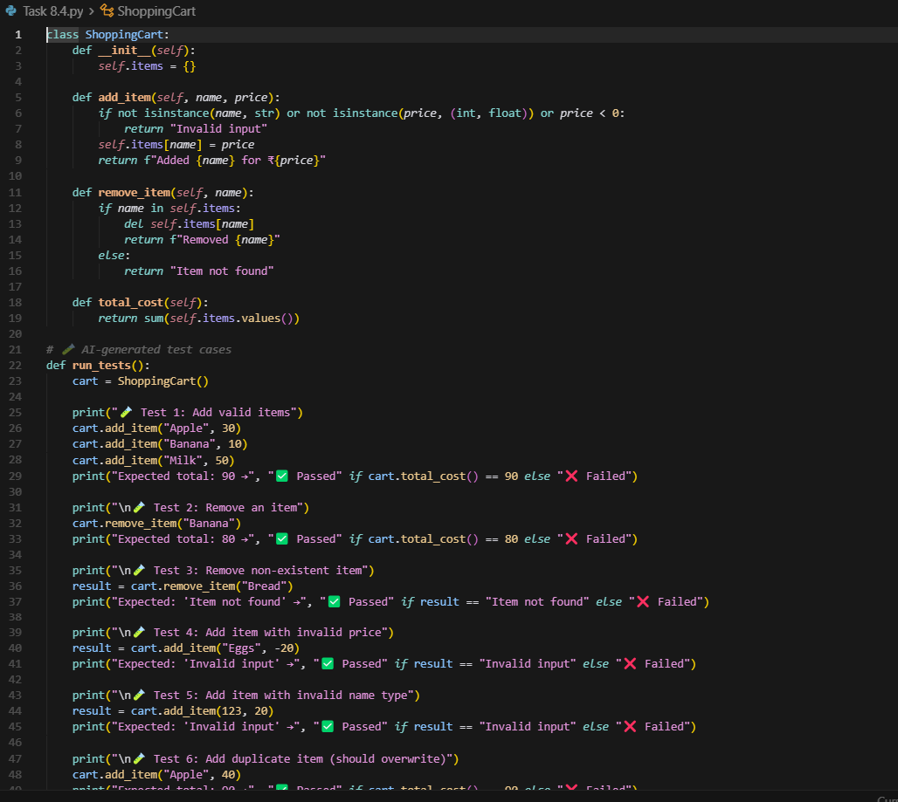

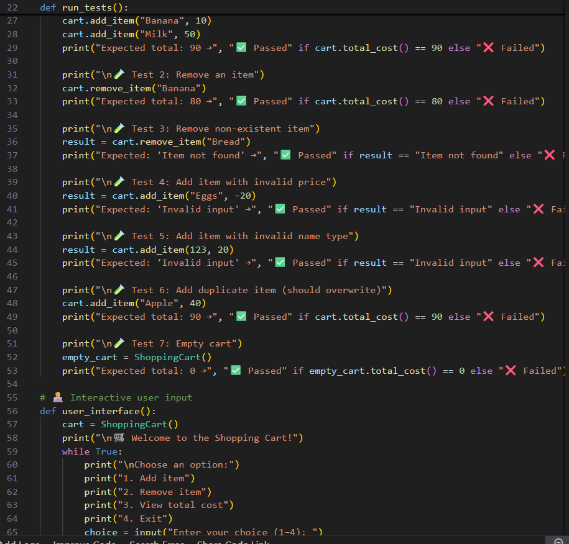

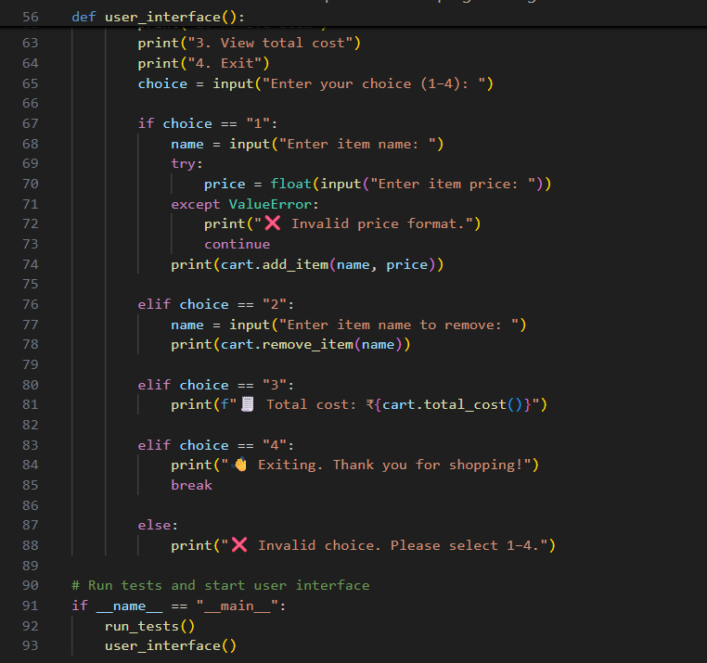

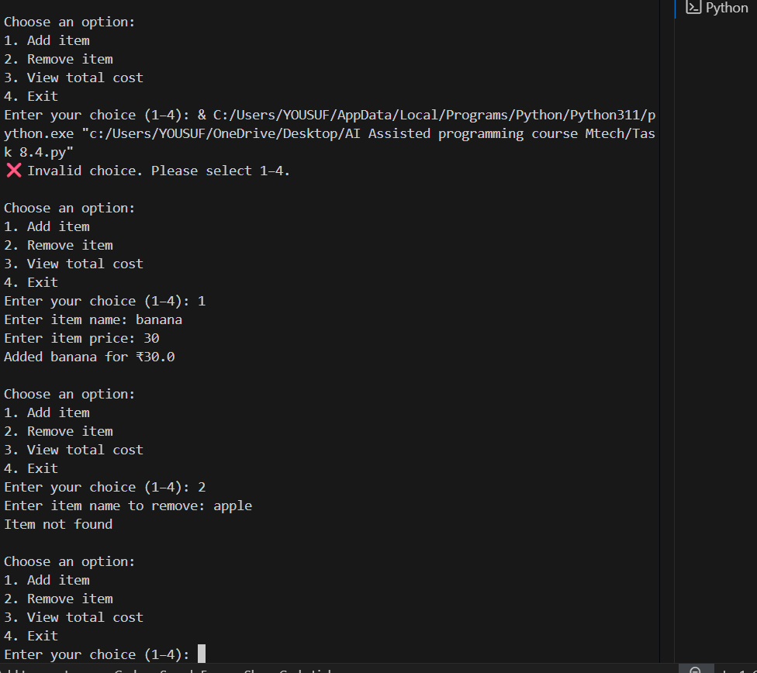

Task Description#5
- Use AI to write test cases for convert_date_format(date_str) to switch from "YYYY-MM-DD" to "DD-MM-YYYY".
Example: "2023-10-15" → "15-10-2023"

Expected Output#5
- Function converts input format correctly for all test cases

