**DIGITAL LOGIC DESIGN**

**“WATER TANK CONTROL MECHANISM”**

**Project Report**

**Submitted By:**

ZOHA BINTE WAJAHAT, NOOR-UL-AIN

**Submitted To:**

MA’AM AYESHA MARYAM

**CONTENTS**

1. Introduction
2. Components Used
3. Working
4. Proteus and Hardware
5. Conclusion

**INTRODUCTION**

 Water is an essential resource for all living beings, and its control and management are crucial for sustaining life on our planet. It is important to understand water control mechanisms, examining their significance, functionality, and impact on various aspects of our lives. By understanding these mechanisms, we can ensure the efficient utilization and conservation of water resources, ultimately contributing to a sustainable future

**COMPONENTS USED**

1. Four NPN transistors (such as BC547) that act as switches to turn on the LEDs when the water level reaches a certain height.
2. Three LEDs used to indicate the water level. Each LED corresponds to a specific water level.
3. Three resistors used to limit the current flowing through the LEDs and the transistors.
4. One buzzer used to provide an audible alarm when the water level reaches a critical

**WORKING**

Here's how the water level indicator with four transistors works:

The circuit is powered by a 9V battery. The circuit uses four probes made of wires to detect the water level. The probes are inserted into the tank or container at different heights. When the water level reaches a certain height, it makes contact with one or more of the probes, creating a path for the current to flow.

The current flows through the resistor connected to the corresponding probe and then through the base of the transistor. This turns on the transistor, allowing current to flow through the LED connected to its collector. The LED lights up, indicating the water level. If the water level continues to rise and reaches a critical level, it will make contact with the probe connected to the buzzer. This will turn on the buzzer, providing an audible alarm to alert the user.

Overall, the water level indicator with five transistors is a simple and effective circuit that can be used to monitor the water level in a tank or container.

**PROTEUS AND HARDWARE**

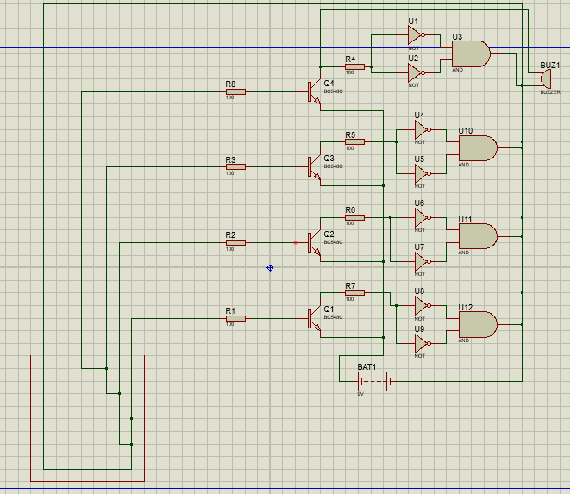

Proteus

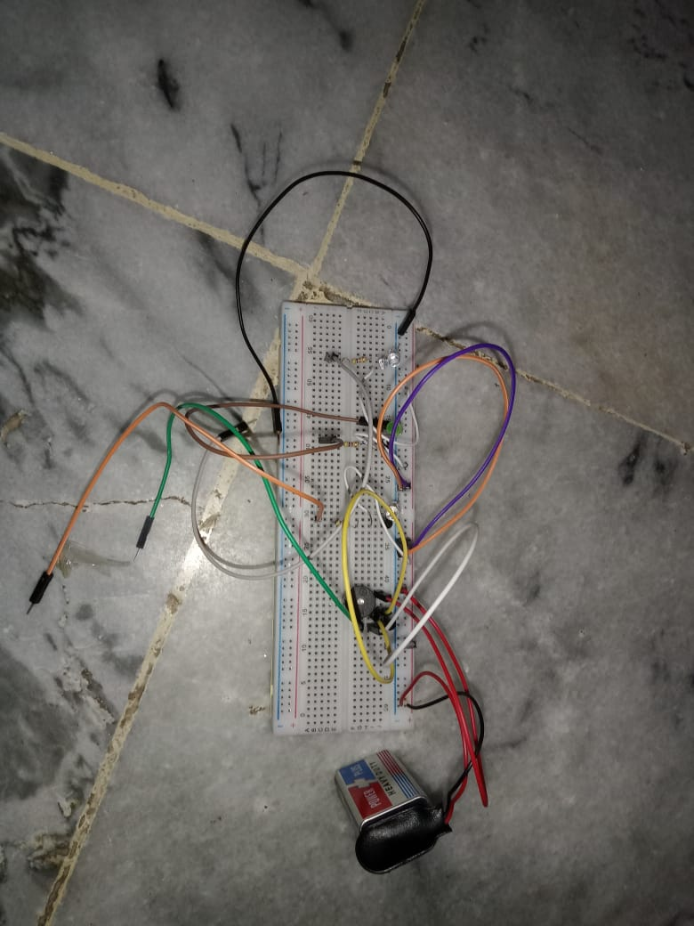

Hardware

**CONCLUSION**

In summary, the water level indicator project offers an accessible and cost-effective solution for monitoring water levels, making it applicable in diverse scenarios such as residential homes, farms, and industrial facilities. The project's development involved acquiring fundamental knowledge in electronics, conductivity, transistor technology, circuit design, and power supply design.

Through simulation and hardware testing, the water level indicator system demonstrated its capability to effectively detect and display water levels using LED indicators. The practical applications of this project extend beyond preventing overflows and shortages; it provides a valuable educational opportunity for individuals interested in gaining insights into basic electronics and circuit design.

In conclusion, the water level indicator project stands as a practical and educational endeavor. Its simplicity and adaptability make it suitable for various settings, while the acquired technical knowledge forms a solid foundation for those seeking to delve deeper into electronic systems. Furthermore, the project's potential for improvement and expansion opens doors to incorporating more features and functionalities, making it a dynamic and valuable learning tool.