Lab 11:Integer Arithmetic

#Task 1:
Include irvine32.inc
.data
.code
main PROC
mov eax,10
mov ebx,eax
mov edx,eax
shl ebx,4
shl eax,2
add ebx,edx
add eax,ebx
call writedec
exit
main endp
end main

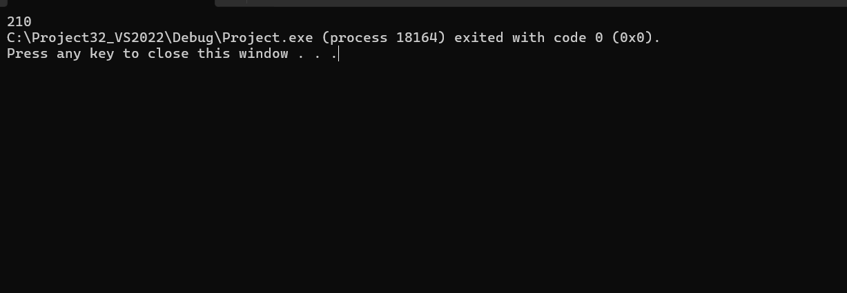

#Task2:

INCLUDE Irvine32.inc
.data
res BYTE "After expanding EAX: ", 0
.code
main PROC
xor eax, eax
mov ax, -128
sar eax, 0

call dumpregs

mov edx, offset res
call writestring
call writedec
call crlf
exit
main ENDP
END main
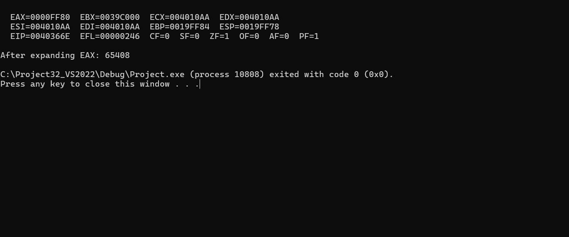

#Task3:
Include irvine32.inc
.data
.code
main PROC
mov ecx,8
mov eax,0
mov ebx,0
mov ax,0ABCDh
l1:
shr ax,1
rcr bx,1
loop l1
call dumpregs
exit
main endp
end main

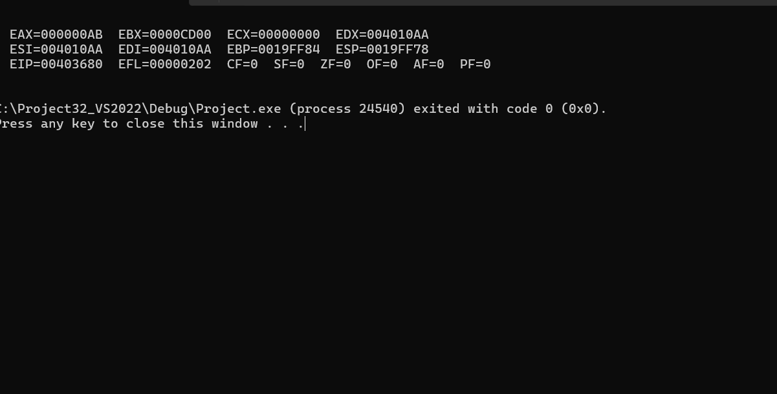

#Task4:

INCLUDE Irvine32.inc
.data
val1 SDWORD 20
val2 SDWORD 10
val3 SDWORD 2
resultMsg BYTE "Result val1: ", 0
.code
main PROC
mov eax, val2
cdq
idiv val3
push eax
mov eax, val1
cdq
idiv val2
mov ebx, eax
pop eax
imul eax, ebx
mov val1, eax
call dumpregs
mov edx, offset resultMsg
call writestring
mov eax, val1
call writedec
call crlf

exit
main ENDP
END main

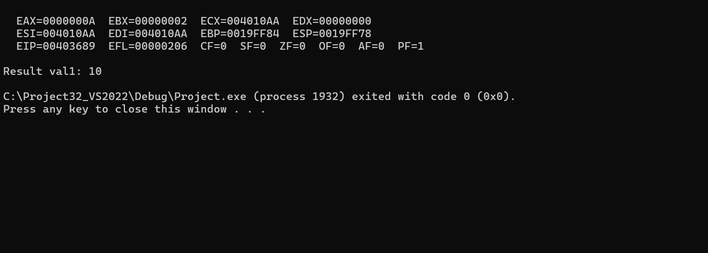

#Task5:
INCLUDE Irvine32.inc
.data
resultMsg BYTE "64-bit sum is: ", 0
colon BYTE ":", 0
.code
Extended_Add PROC
add eax, ebx
adc edx, ecx
ret
Extended_Add ENDP
main PROC
mov eax, 2
mov edx, 1
mov ebx, 4
mov ecx, 3
call Extended_Add
call dumpregs
mov edx, offset resultMsg
call writestring
mov eax, edx
call writedec
mov edx, offset colon
call writestring
mov eax, eax
call writedec
call crlf
exit
main ENDP
END main

