Lab1 Web Engineering Lab

1:Live server check
}
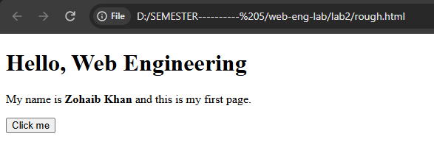

2:TOTAL REQUESTS
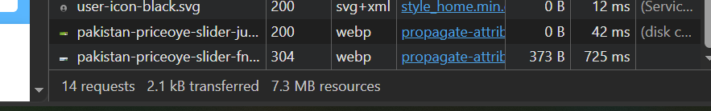
3: STATUS 200
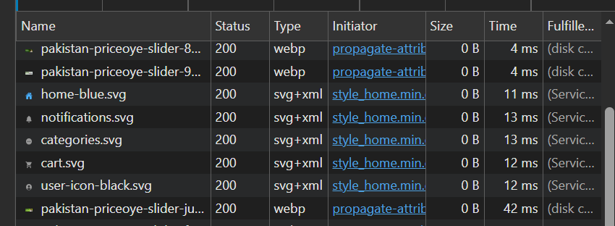

4:App: YouTube
1. Client: The YouTube app displays the video and sends my request when I click a video.
2. Server: The server finds the requested video and sends the video data to my device.
3. Network failure: The video would stop loading if the network failed while the video was playing.

5:Website URL
https://priceoye.pk/smart-watches/samsung/samsung-watch-8-classic-46mm
Part | Value
Protocol | https
Host | priceoye.pk
Port | None specified
Path | /smart-watches/samsung/samsung-watch-8-classic-46mm
Query | None
Fragment | None
Note:Only Highlighted part changes when I click the other product

